Lab Assignment 6 – AI Assistant Coding
2303A52173
K SAI PRANEETH
Task 1: Student Performance Evaluation System
Prompt used:
#Generate a python code that defines a class Student with attributes name, roll number, and marks. And methods to display student details, check if marks are above class average, and return performance status.
Code:
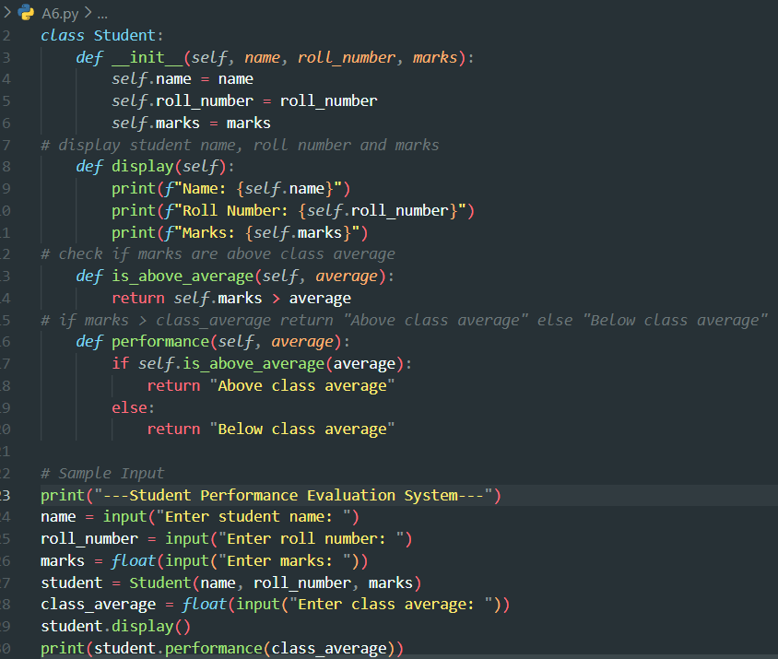

Output:
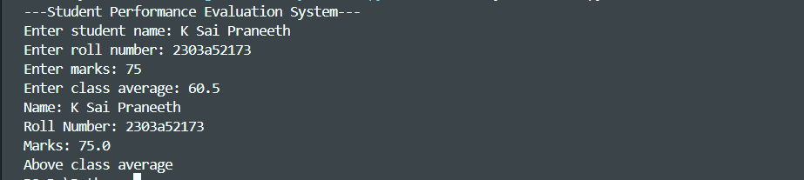
Justification:
The Student class models a student using object-oriented principles.
The constructor initializes student details using self for data encapsulation.
Separate methods handle displaying details and evaluating performance for better modularity. Conditional logic (if-else) is used to compare marks with the class average. The program dynamically evaluates and displays a student’s performance status.
Task 2: Data Processing in a Monitoring System
Prompt used:
# Create a Data monitoring system using python to find a prime number in a list of numbers and square them.
Code:
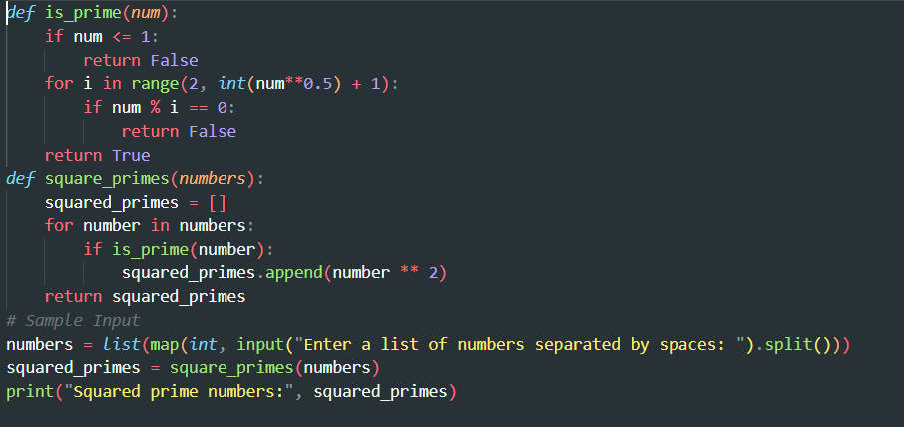

Output:
Justification:
The is -prime() function efficiently checks primality by testing divisibility up to the square root of the number. The square-primes() function iterates through the list and filters only prime numbers. Prime numbers are squared and stored in a new list, ensuring separation of logic and clarity. This modular approach improves readability, reuse, and maintainability of the code
Task 3: Student Performance Evaluation System
Prompt used:
#Generate a python code for Banking Transaction Simulation using class named BankAccount with attributes,account_holder,balance, Depositing money, Withdrawing money,Preventing withdrawals when the balance is insufficient.
Code:
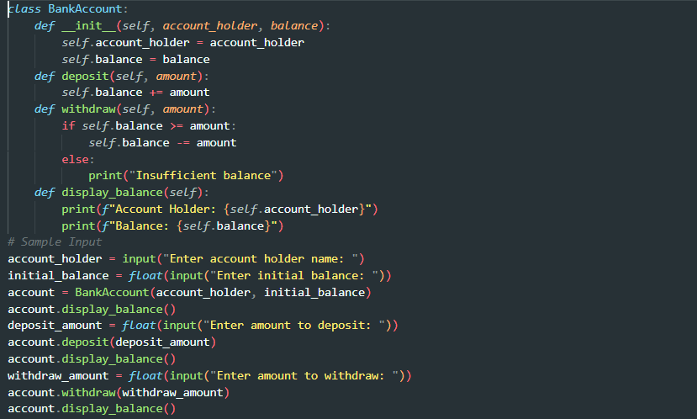
Output:
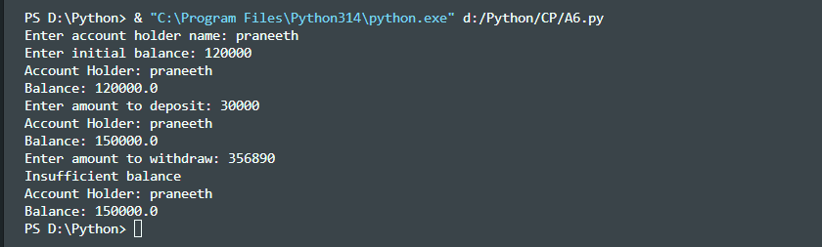
Justification:
The BankAccount class models a real-world bank account using object-oriented principles. The constructor initializes account holder details and balance using self. The deposit() and withdraw() methods update the balance with proper validation. An if-else condition prevents withdrawals when funds are insufficient. The program demonstrates secure and modular handling of basic banking operations.
Task 4: Student Scholarship Eligibility Check
Prompt used:
#Generate a python code to Student Scholarship Eligibility based on marks who scored above 75 are eligible for scholarship. create a list dictionary to store student name and marks and check eligibility for each student.
Code:
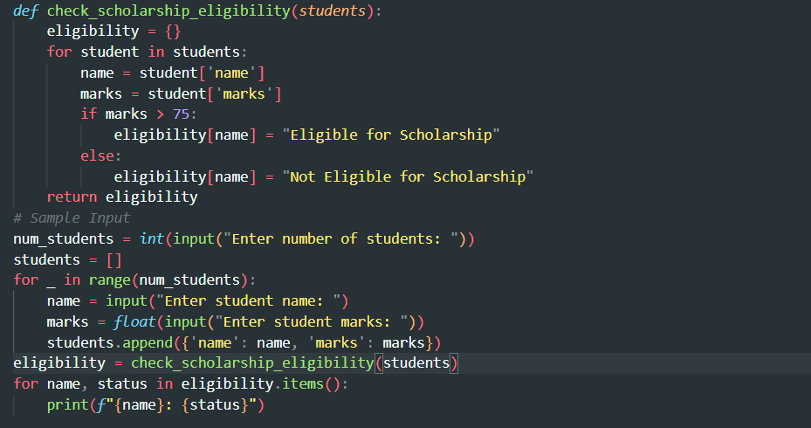
Output:
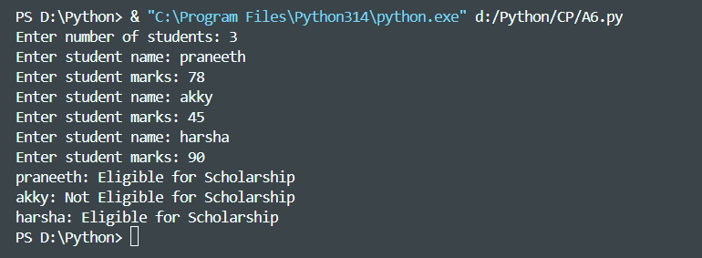
Justification:
The program correctly checks each student’s marks against the eligibility criterion (>75).It uses a dictionary to clearly map student names to their scholarship status.The function-based approach improves readability and reusability.User input handling allows the program to work for any number of students
Task 5: Online Shopping Cart Module
Prompt used:
#Create a Python class named ShoppingCart for an online shopping cart system.Initialize the class with an empty list to store items, where each item contains name, price, and quantity.
# Generate methods to add items to the cart, remove items by name, and calculate the total bill using a loop (price × quantity).
# Include a method to apply a conditional discount (for example, apply a 10% discount if the total bill exceeds 5000).
Code:

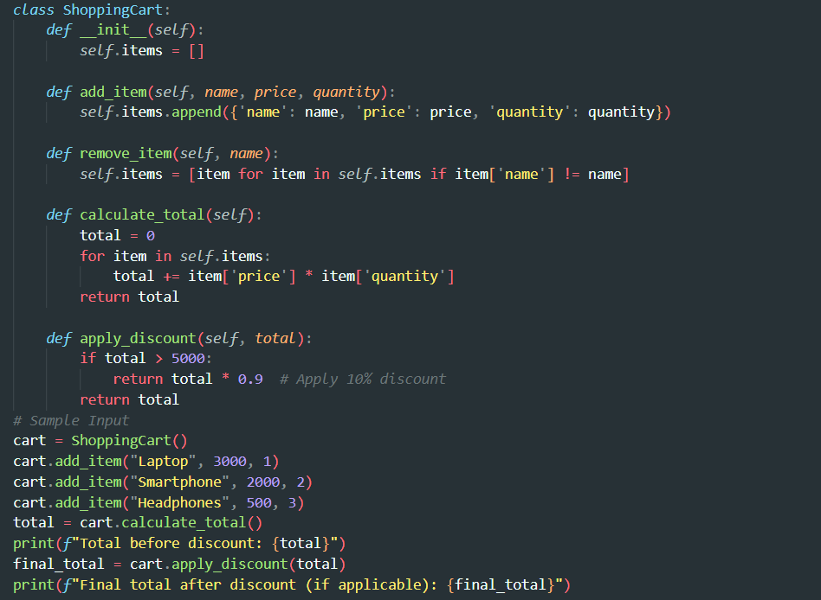
Output:
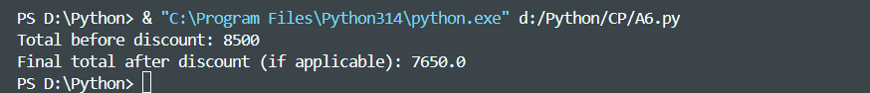
Justification:
The program effectively uses a class to manage shopping cart operations in an organized manner. It calculates the total bill using a loop, ensuring accurate price–quantity computation. Conditional logic is applied to give a discount when the total exceeds the defined limit. The design is simple, readable, and suitable for a basic e-commerce system.

