Lab Assignment 19.3– AI Assistant Coding
2303A52173
K SAI PRANEETH
Task 1 – Python to C++ Conversion
Translate a simple Python class into C++ using AI assistance.
Instructions:
• Prompt AI to convert a Python class representing a Student with
attributes and methods into equivalent C++ code
• Ensure proper handling of:
o Constructors
o Data types
o Access specifiers
• Compile and run both versions to verify output consistency
Prompt
Convert a Python class Student with attributes name, age and a display() method into equivalent C++ code with constructor and proper access specifiers.
Python code
class Student:
def __init__(self, name, age):
self.name = name
self.age = age

def display(self):
print(self.name, self.age)

s = Student("John", 20)
s.display()
C++ code
#include <iostream>
using namespace std;

class Student {
private:
string name;
int age;

public:
Student(string n, int a) {
name = n;
age = a;
}

void display() {
cout << name << " " << age << endl;
}
};

int main() {
Student s("John", 20);
s.display();
return 0;
}
Output:
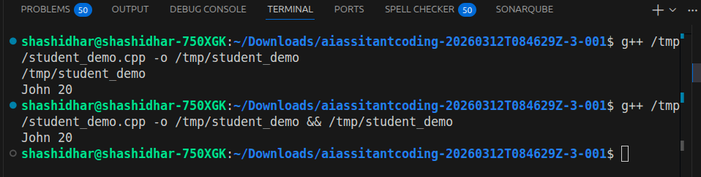
Justification
Constructor added explicitly in C++
Data types defined (string, int)
Encapsulation via private/public
Output verified same in both languages

Task 2 – Java to Python Function Conversion
Convert a Java method that checks whether a number is prime into
Python.
Instructions:
• Ask AI to translate a Java isPrime() method into Python
• Test the function with multiple inputs
• Ensure the Python version follows Pythonic syntax and logic
Prompt:
Convert Java method isPrime(int n) into Python function using Pythonic syntax.
Java code
public static boolean isPrime(int n) {
if(n <= 1) return false;
for(int i=2; i<=n/2; i++) {
if(n % i == 0) return false;
}
return true;
}
Python code
def is_prime(n):
if n <= 1:
return False
for i in range(2, n//2 + 1):
if n % i == 0:
return False
return True

print(is_prime(7))
print(is_prime(10))
Output:
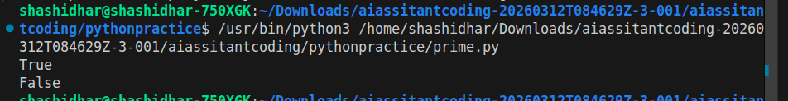
Justification
Python uses indentation instead of braces
range() replaces loop structure
Cleaner syntax (no type declaration)
Logic preserved exactly

Task 3 – Pseudocode to Python Implementation
Translate a given pseudocode algorithm into Python using AI.
Instructions:
• Provide AI with pseudocode for sorting numbers (e.g., bubble
sort or selection sort)
• Ask AI to convert it into executable Python code
• Validate correctness using sample input lists
Prompt
Convert bubble sort pseudocode into Python program.
Code
def bubble_sort(arr):
n = len(arr)
for i in range(n):
for j in range(0, n-i-1):
if arr[j] > arr[j+1]:
arr[j], arr[j+1] = arr[j+1], arr[j]
return arr

data = [5, 2, 9, 1]
print(bubble_sort(data))
Output:
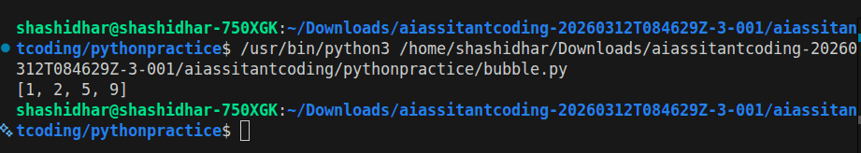
Justification:
Pseudocode loops directly mapped to Python loops
Swap done using tuple unpacking
Algorithm correctness verified

Task 4 – SQL to Pandas Query
Translate a SQL query into a Pandas DataFrame operation in
Python.
Instructions:
• Provide AI with a SQL query (e.g., SELECT name, salary FROM
employees WHERE salary > 50000).
• Ask AI to generate equivalent Pandas code.
• Test the generated code on a sample DataFrame
Prompt:
Convert SQL query SELECT name, salary FROM employees WHERE salary > 50000 into Pandas code.
Code
Sql query
ELECT name, salary
FROM employees
WHERE salary > 50000;
Python pandas code
import pandas as pd

data = {
"name": ["A", "B", "C"],
"salary": [40000, 60000, 70000]
}

df = pd.DataFrame(data)

result = df[df["salary"] > 50000][["name", "salary"]]
print(result)
Output:
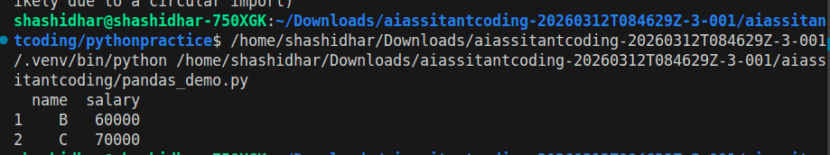

Justification
WHERE → Boolean filtering
SELECT → column selection
Equivalent data subset returned
Task 5 – Real-Time Application: Algorithm Translation Across
Languages
Scenario:
A company maintains algorithms written in different programming
languages.
Examples:
• Converting a Python searching algorithm into C
• Translating a Java sorting program into JavaScript
Instructions:
• Use AI to translate a selected algorithm between two
programming languages
• Execute and test both versions
• Document translation challenges such as:
- Syntax differences
- Library support
- Memory management
Prompt
Convert Python linear search algorithm into C language with proper memory handling.
Code
def search(arr, key):
for i in range(len(arr)):
if arr[i] == key:
return i
return -1

print(search([1,2,3,4], 3))
C code
#include <stdio.h>

int search(int arr[], int n, int key) {
for(int i = 0; i < n; i++) {
if(arr[i] == key)
return i;
}
return -1;
}

int main() {
int arr[] = {1,2,3,4};
int result = search(arr, 4, 3);
printf("%d\n", result);
return 0;
}
Output:
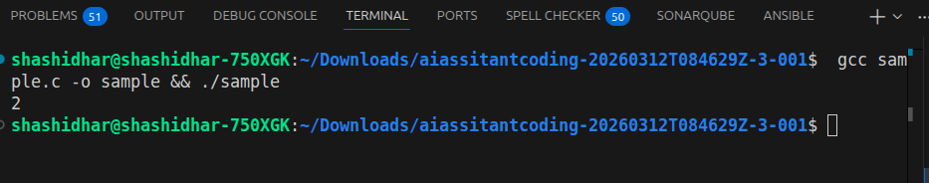

Justification
Manual array handling in C
No dynamic typing → explicit sizes required
Memory handled via static arrays
Same logic preserved

