Task 1 – Problem Identification & AI-Assisted Ideation
Task:
Identify and refine a real-world problem using AI.
Prompt:
Suggest 3 real-world civic problems that can be digitized such as complaint systems, parking, or waste management.

Refine the selected problem into a clear problem statement and generate key features, target users, and expected impact.
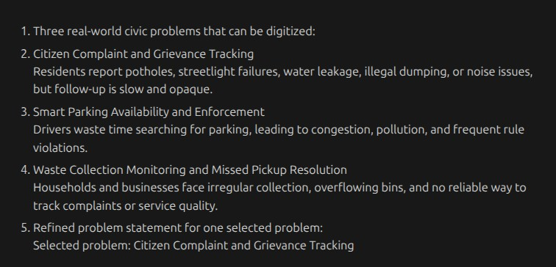
Output:
Selected problem
1. Citizen Complaint and Grievance Tracking
Residents report potholes, streetlight failures, water leakage, illegal dumping, or noise issues, but follow-up is slow and opaque.
Refined Problem Statement

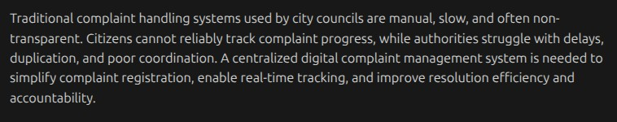
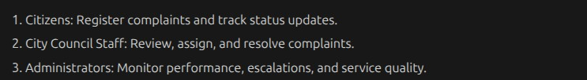
Target Users

Key Features
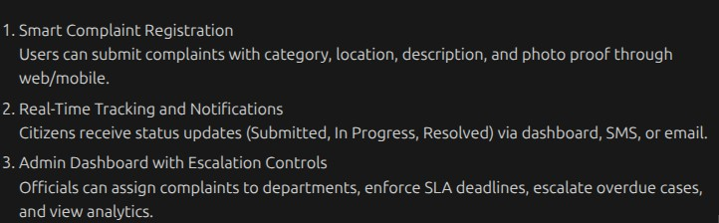
Task 2 – System Planning & Architecture Design
Task:
Design the system architecture with AI support. Prompt used
Design a system architecture for a digital complaint management system. Include frontend, backend, database, data flow, API design, and database schema. System Components

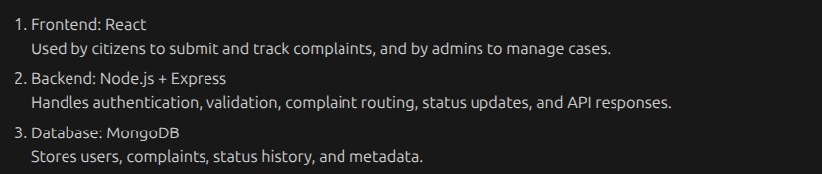
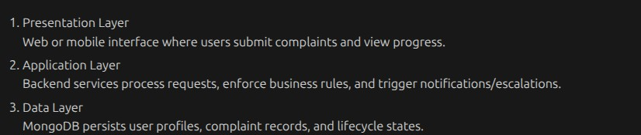
Architecture Description
Data Flow
Flow Explanation:

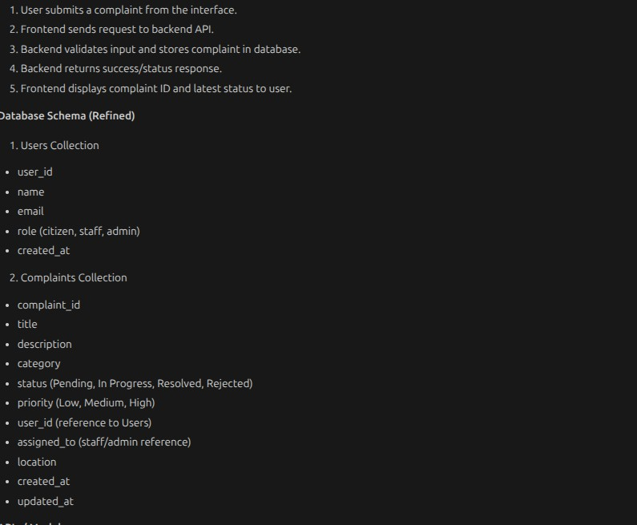

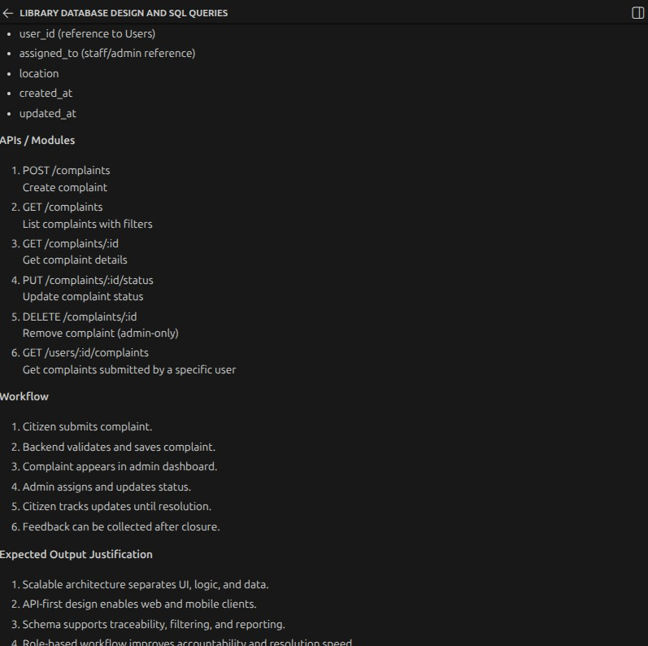
Task 3 – Modular Code Development with AI
Task:
Develop core modules of the application using AI. Prompt:
Generate modular JavaScript code for a complaint management system including input handling, core logic,

and data storage. Include validation, error handling, and clean function-based structure.
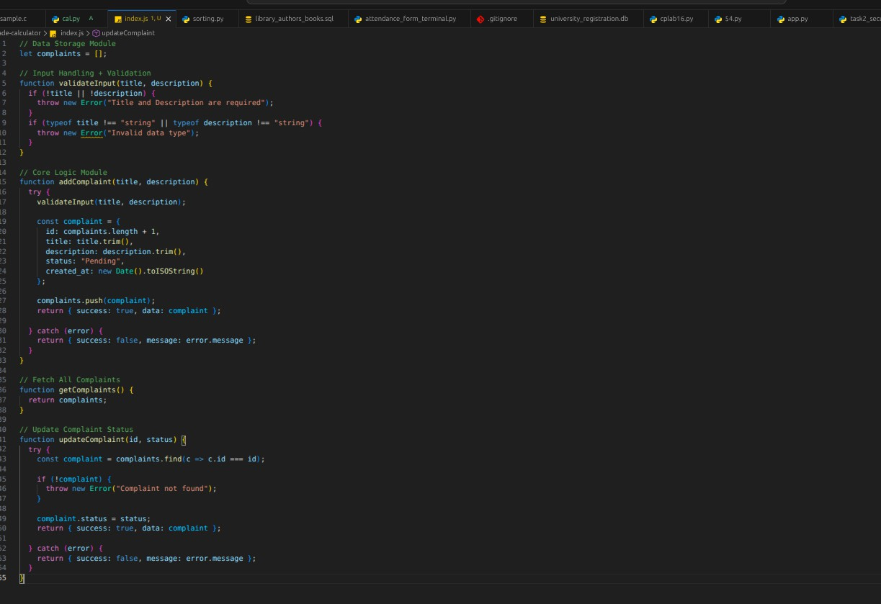
Code

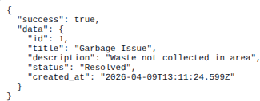
Input1 Output1:
Input2 Output2:

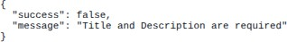

Input3:
Output3:
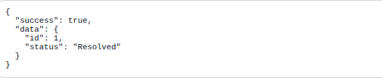
Task 4 – AI-Assisted Testing, Debugging & Optimization
Task:
Validate and improve your application. Prompt used
Generate test cases, identify bugs, and suggest optimizations for a JavaScript complaint management system with input validation and in-memory storage.
Test Case 1 – Valid Input
Output1
Test case 2-Empty input

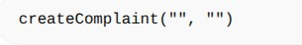

Output2:
Test Case 3 – Invalid Update
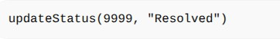
Output3:
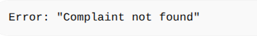

Bugs Identified
No persistent storage (data lost after refresh)
ID generation using Date.now() may conflict in rare cases
No validation for status values Fixes & Improvements Added status validation Improved ID generation logic Structured error handling
Optimized Code (Improved Version)

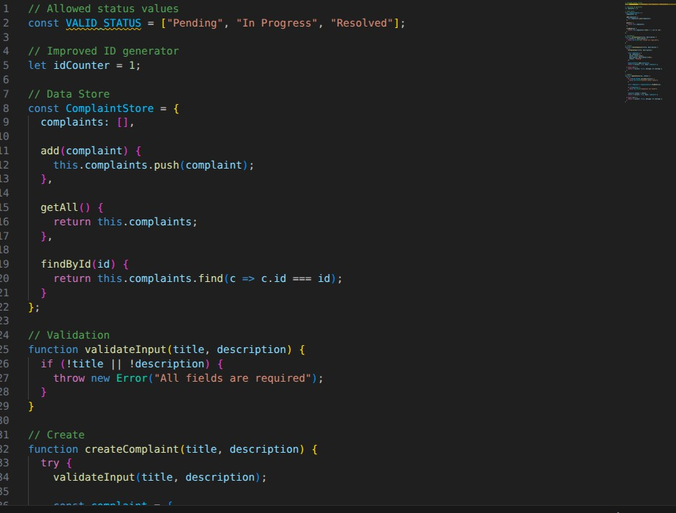

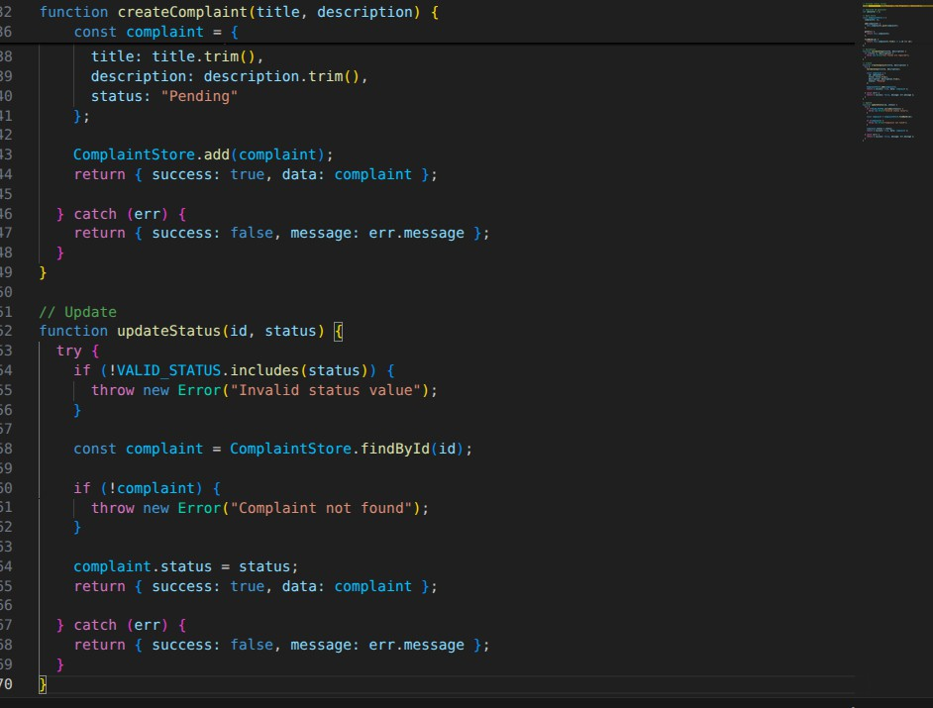
Task 5 – Documentation, Version Control & Reflection
Task:
Prepare the project for submission and collaboration. Prompt used :
Generate a README file, add code comments, suggest Git commit messages, and write a reflection for a complaint management system project.
README (ai generated)

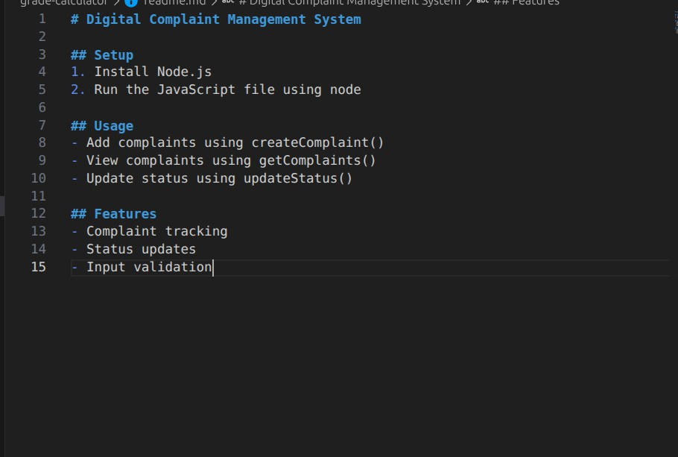
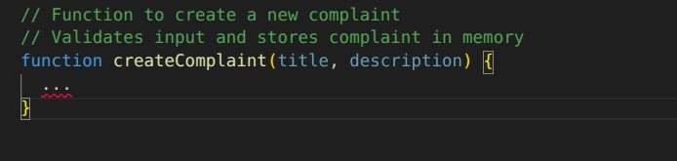
Code Documentation

Sample Commit Messages
Initial project setup
Added complaint creation module Implemented input validation Fixed status update bug

Optimized code structure
Reflection Report
->how ai helped
Generated initial code quickly Assisted in debugging and testing Helped design system architecture
->LImitation faced
Generated initial code quickly Assisted in debugging and testing Helped design system architecture
->Improvements Possible Add database (MongoDB) Build frontend UI
Deploy as full-stack app Add authentication system

