Lab Assignment 1 – AI Assistant Coding
2303A52173
K SAI PRANEETH

Task 1: Stack Implementation for Undo Operations (LIFO)
Prompt used:
#Generate Stack class in Python with the following methods: push() ,pop(), peek(),is_empty() along with properdocstrings .Explain why a stack is suitable for undo functionality ,testcases fro undo ando also suggest an alternative implementation using collections.deque.
Code:
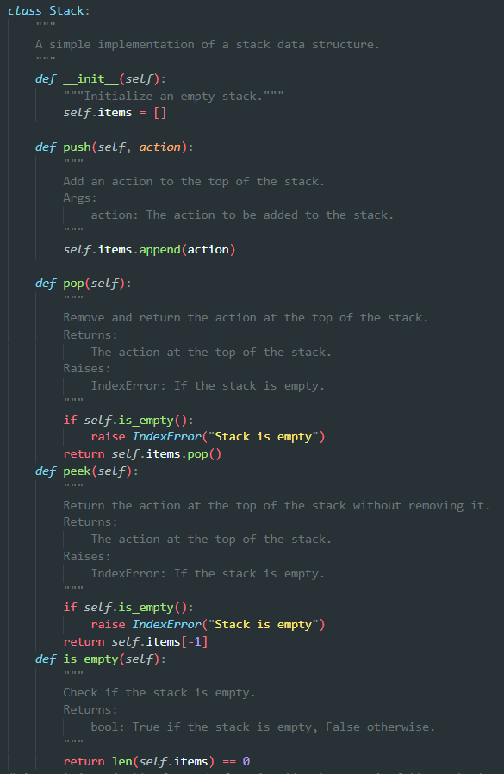

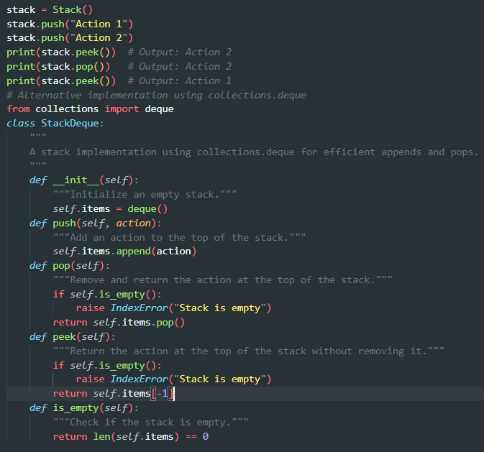
Output:
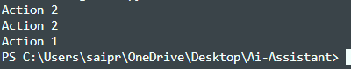
Justification:
A stack is suitable for undo functionality because it follows the Last In, First Out (LIFO) principle. When a user performs an action, it is pushed onto the stack. If the user wants to undo the last action, we can simply pop the top action from the stack and reverse it. This allows us to easily manage and track the sequence of actions.
Task 2: Queue for Customer Service Requests (FIFO)
Prompt used:
#Implement a Queue class for a customer support system where requests are handled in FIFO order using a Python list with enqueue(request), dequeue(), and is_empty(), review its performance, then implement an optimized version using collections.deque, compare time complexity, and justify why deque is better.
Code:
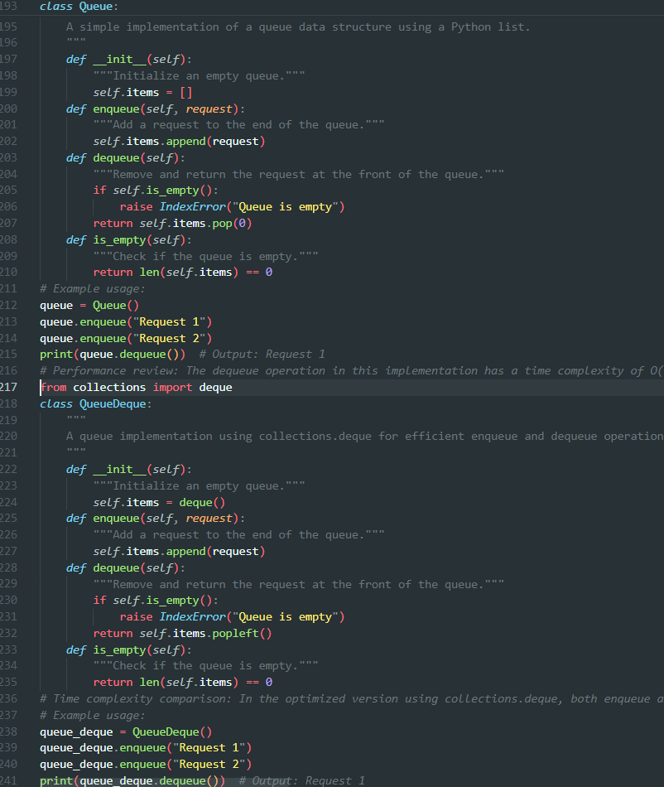
Output:
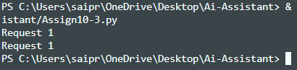
Justification:
In the list-based queue, enqueue runs in O(1) time but dequeue uses pop(0) which takes O(n) time because all remaining elements must shift left, making it inefficient for large numbers of customer requests, whereas in the deque-based queue both enqueue and dequeue run in O(1) time since deque is implemented as a doubly linked structure that allows efficient insertion and removal from both ends without shifting elements, making deque more scalable and better suited for real-world customer support systems handling high request volumes.

Task 3: Singly Linked List for Dynamic Playlist Management
Prompt used:
#Design a Singly Linked List for managing a music playlist where songs can be added at the end, removed by name, and displayed in order. The implementation should clearly explain how pointers move during insertion and deletion, highlight tricky parts, and include proper test cases for edge conditions like empty list, single node, and deleting the head.
Code:
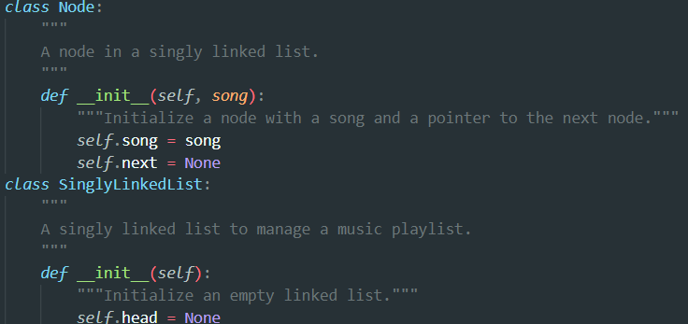
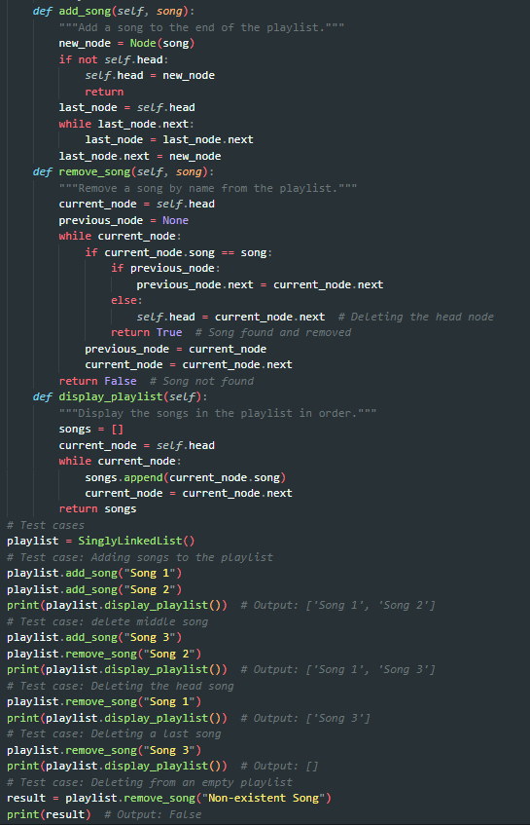
Output:

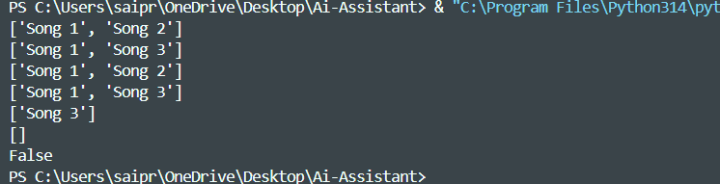
Justification:
A singly linked list is perfect for a playlist because you can easily add or remove songs without disturbing the entire list. When adding a song, the important part is making sure the last song properly points to the new one.
While deleting, extra care is needed if the song is the first one orsomewhere in the middle, so the links stay correct.By handling cases like an empty playlist or a single song, we make sure the system works smoothly every time
Task 4: Binary Search Tree for Fast Record Lookup.
Prompt used:
Build a Binary Search Tree (BST) for a student record system where fast searching by roll number is required. Complete the missing methods for insert, search, and inorder traversal, add clear docstrings, and explain how a BST improves search efficiency compared to linear search, including best-case and worst-case performance.
Code:
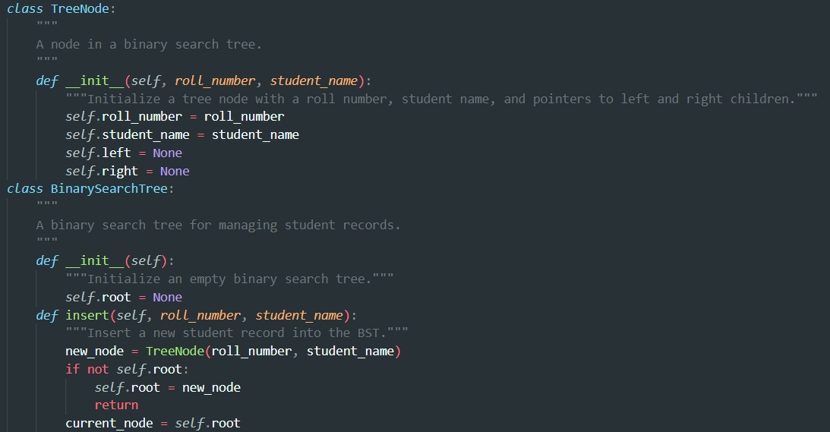
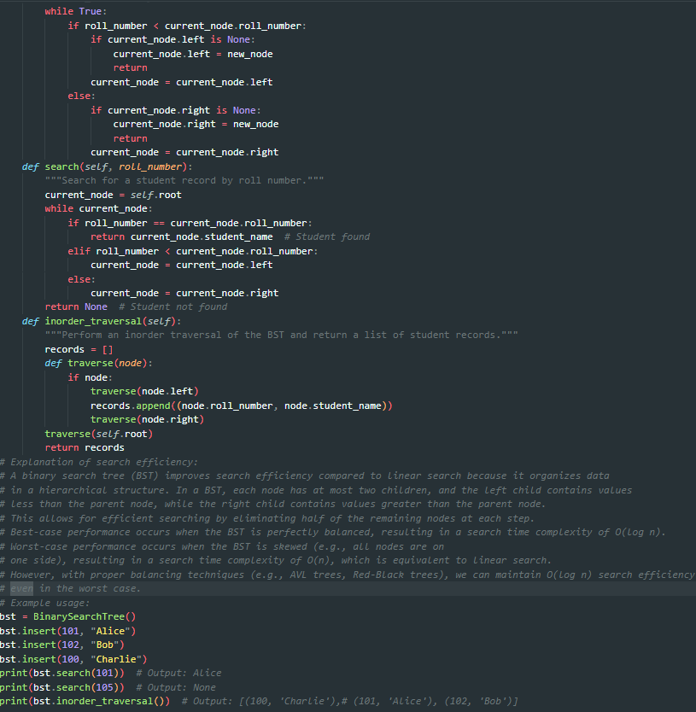
Output:
Justification:
A Binary Search Tree improves search efficiency by dividing the data at each step, reducing the search time to O(log n) in the best (balanced) case compared to O(n) in linear search.However, in the worst case when the tree becomes unbalanced, the search time can degrade to O(n), similar to linear search.

Task 5: Graph Traversal for Social Network Connections
Prompt used:
#Create a social network graph using an adjacency list and implement BFS to find nearby friends and DFS to explore deeper connections, with clear comments and explanation of when to use each.
Code:
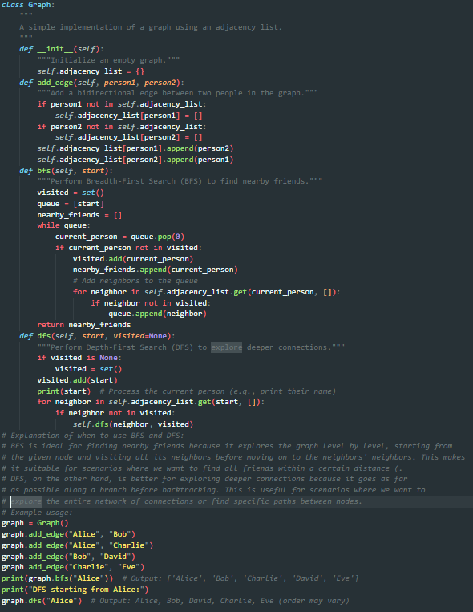
Output:
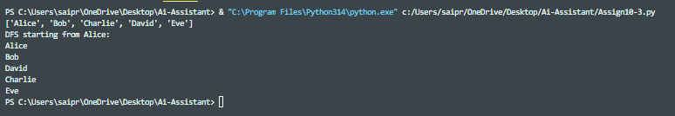
Justification:
BFS is useful when we want to find nearby friends or the shortest connection between users because it explores level by level. DFS is better when we want to explore deep relationship chains or analyze the overall structure of the network .Recursive DFS is simpler to write, while iterative DFS is safer for large networks as it avoids recursion limits.

