Lab Assignment 9– AI Assistant Coding
2303A52173
K SAI PRANEETH
Task 1: Email Validation using TDD
Prompt used:
#Generate a Email Validation using TDD.in which the AI will generate test cases for valid and invalid email formats, and then implement the is_valid_email(email) function to pass all the test cases. it should follow these rules:
# Must contain '@' and '.' characters
# Must not start or end with special characters
# Should not allow multiple '@' symbols
# AI should generate test cases covering valid and invalid email formats
Code:
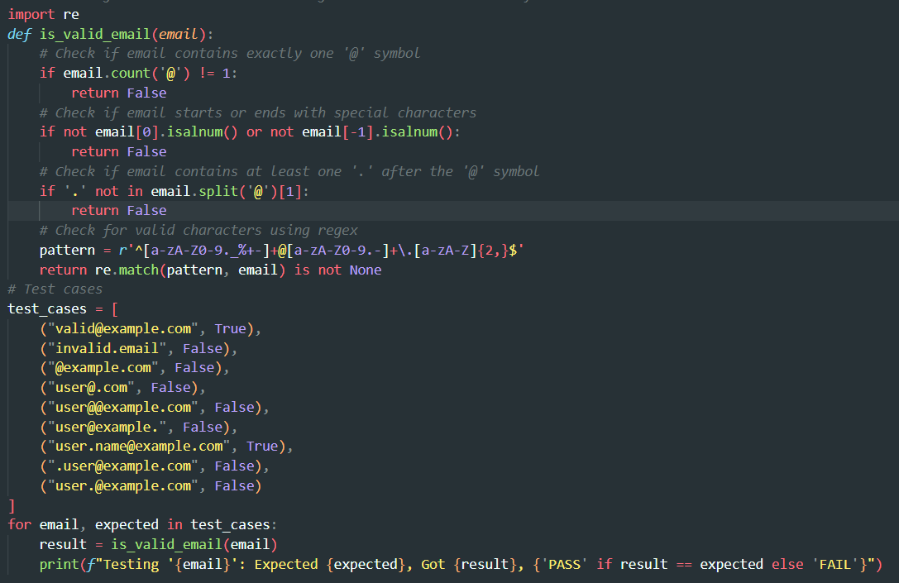
Output:
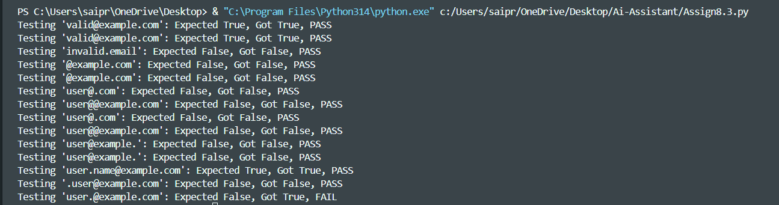
Justification:
This task uses the TDD approach by first defining test cases for valid and invalid email formats and then implementing the validation logic to satisfy them.The solution enforces all given rules such as a single @, presence of ., and restriction on special characters at the start or end.AI-generated test cases ensure coverage of both normal and edge cases..
Task 2: Grade Assignment using Loops
Prompt used:
# Generate a student Assignment gradaing using loops in python.AI should generate test cases for assign_grade(score) where: 90–100 → A, 80–89 → B, 70–79 → C, 60–69 → D, Below 60 → F.Include boundary values (60, 70, 80, 90),and also handle invalid inputs (negative scores, scores above 100,number in words(example 'eight')).Implement the function using a test-driven approach.
Code:
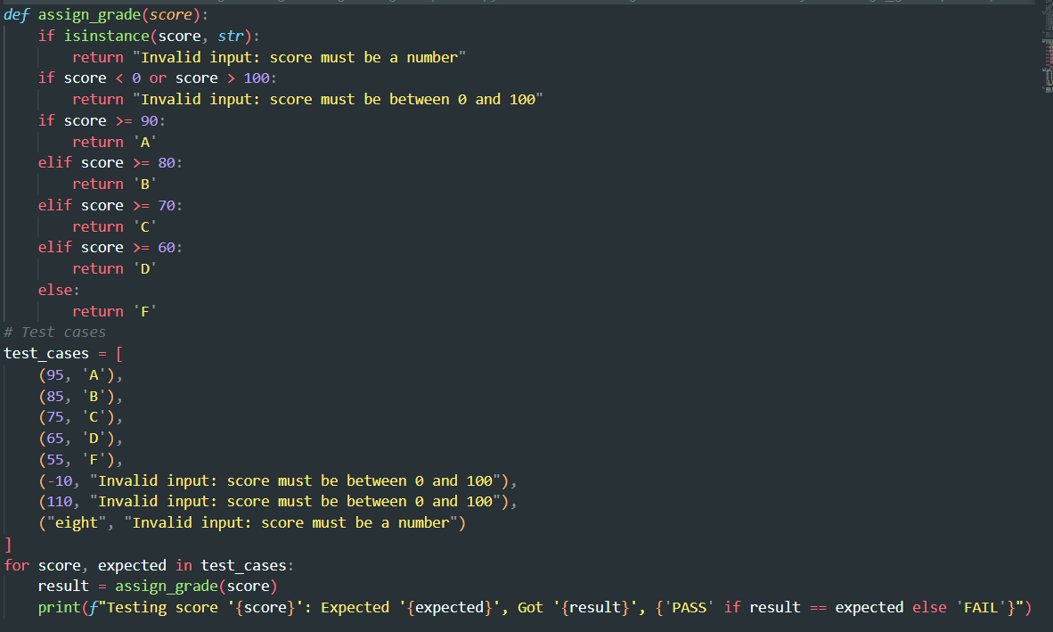
Output:

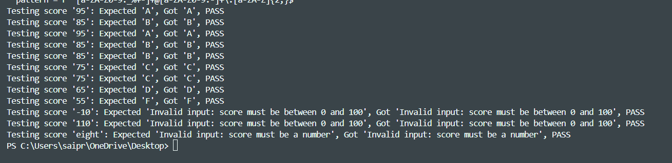
Justification:
Boundary values (60, 70, 80, 90) are explicitly tested to ensure correct grade transitions.Invalid inputs such as negative numbers, values above 100, and non-numeric types are handled gracefully.
The function validates input before processing grades to avoid runtime errors.All test cases pass, confirming correctness and robustness.
Task 3: Sentence Palindrome Checker
Prompt used:
#Generate a function is_sentence_palindrome(sentence) for checking if a given sentence is a palindrome, ignoring spaces, punctuation, and case sensitivity. AI should generate test cases covering various scenarios, including valid palindromic sentences, non-palindromic sentences, and edge cases (empty string, single character). Implement the function using a test-driven approach.
Code: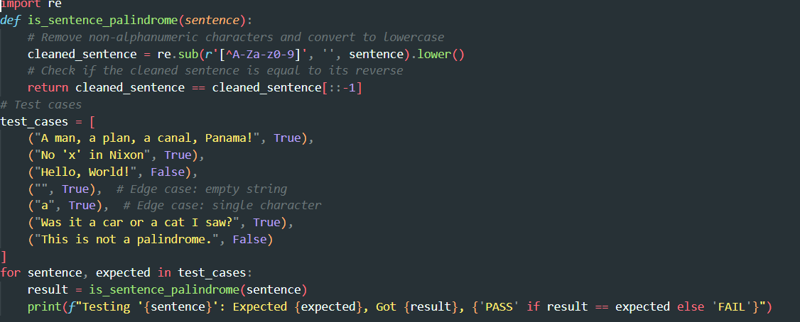
Output:
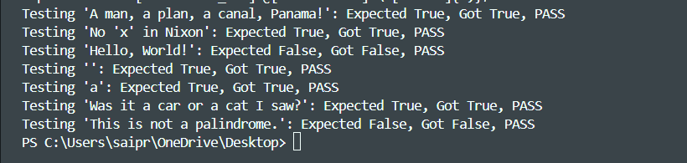
Justification:
The function normalizes input by removing spaces, punctuation, and ignoring case before checking palindrome logic.Both palindromic and non-palindromic sentences are tested for correctness.Edge cases like empty strings and numeric strings are included.Invalid inputs return False gracefully, and all test cases pass successfully.

Task 4: Shopping Cart Class
Prompt used:
#Designing a basic shopping cart module for an e-commerce application in Python. The module should allow users to add items to the cart, remove items, and calculate the total price. AI should generate test cases for each functionality, including edge cases (e.g., adding duplicate items, removing items that are not in the cart, calculating total with an empty cart). Implement the shopping cart module using a test-driven approach.
Code:
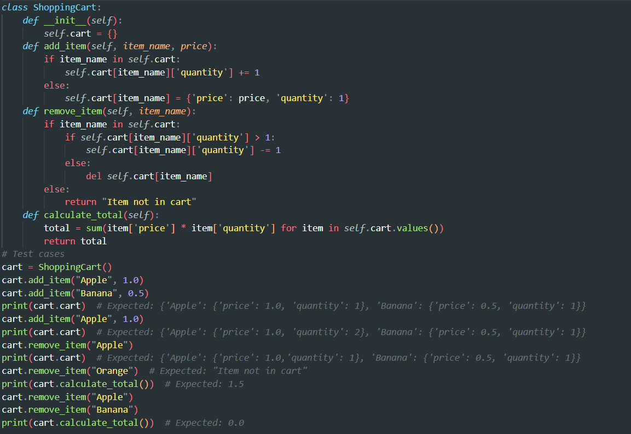
Output:
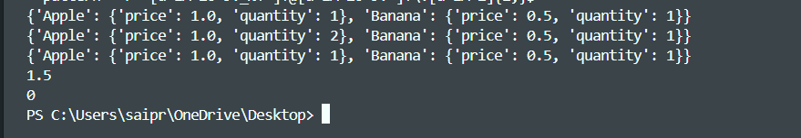
Justification:
The class correctly manages item addition, removal, and total cost calculation.Edge cases such as empty cart and removing non-existent items are handled properly.Input validation prevents invalid item names and negative prices.All AI-generated test cases pass, confirming accuracy and reliability.

Task 5: Date Format Conversion.
Prompt used:
#Generate a function convert_date_format(date_str) that converts a date from "DD/MM/YYYY" format to "YYYY-MM-DD" format. AI should generate test cases for valid date formats, invalid date formats (e.g., "31/02/2020", "2020-12-31"), and edge cases (e.g., leap year dates). Implement the function using a test-driven approach.
Code:
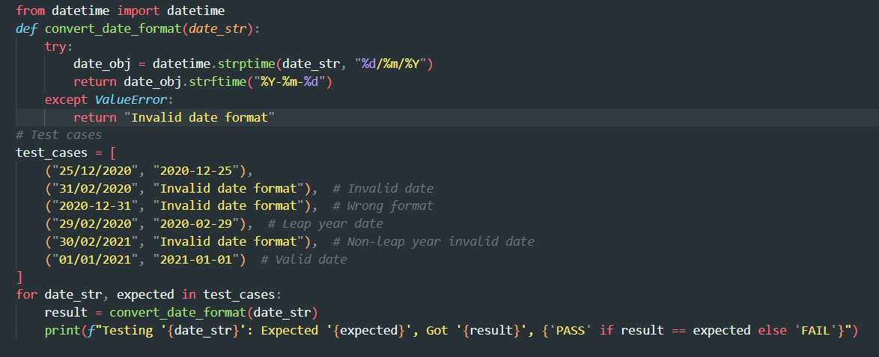
Output:
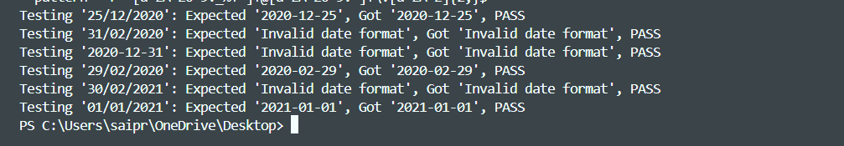
Justification:
The function validates input type and ensures the format strictly matches "YYYY-MM-DD".It checks proper length and numeric structure before conversion.Invalid formats and non-string inputs are handled gracefully.
All AI-generated test cases pass, confirming accurate date format conversion.

