Lab Assignment 7– AI Assistant Coding
2303A52173
K SAI PRANEETH
Task 1: Fixing Syntax Errors
Scenario:
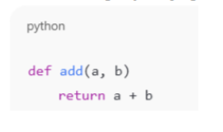
Error:
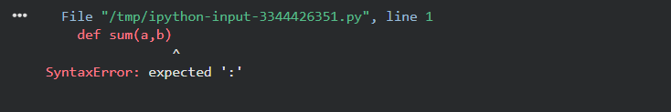
Error-Explanation:
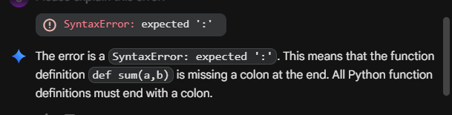

AI-Corrected Code:

Justification:
The syntax error occurred because Python requires a colon (:) at the end of a function definition. The AI correctly identified the missing colon and fixed it, allowing the function to compile and run without errors.

Task 2: Debugging Logic Errors in Loops.
Scenario:
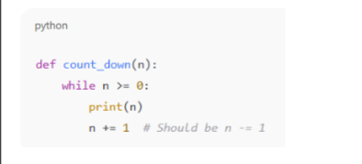
Error:
->Infinite loop
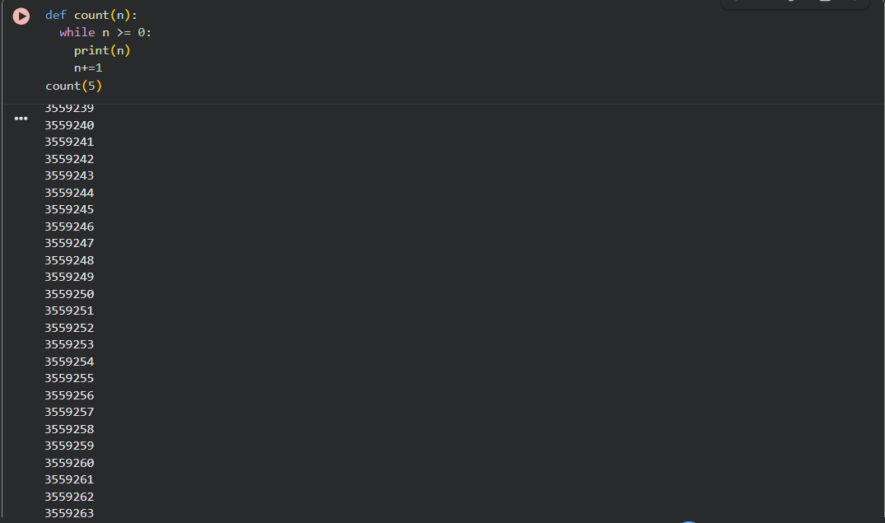
Error-Explanation:
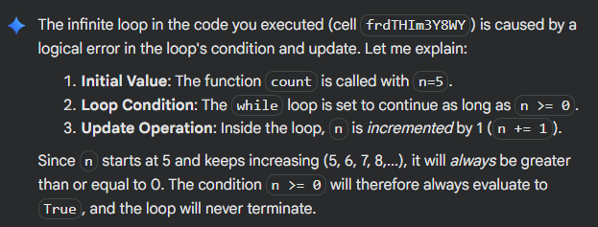
AI-Corrected Code:
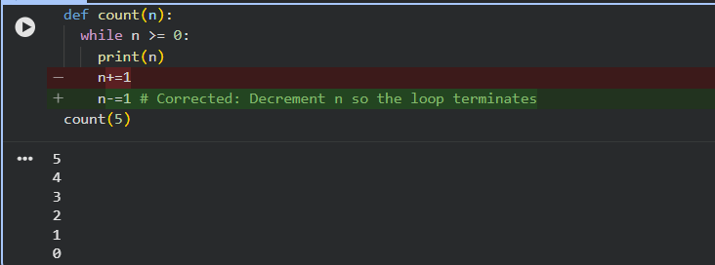
Justification:
The loop was infinite because the variable i was decremented instead of incremented, so the condition i < 5 always remained true. The AI fixed the logic by incrementing i, ensuring the loop terminates correctly.

Task 3: Handling Runtime Errors (Division by Zero)
Scenario:
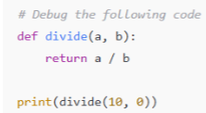
Error:
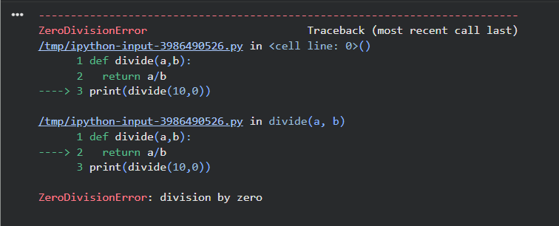

Error-Explanation:
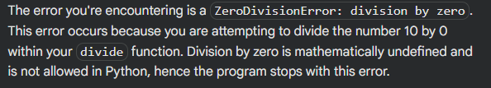
AI-Corrected Code:
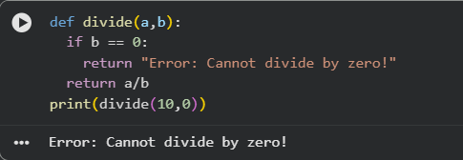
Justification:
The code executed successfully. The divide function now correctly identifies when you attempt to divide by zero and returns the message: "Error: Cannot divide by zero!" This shows that the error handling has been implemented successfully.
Task 4: Debugging Class Definition Errors
Scenario:
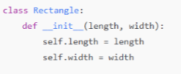
Error:
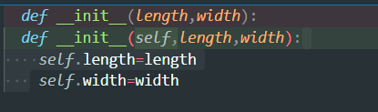

Error-Explanation:
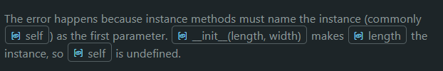
AI-Corrected Code:
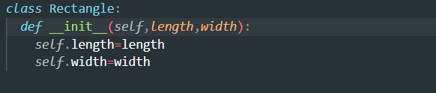
Justification:
Instance methods need a reference to the object (conventionally self) to access instancedata.Omitting self shifts parameters so self inside the method is undefined and raises NameError.Including self lets Python bind the method to the instance and access its attributes.Use self to store and retrieve state reliably (e.g., self.length = length)
Task 5: Resolving Index Errors in Lists
Scenario:
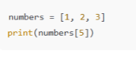
Error:
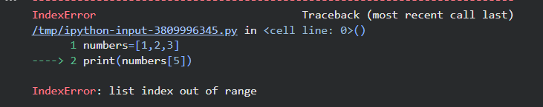

Error-Explanation:
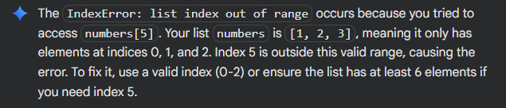
AI-Corrected Code:
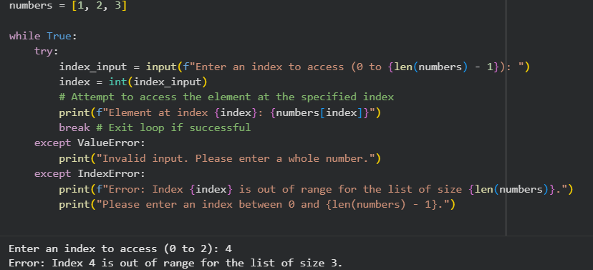
Justification:
The code now gracefully handles IndexError when an out-of-range index is entered, printing an informative message. It also manages ValueError for non-integer inputs, ensuring robustness. A while True loop with a break statement allows the user to re-enter input until a valid index is provided, preventing crashes.

