Lab Assignment 12– AI Assistant Coding
2303A52173
K SAI PRANEETH

Task 1: Sorting Student Records for Placement Drive
Prompt used:
#generate a program that stores student records Name, Roll Number, CGPA.And implement Quick Sort and Merge Sort. Measure and compare the time taken by both sorting algorithms.finally Write a function to display the top 10 students based on CGPA.
Code:
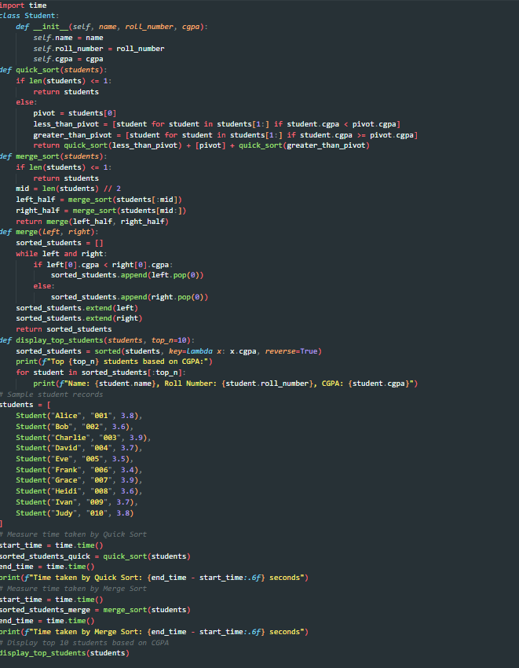
Output:
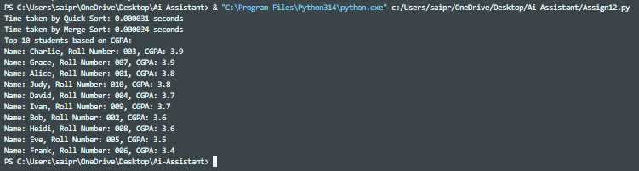
Justification:
Quick Sort and Merge Sort both provide O(n log n) average performance, suitable for large student datasets.Quick Sort is faster in practice, while Merge Sort guarantees stable and worst-case O(n log n).Displaying top 10 after sorting avoids extra computation and improves efficiency.
Task 2: Implementing Bubble Sort with AI Comments
Prompt used:
#generate inline comments explaining key logic for the above code and provide time complexity analysis.
Code:
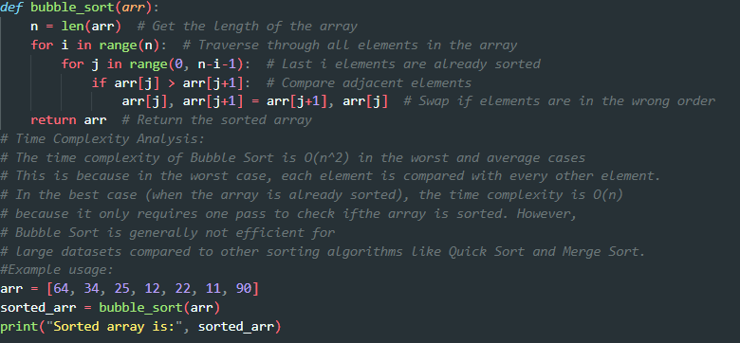
Output:
Justification:
Bubble Sort is simple and useful for understanding basic sorting logic.
It works well only for small datasets due to O(n²) complexity.
AI comments improve clarity on swapping, passes, and termination.
Task 3: Quick Sort and Merge Sort Comparison.
Prompt used:
#for the above merge sort and quick sort code complete the missing logic and add docstring and also provide time complexity analysis.
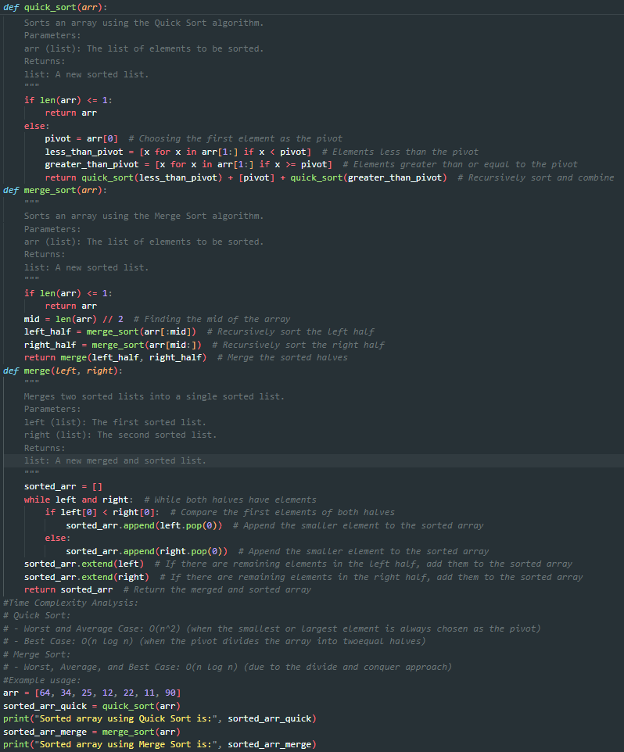

Output:
Justification:
Quick Sort is faster on average but has worst-case O(n²).
Merge Sort guarantees O(n log n) in all cases but uses extra memory.
Comparing on different inputs shows practical performance differences.
Task 4: Inventory Management System(Real-time).
Prompt used:
#Suggest the most efficient search and sorting algorithms for an inventory system with thousands of products with attributes like product ID, name, price, and stock quantity. Searching should be very for a product by ID or name. Sorting is required occasionally by price and quantity. Provide justification and Python implementation.A table mapping operation → recommended algorithm → justification.
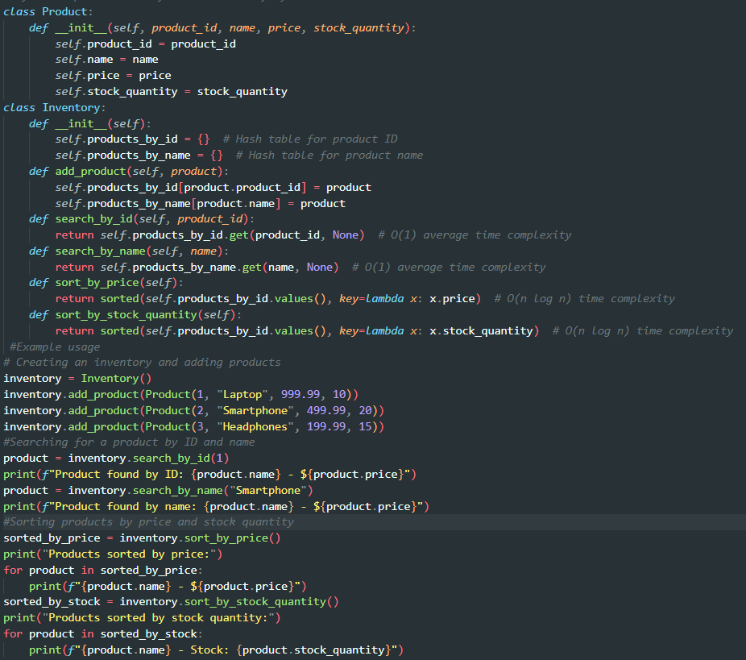

Output:
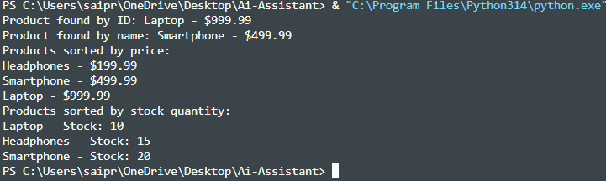
Justification:
The system uses Hash Tables (Dictionaries) to store products by ID and name, ensuring O(1) average search time, which is ideal for large retail inventories with frequent lookups.Sorting is implemented using Python’s built-in sorted() (Timsort), which provides O(n log n) performance and is efficient for medium to large datasets.This combination ensures fast real-time searching while maintaining efficient and scalable sorting for stock and price analysis
Task 5: Real-Time Stock Data Sorting & Searching.
Prompt used:
#Create a Python program to simulate stock data (Stock Symbol, Opening Price, Closing Price). Calculate daily percentage gain/loss, sort stocks using Heap Sort, implement fast searching using a Hash Map, and compare performance with Python’s built-in sorted() and dictionary lookups. Also analyze trade-offs.

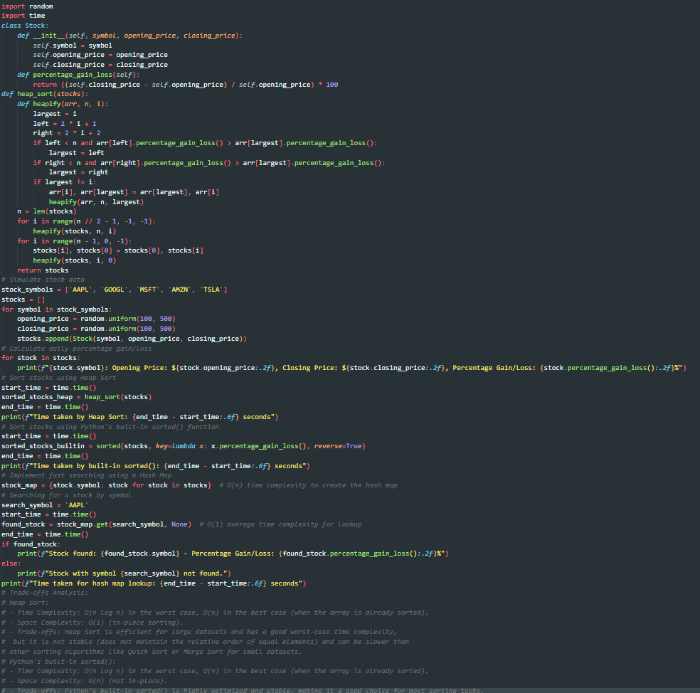
Output:
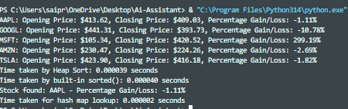
Justification:
Heap Sort efficiently ranks stocks by percentage change in O(n log n).
Hash Maps allow instant stock lookup using symbol in O(1) time.
Comparing with sorted() and dict helps analyze performance trade-offs.

