Task 1 – Rapid App Prototyping with AI Task:
Create a quick mobile app prototype using AI in Replit.
Prompt used:
Create a simple mobile-friendly React app UI for a Fitness Tracker.
Include:
- App title "Fitness Tracker"
- Sections: Steps, Calories, Water Intake
- Add placeholder values (e.g., 0 steps, 0 calories, 0L water)
- Use clean layout and basic CSS
- Make it responsive for mobile screens Output:
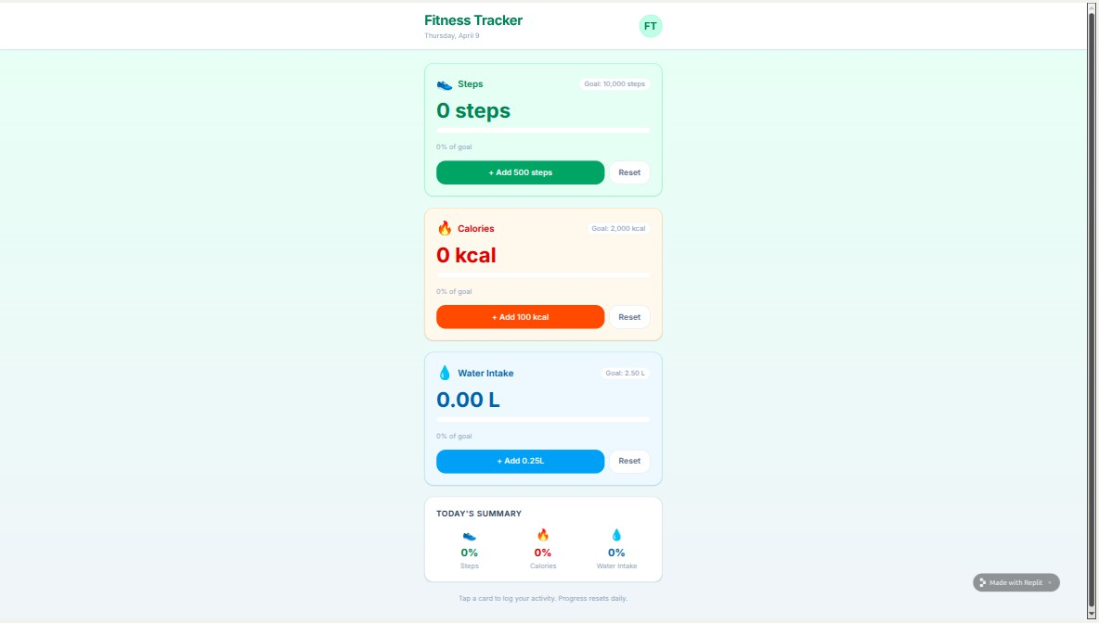
A simple mobile app interface

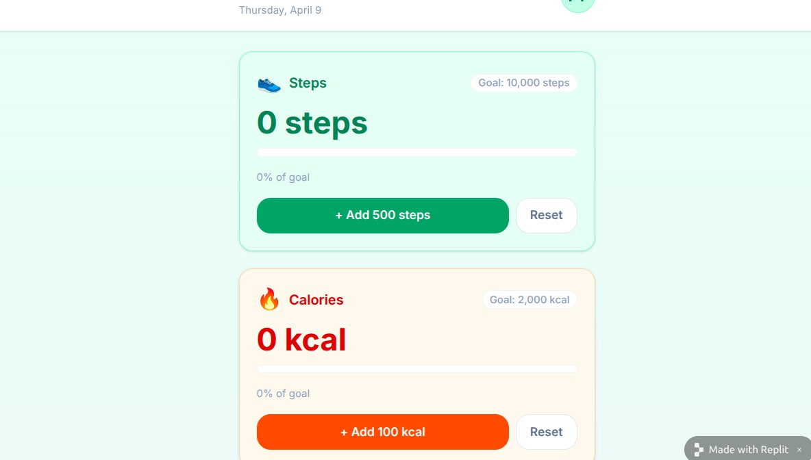
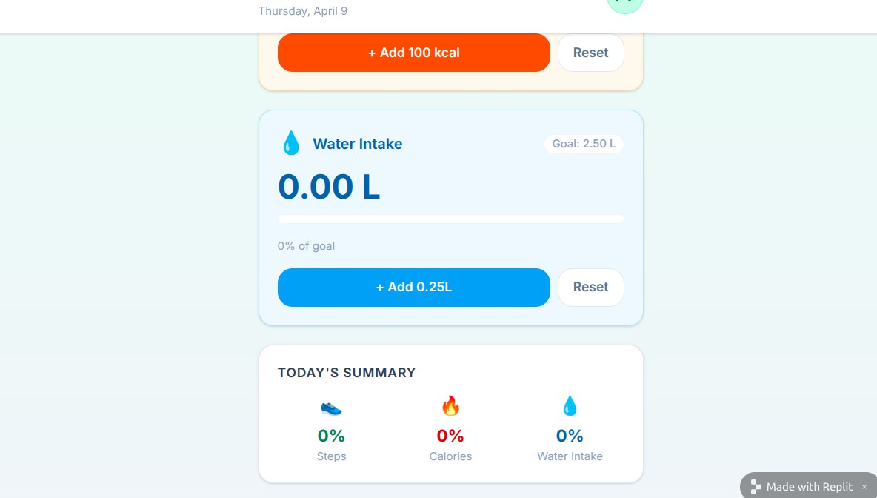
AI-generated layout with clearly visible sections

Responsive design for mobile view

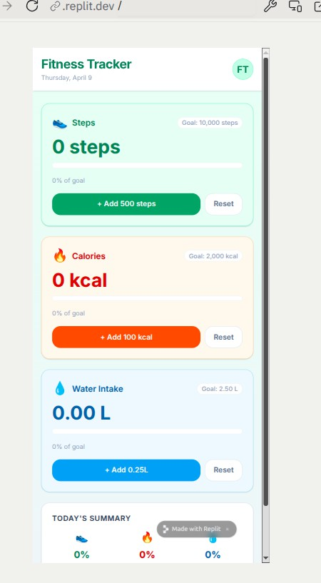
Task 2 – User Input & State Handling

Task:
Develop interactive features for user input. Prompt used:
Enhance the fitness tracker app by:
- Adding input fields for steps, calories, and water intake
- Add buttons to update each value
- Use React useState to manage values
- Update values dynamically on screen
- Add validation to allow only numeric input Output:
->Input fields added
->Buttons for updating values

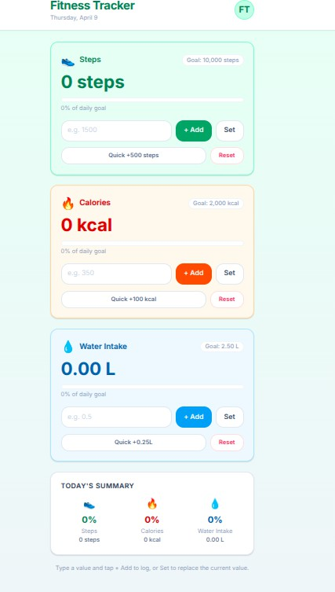
Values update instantly after clicking button

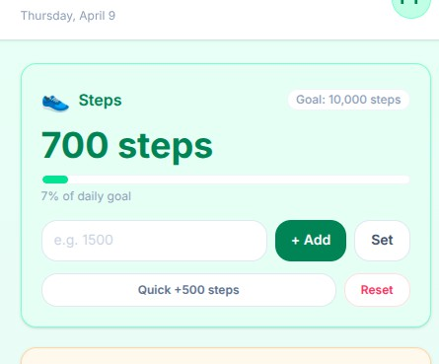
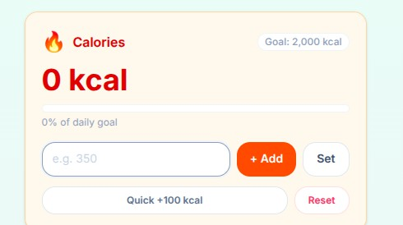
Invalid input (text/symbols) is rejected
->State is maintained using React Task 3 – Multi-Screen Navigation Task:
Add navigation between multiple screens. Prompt used:

Add navigation to the app:
- Create 3 screens: Dashboard, Profile, Settings
- Use buttons or tabs for navigation
- Ensure switching screens does not reload the page
- Keep UI consistent across all screens
- Add simple placeholder content in Profile and Settings Output:

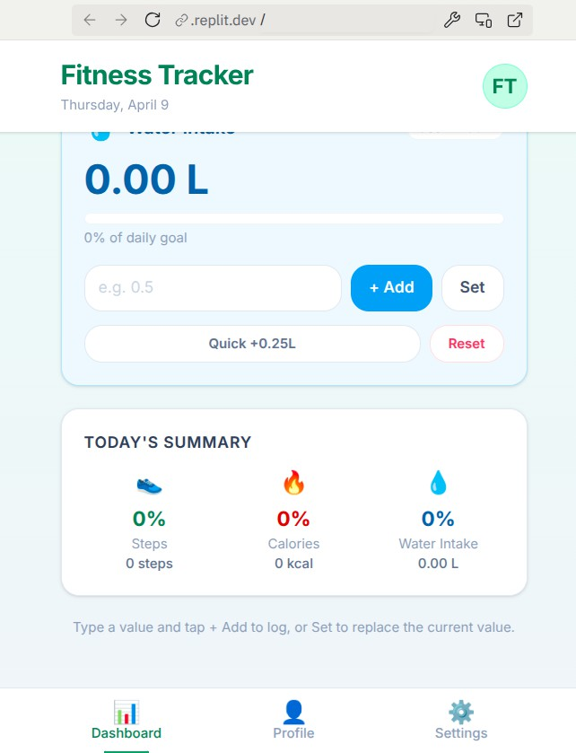
Working navigation system

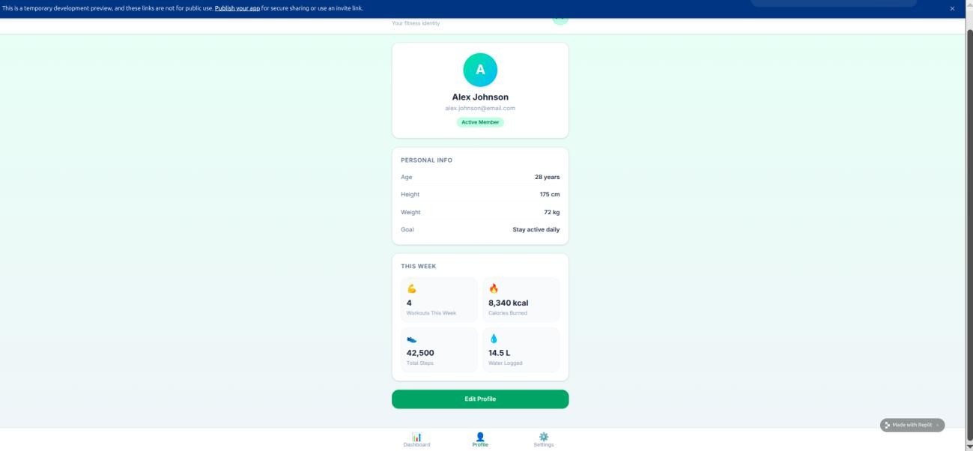
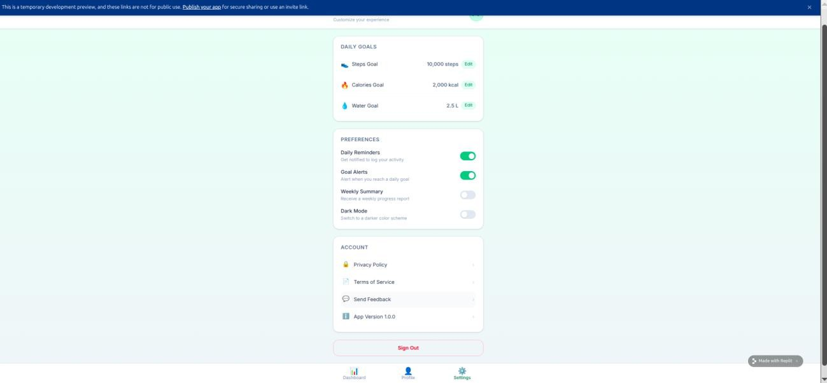
Multiple screens accessible without reload Clean UI transitions

Task 4 – AI-Assisted UI Enhancement & Error Fixing
Task:
Improve UI and fix layout issues. Prompt used:

Improve the UI and fix responsiveness issues:
- Identify alignment problems on small screens
- Improve spacing, font sizes, and layout
- Make buttons and inputs mobile-friendly
- Use better colors and styling
- Ensure all elements align properly on different screen sizes
Output:
Improved UI design
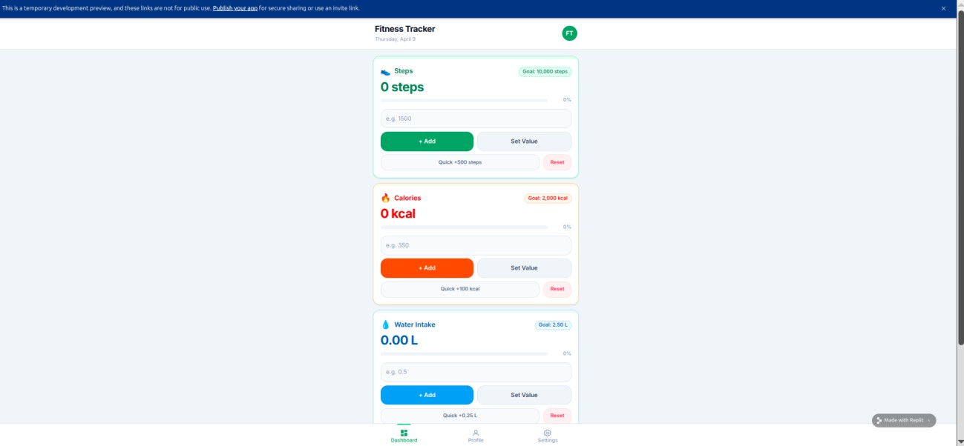
Proper alignment across screen sizes Cleaner and more readable layout

Mobile view

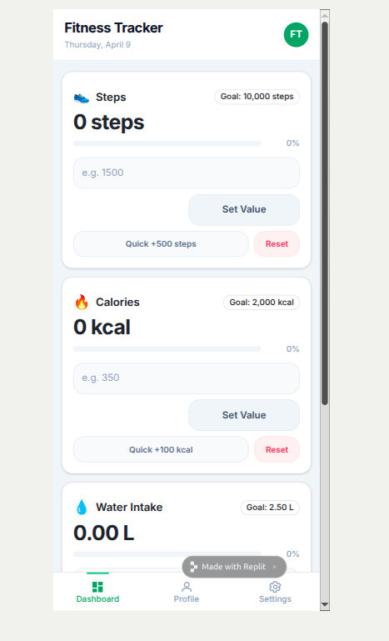

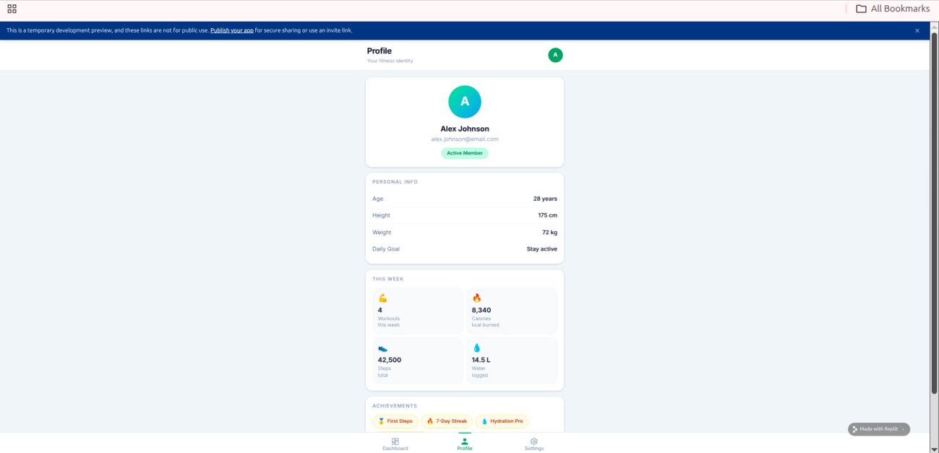

Task 5 – Sharing, Feedback & Iteration Task:
Deploy and refine the app based on feedback. Prompt used;
Suggest improvements based on user feedback:
- Improve UI clarity and usability
- Fix any bugs in input handling or navigation
- Enhance user experience with small changes
- Keep the app simple but more user-friendly App link:
https://fit-tracker-ui--shashidhar202.replit.app Improved version

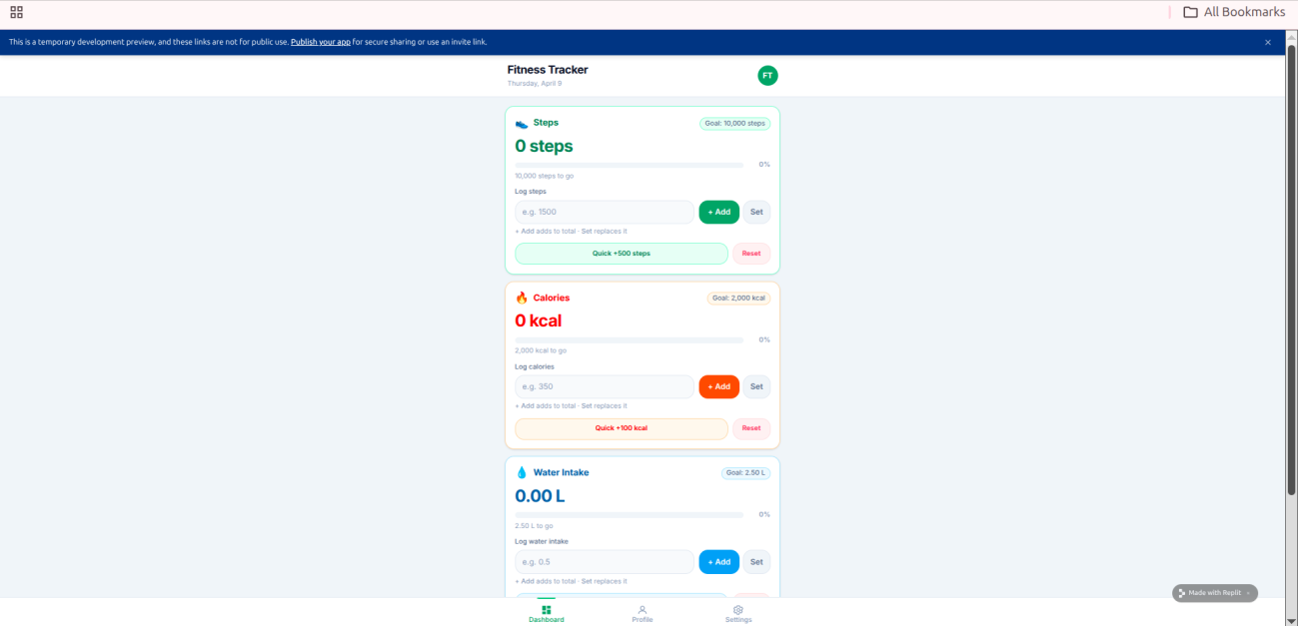

Documented Feedback
User 1 Feedback
UI looks slightly crowded on mobile screens Buttons are too close to each other
Input field not clearly labeled
User 2 Feedback
Confusion about which button updates which value Navigation buttons not visually distinct
Water intake unit (L) not clearly understood

Issues Identified (from feedback)

Poor spacing between UI elements Lack of labels for inputs
Buttons unclear in purpose Weak visual hierarchy
Minor responsiveness issues

Improvements Implemented
UI Improvements
Added proper spacing between sections and buttons Increased padding for better touch interaction Improved font size for readability
Input Enhancements
Added labels:
Enter Steps Enter Calories
Enter Water Intake (Liters)
Button Clarity
Renamed buttons:

Update Steps Update Calories Update Water
Navigation Enhancement
Styled navigation buttons (highlight active tab) Added better alignment and spacing
Responsiveness Fix
Converted layout to column format for mobile Ensured all elements fit within screen width

Improved Version Summary
Cleaner and more organized UI Better readability on small screens Clear input instructions
Improved user interaction More intuitive navigation Fully responsive design

Final output:

The application was deployed using Replit and shared with peers for feedback.
Based on user feedback, several improvements were implemented including better spacing, clearer input labels, improved button naming, and enhanced responsiveness.
The updated version provides a cleaner UI, improved usability, and a more intuitive user experience.

