Lab Assignment 2 – AI Assistant Coding
2303A52173
K SAI PRANEETH
Task 1: Book Class Generation
Prompt used:
#write a program to generate python class with attributes, title, author and a summary() method.
Code:
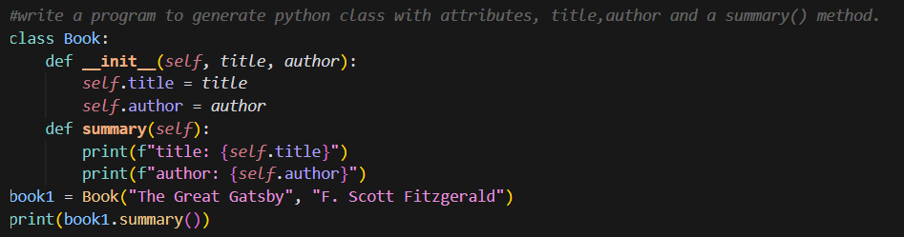

Output:
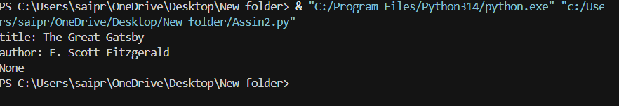

Justification:
The output clearly shows the book title and author, which tells us the data was stored correctly in the object. When the summary() method is called, it prints a complete and meaningful sentence, so we know the method is working properly. The output is easy to read and understand, just like how a real library system would show book details.

Task 2: Sorting Dictionaries with AI
Prompt used:
#write code to sort the list of dictionaries based on the key and print the names of persons in sorted manner with age
Code:
Cursor AI
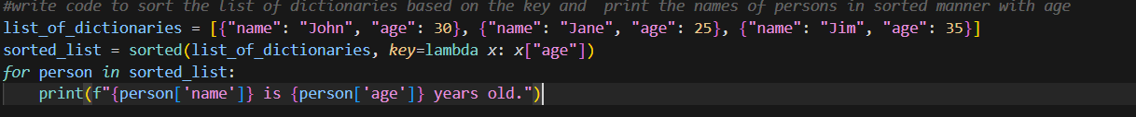
Gemini
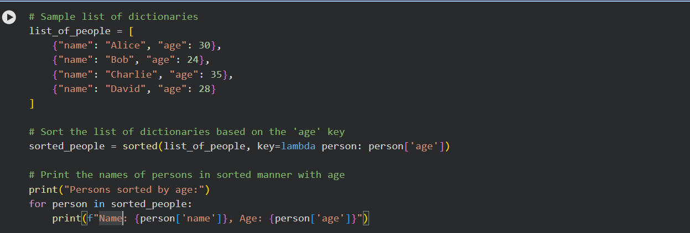
Output:
Cursor AI
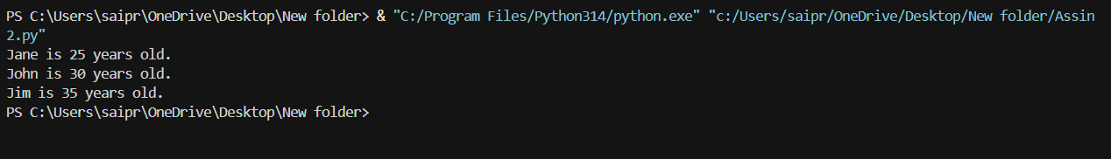
Gemini


Justification:
Both codes do the job properly by arranging the users in order of their age. Gemini’s version is easier to follow, especially for beginners, because it doesn’t change the original list. Cursor’s version feels quicker and more direct since it sorts the list in place. Gemini is clearer to read, while Cursor is more efficient, and both are correct.

Task 3: Calculator Using Functions
Prompt used:
# create a simple calculator using functions where operation is chosen by the user. Addition and multiplication should perform by taking n numbers. Subtraction, power, and division should perform by taking 2 numbers ,where the zero case should be handled in division. Explain the logic in simple terms.
Code:
Cursor AI
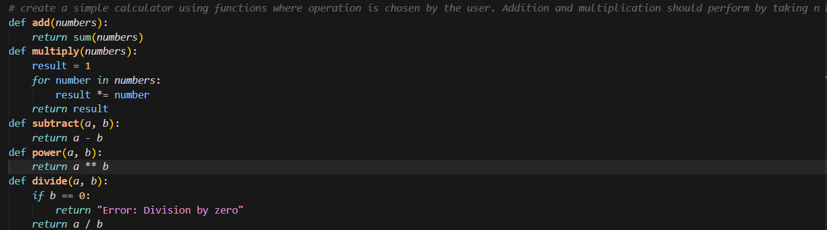
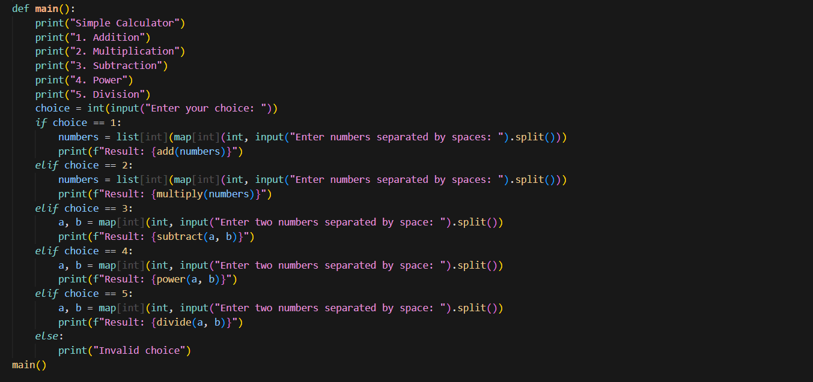

Gemini
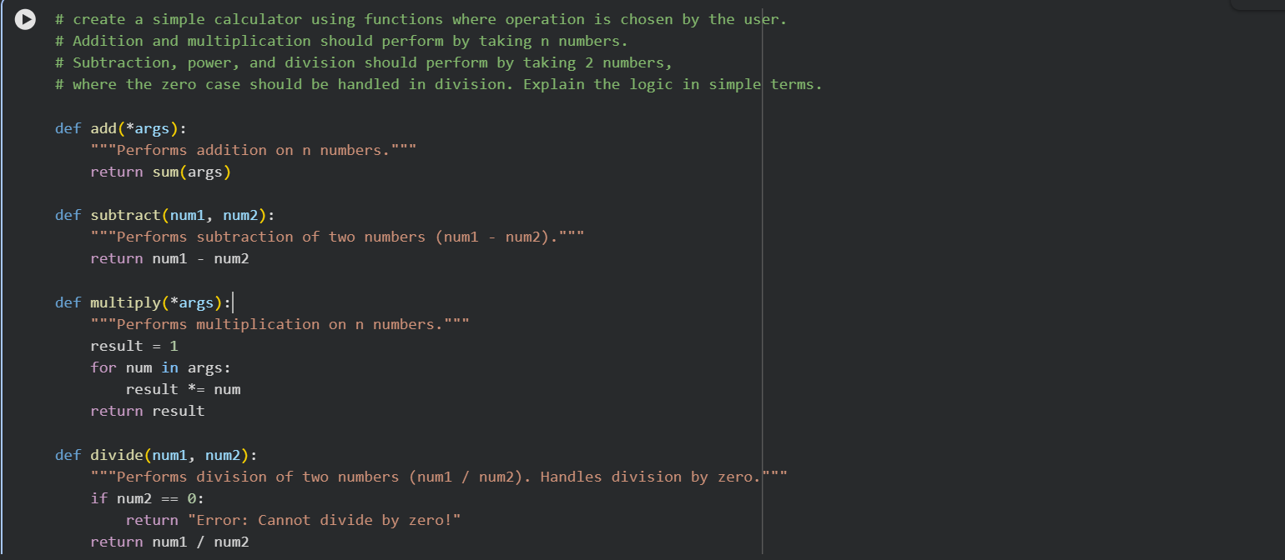

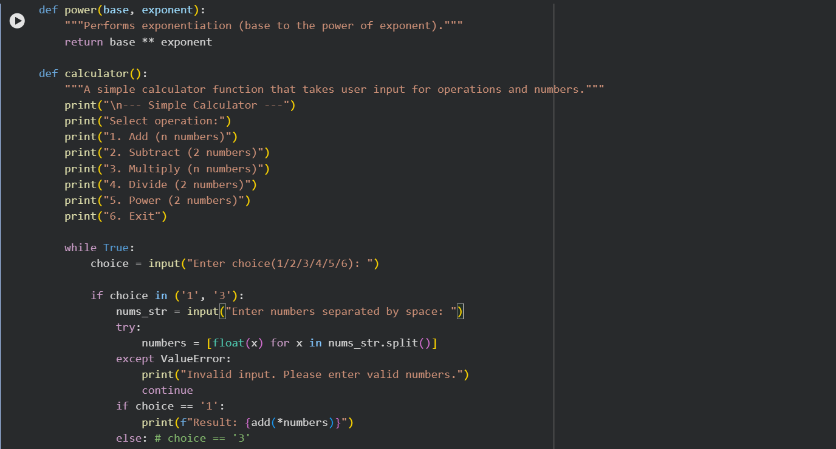

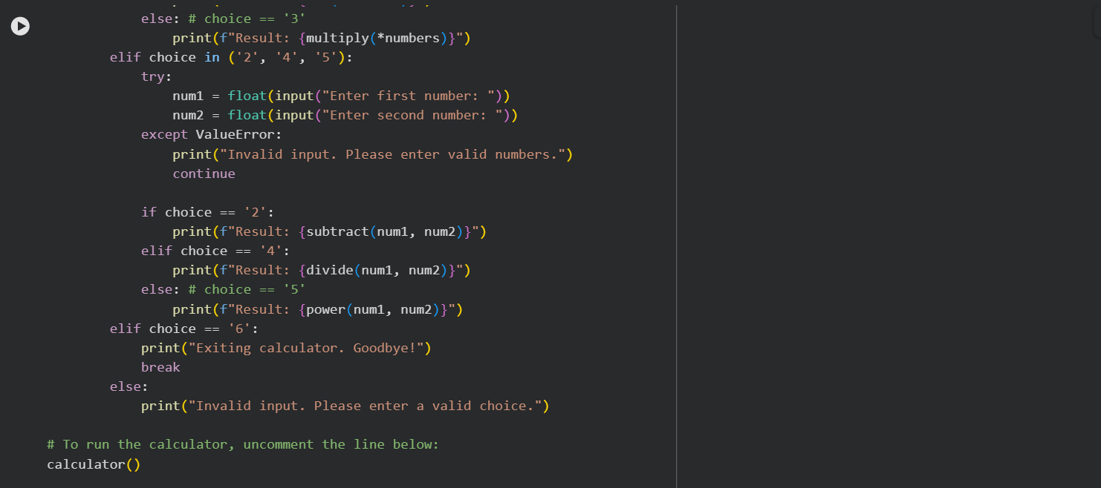

Output:
Cursor AI
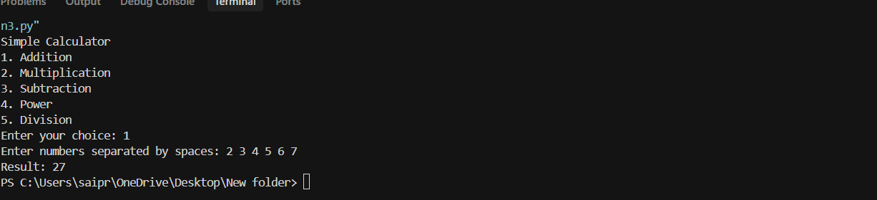

Gemini
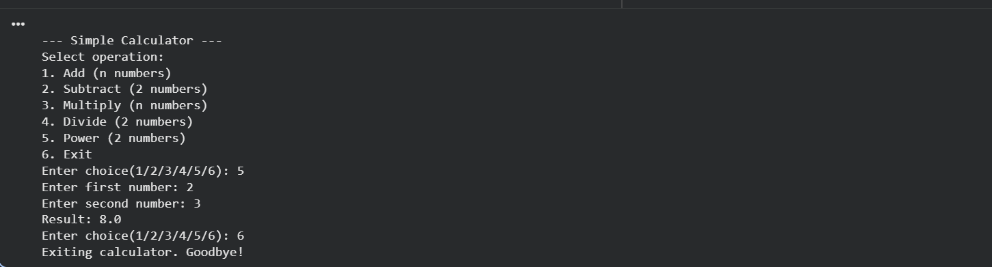

Justification:
The user first selects the operation from a menu. Based on the choice, the corresponding function is called. Addition and multiplication accept any number of inputs. Subtraction and division work with exactly two numbers. This structure makes the calculator easy to use and easy to extend with new operations.

Task 3: Armstrong Number Optimization
Prompt used:
# Function to check if a number is an Armstrong number
Code:
Cursor AI
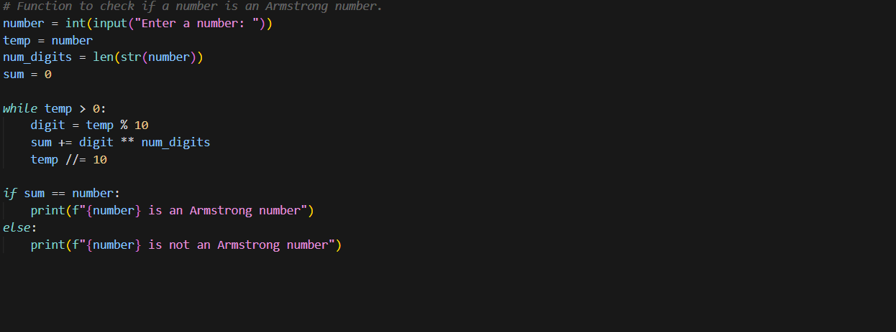

Gemini
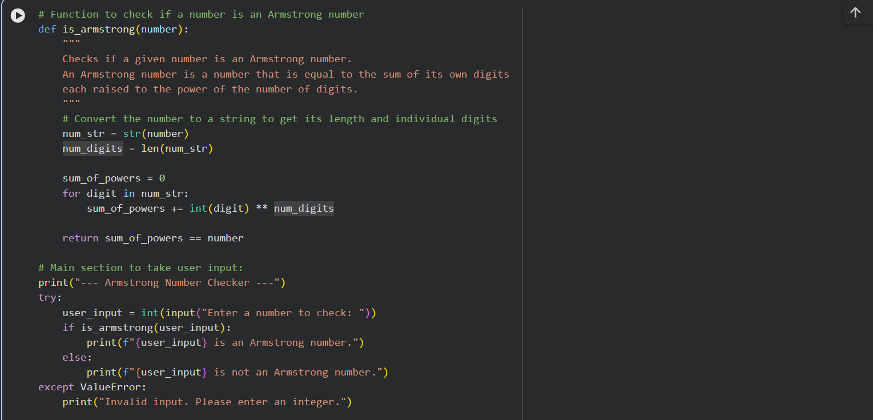

Output:
Cursor AI
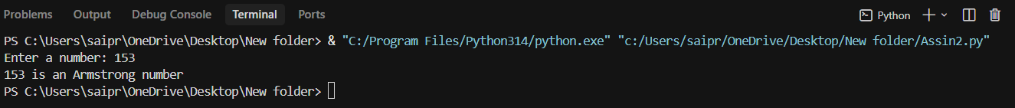

Gemini
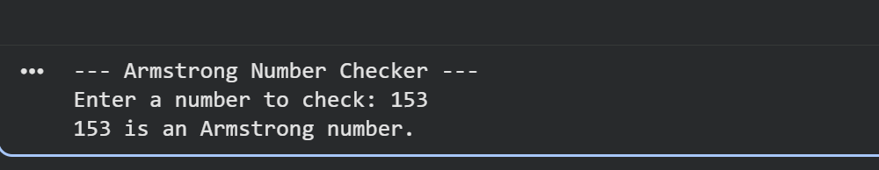
Justification:
In this task, an initial Armstrong number program was first generated using Gemini AI. That version worked, but it was limited and not very efficient. Using Cursor AI, the same logic was improved to make the code cleaner and work efficiently . And also the optimized version is easier to read, this task clearly shows how Cursor AI can be used to improve and optimize existing code.

