Competitive Programming

2303A52173-K Sai Praneeth
Backtracking Assignment 1: N-Queens Problem
Python:
def solve_n_queens(n):
board = [["." for _ in range(n)] for _ in range(n)]
cols = set()
diag1 = set() # r - c
diag2 = set() # r + c

def backtrack(r):
if r == n:
return True
for c in range(n):
if c in cols or (r - c) in diag1 or (r + c) in diag2:
continue
board[r][c] = "Q"
cols.add(c)
diag1.add(r - c)
diag2.add(r + c)

if backtrack(r + 1):
return True

board[r][c] = "."
cols.remove(c)
diag1.remove(r - c)
diag2.remove(r + c)
return False

backtrack(0)
for row in board:
print(" ".join(row))

# Sample Input
n = 4
solve_n_queens(n)

Output:
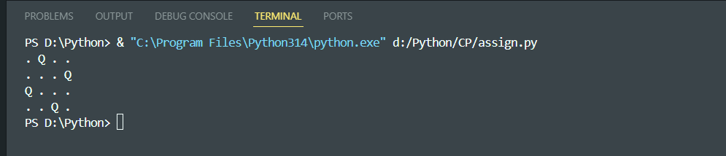

Java:
class Main {
static int N;
static char[][] board;
static boolean[] cols, diag1, diag2;

static boolean solve(int r) {
if (r == N) return true;

for (int c = 0; c < N; c++) {
if (cols[c] || diag1[r - c + N - 1] || diag2[r + c])
continue;

board[r][c] = 'Q';
cols[c] = diag1[r - c + N - 1] = diag2[r + c] = true;

if (solve(r + 1)) return true;

board[r][c] = '.';
cols[c] = diag1[r - c + N - 1] = diag2[r + c] = false;
}
return false;
}

public static void main(String[] args) {
N = 4;
board = new char[N][N];
cols = new boolean[N];
diag1 = new boolean[2 * N - 1];
diag2 = new boolean[2 * N - 1];

for (int i = 0; i < N; i++)
for (int j = 0; j < N; j++)
board[i][j] = '.';

solve(0);

for (int i = 0; i < N; i++) {
for (int j = 0; j < N; j++) {
System.out.print(board[i][j] + " ");
}
System.out.println();
}
}
}

Output:
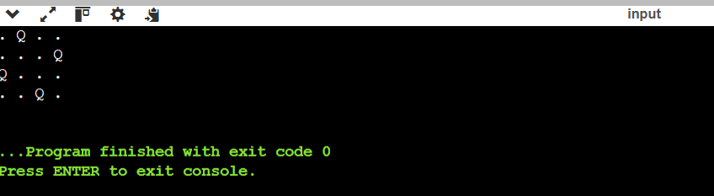

Backtracking Assignment 3: Subset Sum Problem
Python:
def subset_sum(arr, n, target):
def backtrack(index, current_sum):
if current_sum == target:
return True
if index == n or current_sum > target:
return False
if backtrack(index + 1, current_sum + arr[index]):
return True
return backtrack(index + 1, current_sum)

return backtrack(0, 0)

n = int(input())
arr = list(map(int, input().split()))
target = int(input())

print(subset_sum(arr, n, target))

Output:
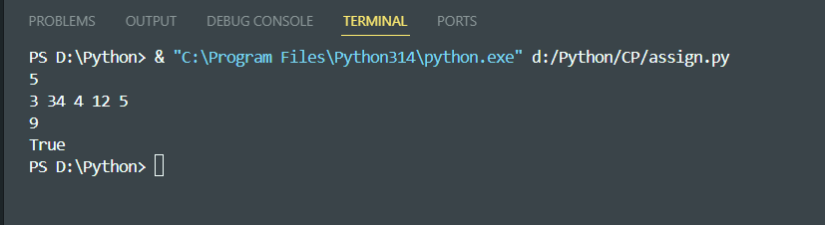

Java:
import java.util.Scanner;

class subset{

static boolean subsetSum(int[] arr, int index, int currentSum, int target) {
if (currentSum == target)
return true;

if (index == arr.length || currentSum > target)
return false;

// include
if (subsetSum(arr, index + 1, currentSum + arr[index], target))
return true;

// exclude
return subsetSum(arr, index + 1, currentSum, target);
}

public static void main(String[] args) {
Scanner sc = new Scanner(System.in);

int n = sc.nextInt();
int[] arr = new int[n];

for (int i = 0; i < n; i++)
arr[i] = sc.nextInt();

int target = sc.nextInt();

System.out.println(subsetSum(arr, 0, 0, target));
}
}

Output:
