Lab Assignment 13– AI Assistant Coding
2303A52173
K SAI PRANEETH

Task 1: Refactoring Data Transformation Logic
Prompt used:
# generate a Pythonic refactoring approach for the above code . Refactor the code using list comprehensions or helper functions.
Legacy Code:
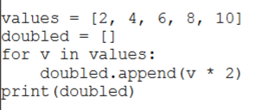
Refactored Code:
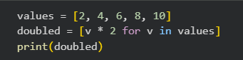
Output:
Justification:
List comprehension removes unnecessary loop syntax.
It makes the code shorter and more Pythonic.
Improves readability and clarity.
Produces the same output efficiently

Task 2: Improving Text Processing Code Readability
Prompt used:
# generate a more efficient and readable approach for the aove code and refactor in such a way that the output remain unchanged.
Legacy Code:
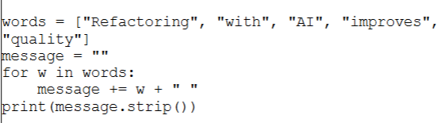
Refactored Code:
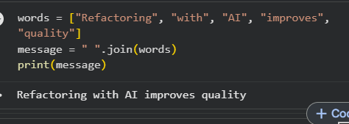
Output:

Justification:
join() avoids repeated string concatenation.
It is more efficient for handling multiple strings.
Code becomes cleaner and easier to understand.
Output remains exactly the same.

Task 3: Safer Access to Configuration Data
Prompt used:
#Refactor the above code to use safer methods for accessing dictionary elements and make sure it still behaves the same way if a key is missing.
Legacy Code:
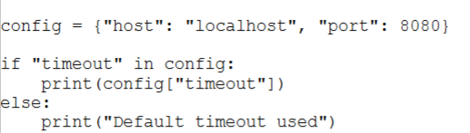
Refactored Code:
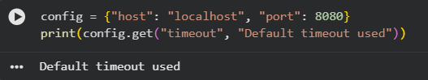
Output:

Justification:
dict.get() safely accesses dictionary values.
Eliminates manual key checking.
Prevents possible KeyError exceptions.
Maintains the same default behavior.

Task 4: Refactoring Conditional Logic for Scalability

Prompt used:
#Refactor the above code logic using mapping techniques while preserving functionality and make it more cleaner, scalable .
Legacy Code:
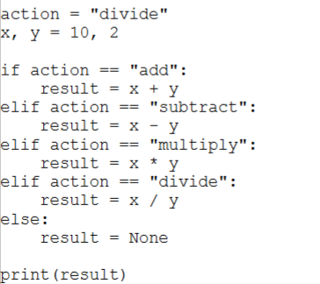
Refactored Code:
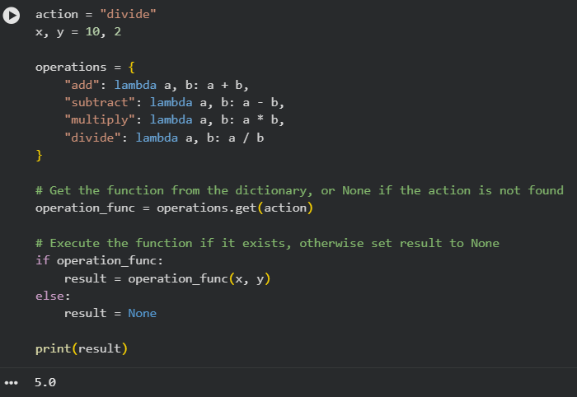
Output:

Justification:
Dictionary mapping replaces long if–elif chains.
Makes the code scalable and modular.
New operations can be added easily.
Functionality remains unchanged.

Task 5: Simplifying Search Logic in Collections

Prompt used:
#Refactor the logic into a more concise and readable form. where output should remain same.
Legacy Code:
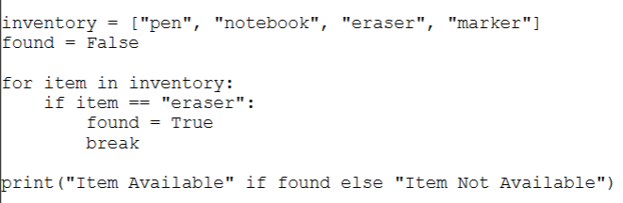
Refactored Code:
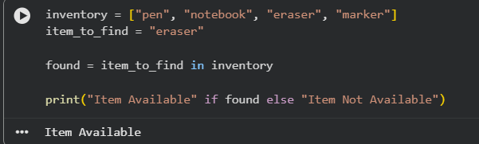
Output:

Justification:
Using in simplifies search logic.
Removes the need for manual looping.
Improves readability and conciseness.
Produces the same result clearly.

