Lab Assignment 15 – AI Assistant Coding
2303A52173
K SAI PRANEETH
Task 1: Initial API Setup for a Service Platform
Prompt used:
Create a basic Flask application. Implement a root endpoint /status that returns a JSON response indicating 'API is live'. Provide the necessary code to run this server locally within the Colab environment and include instructions on how to verify the /status endpoint's response using either a browser or an API testing tool.
Code:
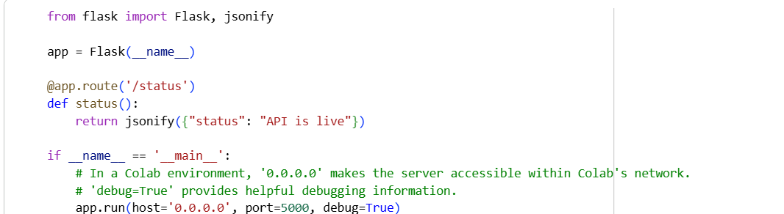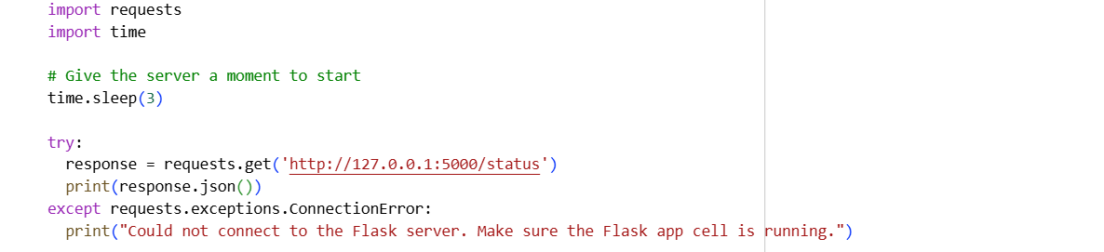
Output:
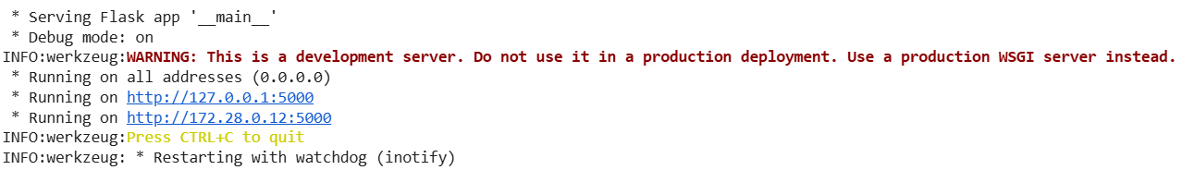
Justification:
Ensures the backend is properly set up and running before adding complexfeatures. The /status endpoint acts as a health check for testing connectivity. Helps developers quickly verify server availability without debugging deeper logic
Task 2: Create API to Add and View Resources
Prompt used:
Expand the existing Flask application to include a GET endpoint at /requests that retrieves all service requests, and a POST endpoint at /requests that adds a new service request. Each request object should have a title and priority. Provide the Flask application code in new cells, along with verification steps to demonstrate an empty list on initial GET, adding a request via POST, and retrieving the added request via a subsequent GET.
Code:
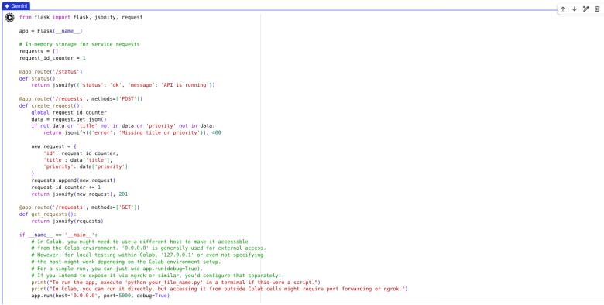
Output:
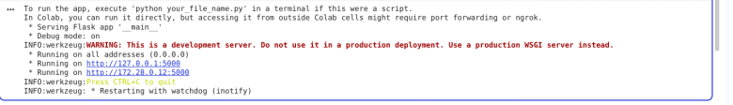
Justification:
Introduces basic CRUD operations by implementing Create and Read functionality. Allows temporary in-memory data handling for quick testing without a database. Builds foundation for managing service requests efficiently.

Task 3: Modify Existing Resource Using AI Assistance
Prompt used:
Add PUT endpoint to update a request by index with proper error handling in Flask.
Code:
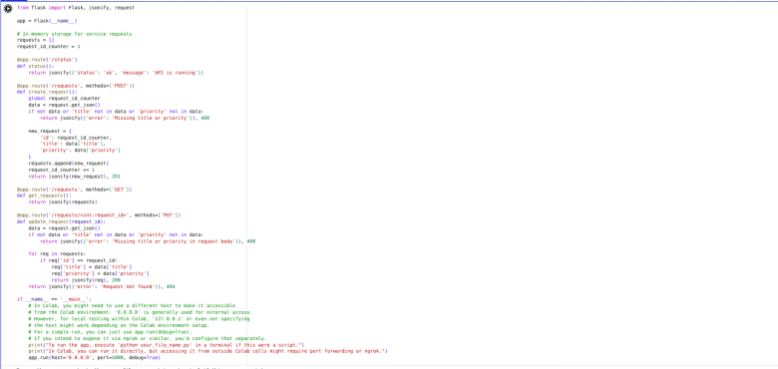
Output:
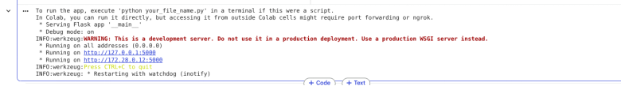
Justification:
Adds Update functionality to modify existing data dynamically. Improves
API robustness by handling invalid inputs with proper error responses.
Task 4: Delete Resource
Prompt used:
Add DELETE endpoint to remove a request by index with safe error handling
Code:
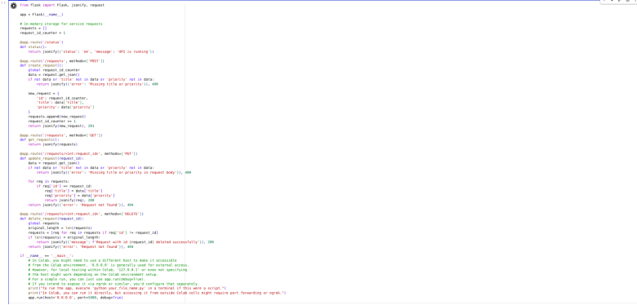
Output:
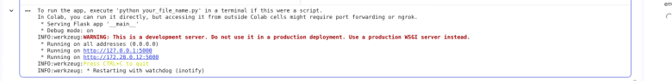
Justification:
Completes CRUD operations by enabling deletion of resources.
Helps maintain clean and relevant data by removing resolved requests.
Prevents server crashes by safely handling invalid delete operations.
Task 5: AI-Assisted API Documentation and Readability
Prompt used:
Add docstrings and comments to Flask API endpoints and optionally integrate Swagger documentation.
Code:
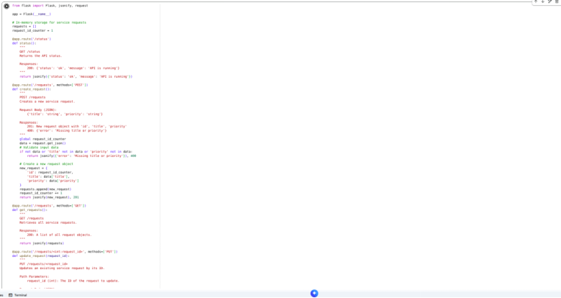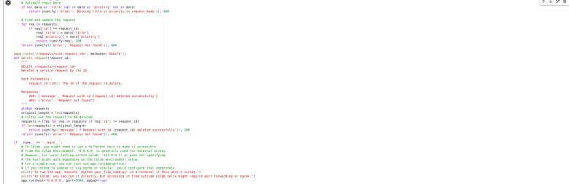
Output:
Justification: Enhances code readability and maintainability using clear documentation.Helps other developers understand and use the API without reading full code.

