Lab Assignment 10– AI Assistant Coding
2303A52173
K SAI PRANEETH
Task 1: I-Assisted Bug Detection
Scenario:
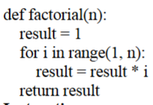
corrected version:
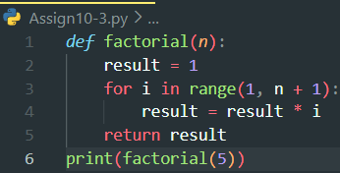
Output:
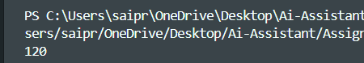
Justification:
The code given by AI and the manually corrected code, both are same.
Bug in the Code
The bug is in the range(1, n) loop, which iterates from 1 to n-1, excluding n. This causes the function to compute the factorial of (n-1) instead of n. For example, factorial(5) returns 24 (4!) instead of 120 (5!).
Reason for the Error
The loop should include n in the multiplication to correctly calculate the factorial. Factorial(n) = n * (n-1) * ... * 1, so the range needs to go up to n inclusive

Task 2: Improving Readability & Documentation
Scenario:
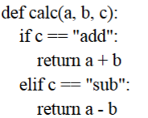
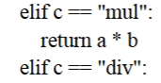
Prompt:
#Rewrite it with Better function and parameter names, Proper docstring
Division by zero handling ,Input validation.
corrected version:
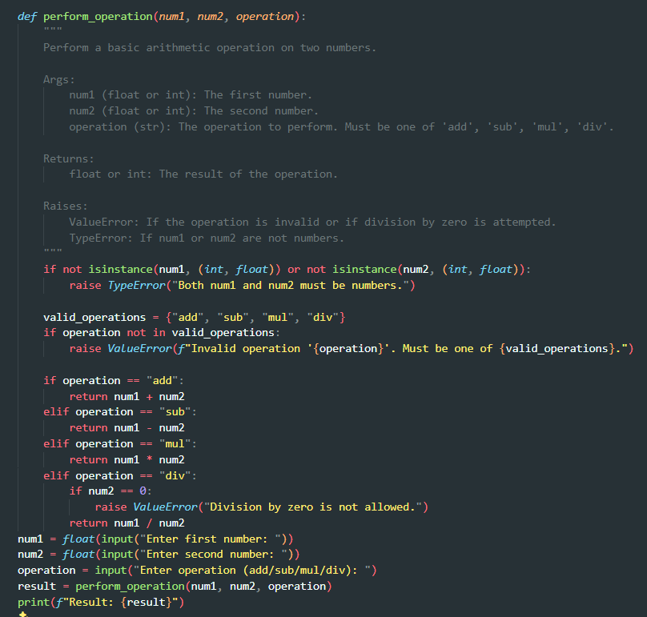
Output:
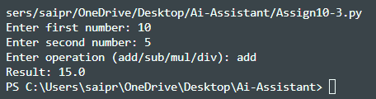
Justification:
Original Version:
1.Poor function name (calc)
2.Poor parameter names (a, b, c)
3.No documentation
4.No error handling
5.Crashes on division by zero
6.No input validation
AI-Improved Version:
1.Clear function name (perform_operation)
2.Descriptive parameters (num1, num2, operation)
3.Complete and detailed docstring
4.Validates input types
5.Handles division by zero
6.Raises meaningful and clear error messages
Task 3: Enforcing Coding Standards
Scenario:
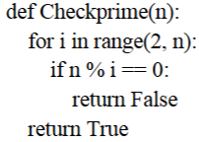
Prompt:
List all PEP8 violations in this code and refactor it properly.

Corrected version:
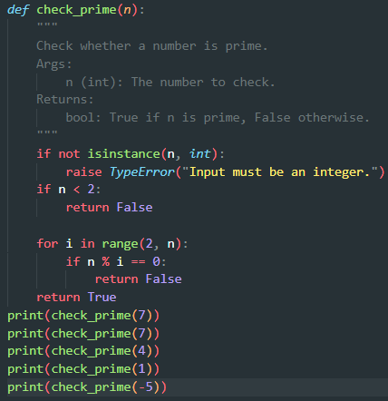
Output:
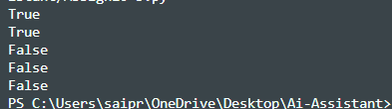
Justification:
The refactored function follows PEP8 standard by using proper snake_case naming (check_prime) and clean indentation. It includes a docstring for better documentation and readability. Input validation ensures only integers are accepted, preventing logical errors. Overall, the updated version is more maintainable and suitable for team-based development.
Task 4: AI as a Code Reviewer in Real Projects
Scenario:
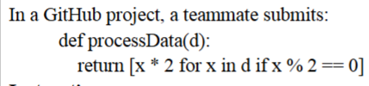
Prompt:
# Review this function for readability, edge cases, and reusability, then refactor it with better naming, type hints, input validation, configurable multiplier, and a proper docstring.
Corrected version:
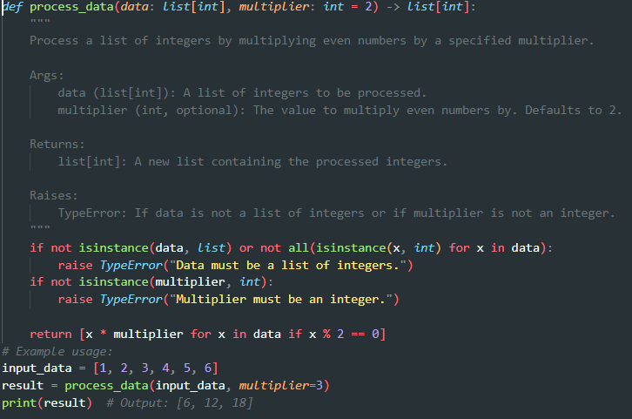
Output:
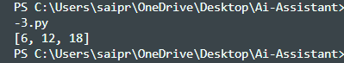
Justification:
AI should act as an assistant rather than a standalone reviewer because it can quickly detect issues and suggest improvements. However, human reviewers are still essential for understanding business logic, context, and making final decisions

Task 5: AI-Assisted Performance Optimization.
Scenario:
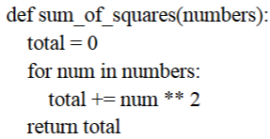
Prompt:
#Analyze the time complexity of this function and refactor it for better performance using built-in functions or NumPy while preserving readability.
Corrected version:
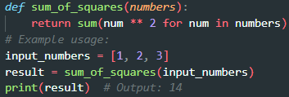
Output:
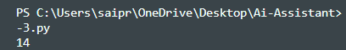
Justification:
The optimized version uses Python’s built-in sum() function, which is implemented in C and slightly faster than a manual loop. Both versions have O(n) time complexity, but the optimized version is more concise and readable. For very large datasets, NumPy can significantly improve performance through vectorized operations. Thus, AI helps balance readability and efficiency.

