Lab Assignment 20– AI Assistant Coding
2303A52173
K SAI PRANEETH
Task 1: Password Strength & Validation Check
Prompt used:
#Create a Python user registration program that asks for a username and keeps asking for a password until a strong one is entered. The password should be at least 8 characters long, include uppercase, lowercase, a number, and a special character, and should not be a common password like "123456" or "password". Show clear error messages for weak passwords and print "Registration successful!" only when a valid password is given.
Code:
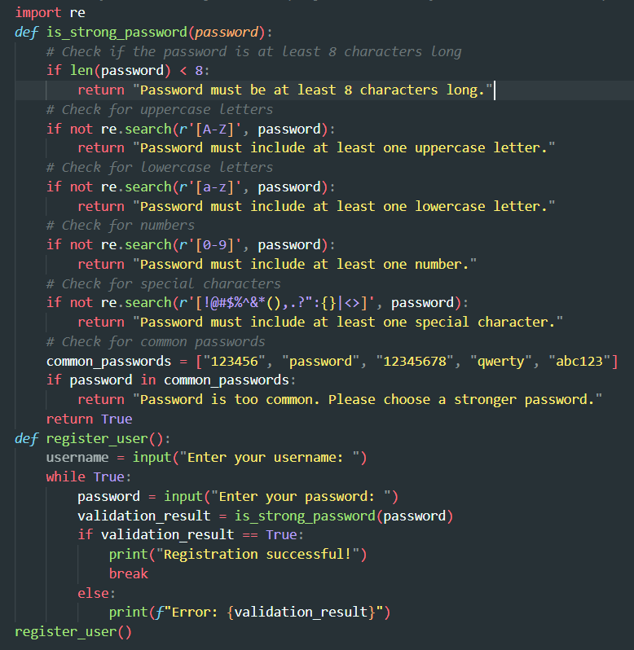
Output:
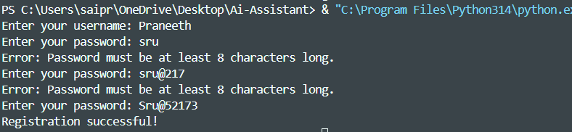
Justification:
The program improves security by enforcing a minimum 8-character password with uppercase, lowercase, digits, and special characters.
It prevents weak and common passwords like "123456" using validation and regex checks.It ensures only a strong password is accepted by repeatedly prompting the user until valid.
Task 2: Insecure File Upload Handling.
Prompt used: Create a Flask application that allows users to upload files. The application should save the uploaded files to a specified directory on the server.
Code:
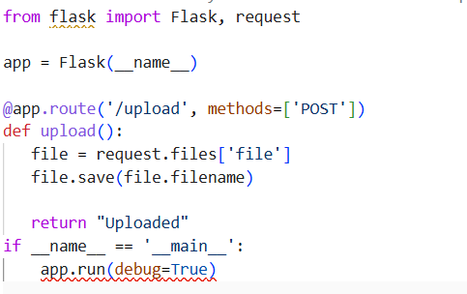

Improved Code:
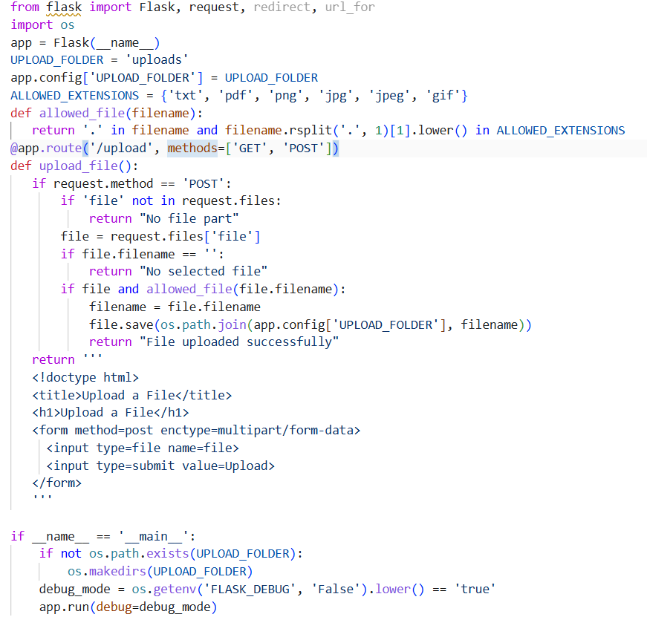
Output:
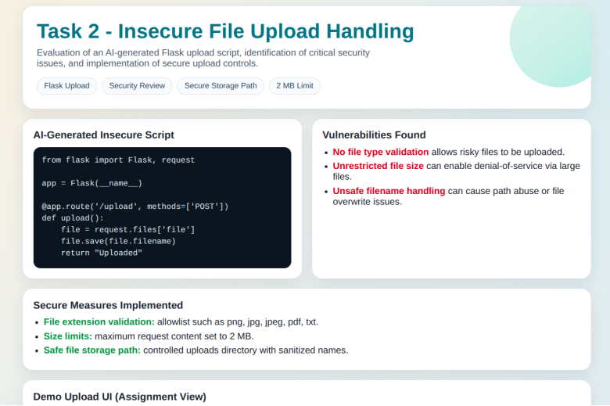
Justification:
It improves security by allowing only specific file types and rejecting invalid uploads.It limits file size to prevent large or harmful files from being uploaded.It uses safe file naming and storage paths to avoid path traversal and server attacks
Task 3: Real-Time Application: API Security Review.
Prompt used: Generate a Flask API endpoint to fetch user data.
InsecureCode:
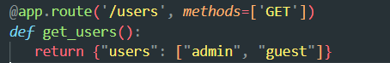
SecureCode:
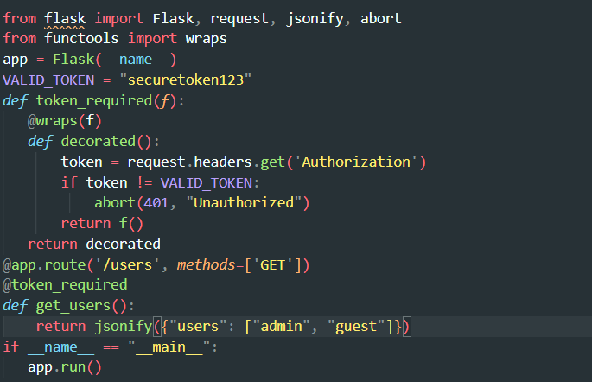
Output:
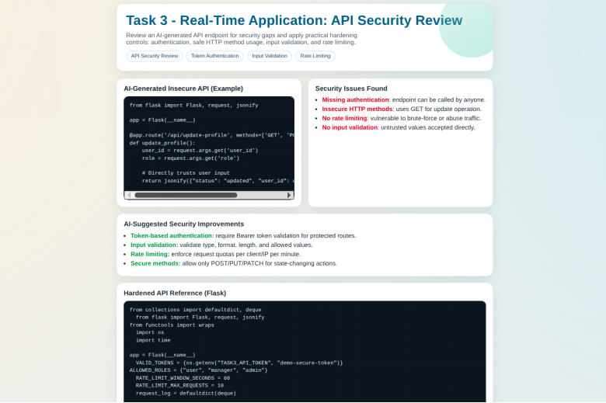
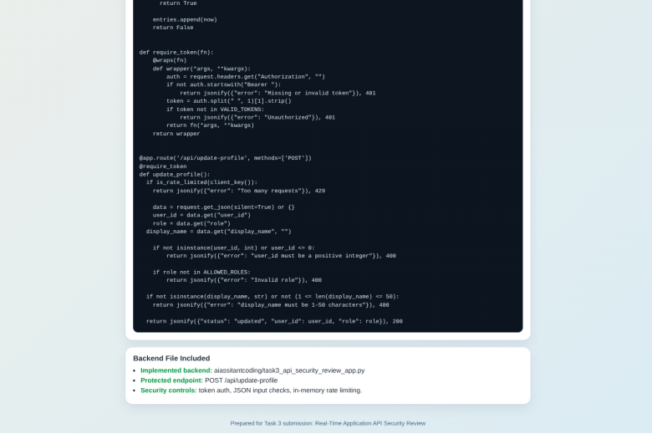
Justification:
- Prevents unauthorized access
- Enforces secure API communication
- Reduces abuse via controlled access
Task 4: Cross-Site Scripting (XSS) Check
Prompt used: Generate an HTML feedback form with JavaScript output
InsecureCode:
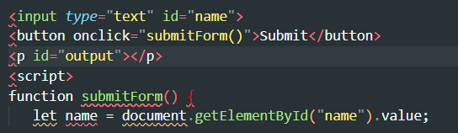
SecureCode:
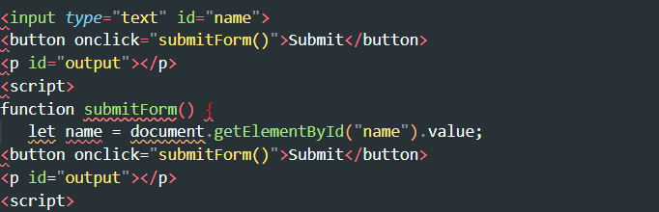
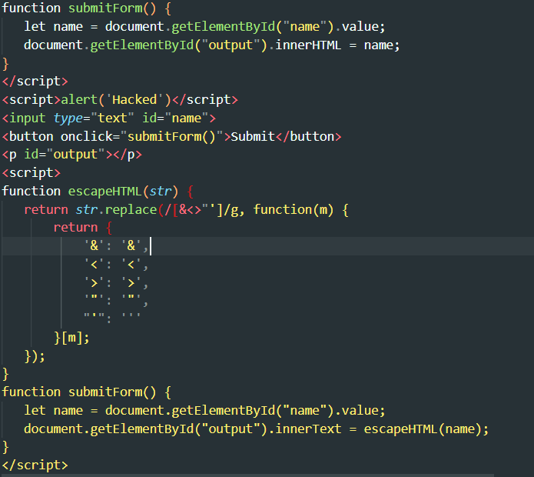
OUTPUT:
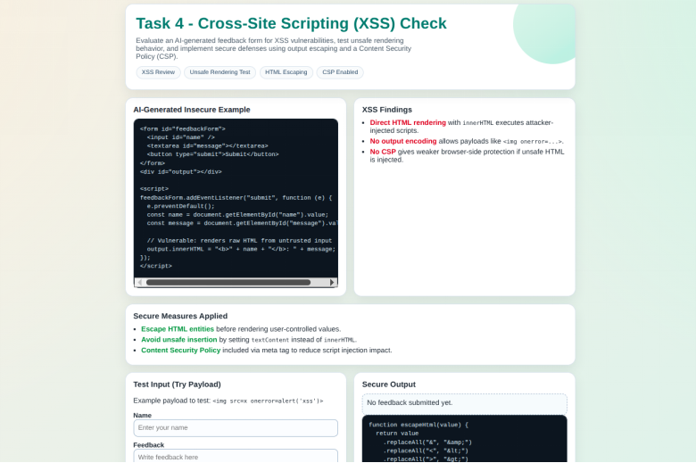
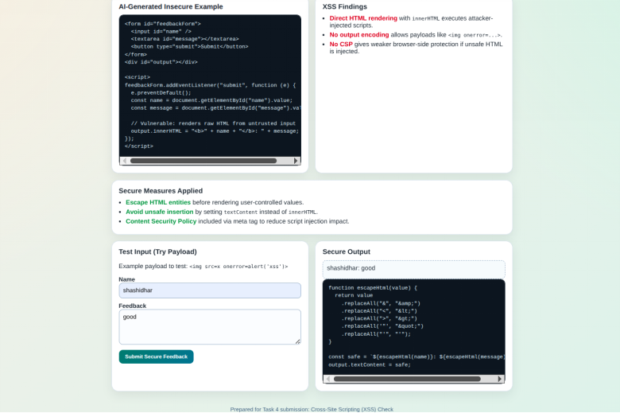
Justification:
- Prevents script injection
- Uses output encoding instead of raw rendering
- Eliminates DOM-based XSS
Task 5: SQL Injection Prevention
Prompt used: Generate a Python script to fetch user details from SQLite database.
InsecureCode:
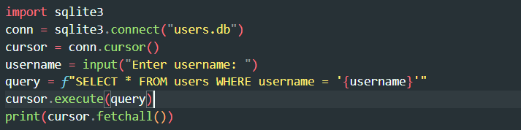
SecureCode:
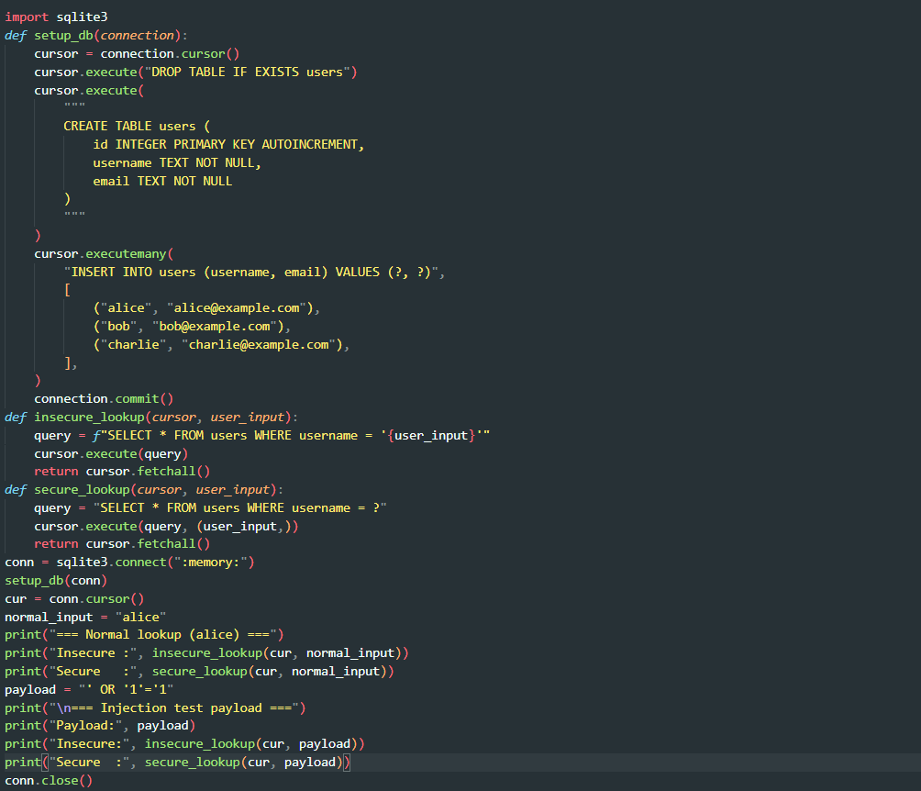


OUTPUT:
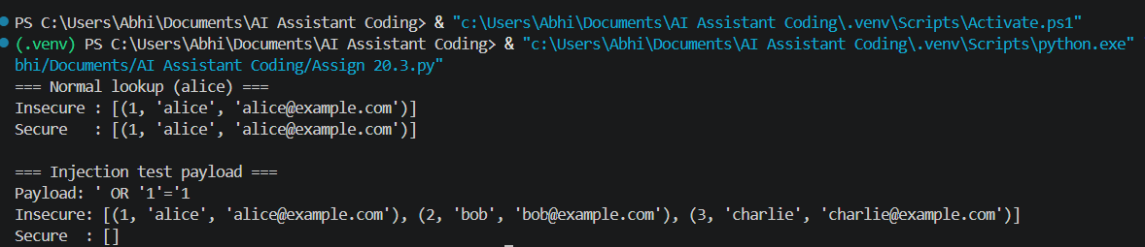
Justification:
- Uses parameterized queries
- Prevents SQL injection attacks
- Ensures safe database interaction

