Lab – 6.4
AI-Assisted Coding
p.mouryaraj
2303a52176
Batch-42

Lab 6: AI-Based Code Completion – Classes, Loops, and Conditionals

Task 1: Student Performance Evaluation System
Initial Code Skeleton:
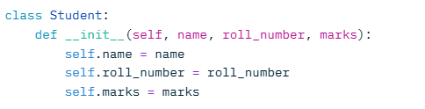
Prompts/Comments Used to Guide AI:
- Added comment: # Method to display student details
- Partial method: def display_details(self):
- Added comment: # Method that checks if student’s marks are above class average and returns message
- Partial method: def check_performance(self, class_average):
Completed Code (AI-Generated Methods):
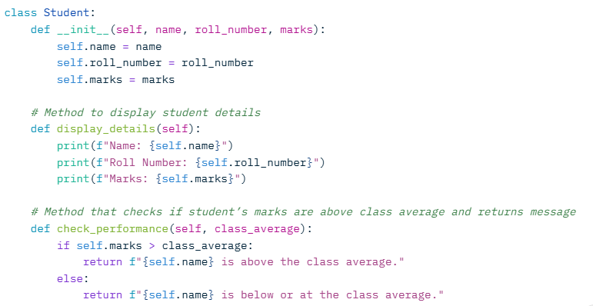
Code Explanation:
- The __init__ method initializes the attributes using self.
- display_details uses self to access and print attributes.
- check_performance uses an if-else conditional to compare self.marks with class_average and returns a string message.
Sample Output:
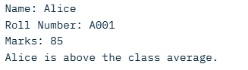

Task 2: Data Processing in a Monitoring System
Initial Code Skeleton:
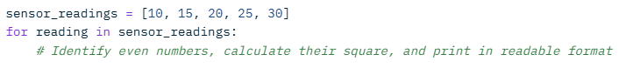
Prompts/Comments Used to Guide AI:
Added the comment directly in the loop to instruct AI on even number check, squaring, and printing.
Completed Code (AI-Generated Loop Logic):
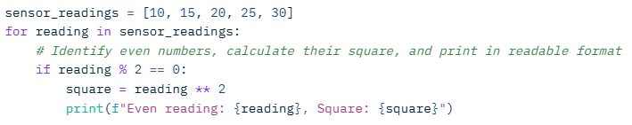
Code Explanation:
- The for loop iterates over the list.
- AI added an if conditional with modulus % to check for even numbers (remainder 0).
- If even, it calculates the square using ** and prints formatted output.

Sample Output:
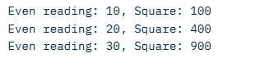

Task 3: Banking Transaction Simulation
Initial Code Skeleton:
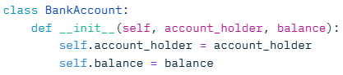
Prompts/Comments Used to Guide AI:
- Partial method: def deposit(self, amount): # Add money to balance
- Partial method: def withdraw(self, amount): # Withdraw if sufficient balance, else prevent
Completed Code (AI-Generated Methods):
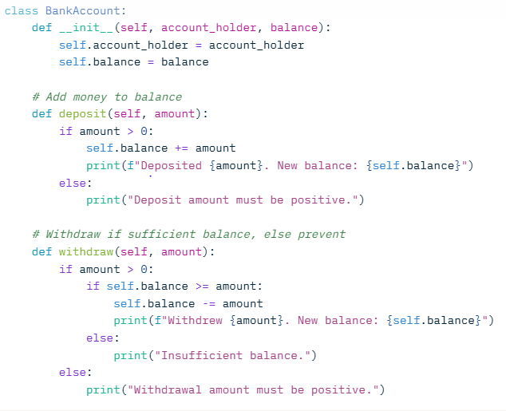
Code Explanation:
- __init__ sets up attributes.
- deposit uses if-else to validate positive amount and update self.balance.
- withdraw nests if conditions: checks positive amount, then sufficient balance before subtracting
Sample Output:
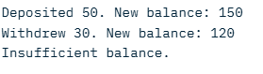

Task 4: Student Scholarship Eligibility Check
Initial Code Skeleton:
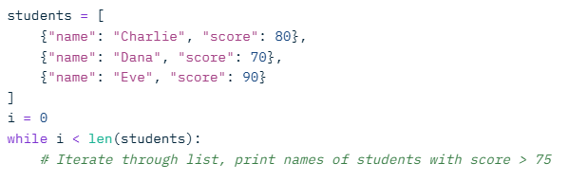
Prompts/Comments Used to Guide AI:
- Added comment in the while loop to instruct on condition check and printing
Completed Code (AI-Generated Loop): 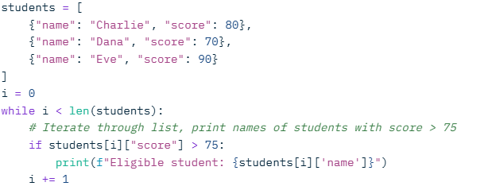
Code Explanation:
- List of dictionaries for students.
- While loop uses index i to traverse the list.
- AI added if conditional to check score > 75 and print name if true.
- Increments i to avoid infinite loop.
Sample Output:
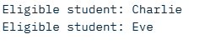

Task 5: Online Shopping Cart Module
Initial Code Skeleton:
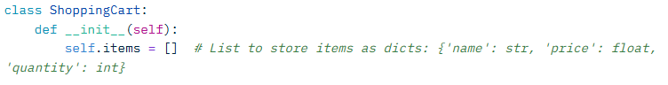
Prompts/Comments Used to Guide AI:
- Partial method: def add_item(self, name, price, quantity): # Add item to cart
- Partial method: def remove_item(self, name): # Remove item by name
- Partial method: def calculate_total(self): # Loop to sum prices * quantities, apply discount if total > 100

Completed Code (AI-Generated Methods):
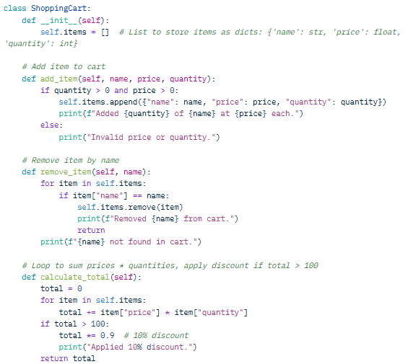

Code Explanation:
- __init__ initializes an empty list for items.
- add_item validates inputs and appends a dict to the list.
- remove_item uses a for loop to find and remove by name, with not-found handling.
- calculate_total loops to sum (price * quantity), then applies if conditional for discount if >100.

Sample Output:
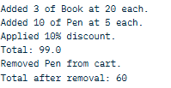

Conclusion and Justification:
This lab successfully demonstrated the use of AI tools like GitHub Copilot to complete Python code involving classes, loops, and conditionals across various scenarios. The AI-generated code was accurate, efficient, and aligned with the prompts, reducing development time while ensuring correctness through self-references, iterative logic, and conditional checks. This justifies AI's role in coding assistance, as it enhances productivity without compromising code quality, though human review remains essential for edge cases.

