Assisgnment 13.4
2303a52184
G.preetham
Batch:42
Task 1:
Code:
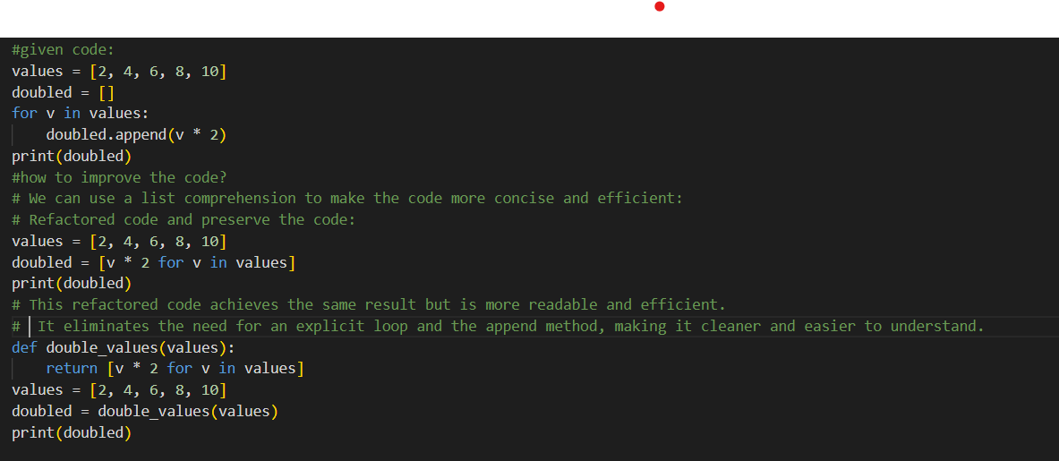
Output:
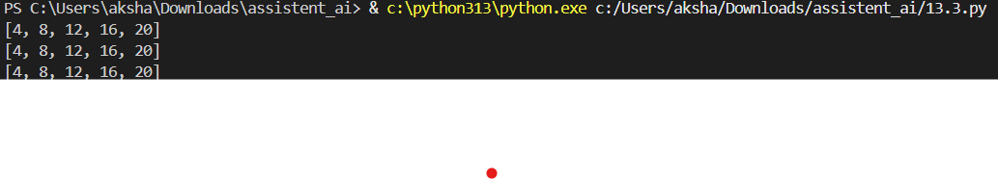

Task 2:
Code:
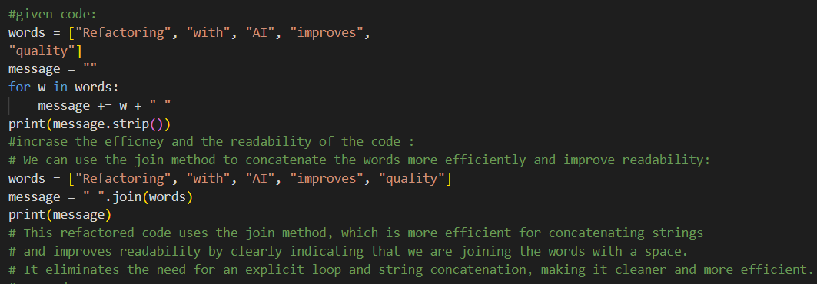
Output:

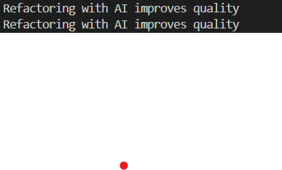

Task 3:
Code:
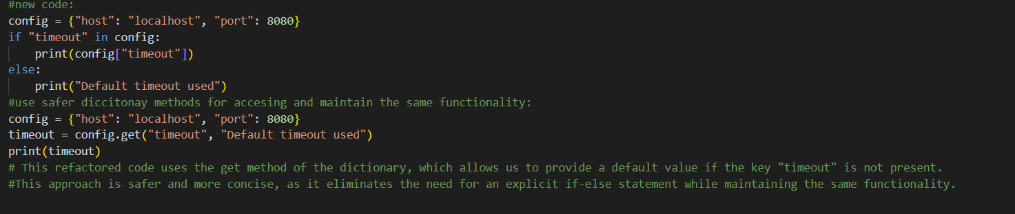
Ouput:
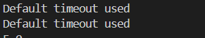
Task 4:
Code:
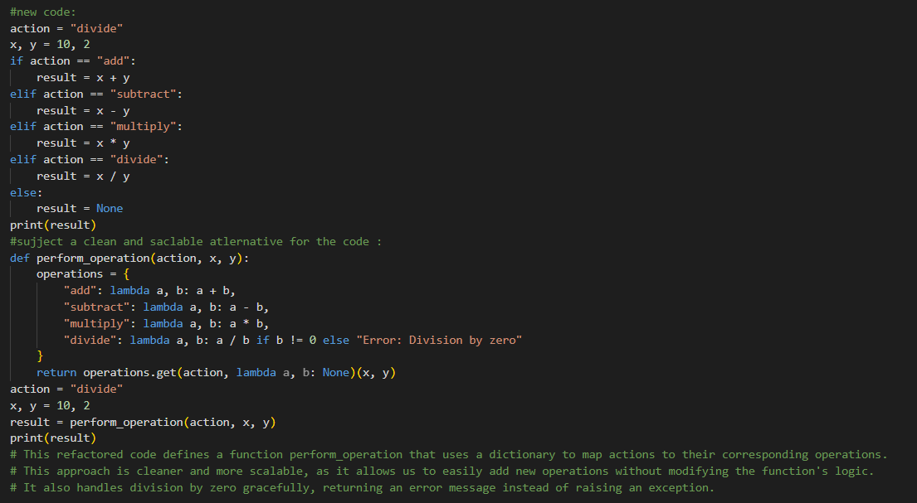
Output:
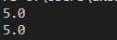

Task 5:
Code:
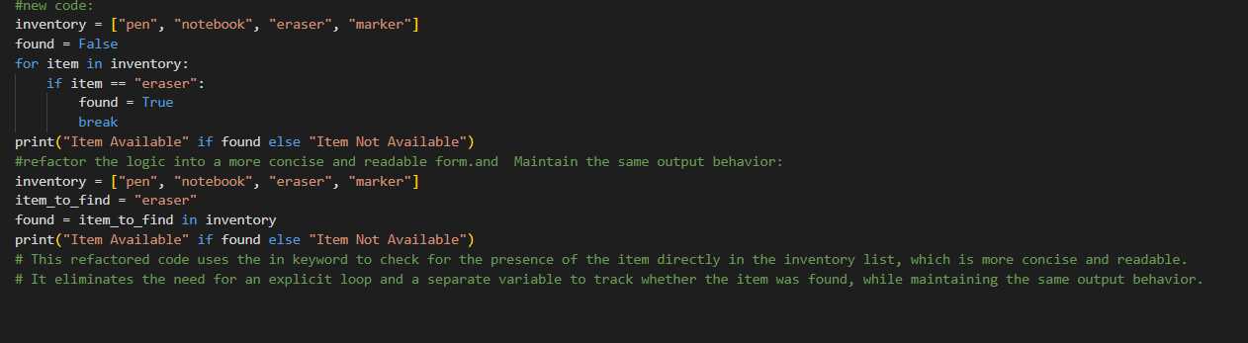
Output:
