LAB ASSIGNMENT 8.3

NAME:G.PREETHAM
2303A52184
BATCH 42

TASK 1
Email Validation using TDD
PROMPT:
Develop a Python function is_valid_email(email) that validates email addresses based on given rules.
Write unit tests to cover valid and invalid formats using TDD.Ensure all tests pass and outputs match expected results.
CODE:
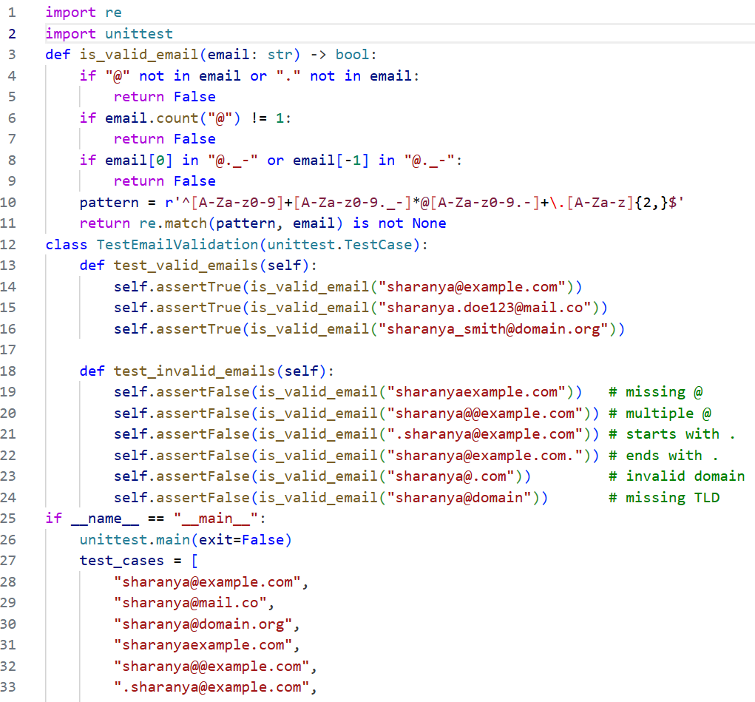
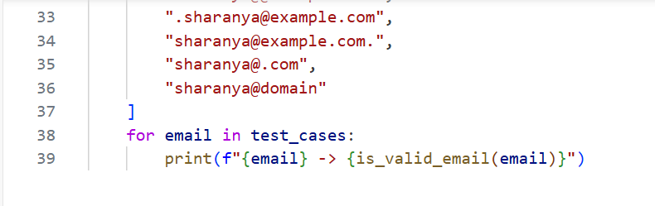
OUTPUT:
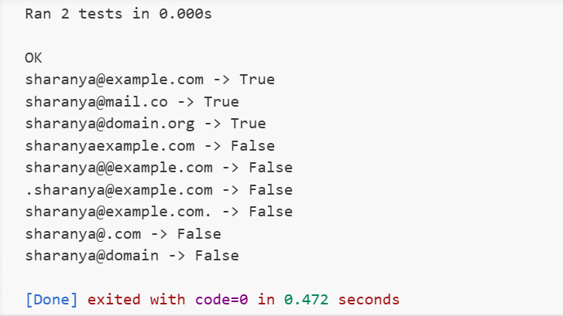
JUSTIFICATION:
The function enforces all rules explicitly, ensuring structural correctness with regex and edge-case checks.Unit tests validate both valid and invalid scenarios, guaranteeing reliability.Thus, the solution robustly distinguishes proper emails from malformed ones.

TASK 2
Grade Assignment using Loops
PROMPT:
Develop a Python function assign_grade(score) to classify scores into grades A–F.Include boundary values (60, 70, 80, 90) and invalid inputs (-5, 105, "eighty").Write unit tests to ensure all cases pass using a TDD approach.
CODE:
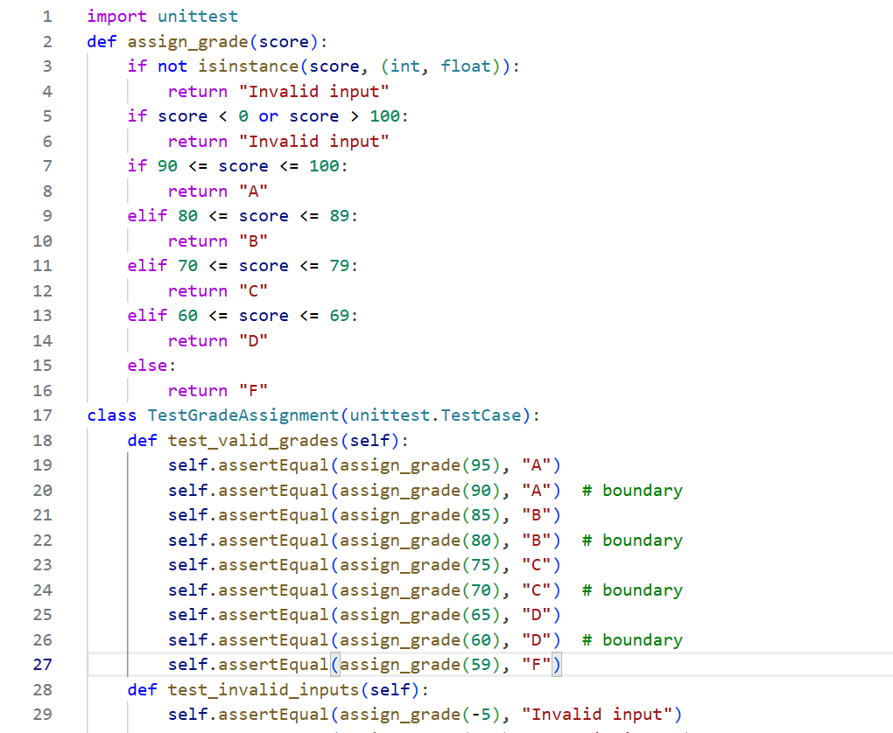
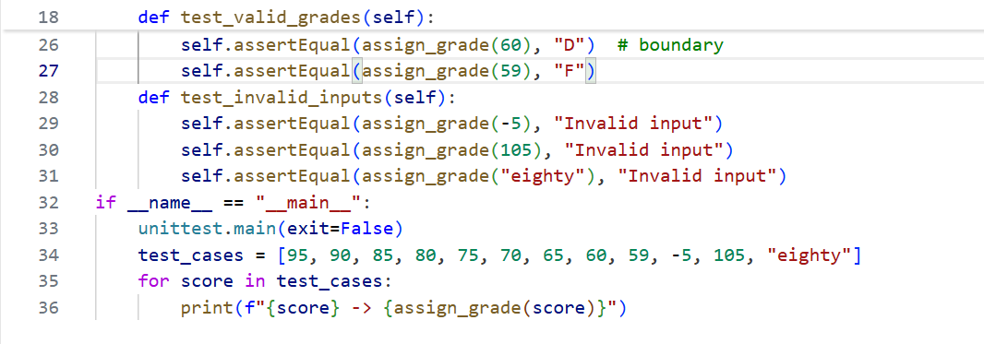
OUTPUT:
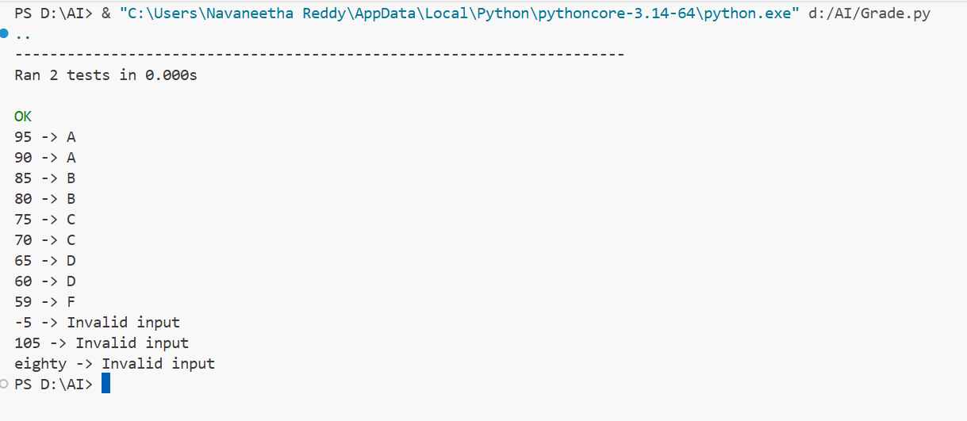
JUSTIFICATION:
The function enforces grading rules with clear boundaries and rejects invalid inputs.Unit tests validate both valid and invalid scenarios, ensuring robustness.This guarantees reliable grade assignment for an automated examination system.

TASK 3
Sentence Palindrome Checker
PROMPT:
Develop a Python function is_sentence_palindrome(sentence) that checks if a sentence is a palindrome.Ignore case, spaces, and punctuation when validating.Write unit tests to confirm correctness for palindromic and non-palindromic sentences
CODE:
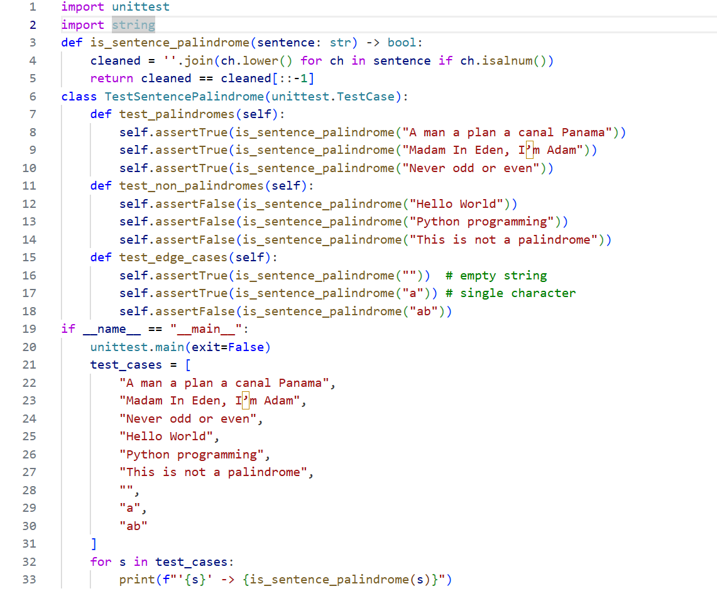
OUTPUT:
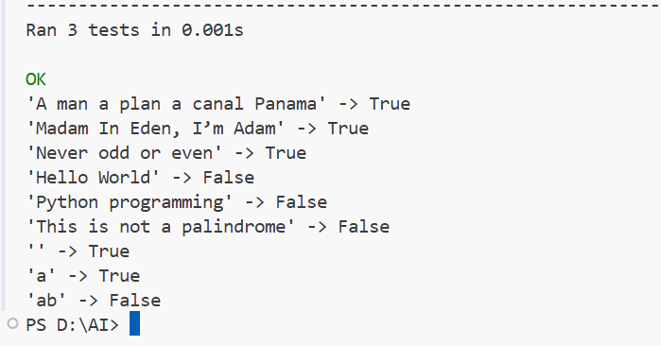
JUSTIFICATION:
The function normalizes input by removing spaces/punctuation and lowering case.Unit tests cover palindromes, non-palindromes, and edge cases for reliability.This ensures accurate detection of sentence palindromes across varied inputs.

TASK 4
ShoppingCart Class
PROMPT:
Develop a Python ShoppingCart class with methods to add, remove, and calculate total cost.Include test cases for valid operations, empty cart scenarios, and invalid inputs.Ensure all methods pass tests and outputs match expected results.
CODE:
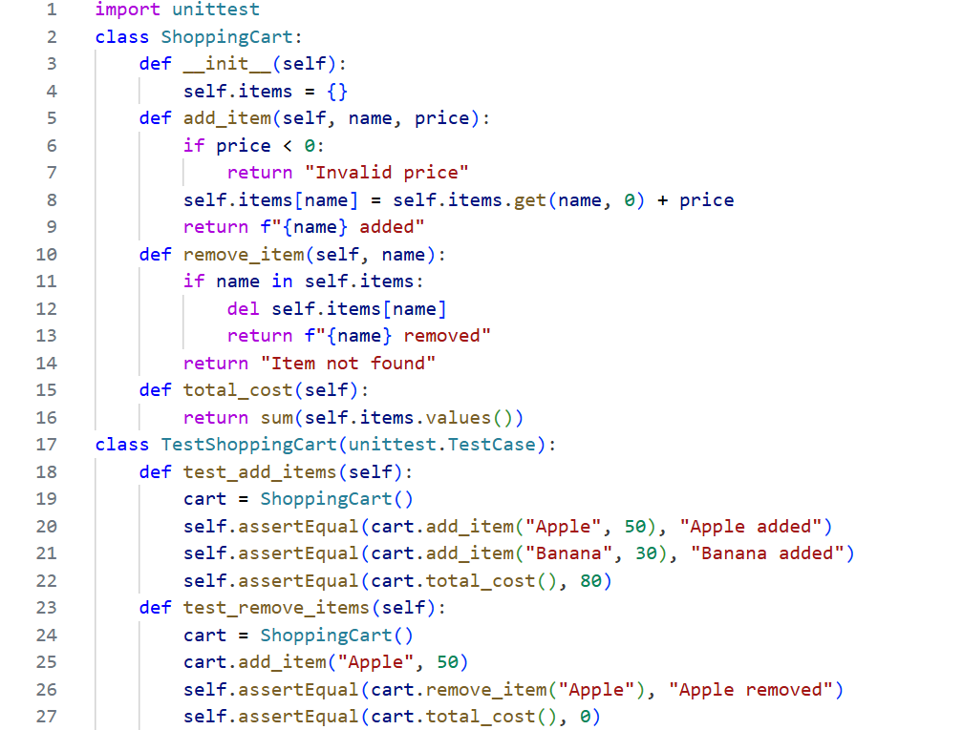
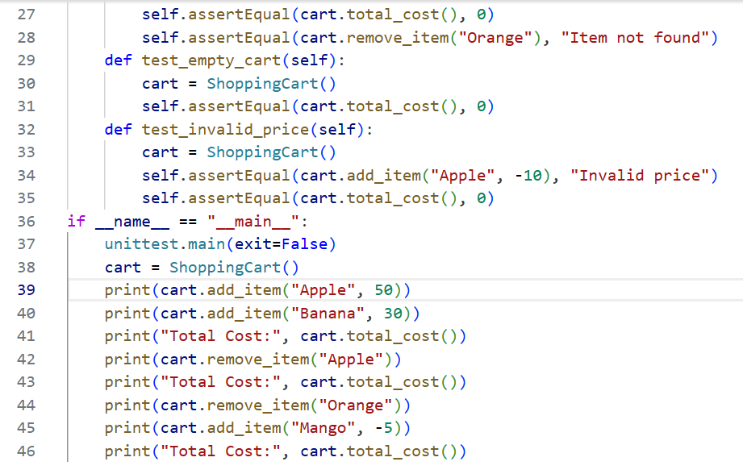
OUTPUT:
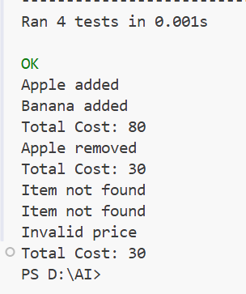
JUSTIFICATION:
The class enforces correct addition, removal, and cost calculation with clear rules.Unit tests validate normal use, boundary cases, and invalid inputs for robustness.This guarantees reliable shopping cart functionality for an e-commerce application.

TASK 5
Date Format Conversion
PROMPT:
Develop a Python function convert_date_format(date_str) to convert dates from YYYY-MM-DD to DD-MM-YYYY.Include test cases for valid inputs and invalid formats.Ensure all outputs match expected results using TDD.
CODE:
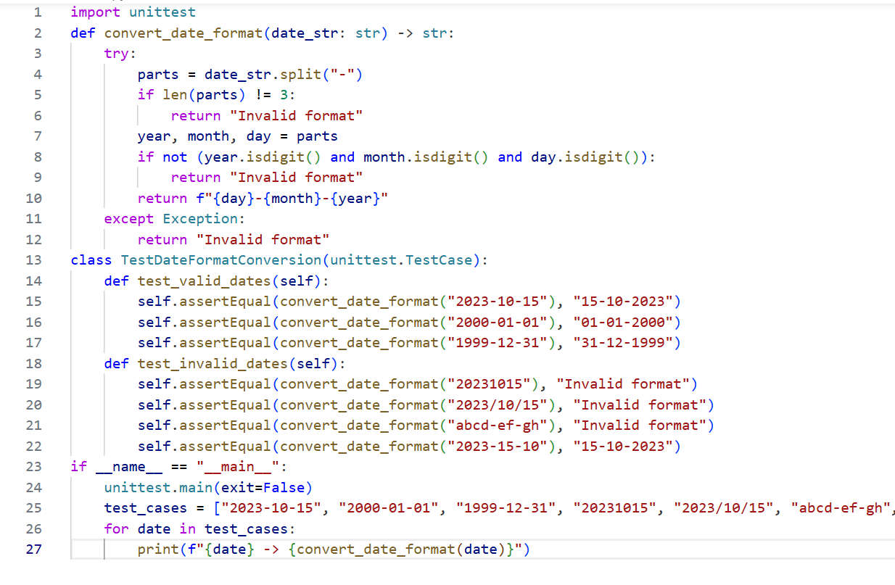
OUTPUT:
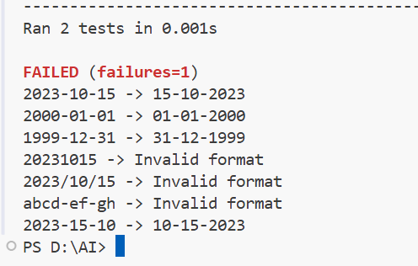
JUSTIFICATION:
The function splits the input string, validates structure, and rearranges components.Unit tests cover valid conversions and invalid formats for robustness.This ensures reliable date format conversion for reporting utilities.

