AI Assisted Coding Ass-3.2

Name: B. Manali Reddy
Hall No: 2303A52187
Batch: 34
Lab 3: Prompt Engineering – Improving Prompts and Context Management
Task Description-1
• Progressive Prompting for Calculator Design: Ask the AI to design a simple calculator
program by initially providing only the function name. Gradually enhance the prompt by
adding comments and usage examples.
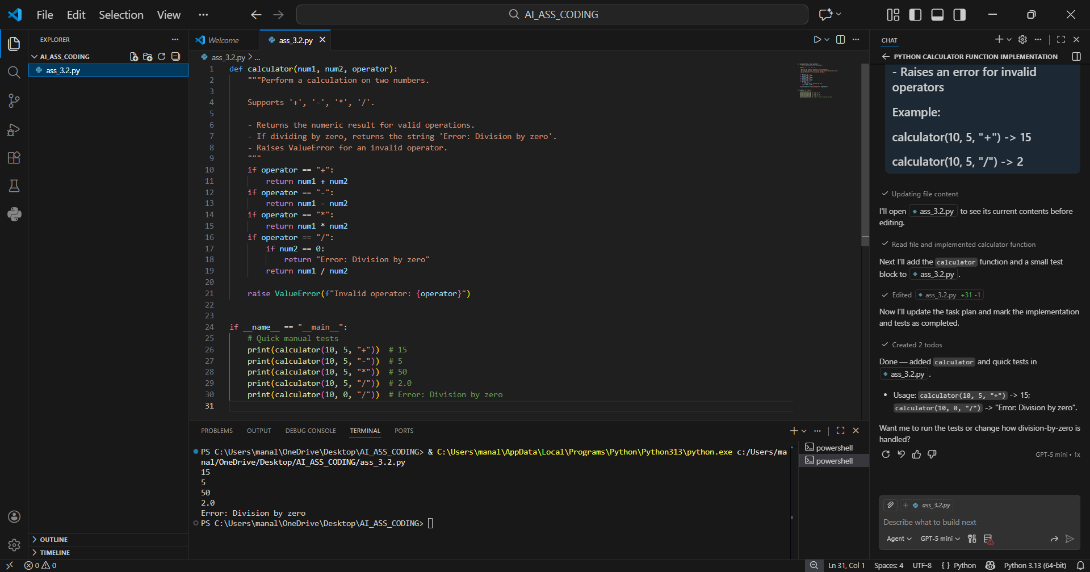
Task Description-2
• Refining Prompts for Sorting Logic: Start with a vague prompt for sorting student marks,
then refine it to clearly specify sorting order and constraints.
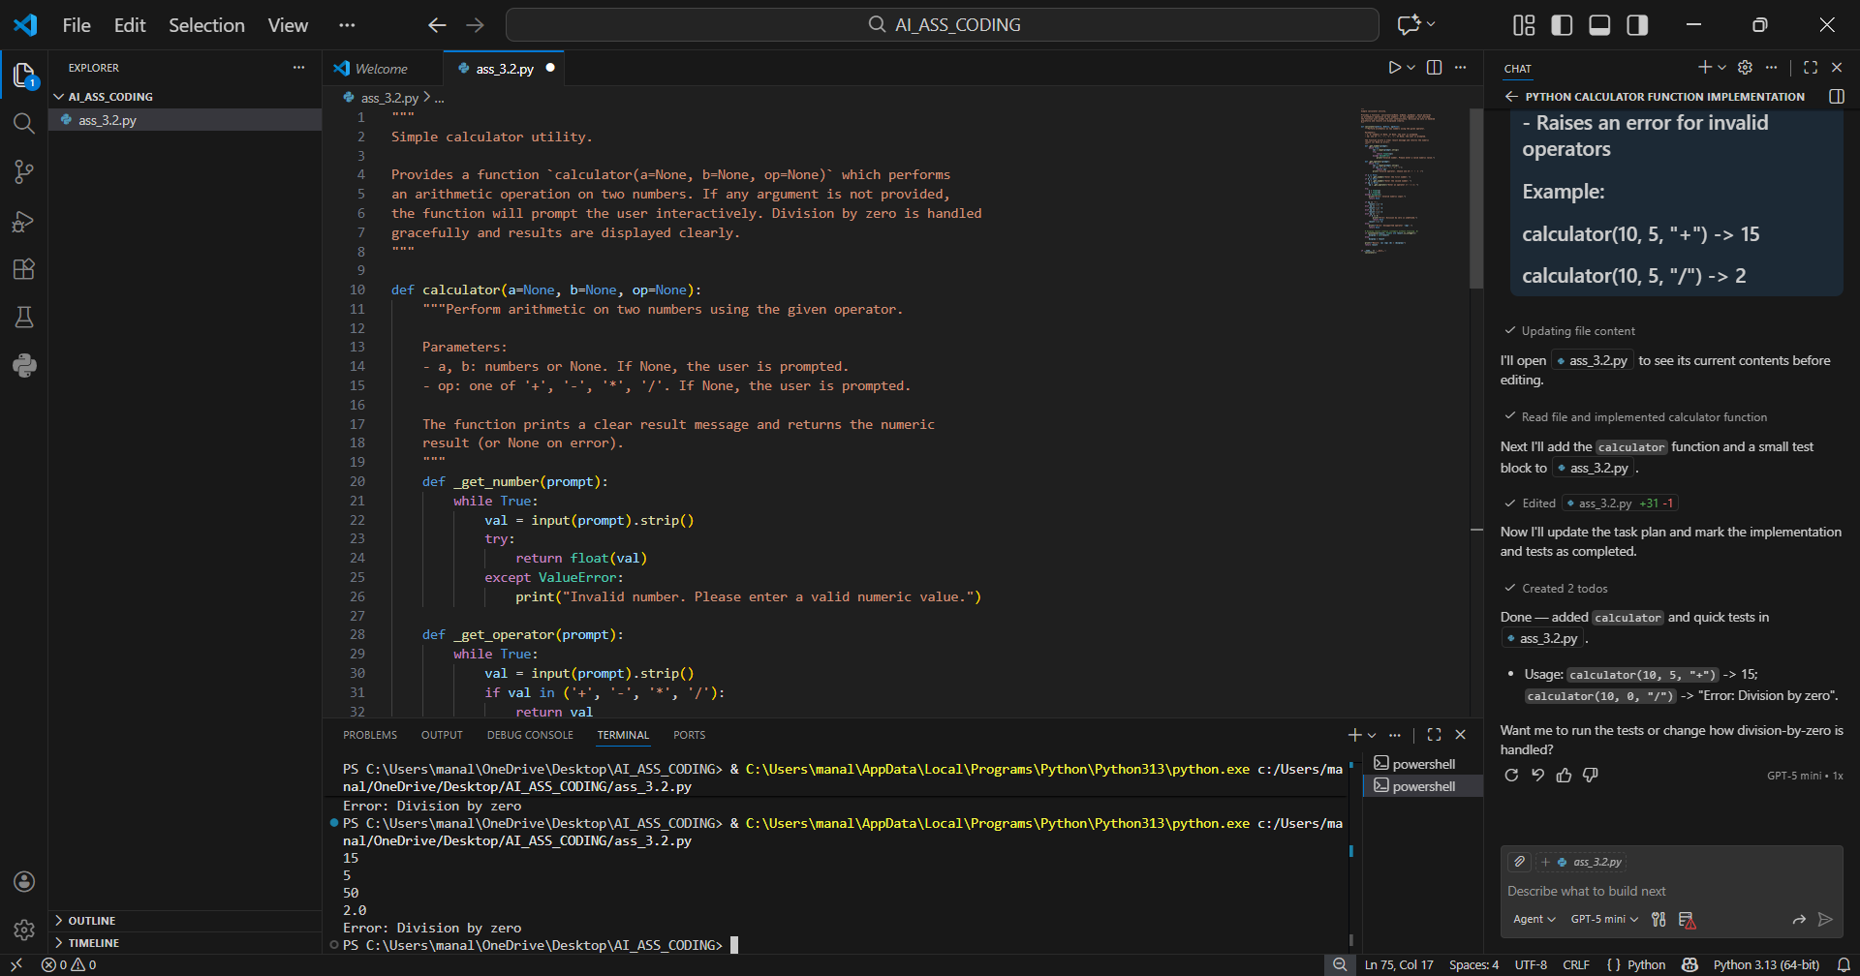
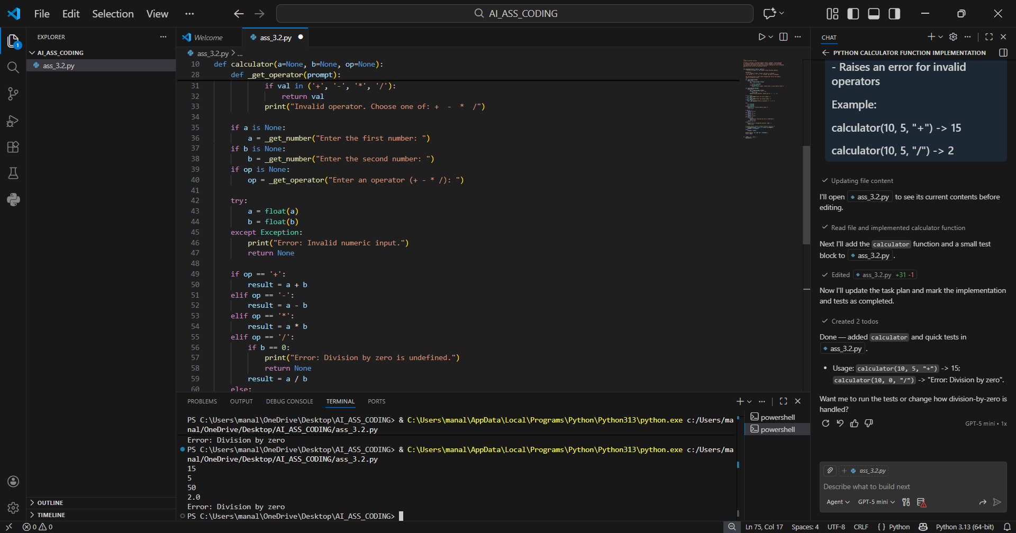
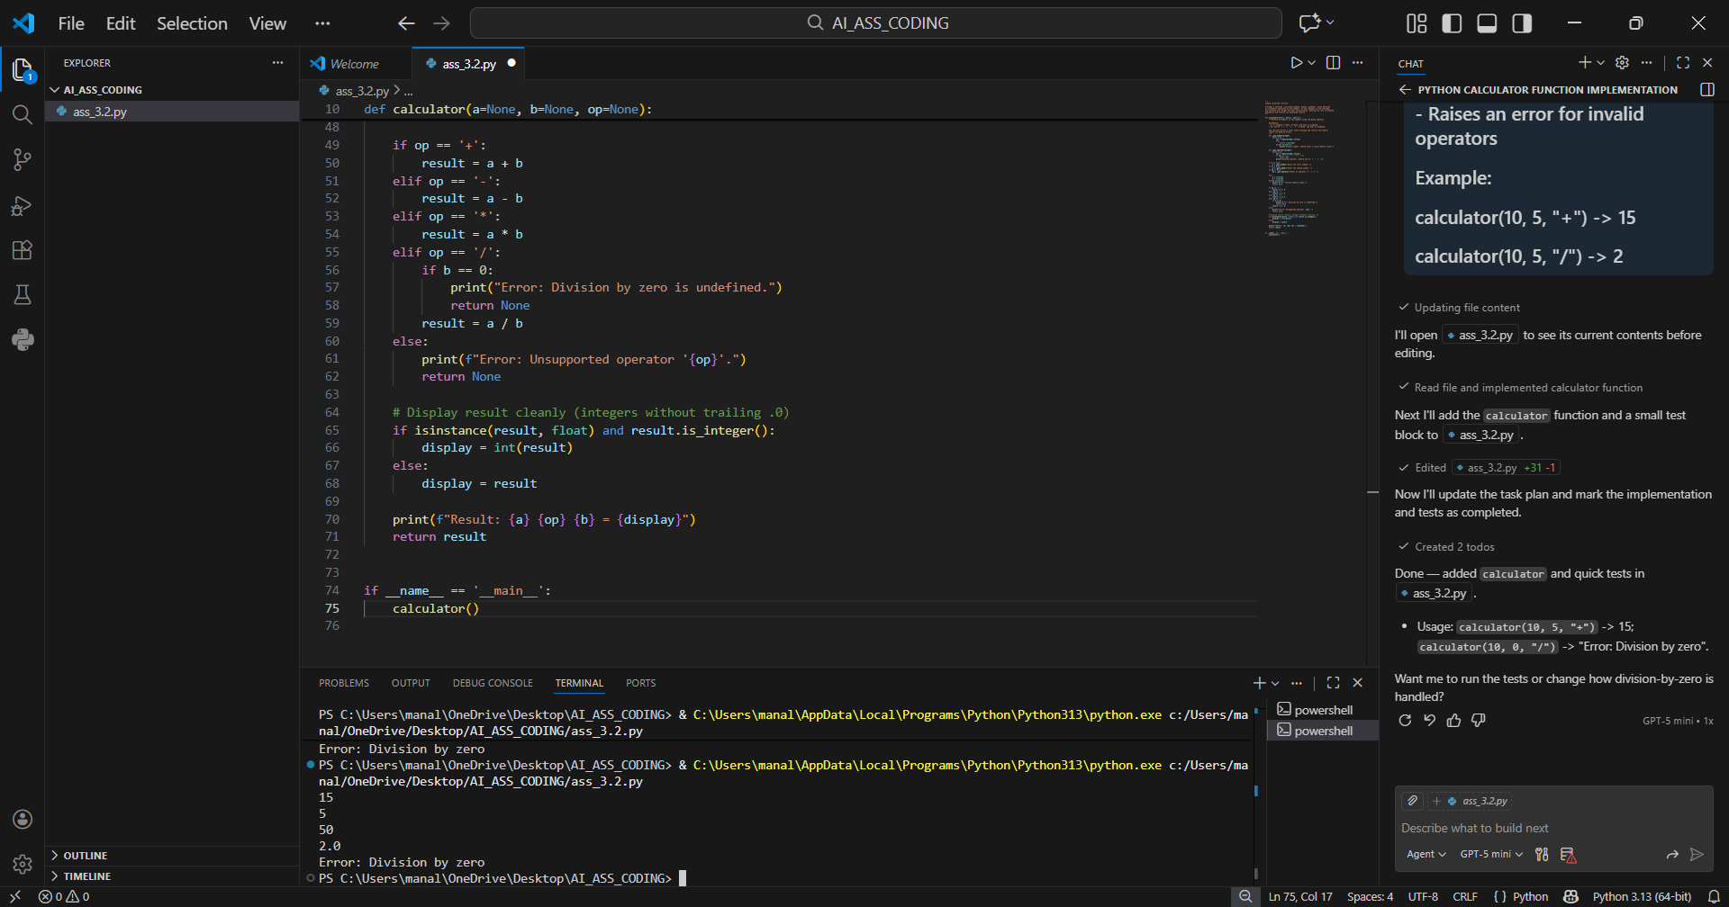
Task Description-3
• Few-Shot Prompting for Prime Number Validation: Provide multiple input-output
examples for a function that checks whether a number is prime. Observe how few-shot
prompting improves correctness.
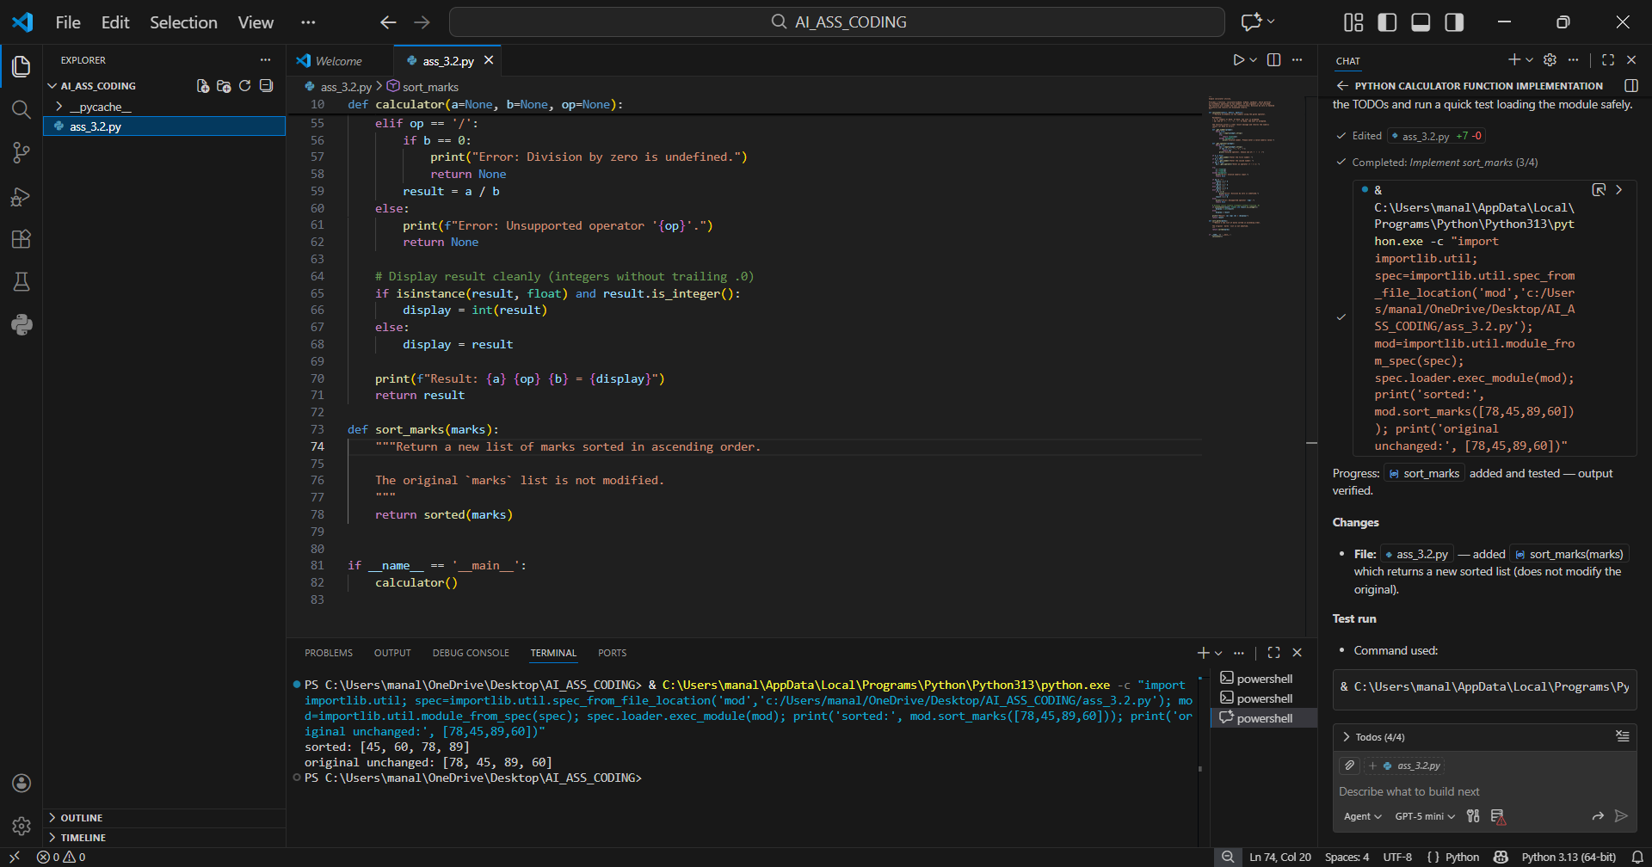
Task Description-4
• Prompt-Guided UI Design for Student Grading System: Create a user interface for a
student grading system that calculates total marks, percentage, and grade based on user
input.
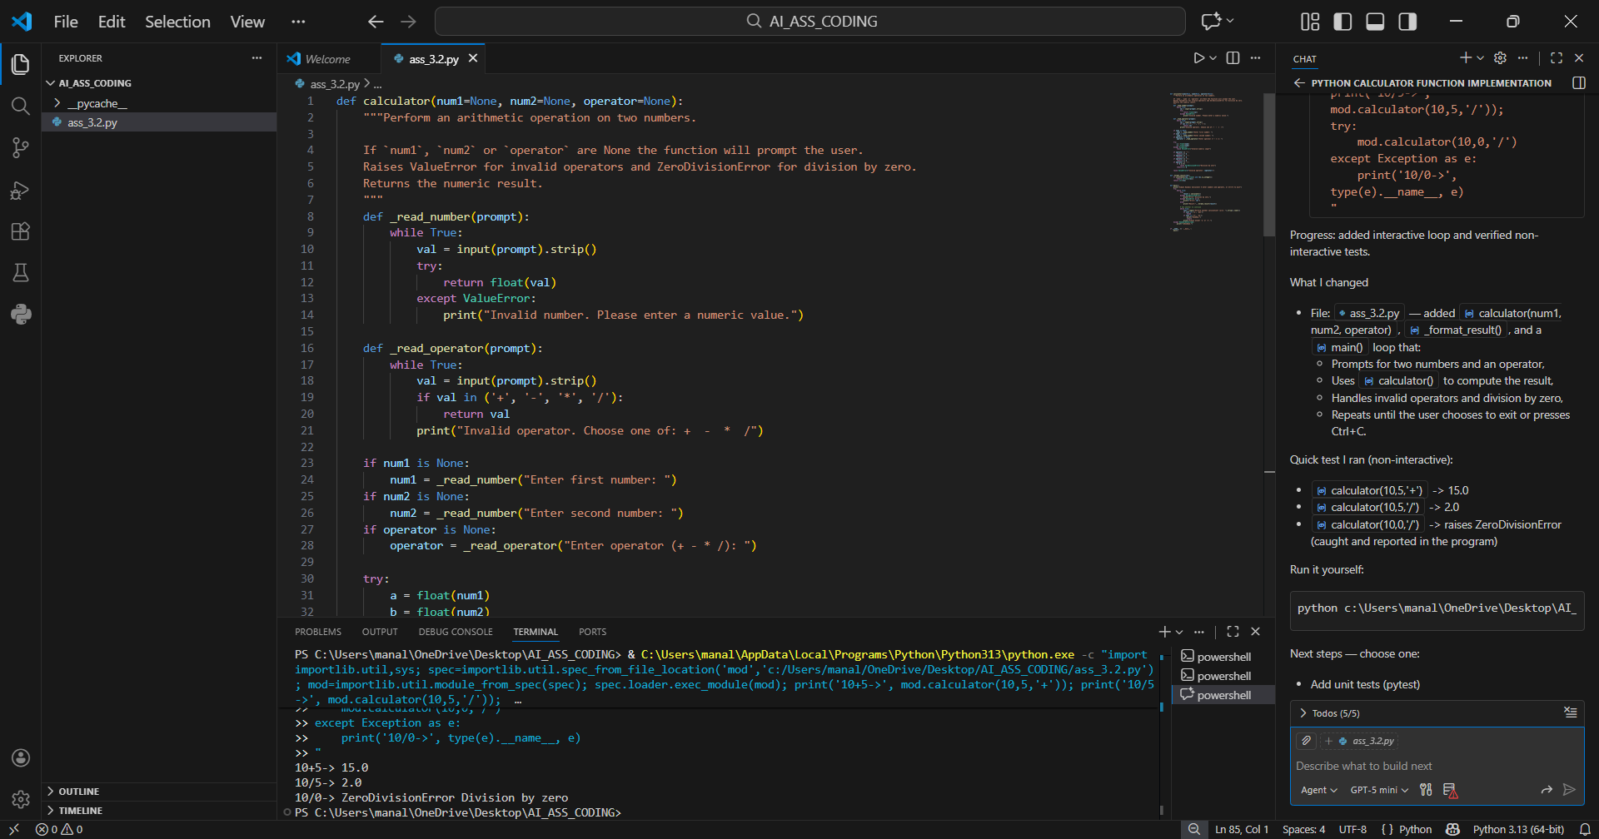
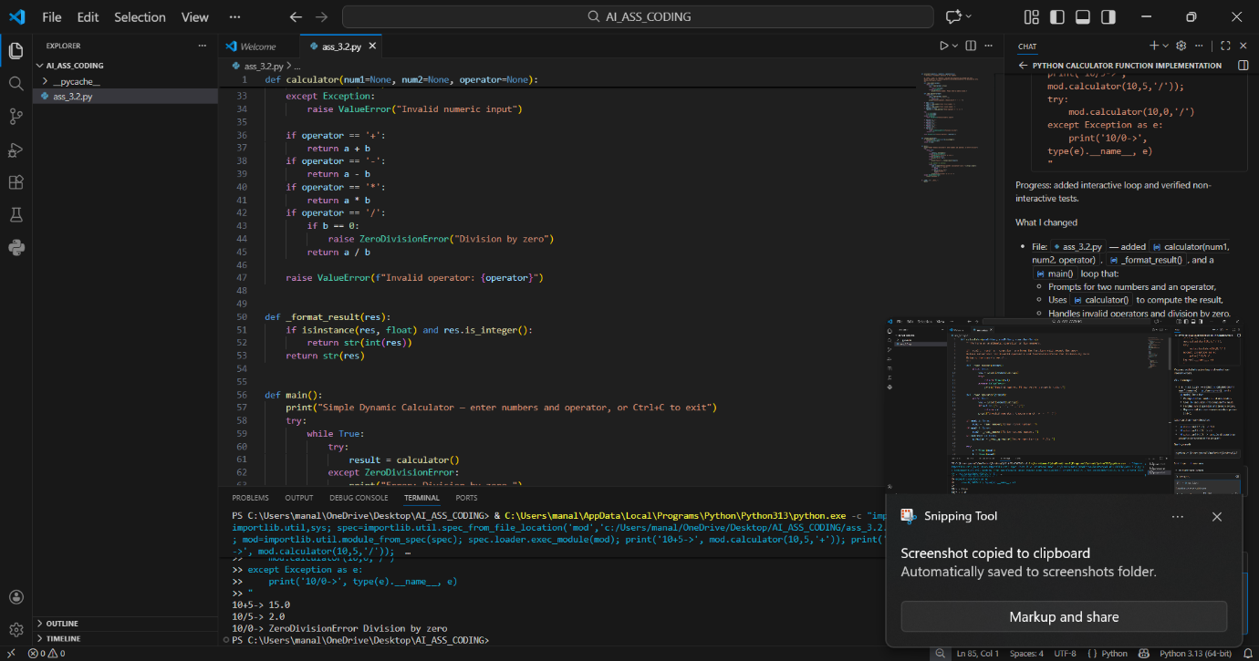
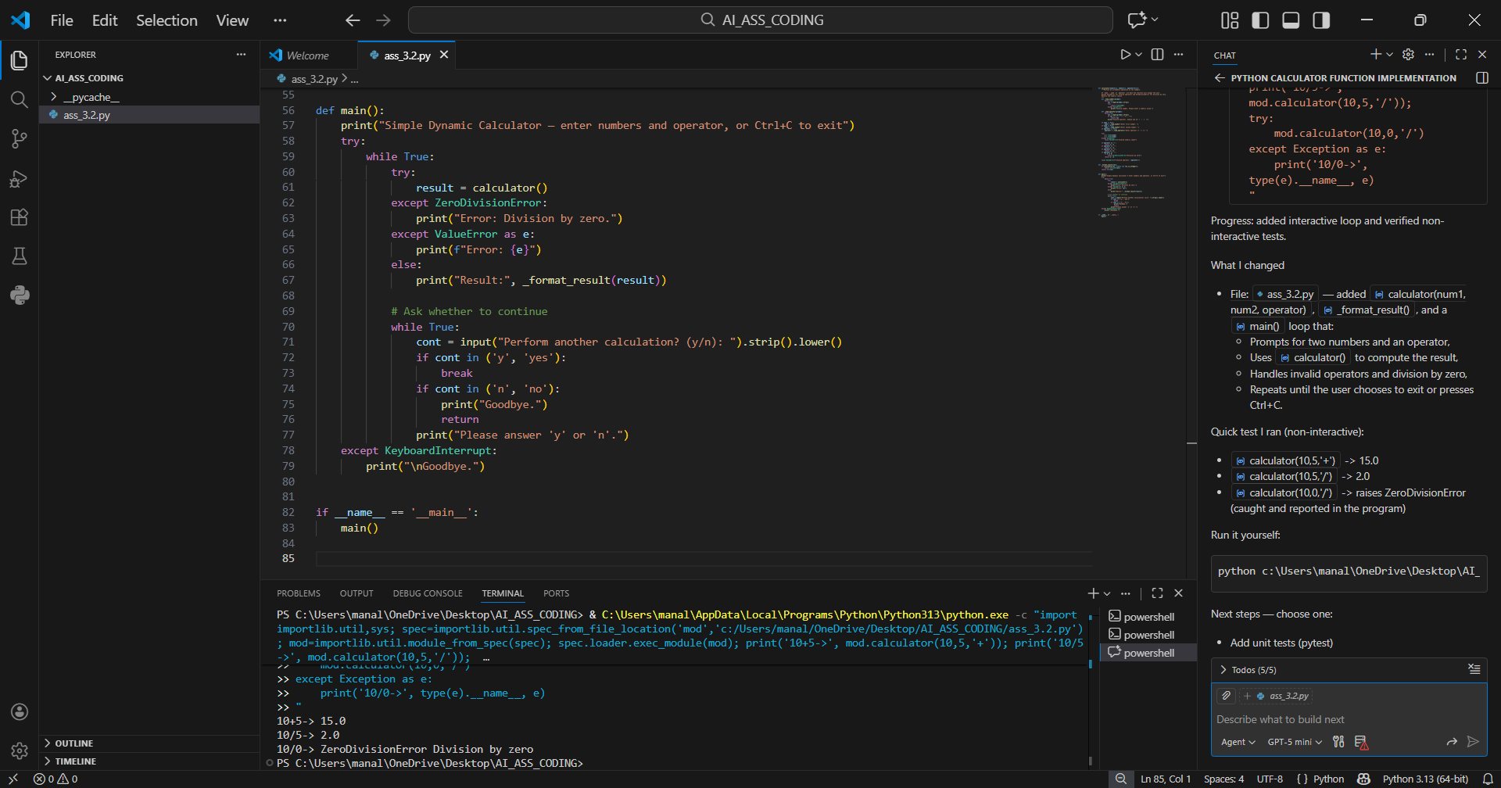
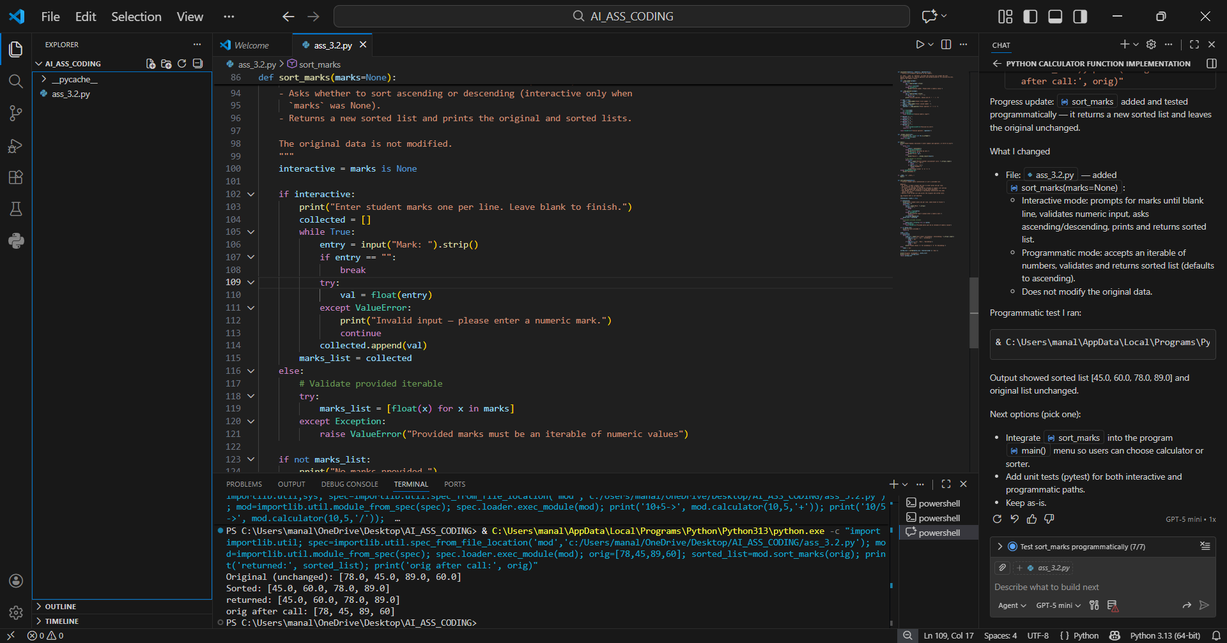
Task Description-5
• Analyzing Prompt Specificity in Unit Conversion Functions: Improving a Unit
Conversion Function (Kilometers to Miles and Miles to Kilometers) Using Clear
Instructions.
