Lab 5: Ethical Foundations – Responsible AI Coding Practices

Student Details
Name: Sumanth Akarapu
Roll Number: 2303a52191
Section: Batch 34
Course: B.Tech
Subject: AI ASSISTANT CODING

Lab Objectives
- Explore ethical risks associated with AI-generated code
- Recognize issues related to security, bias, transparency, and copyright
- Reflect on developer responsibilities when using AI tools
- Promote awareness of responsible and ethical AI coding practices

Lab Outcomes
- Identify insecure coding patterns generated by AI tools
- Detect potential bias in AI-generated outputs
- Evaluate originality and licensing concerns
- Understand transparency in AI-assisted programming
- Reflect on accountability in ethical AI coding

Task 1: Transparency in Algorithm Optimization
Naive Approach (Prime Check):
def is_prime_naive(n):
if n <= 1:
return False
for i in range(2, n):
if n % i == 0:
return False
return True
Time Complexity: O(n)
Optimized Approach (Prime Check):
def is_prime_optimized(n):
if n <= 1:
return False
if n == 2:
return True
if n % 2 == 0:
return False
i = 3
while i * i <= n:
if n % i == 0:
return False
i += 2
return True
Time Complexity: O(√n)
AI PROMPT USED:
“Generate Python code for two prime-checking methods: a naive approach and an optimized approach. Explain how the optimized version improves performance, including time complexity comparison.”
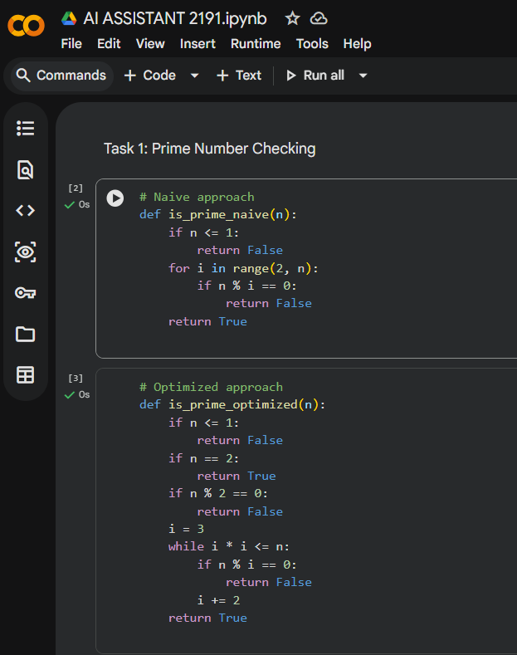

Task 2: Transparency in Recursive Algorithms (Fibonacci)
def fibonacci(n):
if n == 0:
return 0
if n == 1:
return 1
return fibonacci(n - 1) + fibonacci(n - 2)
AI PROMPT USED:
“Generate a recursive Python function to calculate Fibonacci numbers. Add clear comments explaining recursion, base cases, and recursive calls. Explain how the recursion works step by step.”
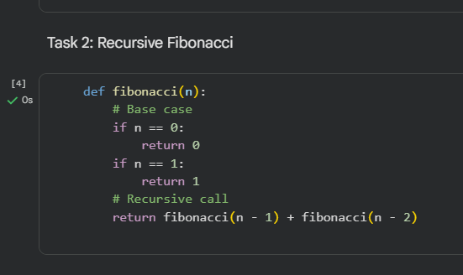

Task 3: Transparency in Error Handling
def read_and_process_file(filename):
try:
file = open(filename, 'r')
data = file.read()
file.close()
return data
except FileNotFoundError:
print('File not found')
except PermissionError:
print('Permission denied')
except Exception as e:
print('Unexpected error', e)
AI PROMPT USED:
“Generate a Python program that reads a file and processes data. Include proper error handling and clearly explain each exception scenario.”
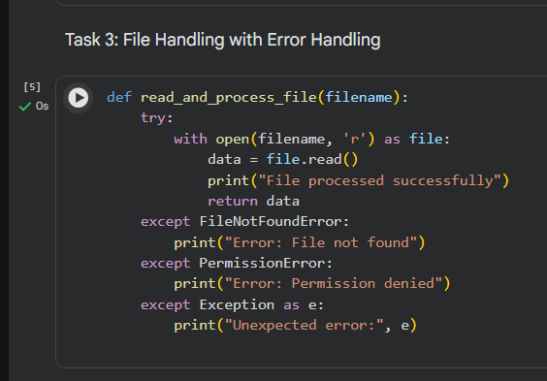

Task 4: Security in User Authentication
Security Issues:
- Plain-text password storage
- No hashing or encryption
Secure Practice:
- Use password hashing
- Validate inputs
AI PROMPT USED:
“Generate a Python-based login system. Analyze whether secure password handling practices are used. Identify security flaws and provide a revised secure version using password hashing and input validation. Explain best practices for secure authentication.”
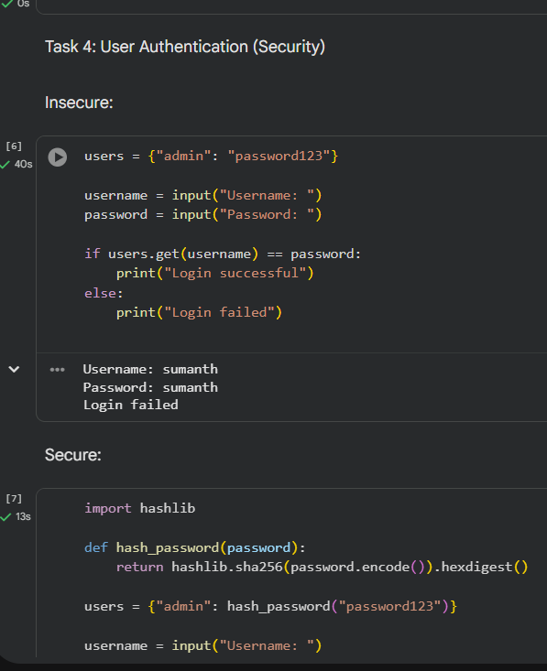
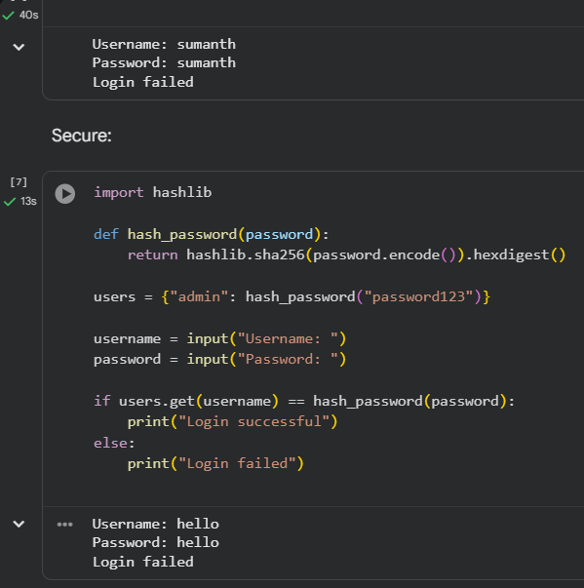

Task 5: Privacy in Data Logging
Privacy Risks:
- Logging full username and IP address
Privacy-Aware Practices:
- Mask IP addresses
- Anonymize user identity
AI PROMPT USED:
“Generate a Python script that logs user activity including username, IP address, and timestamp. Analyze privacy risks and provide an improved version using anonymized or masked data. Explain privacy-aware logging principles.”
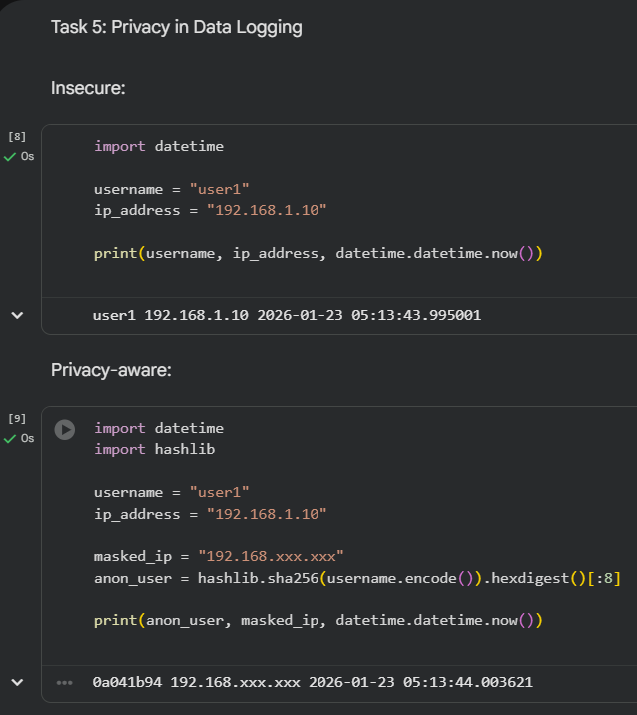

Final Reflection
AI-generated code should always be reviewed by humans. Developers are responsible for ensuring ethical, secure, transparent, and privacy-preserving AI-assisted software development.

