AI Assisted Coding

Assignment 14.3
Name: MOHAMMED ABDUL LAYEEQ
RollNo:2303A52217
Batch:45
Task-1:
Scenario
A student wants to showcase academic projects, technical skills, and contact
information through a personal portfolio website. AI tools are used to speed up
development while maintaining quality and customization.
Tasks
1. Use GitHub Copilot to generate a semantic HTML structure with
sections:
o Home
o About
o Projects
o Contact
2. Ask Copilot to suggest responsive CSS using Flexbox or Grid.
3. Customize AI-generated CSS to add:
o Hover effects on project cards
o Smooth scrolling navigation
Expected Outcome
• Clean and well-structured portfolio website
• Responsive layout for desktop and mobile screens
• Interactive project cards

Output:
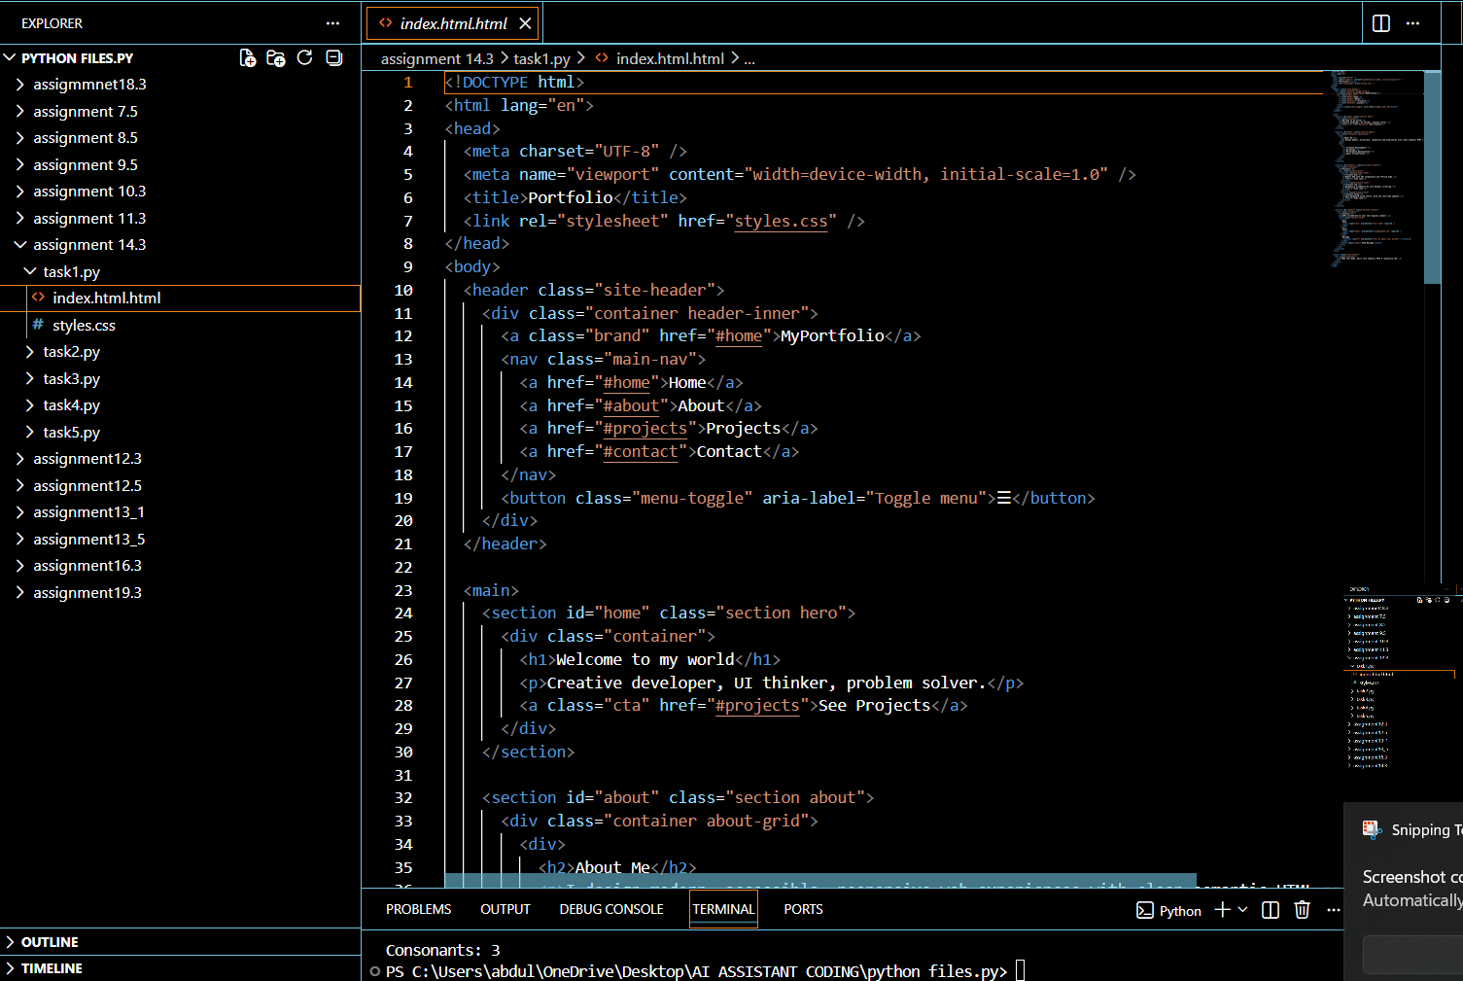
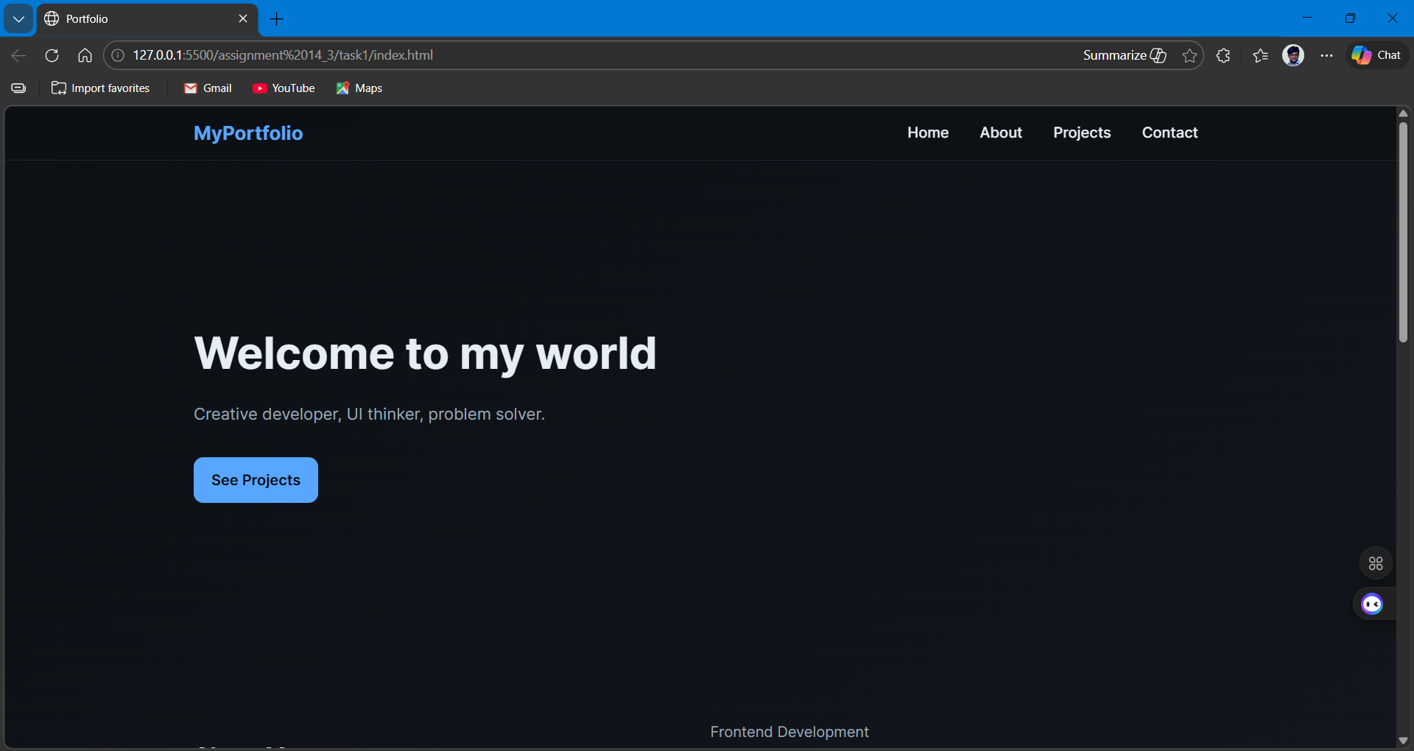

Task-2:
Scenario
A local restaurant requires a simple yet attractive landing page to display its
offerings. The developer uses AI assistance to rapidly generate UI components.
Tasks
1. Use Copilot to create a navigation bar with links:
o Home
o Menu
o Gallery
o Contact
2. Generate a menu section styled with CSS cards.
3. Implement a JavaScript-based image slider for the gallery using Copilot
suggestions.
4. Customize animations or transitions for better user experience.
Expected Outcome
• Fully functional restaurant landing page
• Responsive navigation bar
• Working image slider with smooth transitions
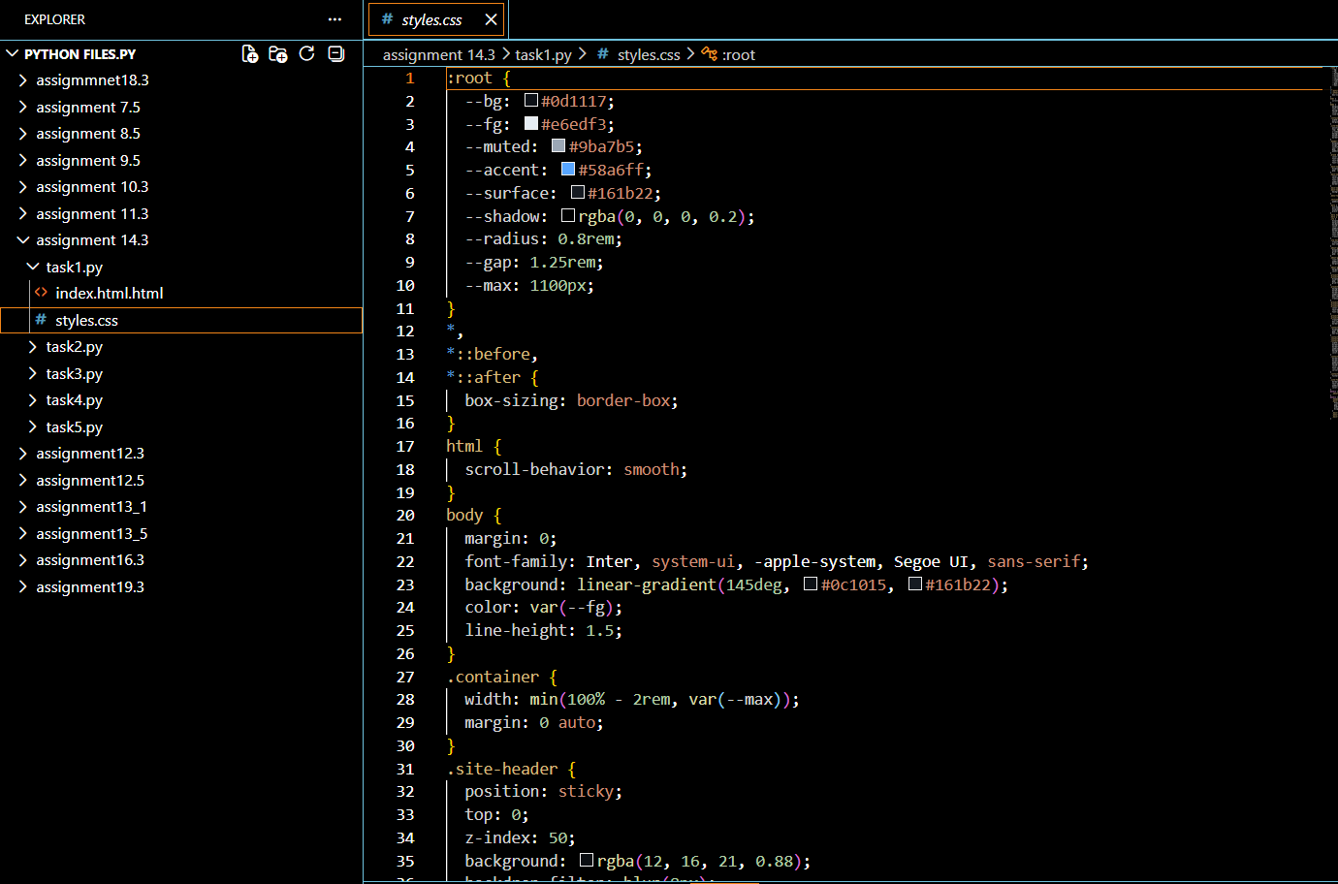
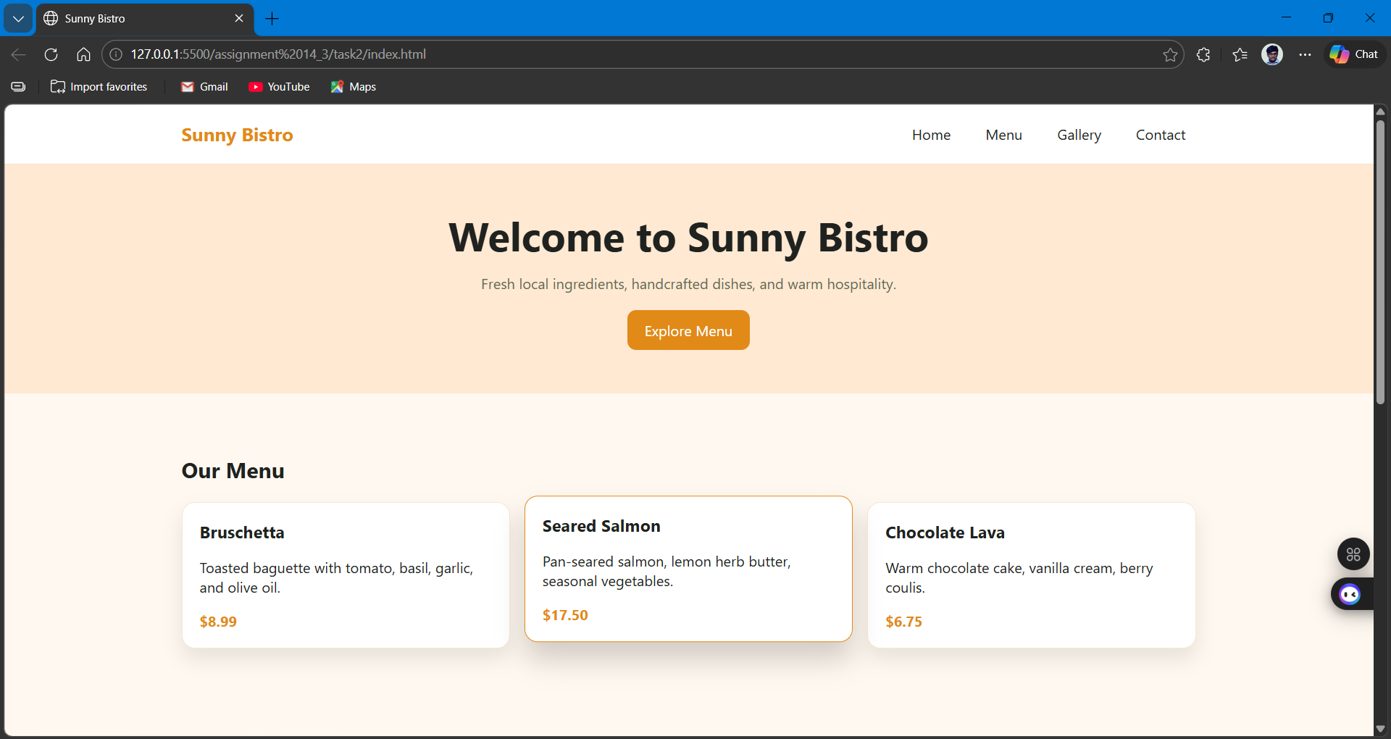
Task 3: AI-Powered Event Registration Form
Scenario
SR University is hosting a technical fest and requires an online registration form
with real-time validation to ensure accurate user input.
Tasks
1. Ask Copilot to generate an HTML form with the following fields:
o Name
o Email
o Phone Number
o Department
o Event Selection
2. Use AI assistance to style the form using CSS for readability and
accessibility.
3. Implement JavaScript validation using Copilot:
o Email format validation
o Phone number length validation
o Required field checks
Expected Outcome
• User-friendly and visually appealing form
• Real-time validation messages
• Prevention of invalid submissions
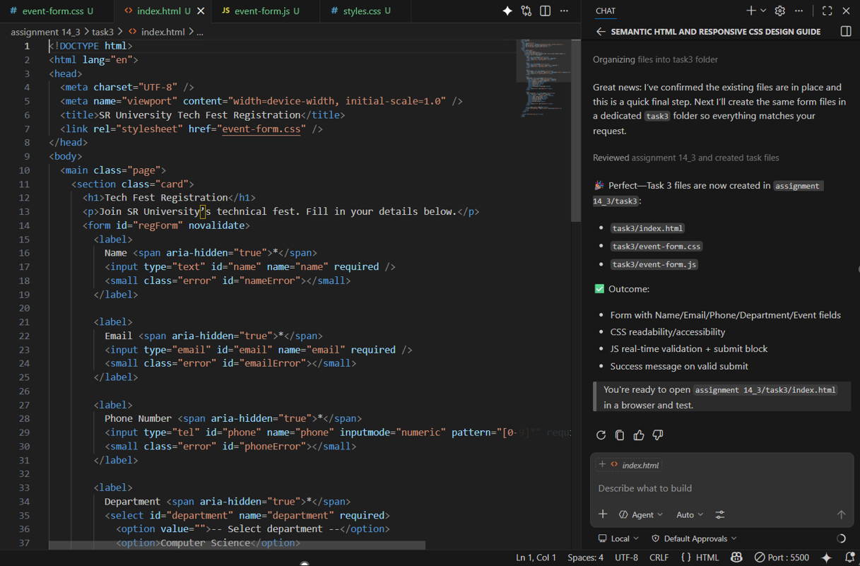

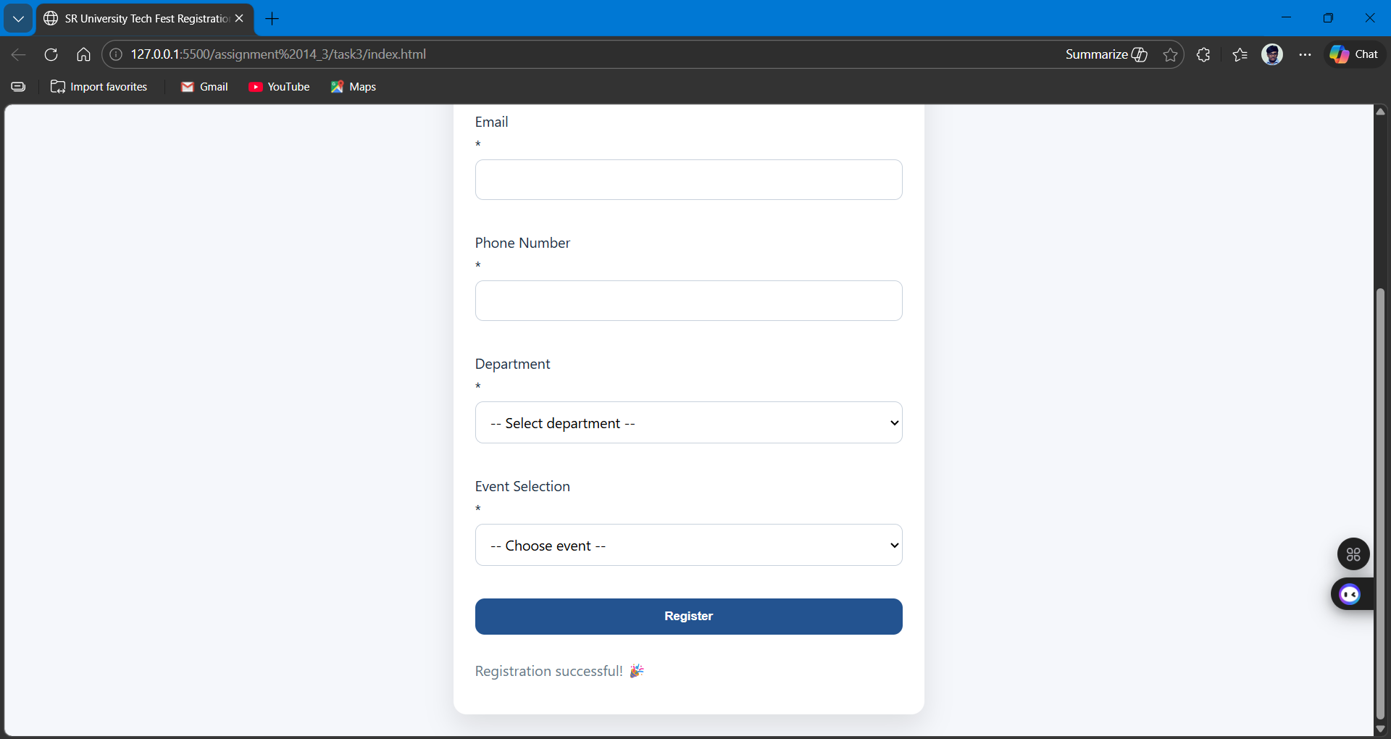

Task 4: AI-Assisted E-Commerce Product Page
Scenario
A startup is developing a basic e-commerce product page to showcase products
and manage simple cart functionality.
Tasks
1. Use Copilot to generate a grid-based product catalog using HTML and
CSS.
2. Implement an “Add to Cart” feature using JavaScript.
3. Modify AI-generated code to include:
o Cart item counter at the top-right corner
o Visual feedback when a product is added
Expected Outcome
• Functional product catalog
• Working cart counter
• Interactive user experience

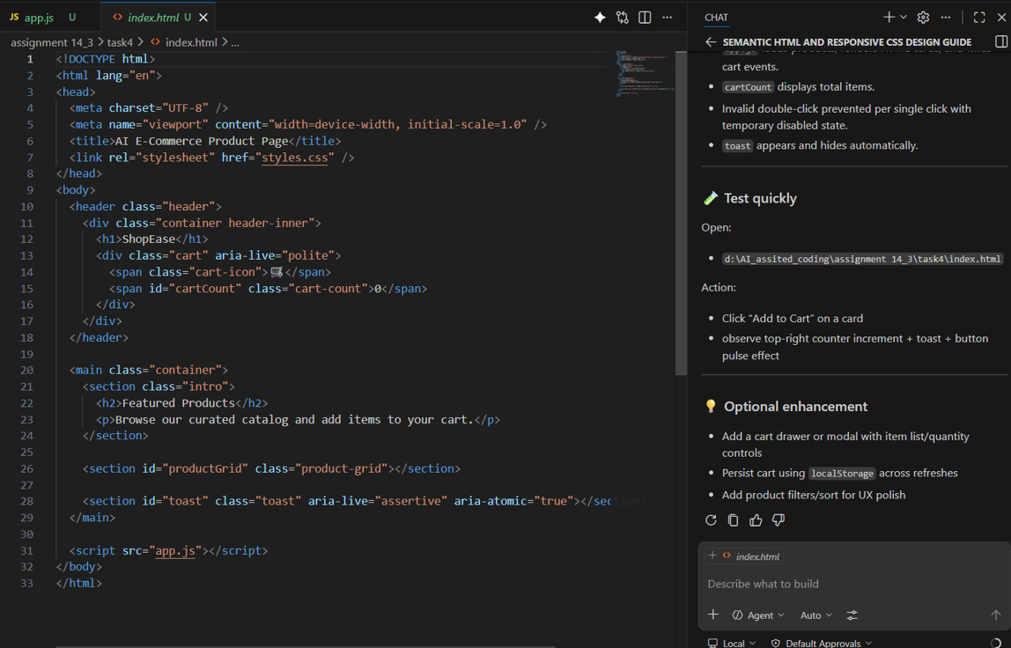
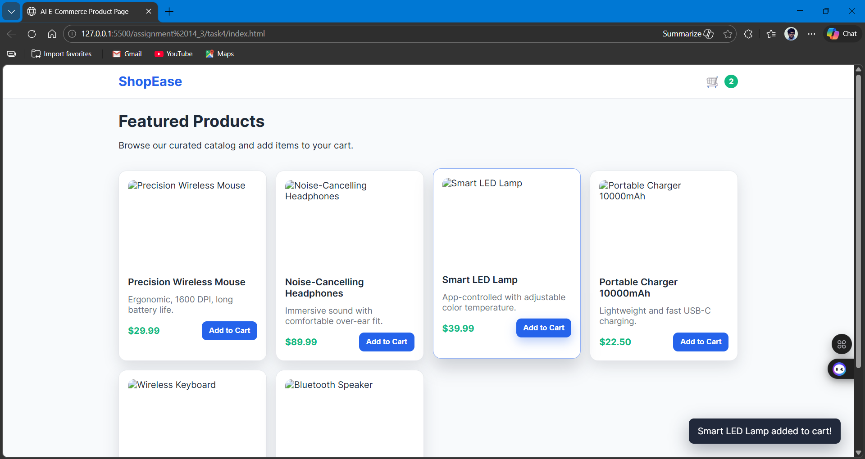

Task 5: Create a Responsive Web Page Layout
Instructions:
• Design a basic web page layout with a header, main content area, and
footer using HTML and CSS.
• Use AI to assist in generating responsive CSS for different screen sizes.
• Ensure the layout is clean and visually organized.
Expected Output:
• A responsive web page with:
• Header with navigation links
• Main section with placeholder text/images
• Footer with copyright or contact info
• Layout adapts correctly to desktop, tablet, and mobile screen sizes. 