AI-Assisted Coding
Assignment 2.5 HTNo:2303A52217
Name:MOHAMMED ABDUL LAYEEQ
Batch:45
Task 1: Refactoring Odd/Even Logic (List Version) ❖ Scenario:
You are improving legacy code.
❖ Task:
Write a program to calculate the sum of odd and even numbers in a list, then refactor it using AI.
❖ Expected Output:
❖ improved code
Output:
+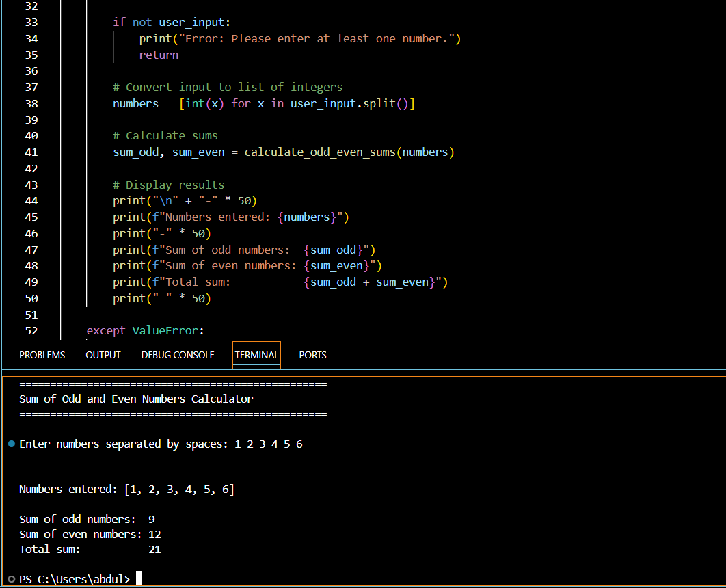

Task 2: Area Calculation Explanation
❖ Scenario:
You are onboarding a junior developer.
❖ Task:
Ask Gemini to explain a function that calculates the area of dierent shapes.
❖ Expected Output:
➢ Code
Output:
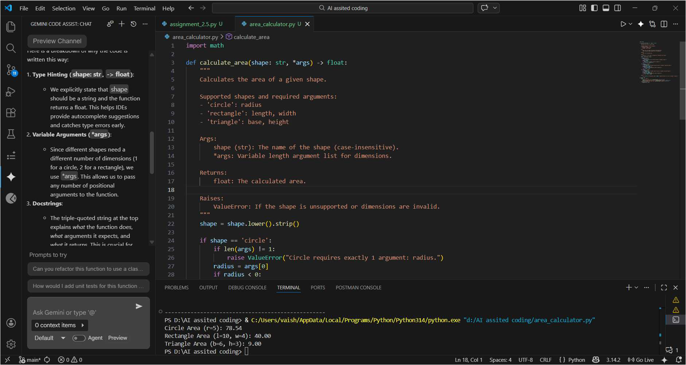
Task 3: Prompt Sensitivity Experiment
❖ Scenario:
You are testing how AI responds to dierent prompts.
❖ Task:
Use Cursor AI with dierent prompts for the same problem and observe code changes.
❖ Expected Output:
➢ Prompt list

➢ Code variations
Prompt:-
=>Calculate the factorial of a number
=> write factorial function in python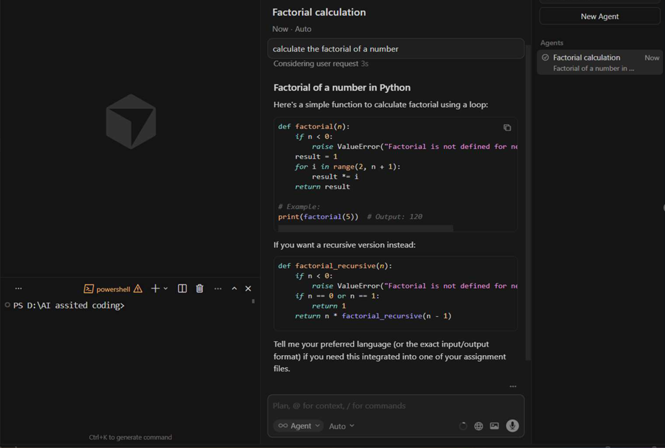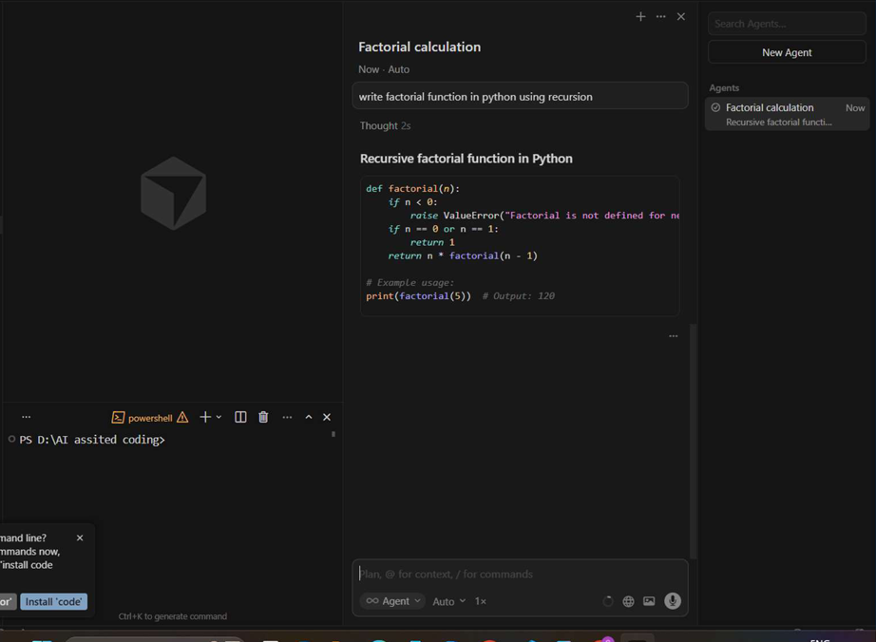 using recursion

