Ai Assisted Coding
Assignment-7.5 Name: MOHAMMED ABDUL LAYEEQ
HT No:2303A2217
Batch:45
Task 1 (Mutable Default Argument – Funcon Bug)
Task: Analyze given code where a mutable default argument causes unexpected behavior. Use AI to fix it.
# Bug: Mutable default argument
def add_item(item, items=[]):
items.append(item)
return items
print(add_item(1))
print(add_item(2))
Expected Output: Corrected funcon avoids shared list bug.
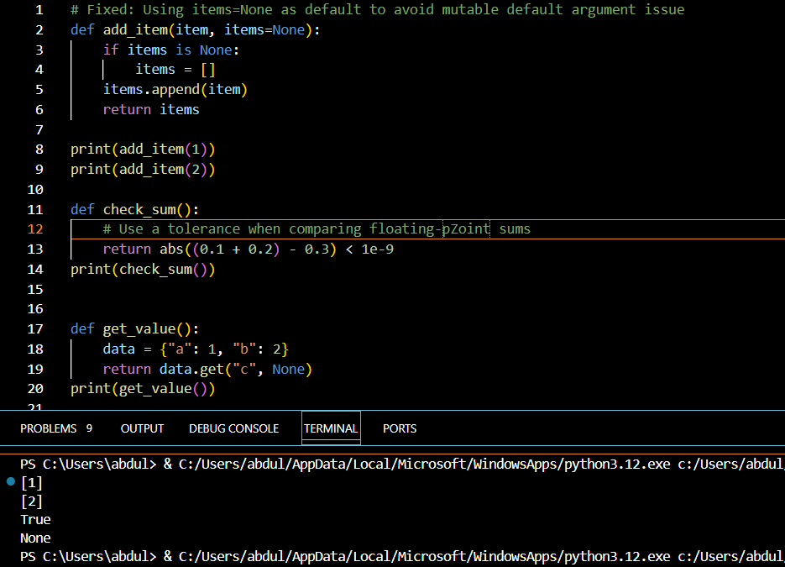

Task 2 (Floang-Point Precision Error)
Task: Analyze given code where floang-point comparison fails. Use AI to correct with tolerance.
# Bug: Floang point precision issue
def check_sum():
return (0.1 + 0.2) == 0.3
print(check_sum())
Expected Output: Corrected funcon
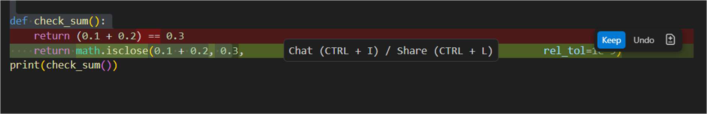
Task 3 (Recursion Error – Missing Base Case)
Task: Analyze given code where recursion runs infinitely due to missing base case. Use AI to fix.
# Bug: No base case
def countdown(n):
print(n)
return countdown(n-1)
countdown(5)
Expected Output : Correct recursion with stopping condion.
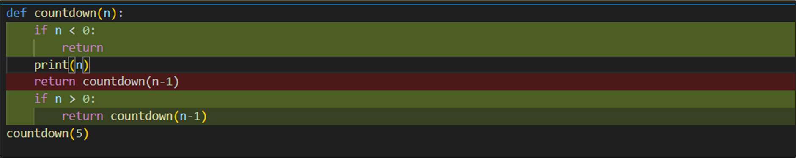
Task 4 (Diconary Key Error)
Task: Analyze given code where a missing diconary key causes error. Use AI to fix it.
# Bug: Accessing non-exisng key

def get_value():
data = {"a": 1, "b": 2}
return data["c"]
print(get_value())
Expected Output: Corrected with .get() or error handling.
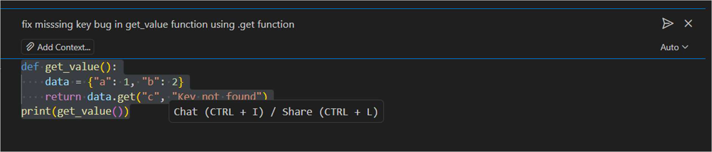
Task 5 (Infinite Loop – Wrong Condion)
Task: Analyze given code where loop never ends. Use AI to detect and fix it.
# Bug: Infinite loop
def loop_example():
i = 0
while i < 5:
print(i)
Expected Output: Corrected loop increments i.
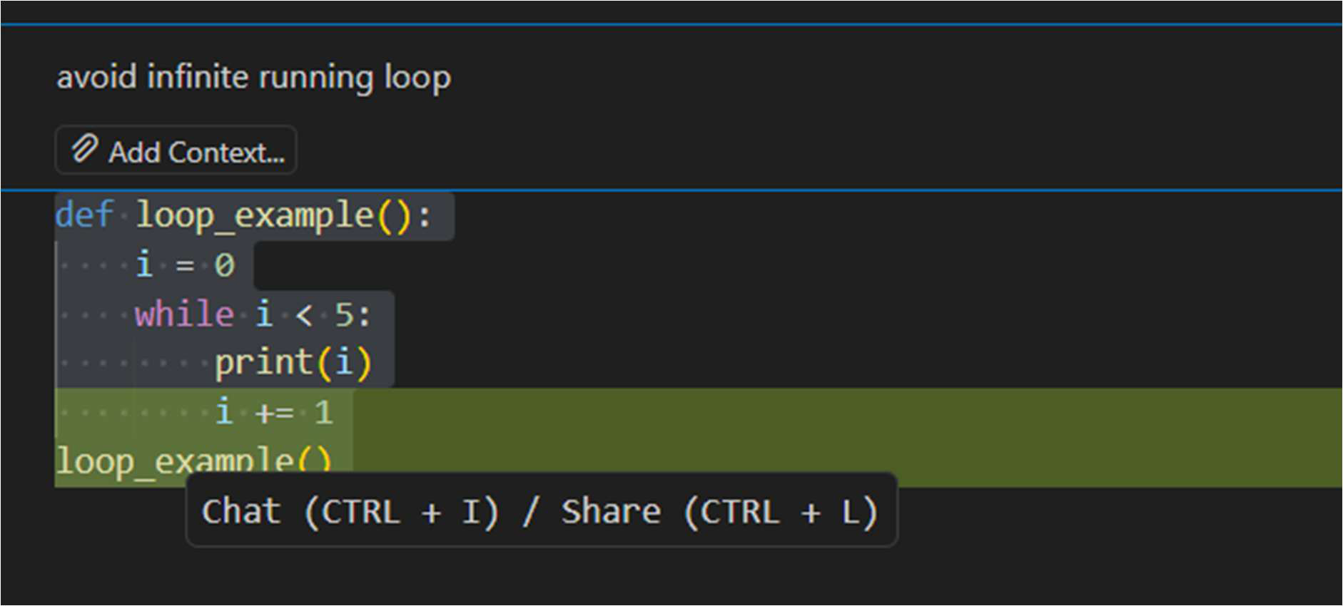
Task 6 (Unpacking Error – Wrong Variables)
Task: Analyze given code where tuple unpacking fails. Use AI to fix it.

# Bug: Wrong unpacking
a, b = (1, 2, 3)
Expected Output: Correct unpacking or using _ for extra values`
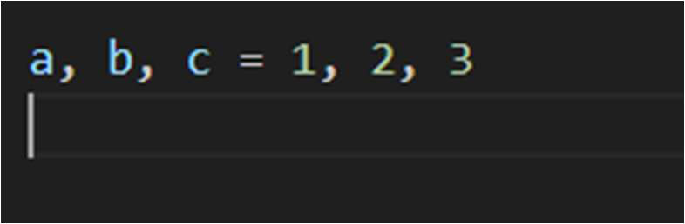
Task 7 (Mixed Indentaon – Tabs vs Spaces)
Task: Analyze given code where mixed indentaon breaks execuon. Use AI to fix it.
# Bug: Mixed indentaon
def func():
x = 5
y = 10
return x+y
Expected Output : Consistent indentaon applied.
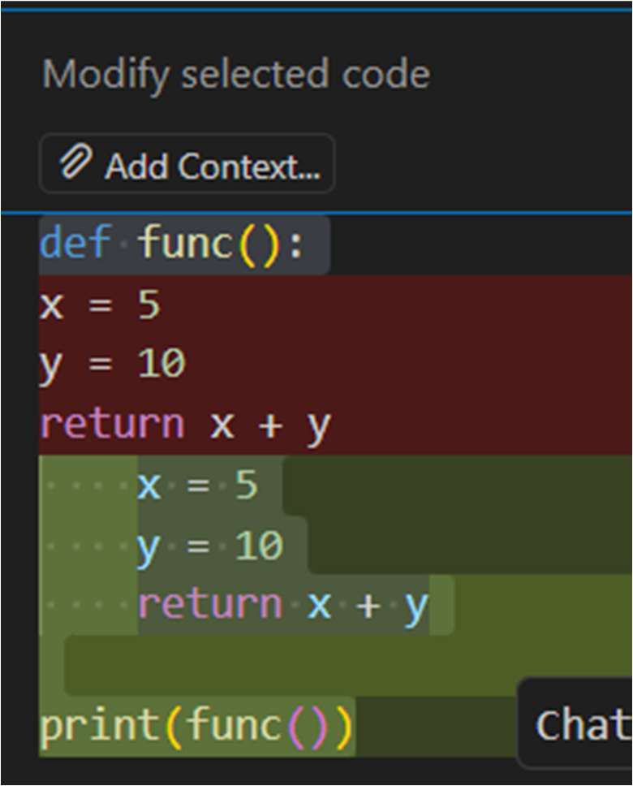
Task: Analyze given code with incorrect import. Use AI to fix.
# Bug: Wrong import
import maths
print(maths.sqrt(16))
Expected Output: Corrected to import math

