AI Assisted Coding Lab 1
Rida Shireen
2303A52224
Batch – 42

Question 1:
Task 1: AI-Generated Logic Without Modularization (Fibonacci Sequence Without Functions)

Prompt:
write a python code for printing fibonacci series upto n terms without using functions
Code:
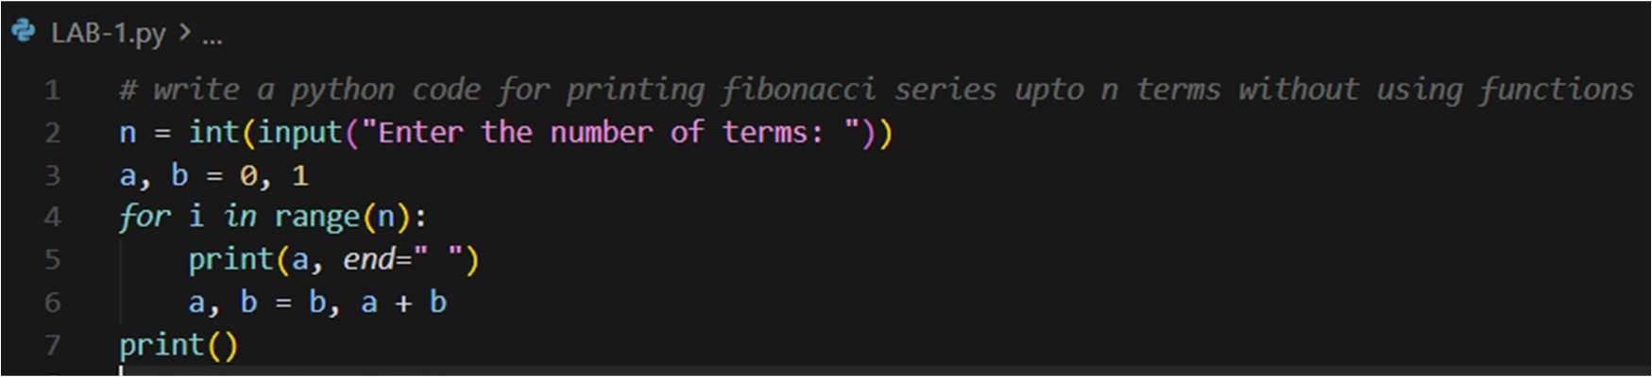
Output:
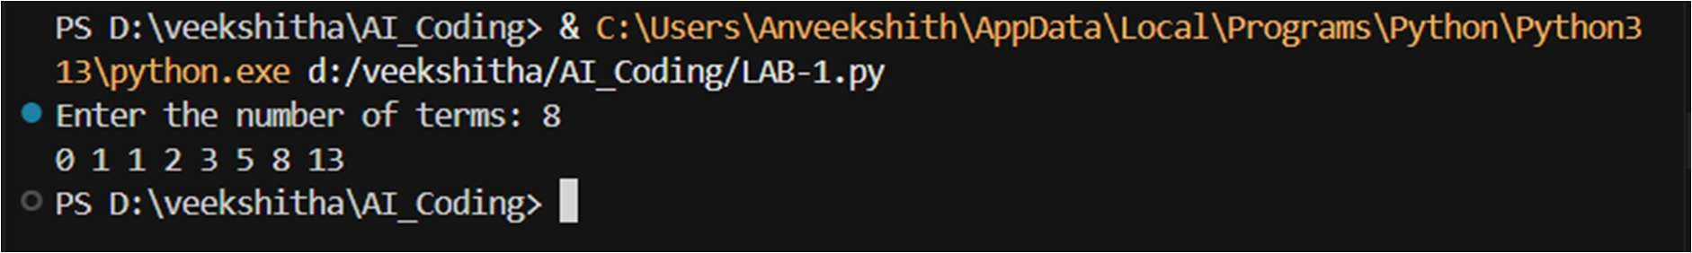
Justification:
This program prints the Fibonacci series upto n terms without using functions. All the logics are written in the main program, which makes it simple to understand. It works correctly for the given input. This approach is useful for small programs or quick testing. But it is a bit hard for larger numbers. The program accepts user input and prints the Fibonacci series upto the nth term.

Question 2:
Task 2: AI Code Optimization & Cleanup (Improving Efficiency)

Prompt:
write a optimized python code for printing fibonacci series up to n terms without using functions

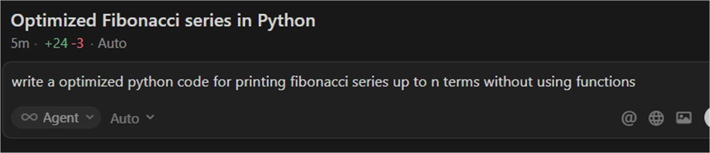
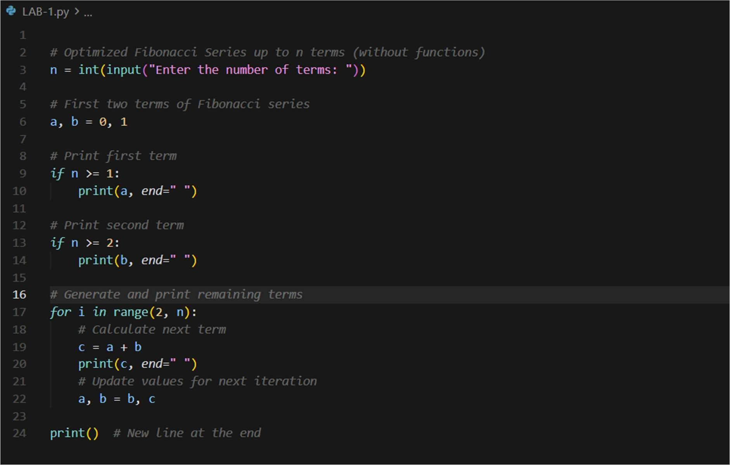
Code:
Output:
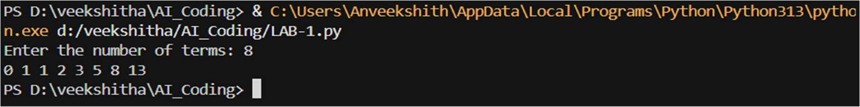
Justification:
This program prints the optimized code of Fibonacci series that removes extra variables and simplifies the logic. Compared to Task 1, it removes the unwanted and extra lines. It uses fewer lines of code and is easier to read. The program runs faster because unnecessary steps are avoided. The output remains correct after optimization. This makes the code more efficient and clean.

Question 3:
Task 3: Modular Design Using AI Assistance (Fibonacci Using Functions)

Prompt:

Write a python code for printing fibonacci series upto n terms and add meaningful comments
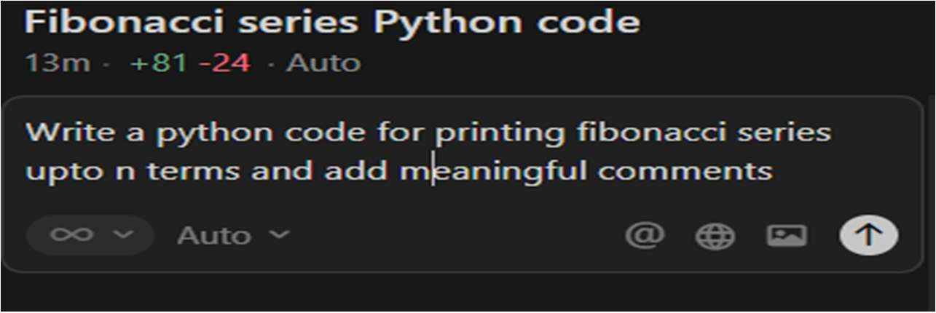
Code:
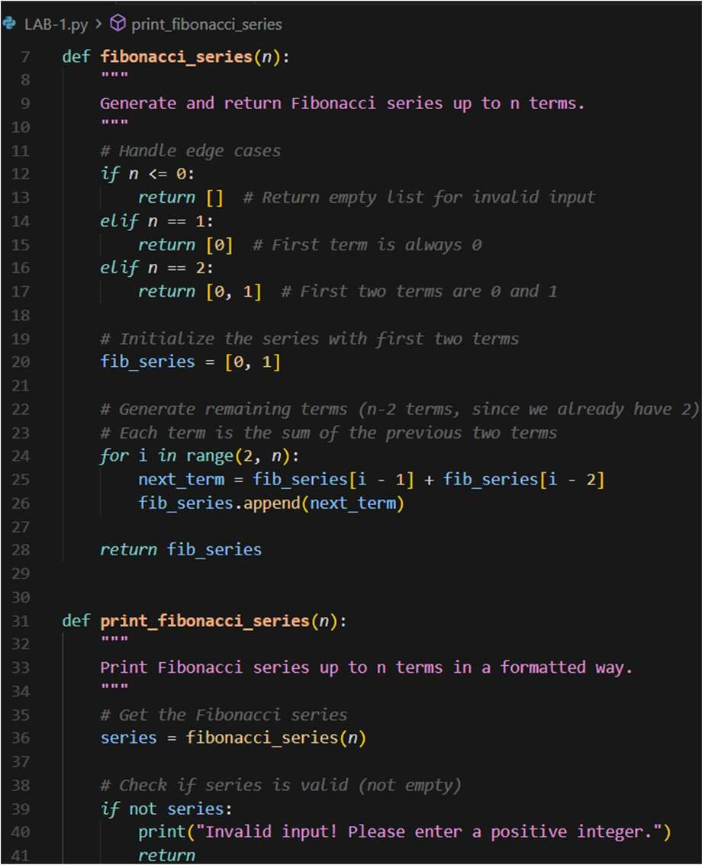
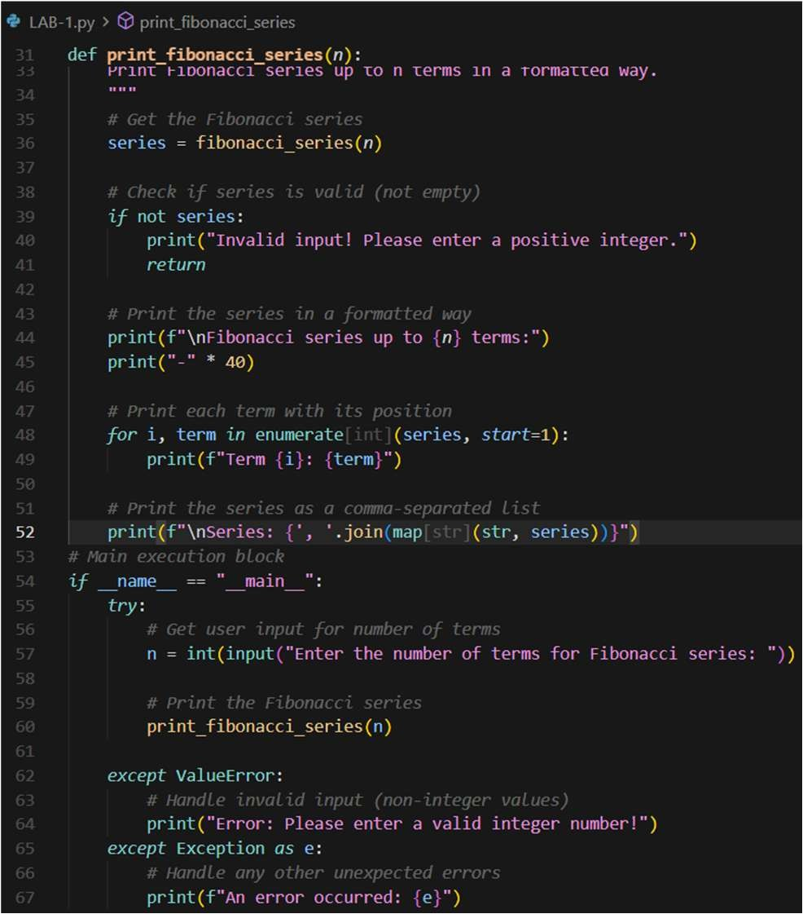

Output:
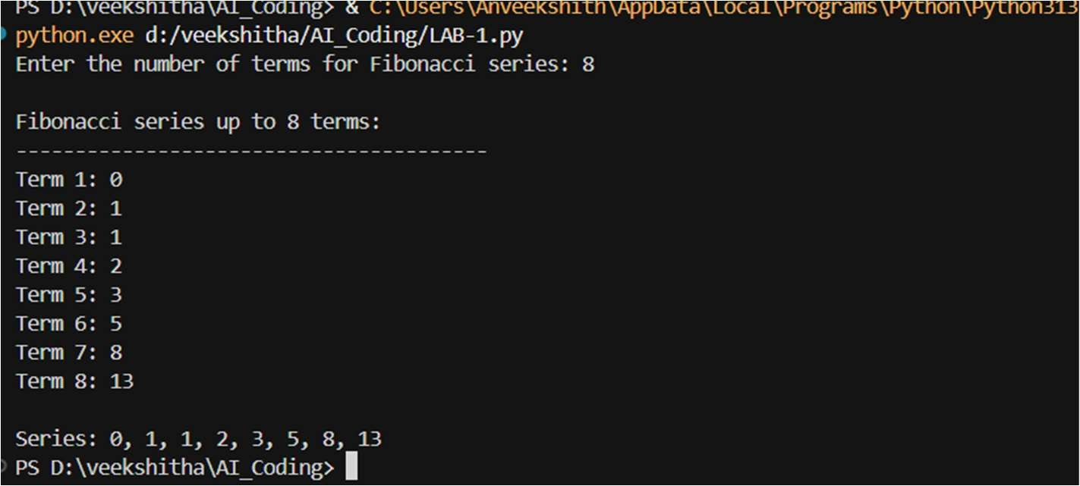

Justifications:
In this task, the program prints the Fibonacci series with meaningful comments. The Fibonacci logic is written inside a user defined function. This makes the program modular and well organized. The function can be reused in different programs. Comments help in understanding the code easily. Debugging becomes simpler due to clear separation of logic. This approach follows good programming practices. It is suitable for large and real world applications.

Question 4
Task 4: Comparative Analysis – Procedural vs Modular Fibonacci Code

Prompt:
Procedular: write a python code for printing fibonacci series upto n terms without using functions
Modular: Write a python code for printing fibonacci series upto n terms and add meaningful comments

Code: Modular:
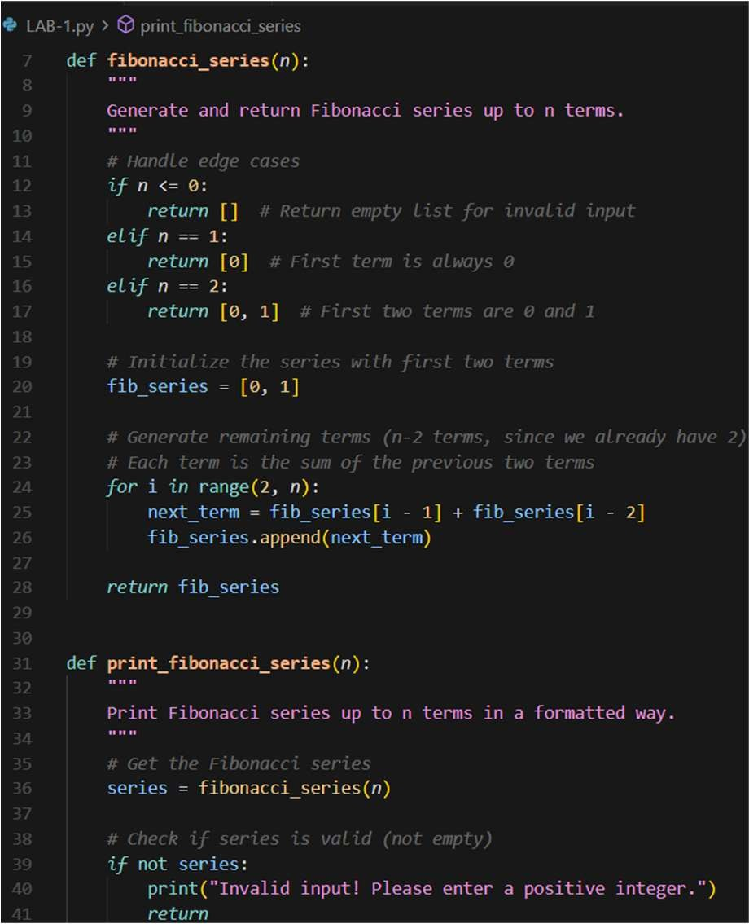
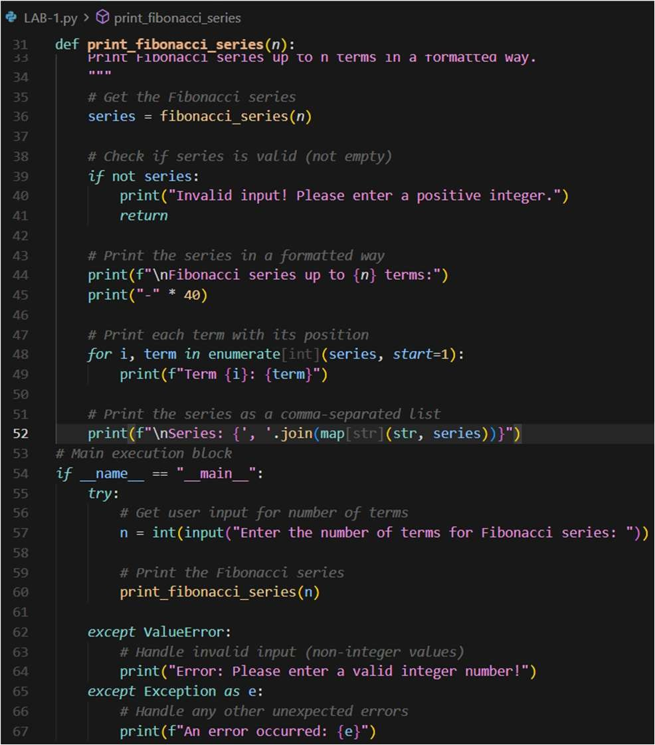

Procedular:
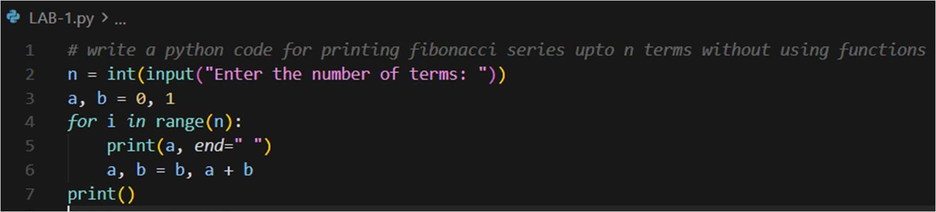

Outputs:
Procedular:
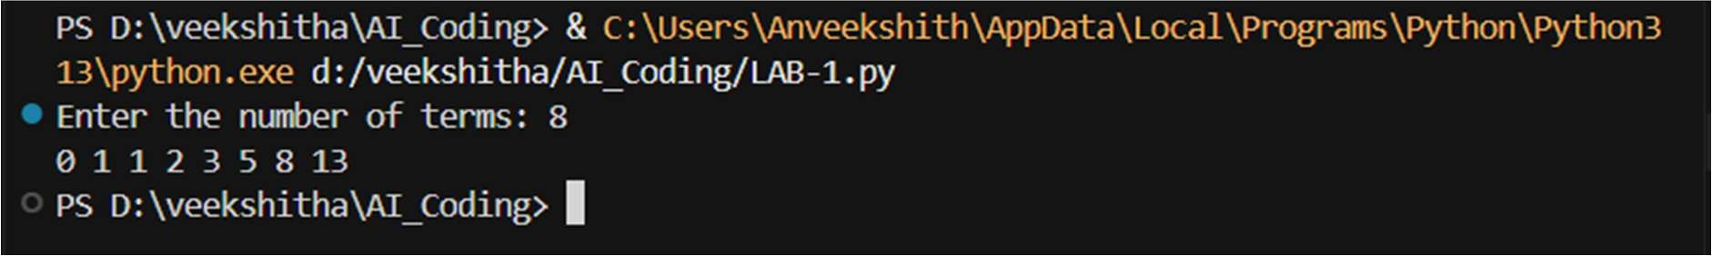
Modular:
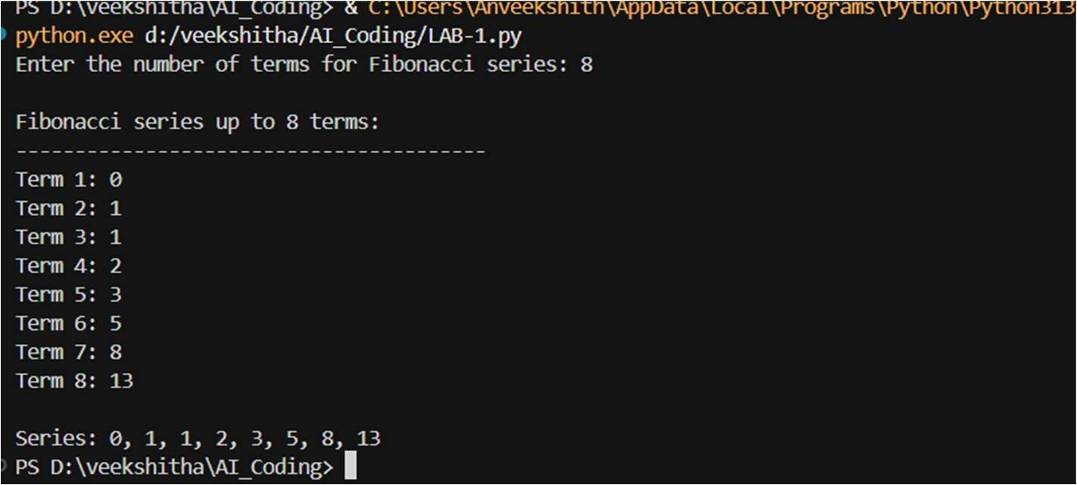

Justification:
In this task, the previous codes are compared(Task1 and Task3). The procedural code is simple but not reusable. All logic is written in one place, making it less organized. The modular code separates logic using functions. Modular code is easier to read and understand. Debugging is simpler in modular programs. It supports reuse and scalability. Therefore, modular code is better for large systems.

Question 5:
Task 5: AI-Generated Iterative vs Recursive Fibonacci Approaches (Different Algorithmic Approaches for Fibonacci Series)

Prompts:
Iterative Approach: write a python code for printing fibonacci series upto n terms using iterative approach

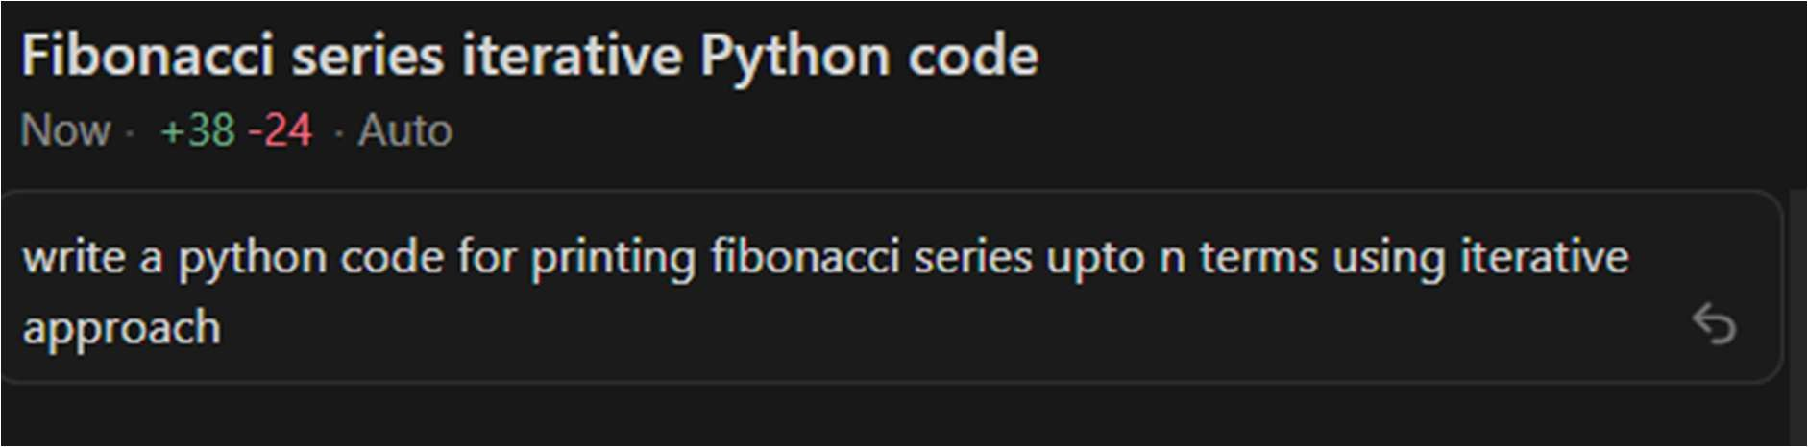
Recursive Approach: write a python code for printing fibonacci series upto n terms using recursion
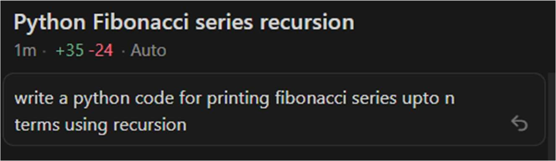

Codes:
Iterative Approach: Recursive Approach:
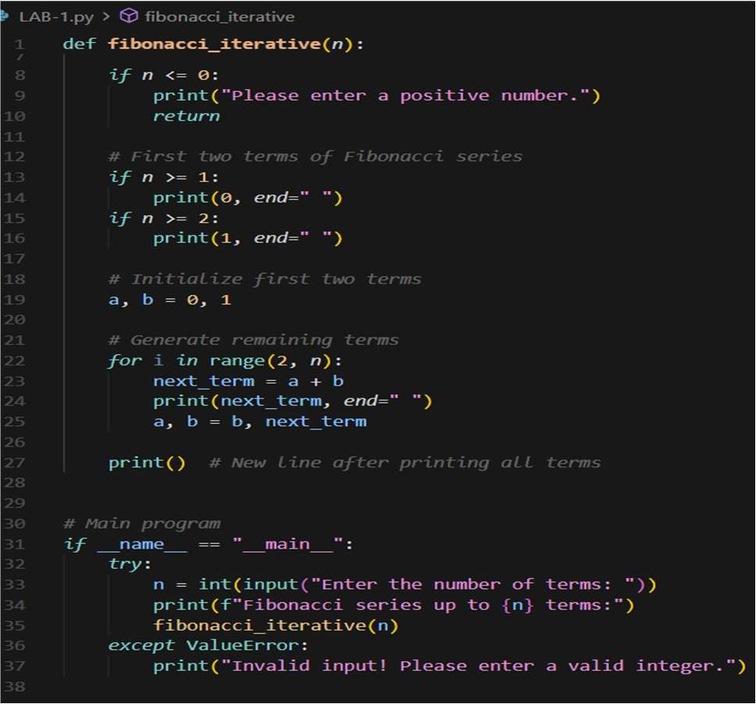
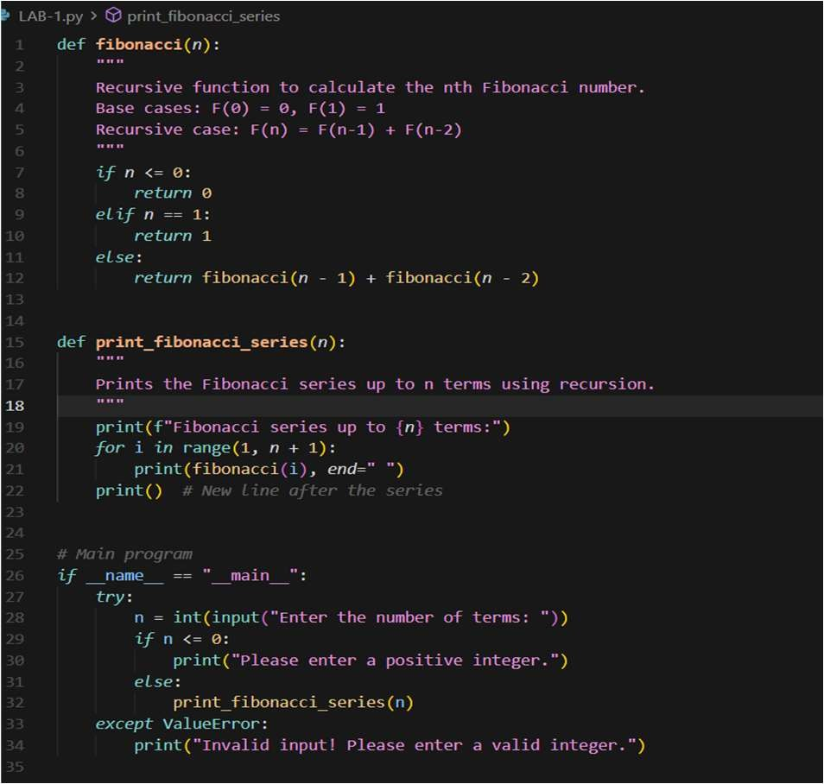

Outputs:
Iterative Approach:
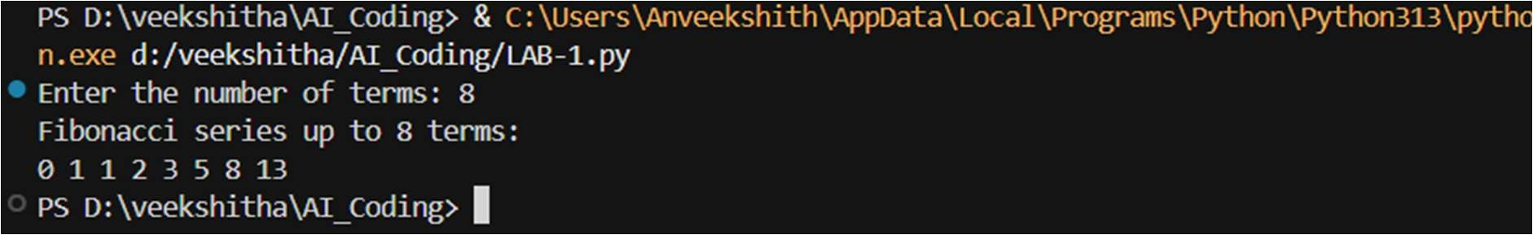

Recursive Approach:
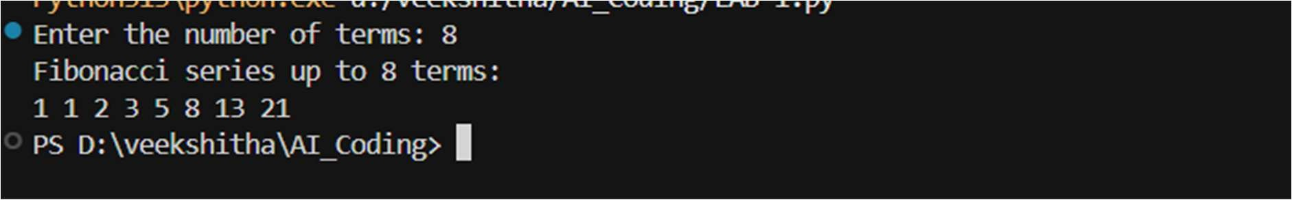

Justification:
The program prints the code by two approaches, Iterative and Recursive. The iterative approach uses a loop to generate Fibonacci numbers. It runs faster and uses less memory. This approach works well for large values of n. The recursive approach uses function calls repeatedly. It takes more time due to repeated calculations. It also uses more memory because of the call stack. Recursion should be avoided for large inputs.

