Name : S Naveen Yadav

Hall Ticket No: 2303A52230

Batch No : 42

Task 1 – Problem Identification & AI-Assisted Ideation Task:
Identify and refine a real-world problem using AI.
Prompt:
Suggest 3 real-world civic problems that can be digitized such as complaint systems, parking, or waste management.

Refine the selected problem into a clear problem statement and generate key features, target users, and expected impact. Output:
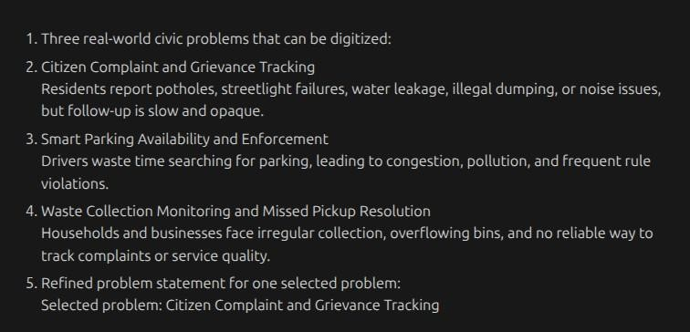

Selected problem

1. Citizen Complaint and Grievance Tracking
Residents report potholes, streetlight failures, water leakage, illegal dumping, or noise issues, but follow-up is slow and opaque.

Refined Problem Statement
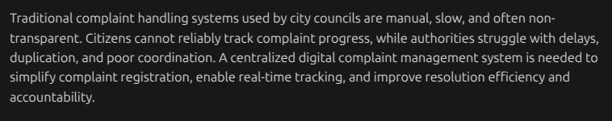

Target Users
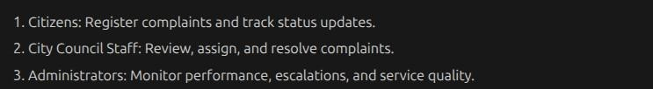

Key Features

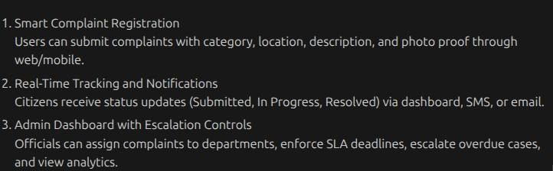
Task 2 – System Planning & Architecture Design Task:
Design the system architecture with AI support.

Prompt used
Design a system architecture for a digital complaint management system. Include frontend, backend, database, data flow, API design, and database schema.

System Components
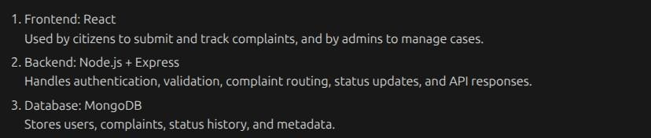

Architecture Description
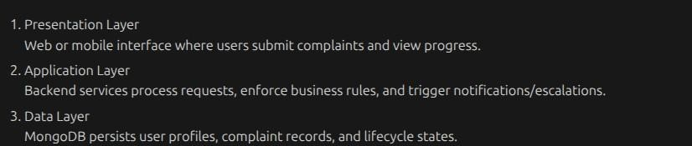

Data Flow

Flow Explanation:
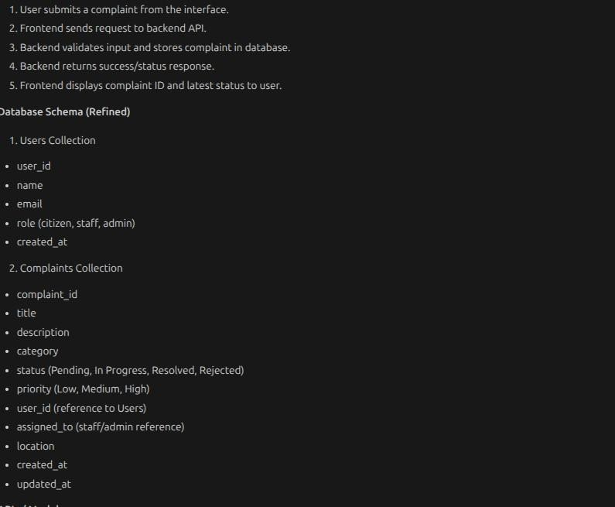
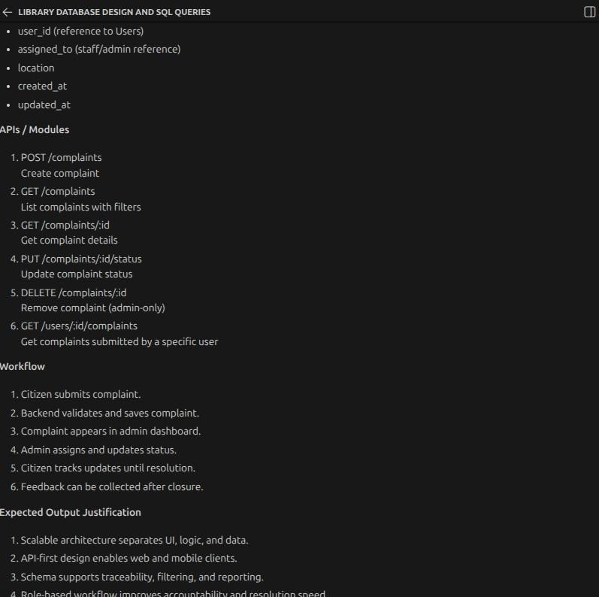

Task 3 – Modular Code Development with AI
Task:
Develop core modules of the application using AI.
Prompt:
Generate modular JavaScript code for a complaint management system including input handling, core logic, and data storage. Include validation, error handling, and clean function-based structure.

Code
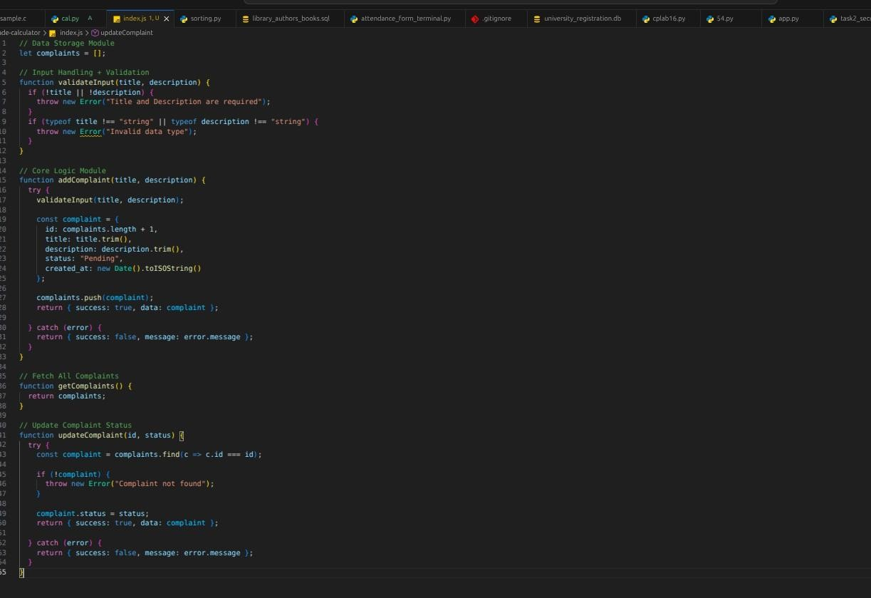

Input1
Output1:
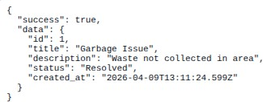

Input2
Output2:
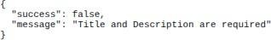

Input3:
Output3:

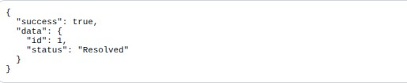
Task 4 – AI-Assisted Testing, Debugging & Optimization Task:
Validate and improve your application.

Prompt used
Generate test cases, identify bugs, and suggest optimizations for a JavaScript complaint management system with input validation and in-memory storage. Test Case 1 – Valid Input
Output1

Test case 2-Empty input

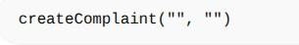
Output2:
Test Case 3 – Invalid Update

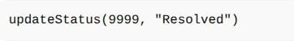
Output3:

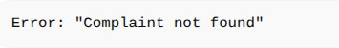

Bugs Identified
No persistent storage (data lost after refresh)
ID generation using Date.now() may conflict in rare cases
No validation for status values

Fixes & Improvements
Added status validation
Improved ID generation logic
Structured error handling

Optimized Code (Improved Version)
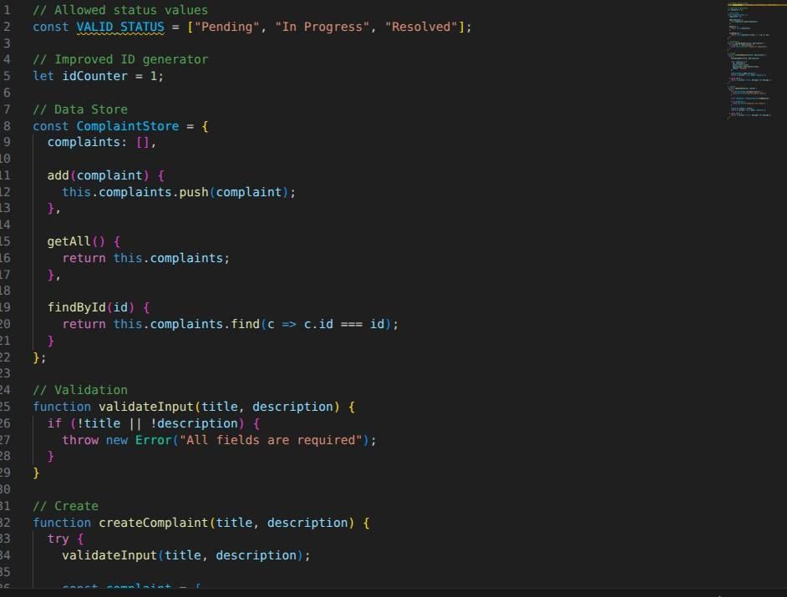
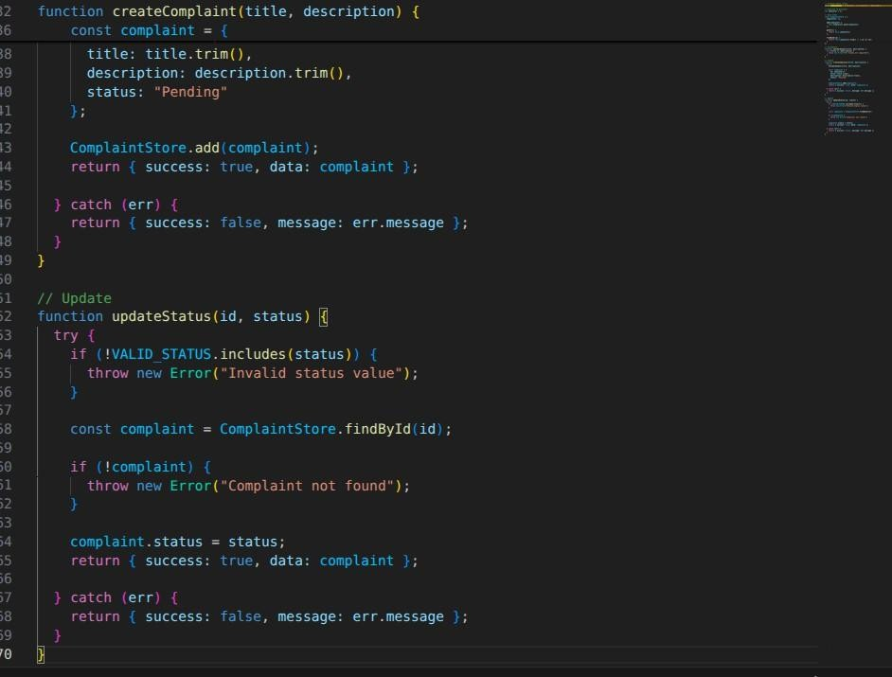

Task 5 – Documentation, Version Control & Reflection Task:
Prepare the project for submission and collaboration.
Prompt used :
Generate a README file, add code comments, suggest Git commit messages, and write a reflection for a complaint management system project.

README (ai generated)
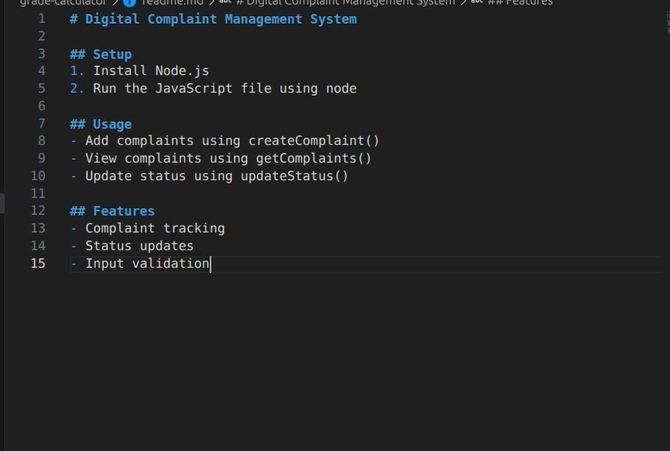

Code Documentation
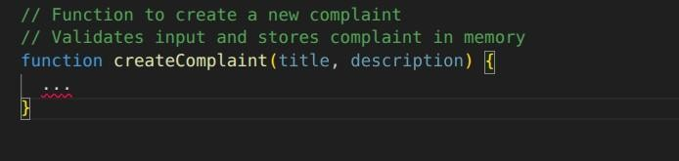

Sample Commit Messages
Initial project setup
Added complaint creation module
Implemented input validation
Fixed status update bug
Optimized code structure
Reflection Report

->how ai helped
Generated initial code quickly
Assisted in debugging and testing
Helped design system architecture

->LImitation faced
Generated initial code quickly
Assisted in debugging and testing
Helped design system architecture

->Improvements Possible
Add database (MongoDB)
Build frontend UI
Deploy as full-stack app
Add authentication system

