Assignment – 01
Batch:42
Salupala Naveen Yadav
2303A52230
Task:1
Prompt: Write a code for printing fibonacci series up to n terms with out using the functions

Code:

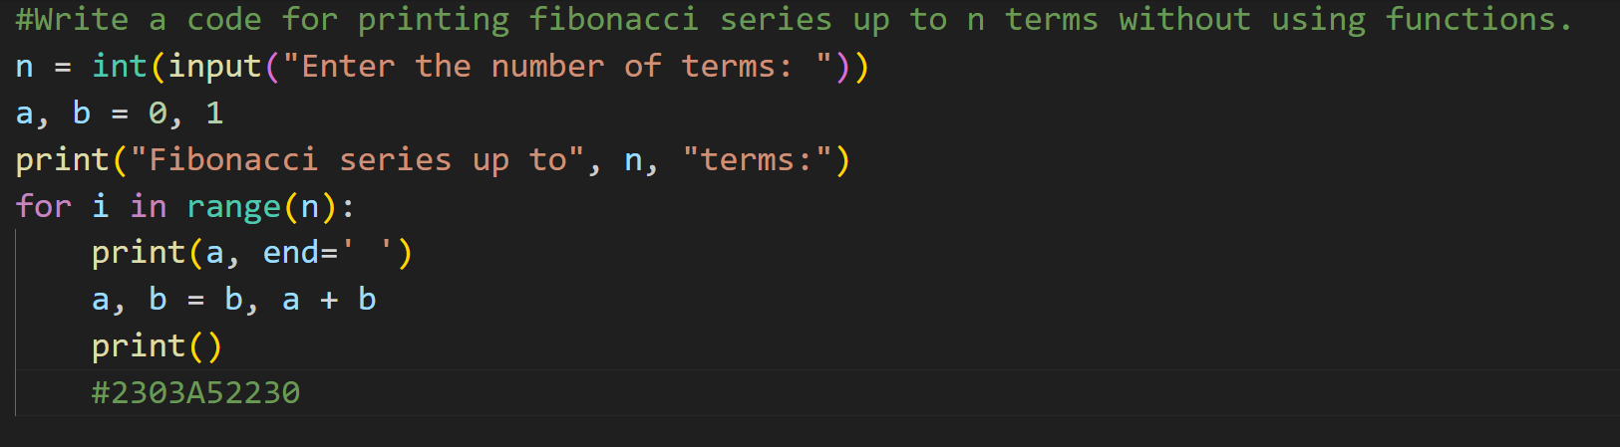

Output:

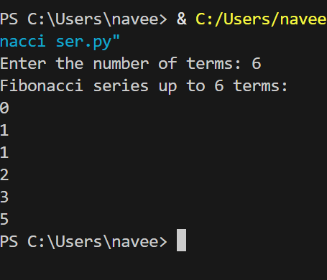

Justification:
By completing this task, we have printed the required Fibonacci series up to n terms without using modularization. The logic is written directly in the main program without defining any user-defined functions. The program accepts user input for the number of terms and generates the Fibonacci sequence using a single for loop.

Task:2 AI Code Optimization & Cleanup (Improving Efficiency)

PROMPT: Optimize version of Fibonacci series up to n terms without using functions

Code:
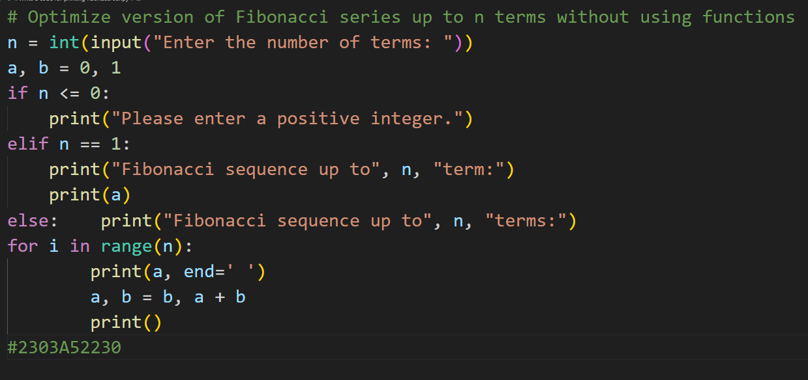

Output:
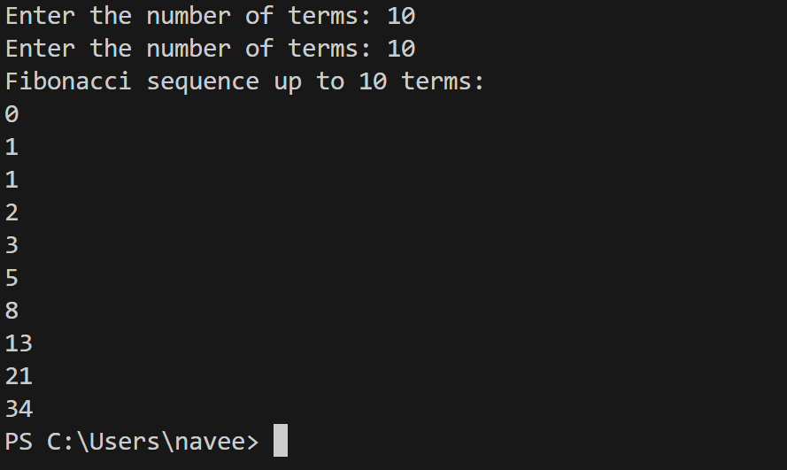
Justification: Here is a very short justification you can write:
Justification:
This optimized Fibonacci code improves efficiency by avoiding recursive calls and unnecessary computations. It uses an iterative approach with minimal variables, reducing time complexity and memory usage while generating the series up to n terms.

Task 3:Modular Design Using AI Assistance (Fibonacci Using Functions)

PROMPT: Optimize version of Fibonacci series up to n terms with using functions

Code:

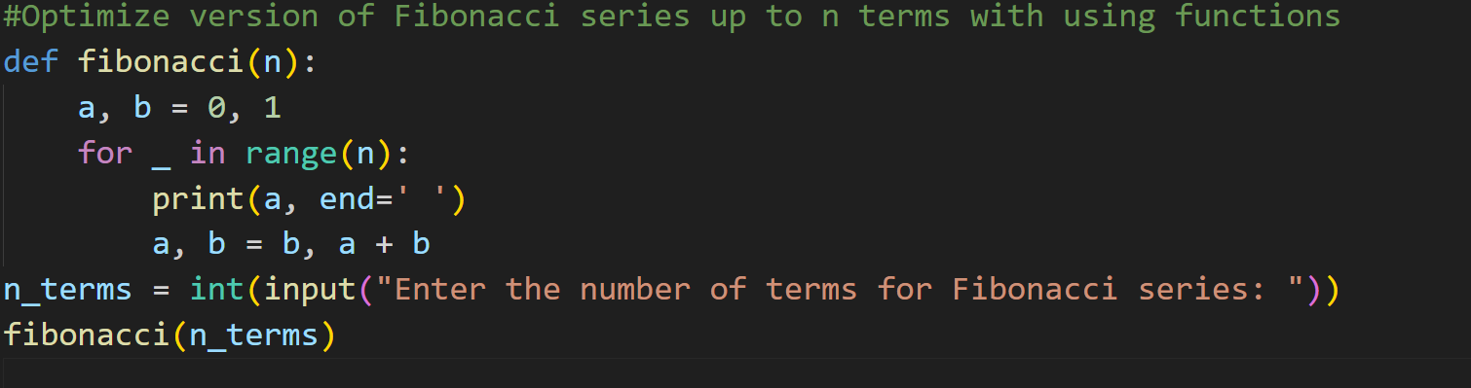

Output:
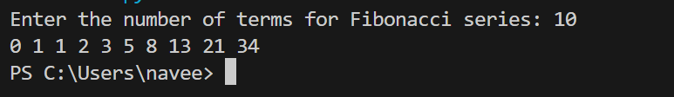

Justification:
By this task , we are able to find the difference between Procedural(without using functions) and Modular(with using functions). The main use of function is • Reusability of the code • Easy to Debug • Code Clarity • Suitable for large systems By observing, we can analyze that using modular method is a better and clean approach.

Task4: Comparative Analysis – Procedural vs Modular Fibonacci Code

PROMPT: Procedural: Write a code for printing fibonacci series up to n terms without using functions Modular: Optimized version of Fibonacci series up to n terms using functions

Code:

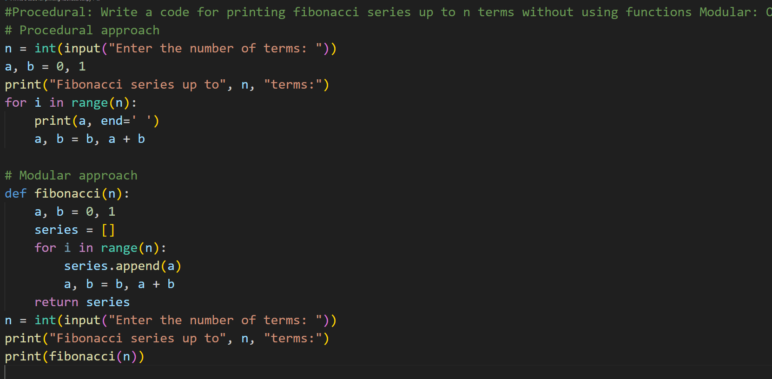

Output:

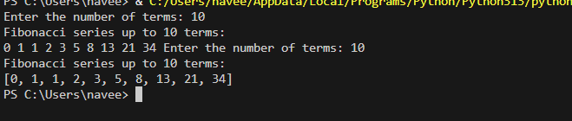
Justification:
By this task , we are able to find the difference between Procedural(without using functions) and Modular(with using functions). The main use of function is • Reusability of the code • Easy to Debug • Code Clarity • Suitable for large systems By observing, we can analyze that using modular method is a better and clean approach.

Task 5: AI-Generated Iterative vs Recursive Fibonacci Approaches (Different Algorithmic Approaches for Fibonacci Series)

PROMPT: Iterative approach: write a code fibonacci series up to n terms using iterative approach Recursive approach : write a code fibonacci series up to n terms using recursive approach

Code:

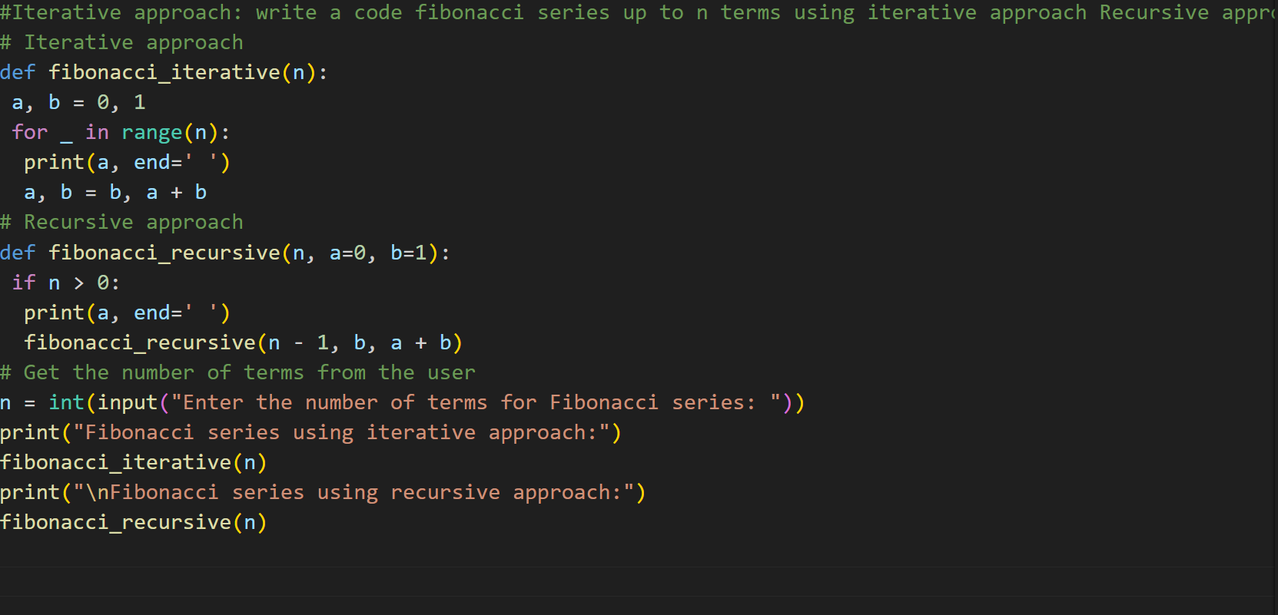

Output:

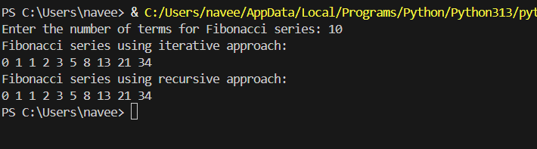

Justification:
Using a loop (iterative method) to find Fibonacci numbers is usually better because it’s faster,
uses less memory, and can handle big numbers easily. The recursive method (using functions
that call themselves) is slower, uses more memory, and can crash if the number is too large.
That’s why in real programs, loops are preferred over recursion.

