AI Assistant lab-21.3

Name : S .Naveen Yadav
Rollno : 2303A52230
Batch : 42

TASK 1 – AI-Assisted Expense Tracker

Initial prompt:
Create a simple Python expense tracker to store daily expenses with category and amount. Initial code:
expenses = []
while True:
name = input("Enter expense name: ") amount = float(input("Enter amount: ")) category = input("Enter category: ")
expenses.append((name, amount, category))
choice = input("Add more? (y/n): ") if choice == 'n':
break
print("Expenses:", expenses)

Output:
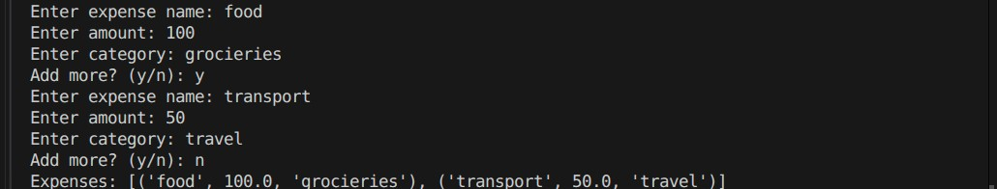
Improvement prompt:
Improve the expense tracker with monthly summary, input validation, and functions.
Improved code
def add_expense(expenses):
name = input("Enter expense name: ")
while True: try:
amount = float(input("Enter amount: ")) break except:
print("Invalid amount")
category = input("Enter category: ") expenses.append({"name": name, "amount": amount, "category": category})
def show_summary(expenses):
total = sum(e["amount"] for e in expenses) print("Total Monthly Expense:", total)

expenses = []
while True:
add_expense(expenses) choice = input("Add more? (y/n): ") if choice == 'n':
break
show_summary(expenses)
Output:
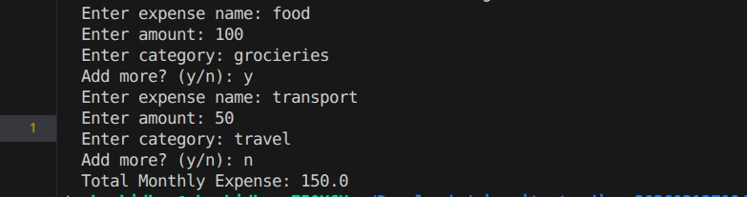

Justification
- Functions → modular design
- Validation → avoids runtime errors
- Summary → real-world usability

TASK 2 – Git Version Control (Student Grade Calculator)

Initialize Repo,Initial Code,Create Branch
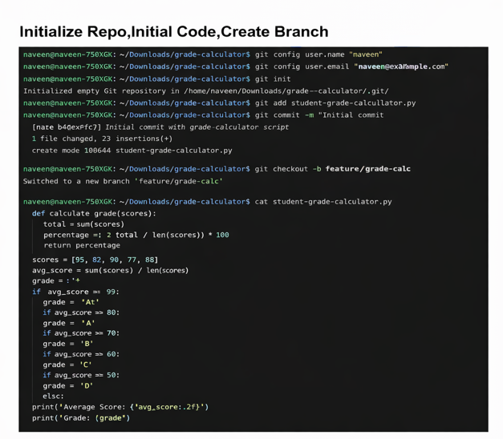

Ai prompt
Add grade classification and percentage calculation to the program.
Updated
marks = list(map(int, input("Enter marks: ").split()))
total = sum(marks) avg = total / len(marks) percentage = (total / (len(marks)*100)) * 100
if avg >= 90: grade = 'A' elif avg >= 75: grade = 'B' elif avg >= 50: grade = 'C' else:
grade = 'F'
print("Average:", avg) print("Percentage:", percentage) print("Grade:", grade)

Commit + Merge
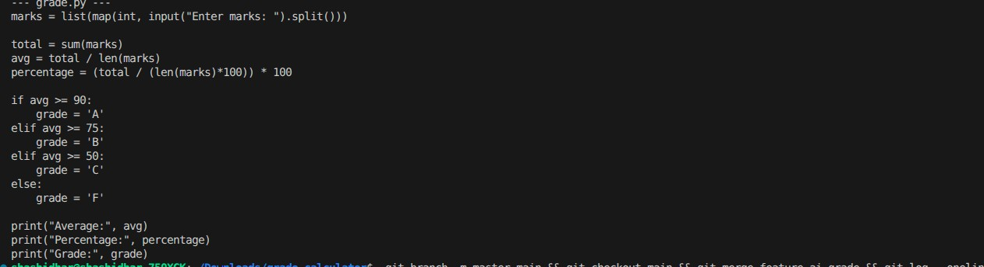

Justification
- Branching → safe feature development
- Merge → integration workflow
- AI → faster feature addition
TASK 3 – AI Commit Messages (Password
Validation)
Setup code
import re
password = input("Enter password: ")
if len(password) < 8:
print("Weak password") elif not re.search(r'[!@#$%^&*]', password):
print("Add special character") else:
print("Strong password")
Prompt
Generate commit message for adding password validation with length and special character rules.
AI Commit Message
Human Version
Added strong password validation rules

Justification
- AI → more structured (uses “feat:” convention)
- Human → less descriptive
TASK 4 – Quiz Management System (Pair Programming)

Student A Code
questions = {
"Capital of India?": "Delhi",
"2+2?": "4"
} for q in questions:
ans = input(q + " ") if ans == questions[q]: print("Correct") else:
print("Wrong")
AI Prompt (Student B)
Add score calculation and input validation to quiz program.
Final code
questions = {
"Capital of India?": "Delhi",
"2+2?": "4"
} score = 0
for q in questions:
ans = input(q + " ").strip()
if ans.lower() == questions[q].lower():
print("Correct") score += 1 else:
print("Wrong")
print("Final Score:", score)

Git Workflow

Output:

Justification
- Score → measurable output
- Validation → better UX
- Collaboration → real Git workflow

