Assignment:6.4
Batch:42
Roll no:2303A52230
Name: Salupala Naveen Yadav.

Task1: Student Performance Evaluation System

Prompt:
Create a program that stores multiple students' marks, asks the user for a roll number, checks if it exists, and calculates both student and class averages. Compare the student’s average with the class average and display Above Average, Below Average, or Average accordingly. If the roll number is not found, show ‘rollnumber not found’, and allow checking multiple students until the user chooses to stop, then print ‘program ended

Code:
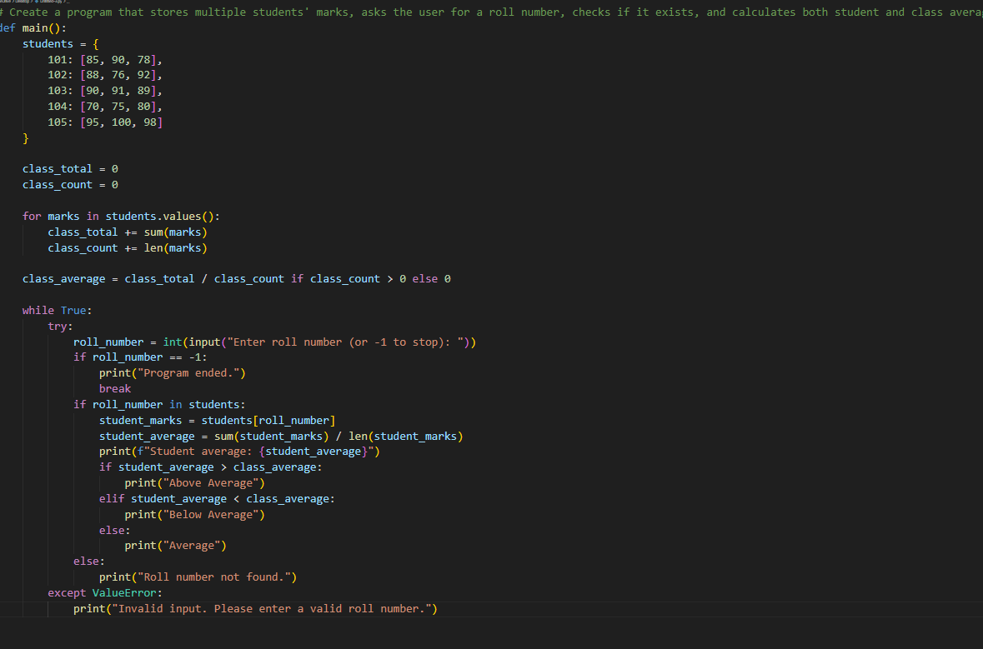

Output:

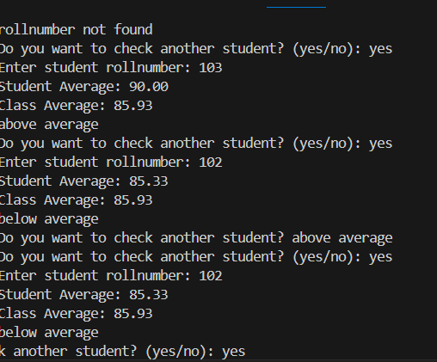

Justification:
This program demonstrates the use of data structures, loops, and conditional statements to manage student records and perform average calculations. It applies comparison logic and user interaction to analyze academic performance efficiently

Task2: Data Processing in a Monitoring System

Prompt:
Write a for loop to iterate over a list of sensor readings . Identify even numbers using modulus operator . Calculate the square of even numbers and print in readable format

Code:
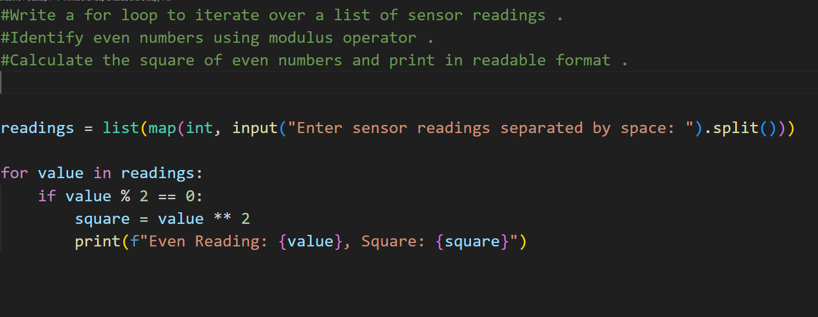

Output:
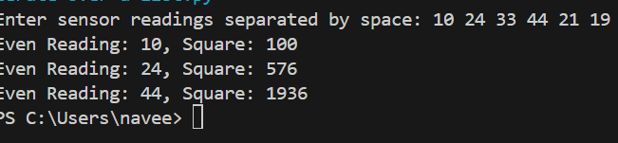

Justification:
This task shows how looping structures and conditional checks are used to analyze sensor readings systematically. AI-generated code reduces manual effort in writing repetitive logic for filtering values and performing calculations, ensuring faster development and accurate data processing.

Task3: Banking Transaction Simulation

Prompt:
Create a class BankAccount with attributes account_holder and balance . Add a method to deposit money into the account . Add a method to withdraw money with balance validation . Prevent withdrawals when balance is insufficient .

Code:
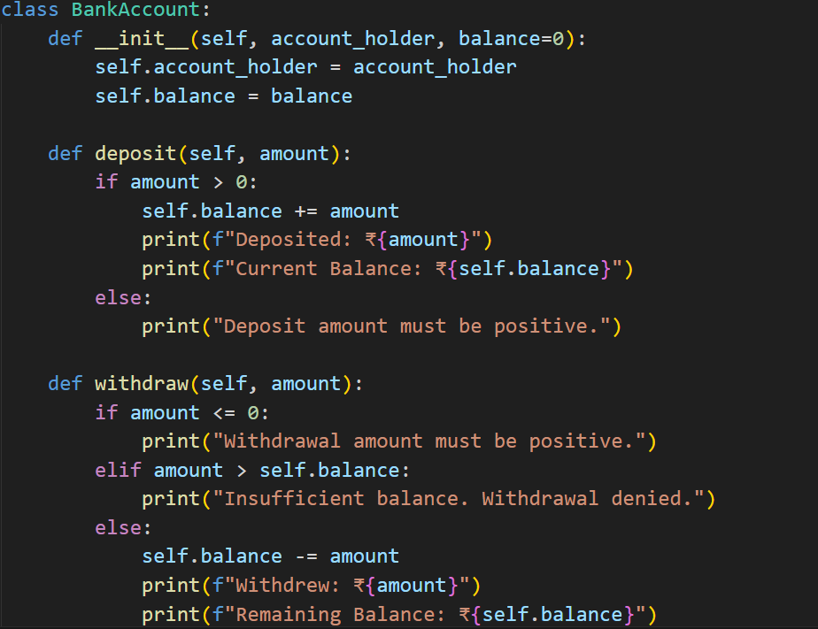

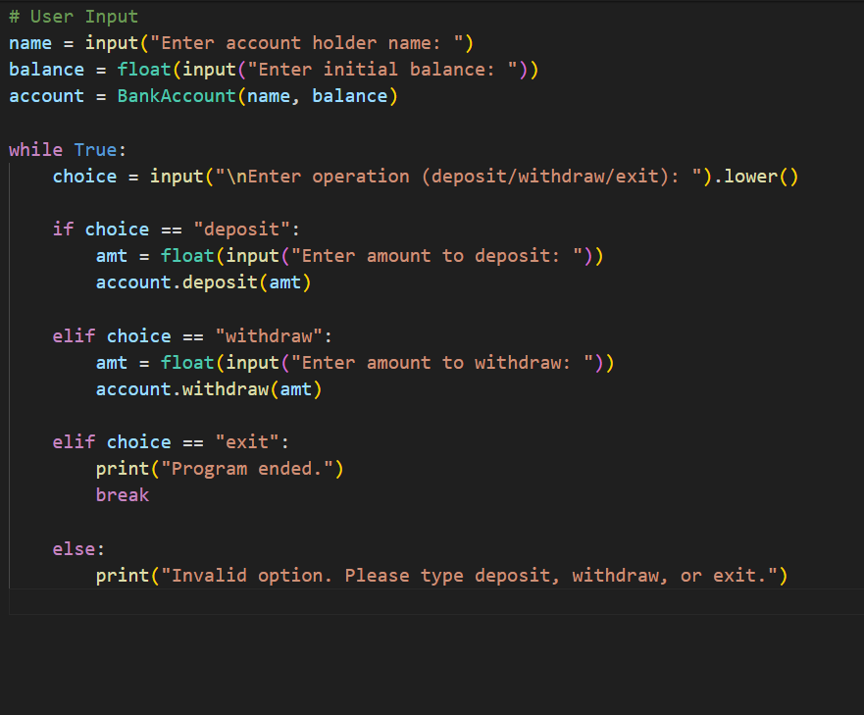

Output:

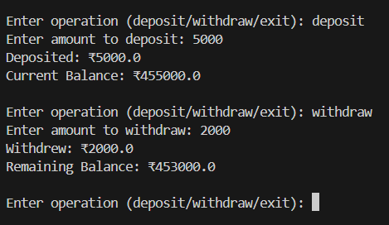

Justification:
This task represents real-world banking operations by implementing secure deposit and withdrawal functionality using proper validation rules. AI-assisted coding supports the correct use of conditions and class methods to prevent invalid transactions, making the system reliable and user-safe

Task4: Student Scholarship Eligibility Check

Prompt:
Create a list of dictionaries with student name and score .
Write a while loop to iterate through the student list .
Print names of students who scored more than 75 .

Code:

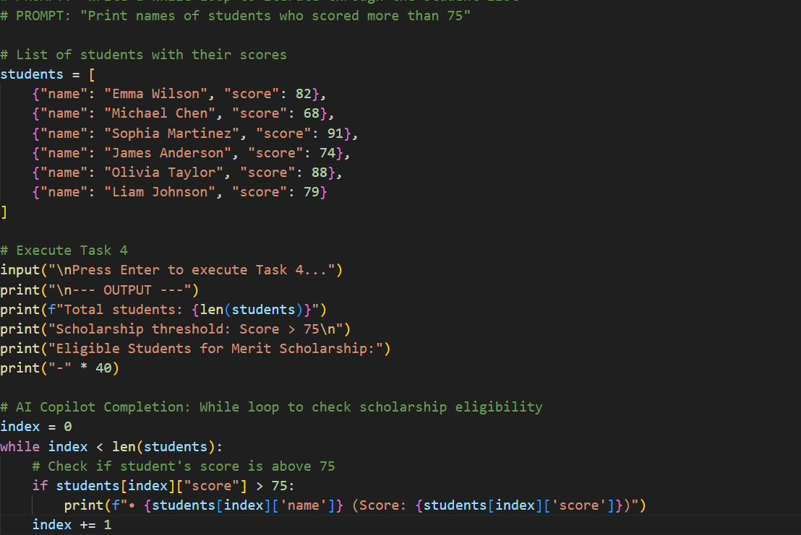

Output:
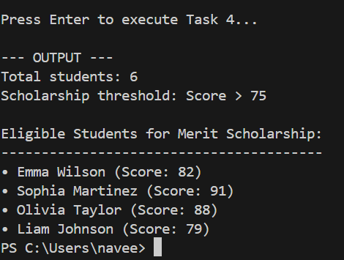

Justification:
This task emphasizes the use of iterative control structures and list handling to process multiple student records. AI-based code completion helps automate the evaluation of eligibility criteria, making the decision-making process efficient and consistent.

Task5: Online Shopping Cart Module

Prompt:
Create a class ShoppingCart with an empty list to store items . Add a method to add items to the cart with name, price, quantity. Add a method to remove items from the cart by name . Add a method to calculate total bill using a loop . Add a method to apply conditional discounts based on total amount .

Code:

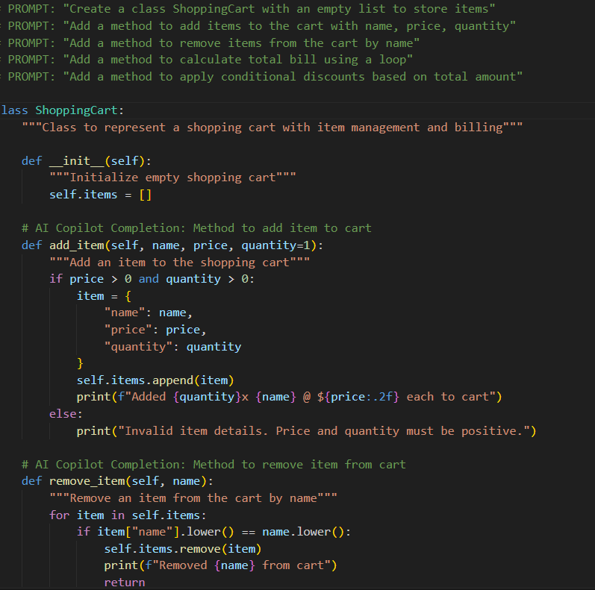

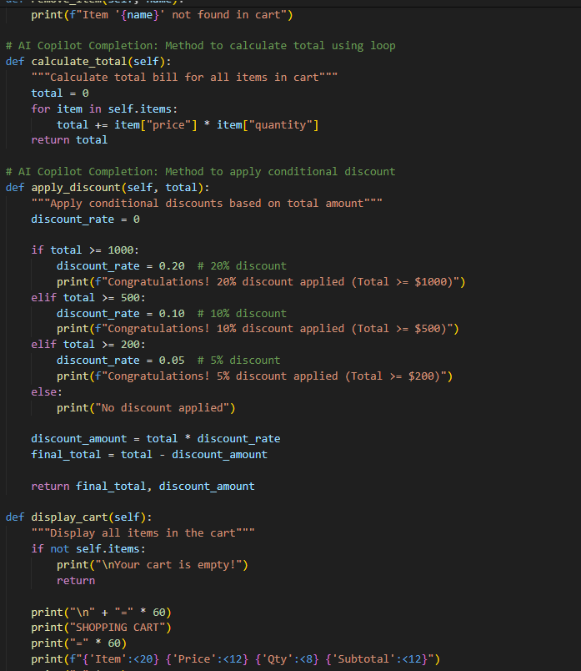

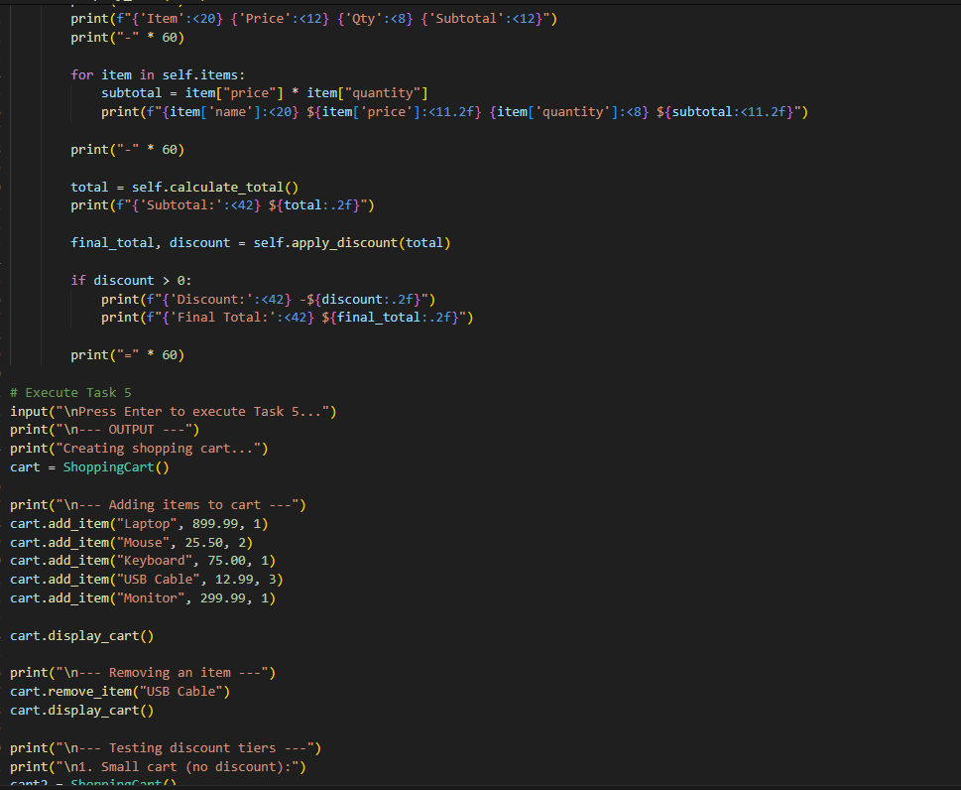

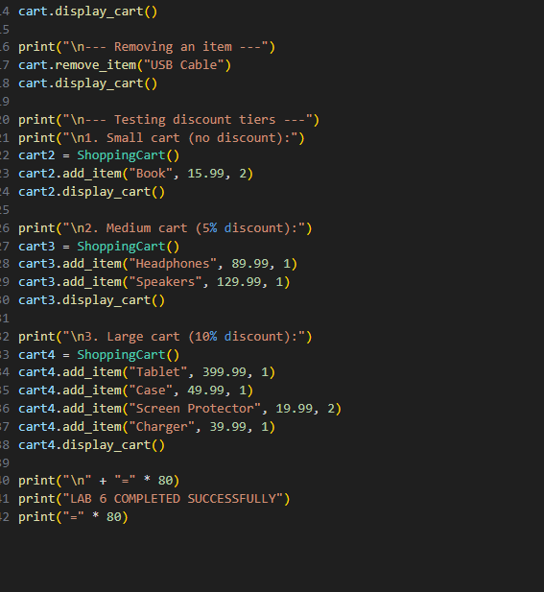

Output:
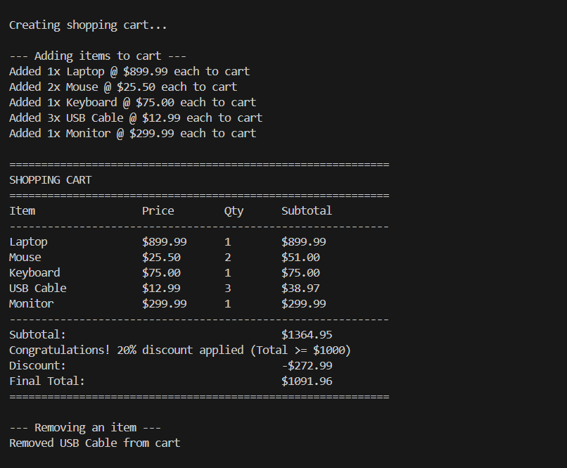

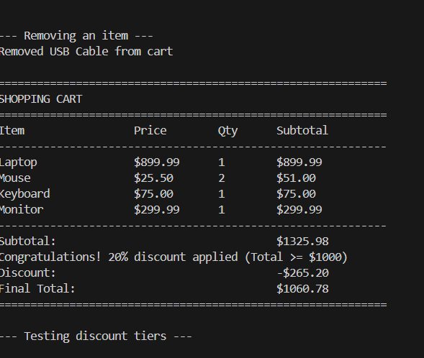

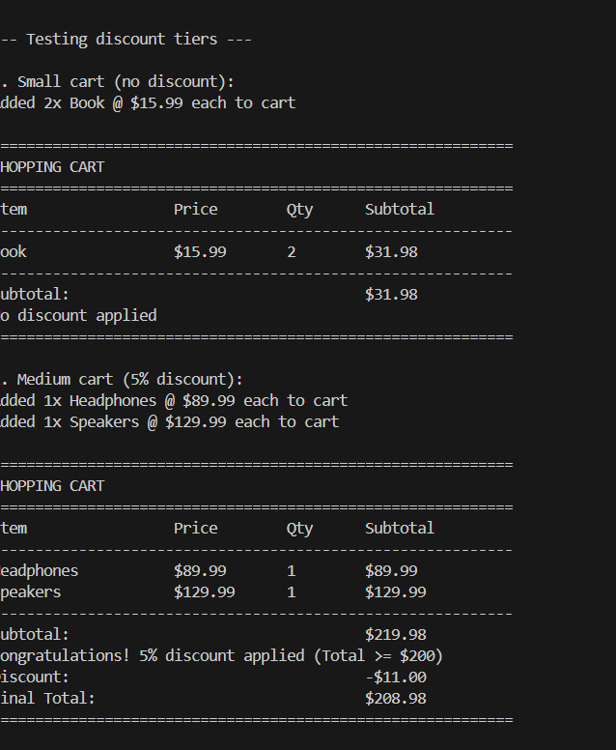

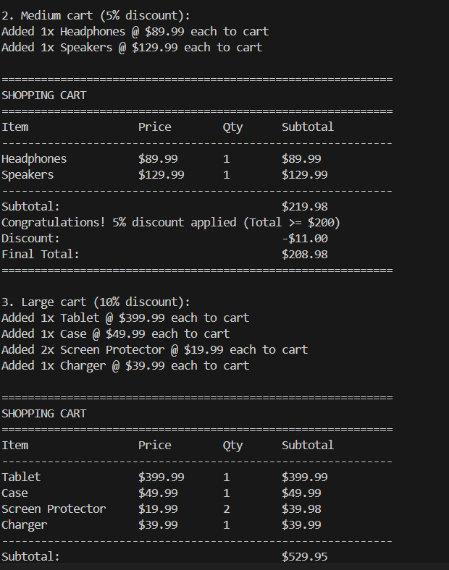

Justification: This task demonstrates how multiple programming concepts are combined to build a functional shopping cart system. AI-generated code simplifies the implementation of product handling, price calculation, and discount application, resulting in a scalable and realistic e-commerce simulation

