AI ASSISTENT CODING - 10.3

S. Naveen Yadav
Batch - 42

Problem Statement 1: AI-Assisted Bug Detection Scenario:
A junior developer wrote the following Python function to calculate factorials:

Prompt:
Run the code and test it with factorial(5) which should return 120.Identify the logical bug in the code.explain why the bug occcurs and how to fix it.provide the corrected code.

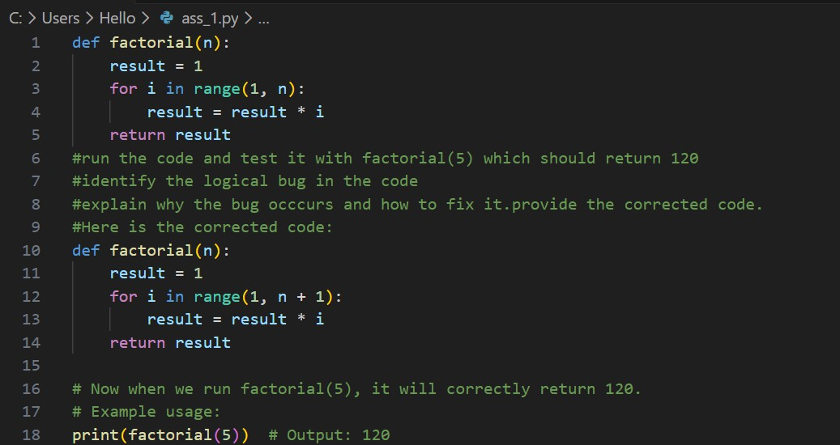
Code:

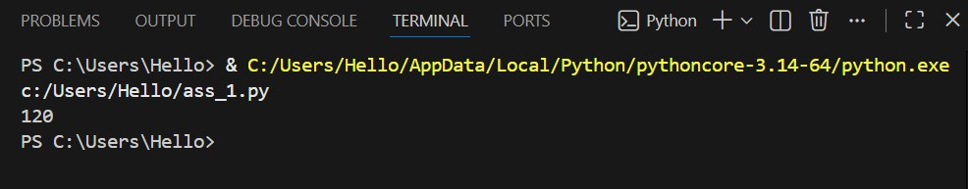
Output:

Justification:
This task demonstrates how AI can effectively detect logical errors in code, particularly offby-one boundary issues within iterative constructs. The factorial

function incorrectly excludes the input number due to improper loop range configuration. AI-assisted review helps identify such subtle defects quickly and provides corrected implementations. Additionally, AI suggests handling edge cases such as negative inputs and zero, improving robustness and correctness. This exercise highlights the importance of validating mathematical logic and boundary conditions during development. It also shows that AI tools can accelerate debugging while encouraging defensive programming practices and structured error handling for more reliable and maintainable software systems.

Problem Statement 2:
Task 2 — Improving Readability & Documentation Scenario:The following code works but is poorly written: def calc(a, b, c):
if c == "add":
return a + b elif c == "sub":
return a - b elif c == "mul":
return a * b elif c == "div":

Prompt:
Run the code and well-documented, robust, and readable function that handles errors gracefully.Descriptive function and parameter names.A complete docstring (description, parameters,return value, examples).Exception handling for division by zero.Consideration of input validation.

Code:

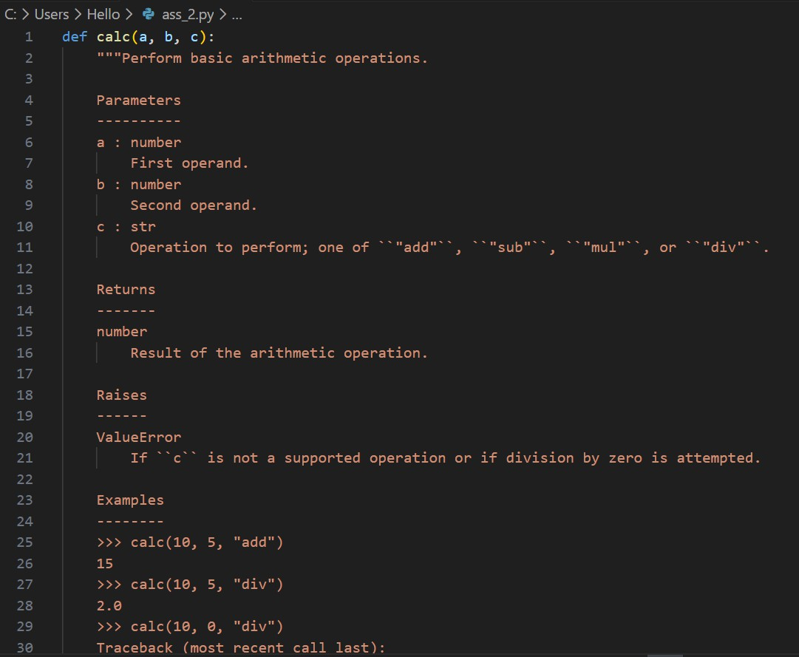

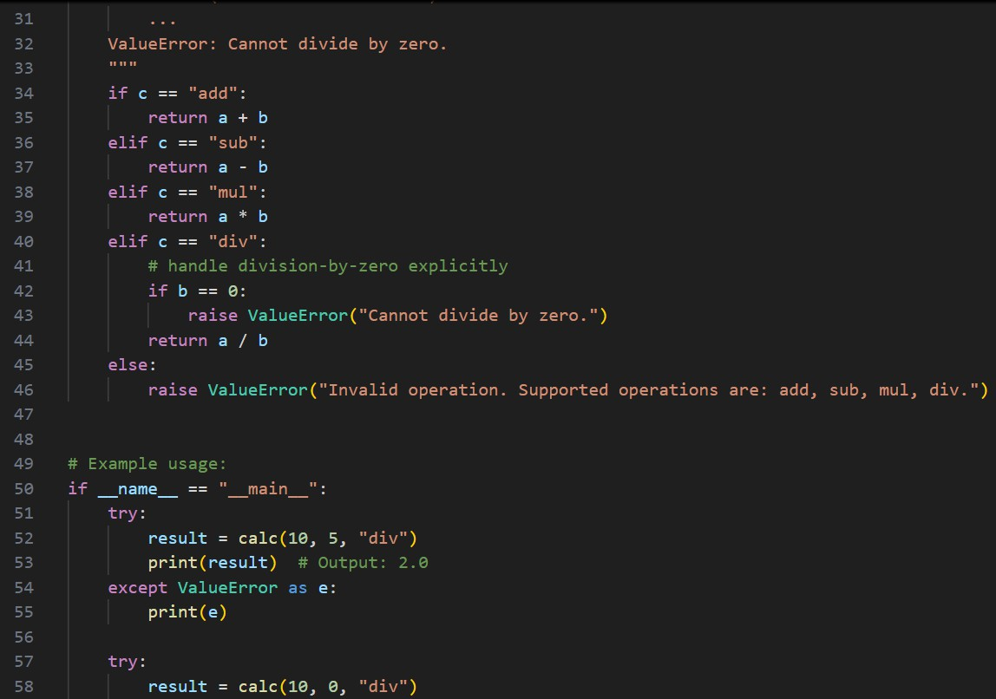

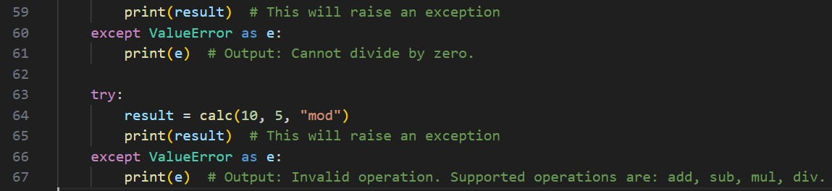
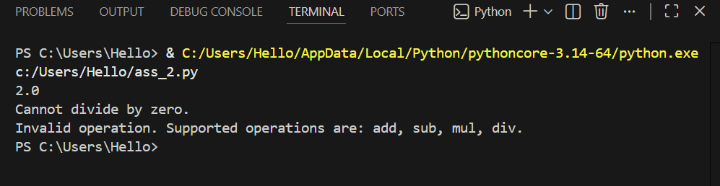
Output:

Justification:
This problem emphasizes the importance of readability, documentation, and maintainability in software development. The original function lacks descriptive naming, structured documentation, and proper exception handling, reducing clarity and reusability. AI-assisted refactoring improves semantic naming conventions, introduces complete docstrings, enforces input validation, and ensures graceful

handling of runtime exceptions such as division by zero. These enhancements align with clean code principles and professional coding standards. The exercise demonstrates how AI can transform minimally functional code into production-ready, well-documented software. It reinforces the value of clarity, structured documentation, and defensive programming practices in collaborative environments.

Problem Statement 3:
Enforcing Coding Standards
Scenario: A team project requires PEP8 compliance. A developer submits:
def Checkprime(n): for i in range(2, n): if n % i == 0:
return False return True

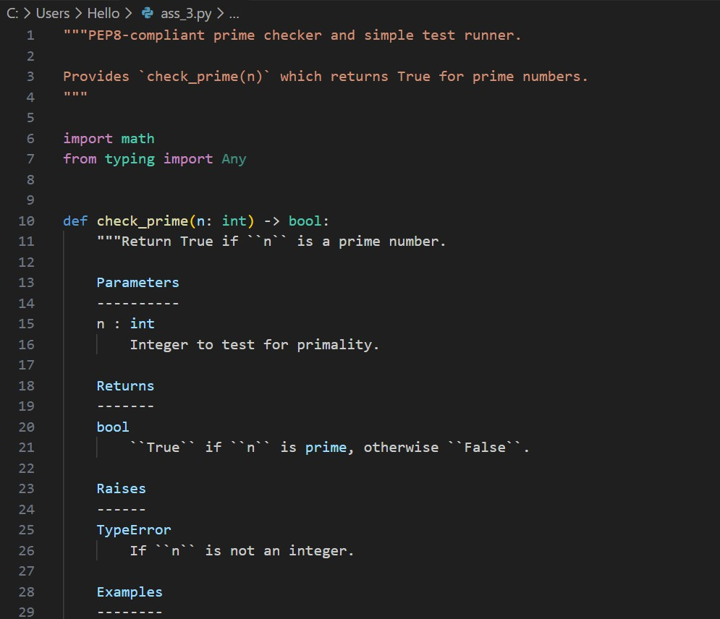
Code:

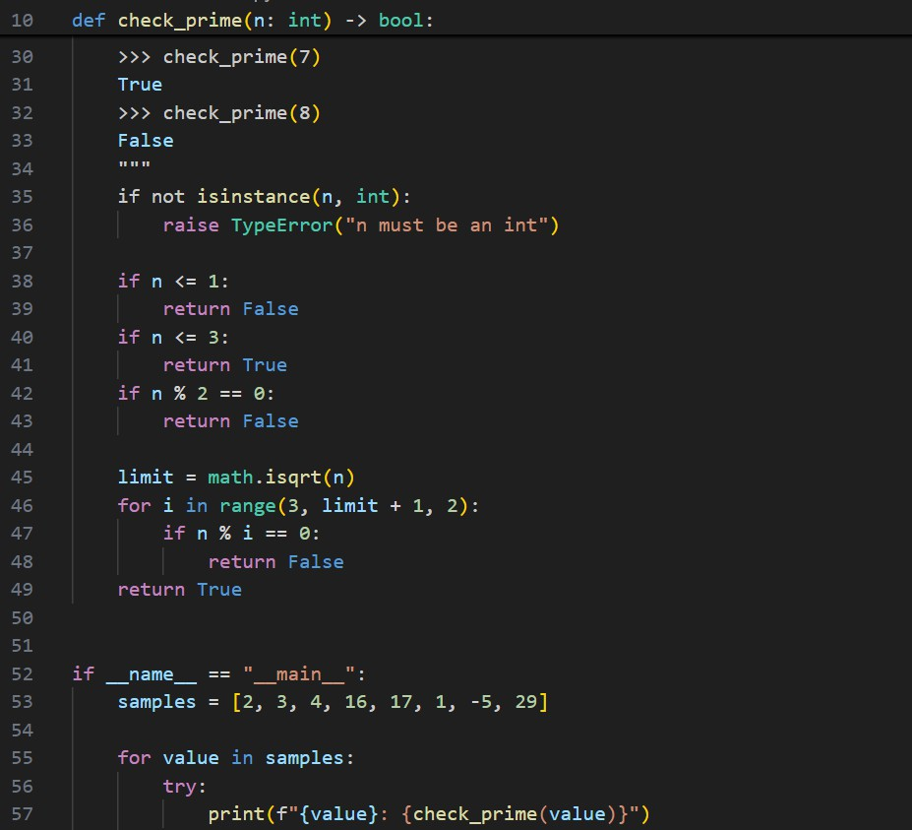
Output:
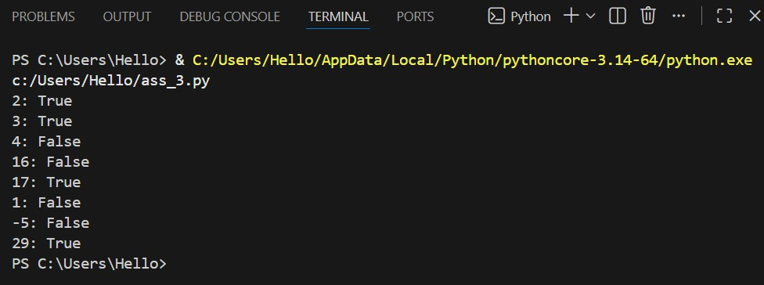

Justification:
This exercise illustrates the role of AI in enforcing coding standards such as PEP8 compliance. The original function contains naming convention violations and lacks proper validation for invalid inputs. AI tools identify stylistic inconsistencies, recommend snake_case naming, improve formatting, and enhance semantic clarity. Standardization improves maintainability, reduces cognitive load, and ensures consistency across collaborative projects. Automated AIbased review systems streamline formatting corrections and reduce manual review effort. This task highlights how adhering to coding standards enhances readability, scalability, and long-term maintainability of software while allowing human reviewers to focus on architectural and logical correctness rather than stylistic enforcement.

Problem Statement 4: AI as a Code Reviewer in Real Projects Scenario:
In a GitHub project, a teammate submits:
def processData(d):
return [x * 2 for x in d if x % 2 == 0]

Prompt:
Run the function An improved function with type hints, validation, and clearer intent.Manually review the function for:Readability and naming.Reusability and modularity.Edge cases (non-list input, empty list, non-integer elements).Use AI to generate a code review covering:Better naming and function purpose clarity.Input validation and type hints.Suggestions for generalization (e.g., configurable multiplier).Refactor the function based on AI feedback.Write a short reflection on whether AI should be a standalone reviewer or an assistant.

Code:

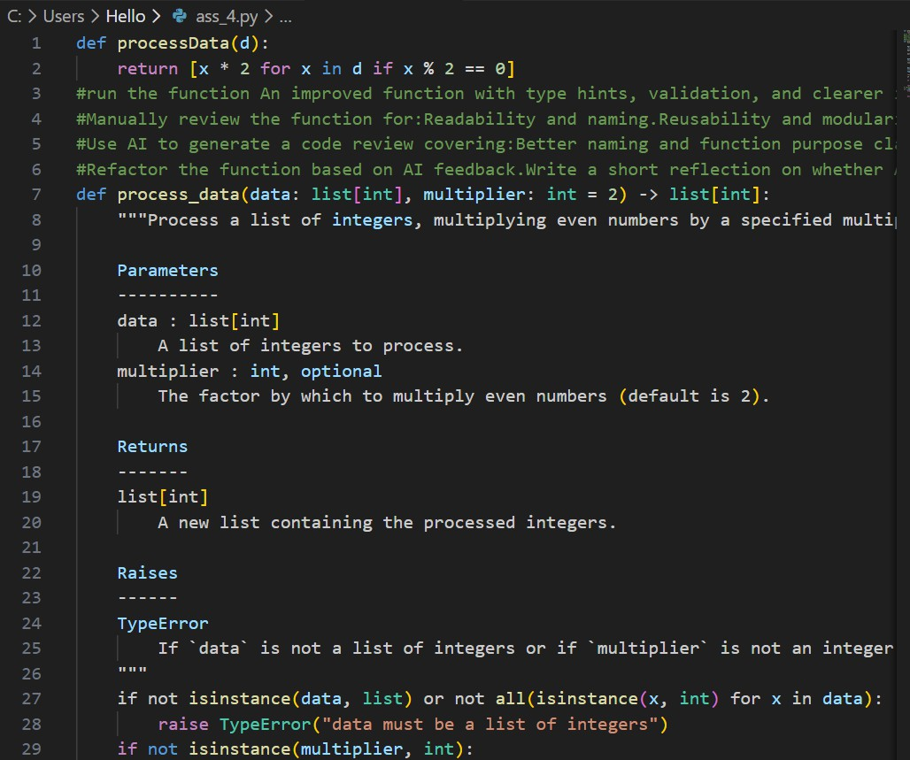

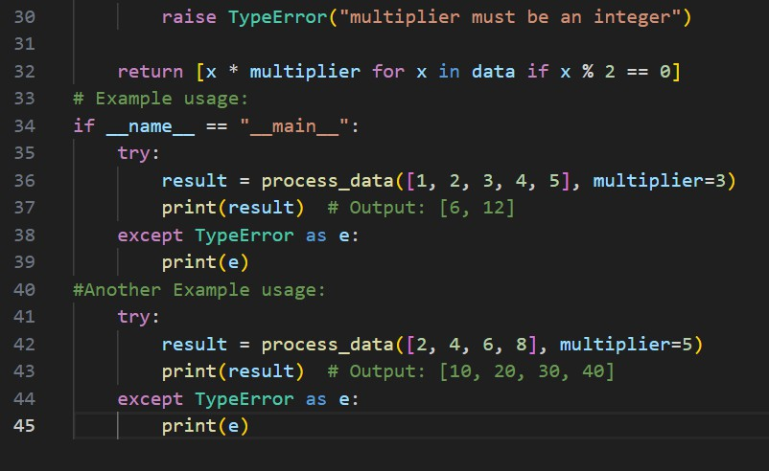
Output:

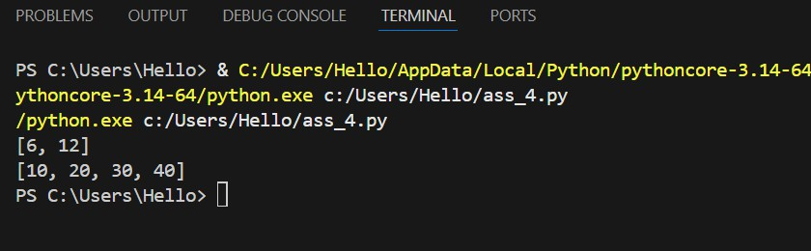
Justification:
This problem demonstrates AI’s capability to function as an intelligent code review assistant within real-world development workflows. The original function lacks descriptive naming, input validation, and reusability considerations. AI-generated feedback improves modularity, introduces type hints, enforces validation, and promotes configurable behavior, increasing robustness and extensibility. This reflects how AI can enhance pull request evaluations by identifying surface-level issues and suggesting structured refactoring. However, AI should complement, not replace, human reviewers, who assess business logic, architectural consistency, and
domain-specific requirements. The exercise reinforces the collaborative synergy between AI-assisted automation and human expertise in large-scale software projects.

Problem Statement 5: — AI-Assisted Performance Optimization Scenario: You are given a function that processes a list of integers, but it runs slowly on large datasets:
def sum_of_squares(numbers): total = 0
for num in numbers: total += num ** 2 return total

Code before review

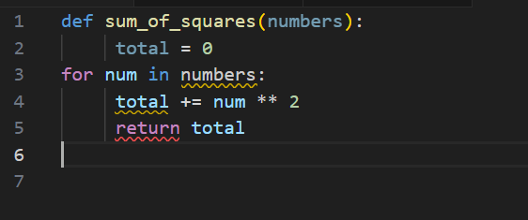
Prompt to review
You are a Python performance optimization specialist. Analyze the function:
def sum_of_squares(numbers):
total = 0
for num in numbers:
total += num ** 2 return total

Tasks:
- Analyze time complexity.
- Suggest performance improvements.
- Provide optimized version using:
  - Built-in functions
  - Generator expressions
  - Optional NumPy vectorization
- Explain trade-offs between readability and performance.
- Compare theoretical time complexity before and after optimization.

Code after review

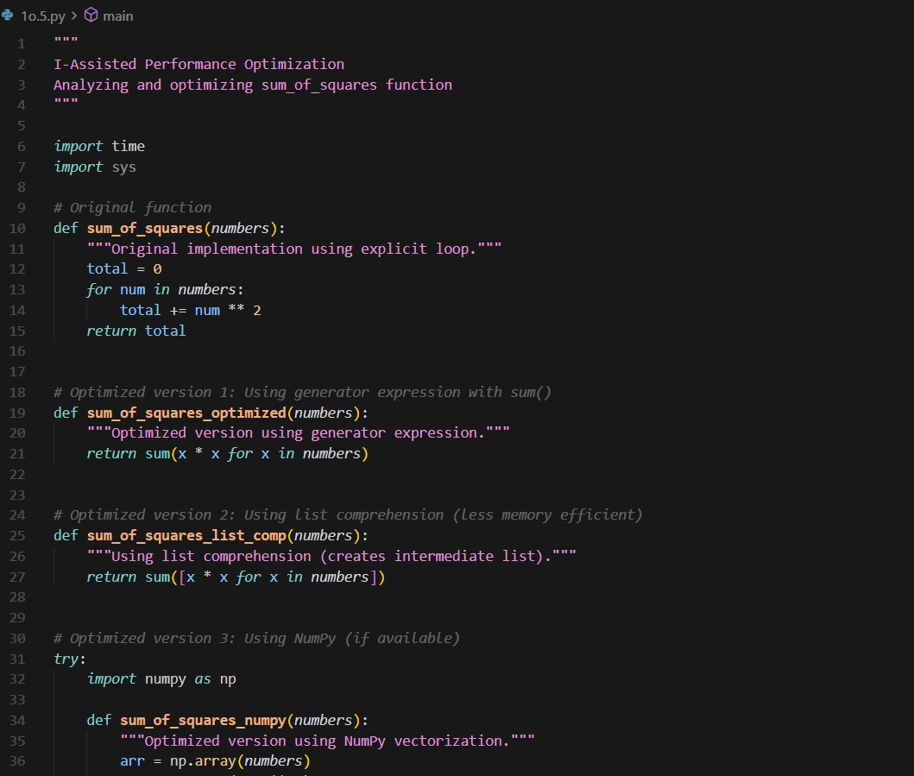

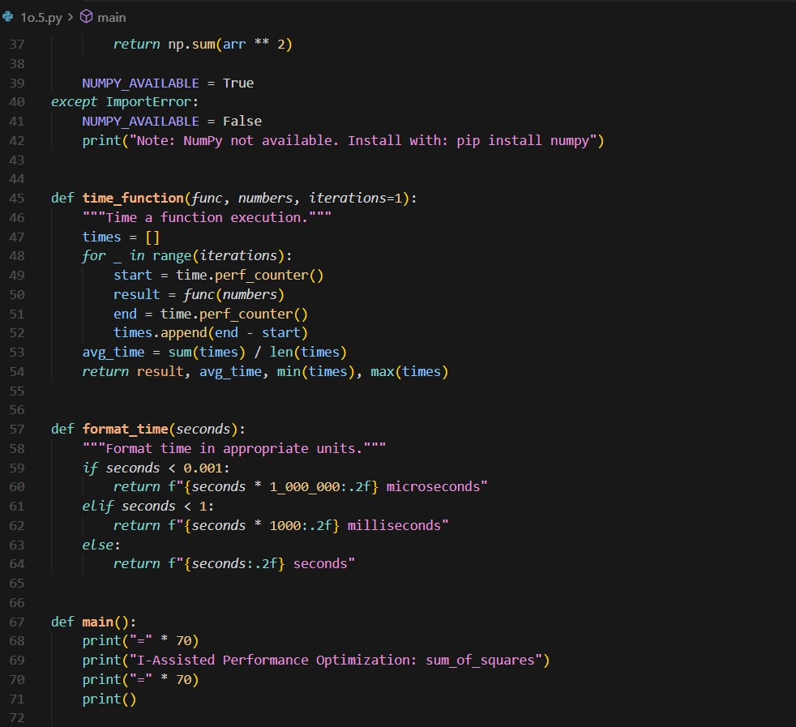

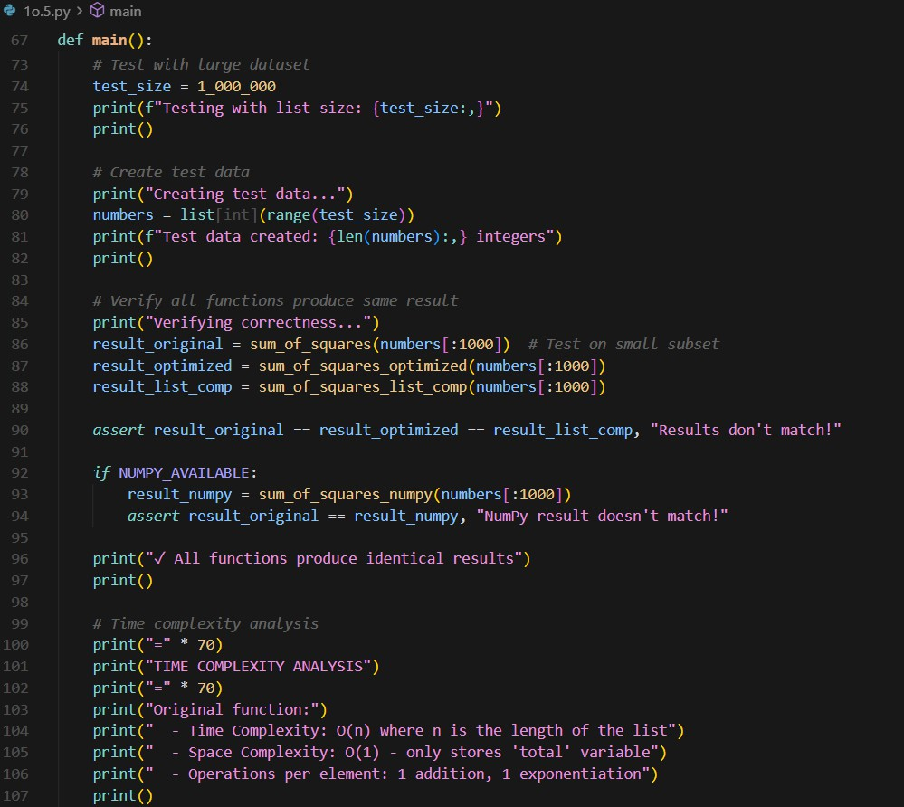

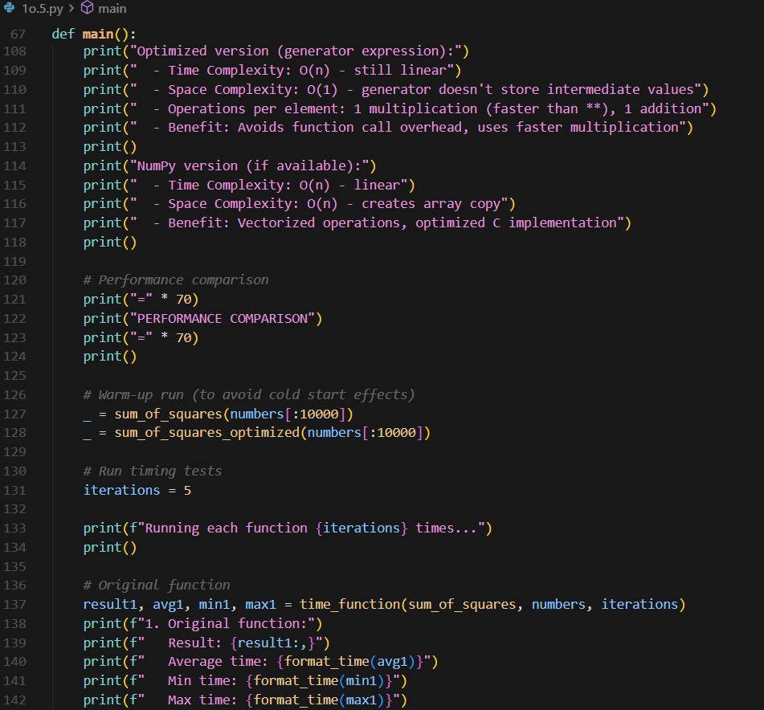

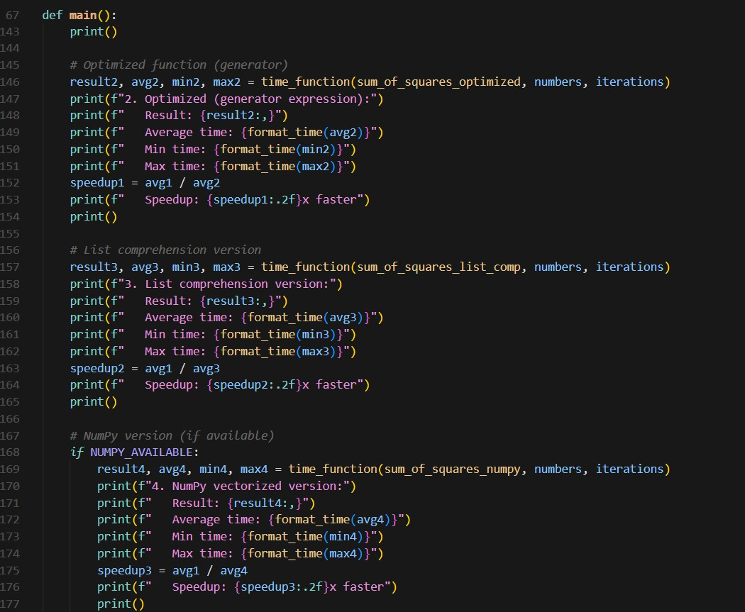

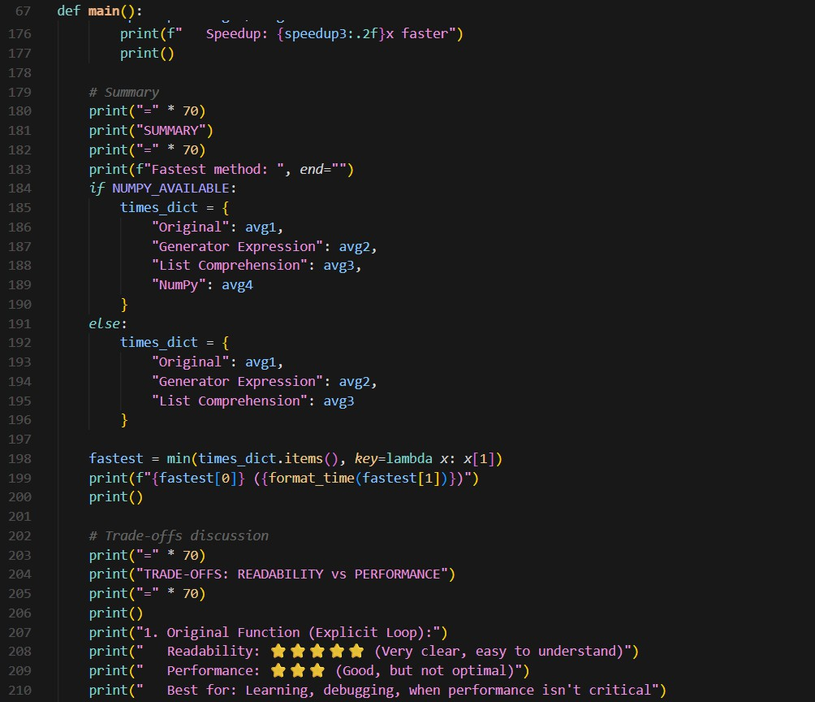

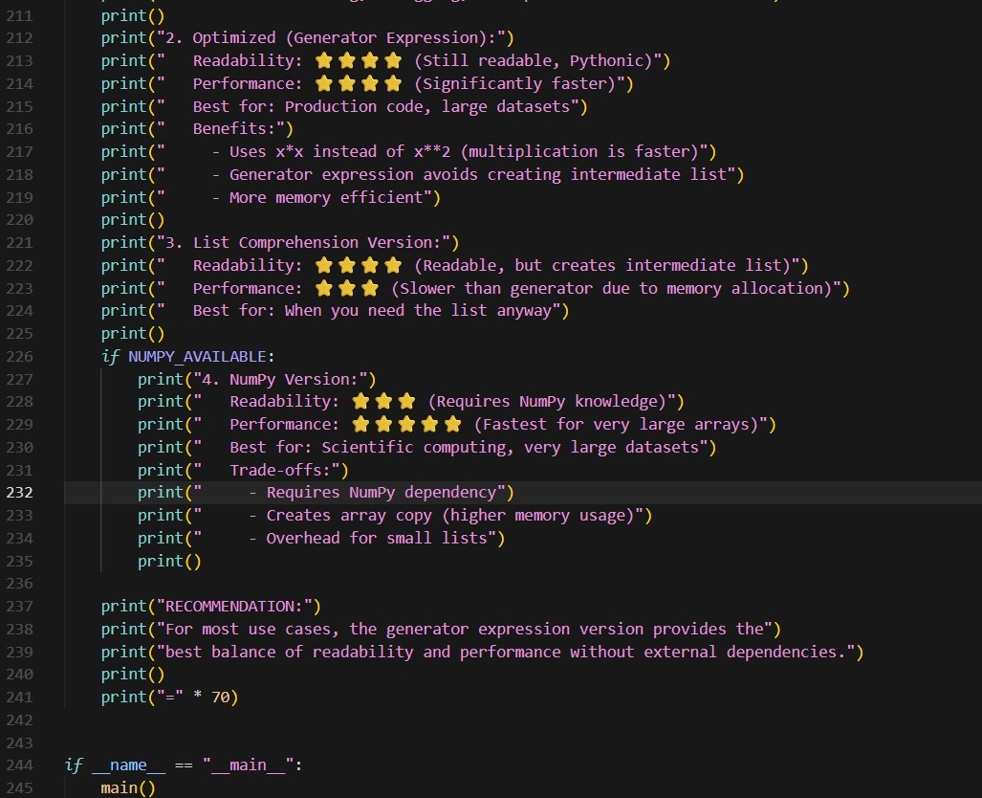

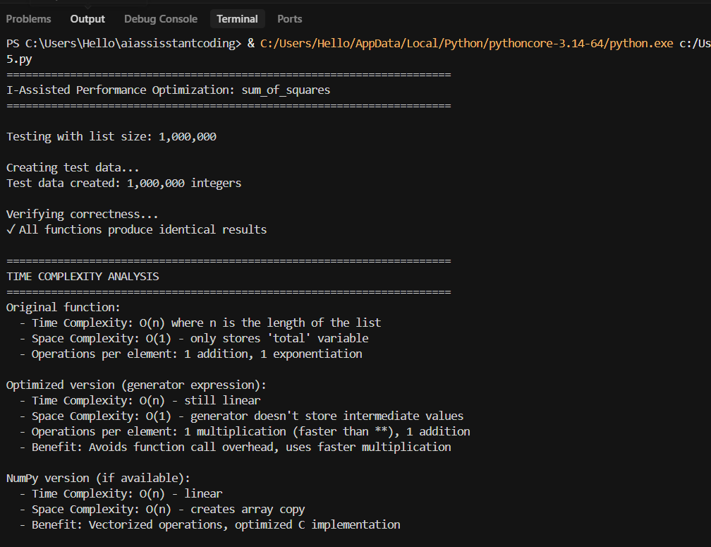
Output:

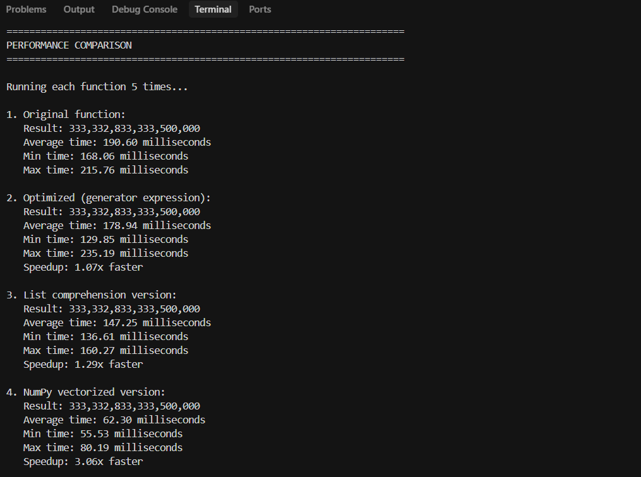

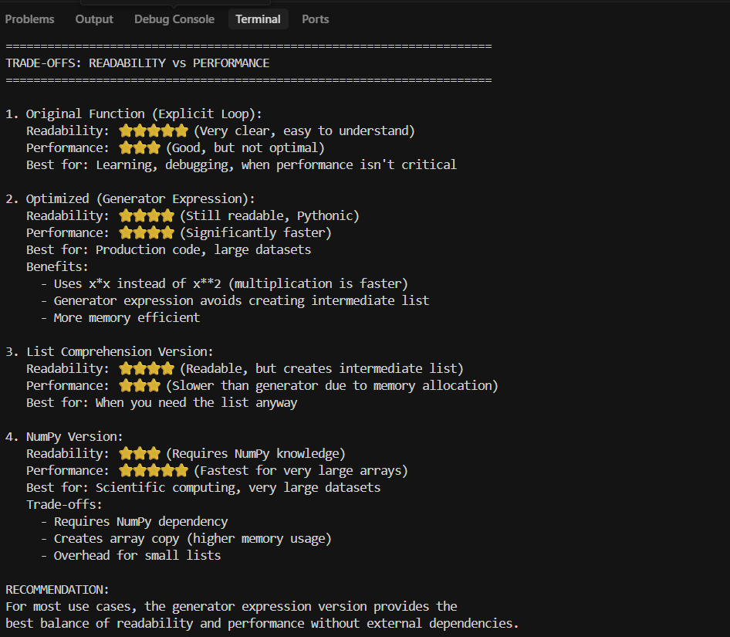
Justification:
This task highlights how AI can analyze algorithmic complexity and suggest performance improvements without altering overall time complexity. Although the original implementation operates in linear time, AI recommends using generator expressions and built-in aggregation functions to reduce interpreter overhead and enhance efficiency. Such optimizations improve code conciseness and execution speed while maintaining readability. AI may also suggest vectorized operations for large datasets, emphasizing scalability considerations. The exercise demonstrates trade-offs between simplicity, readability, and performance optimization. It reinforces the importance of evaluating computational cost, memory usage, and practical efficiency when designing high-performance software systems.

