AI Assistant Coding
Assignment - 2.4

Salupala Naveen Yadav
2303A52230
Batch - 42

Task 1: Book Class Generation ❖ Scenario:
You are building a simple library management module.
❖ Task:
Use Cursor AI to generate a Python class Book with attributes title, author, and a summary() method.

Prompt:
Create a simple Python library management system. Generate a Book class with attributes title and author. Include a summary() method that returns book details.

Generated class :
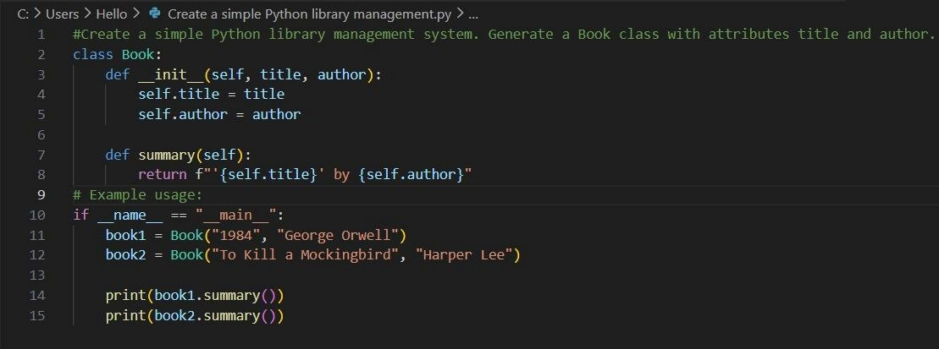

Output:
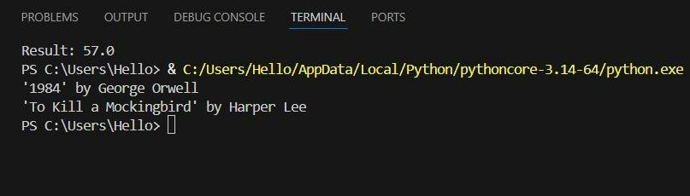

Justification :
By finishing this task, we can display the book information as required in the question using Cursor AI. The code is easy to understand.

Task 2: Sorting Dictionaries with AI ❖ Scenario:
You need to sort user records by age.
❖ Task:
Use Gemini and Cursor AI to generate code that sorts a list of dictionaries by a key.

PROMPT :

CURSOR: Create efficient Python code to sort a list of dictionaries by the key "age".
Each record contains "name" and "age"
GEMINI: #Generate Python code to sort a list of dictionaries containing user records by the key "age". Each dictionary has the keys: "name" and "age". Find and print names of users with the given age

Cursor:
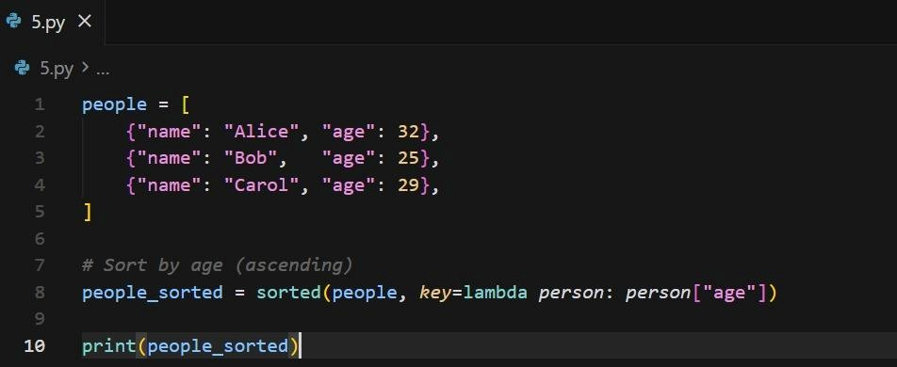
Output:

Gemini:
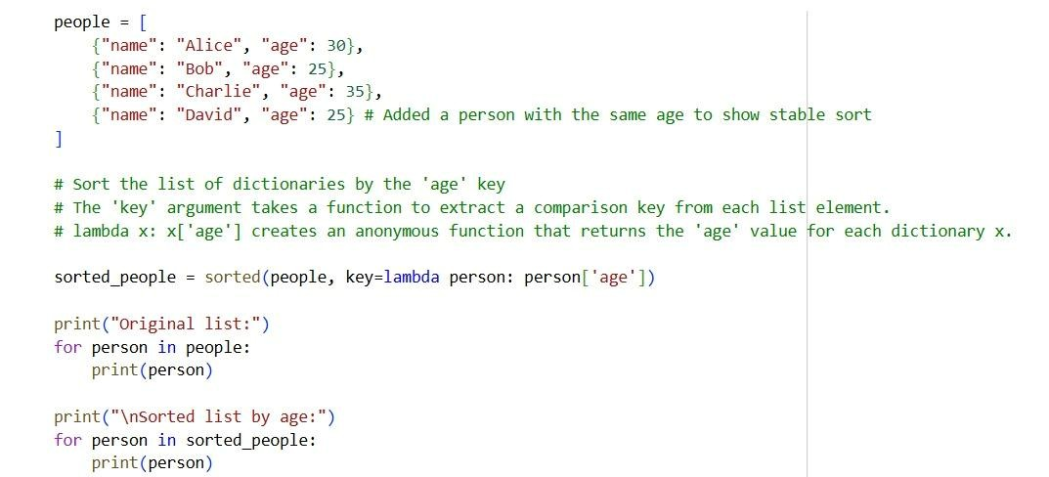

Output:
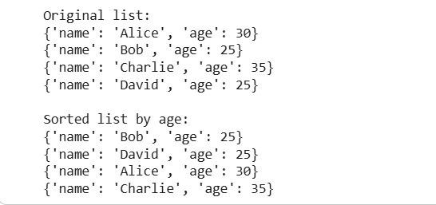

Justification:
In this task, even though we used two different AI tools, both produced the required output. we can clearly notice a difference in the way the code is written. The clarity of both codes is very good, but when it comes to output presentation, the output from Cursor AI is more neat and easier for anyone to understand.

Task 3: Calculator Using Functions ❖ Scenario:
You are reviewing a basic calculator module.
❖ Task:
Ask Gemini to generate a calculator using functions and explain how it
works.

PROMPT:
Write a python code for simple calculator with functions addition of n numbers, subtraction of n numbers, multiplication of n numbers, division of n numbers and power of n numbers which chooses the operation on the user input.

Gemini:
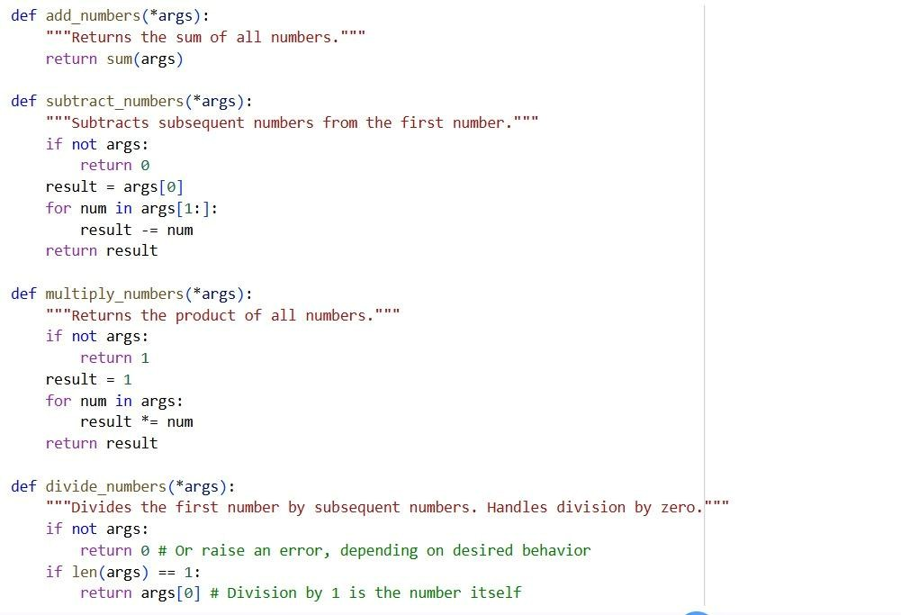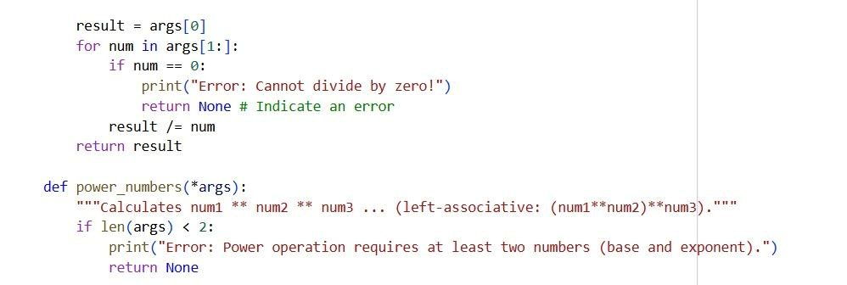
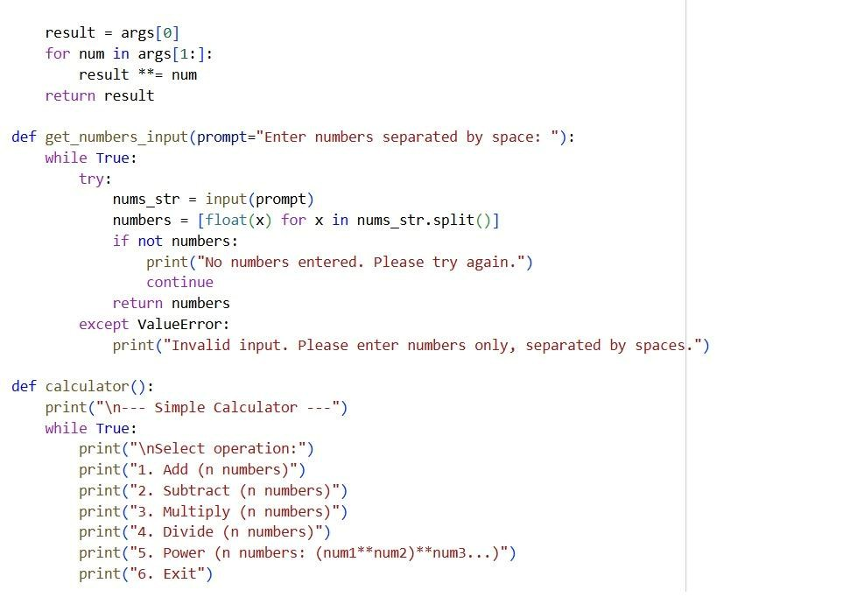
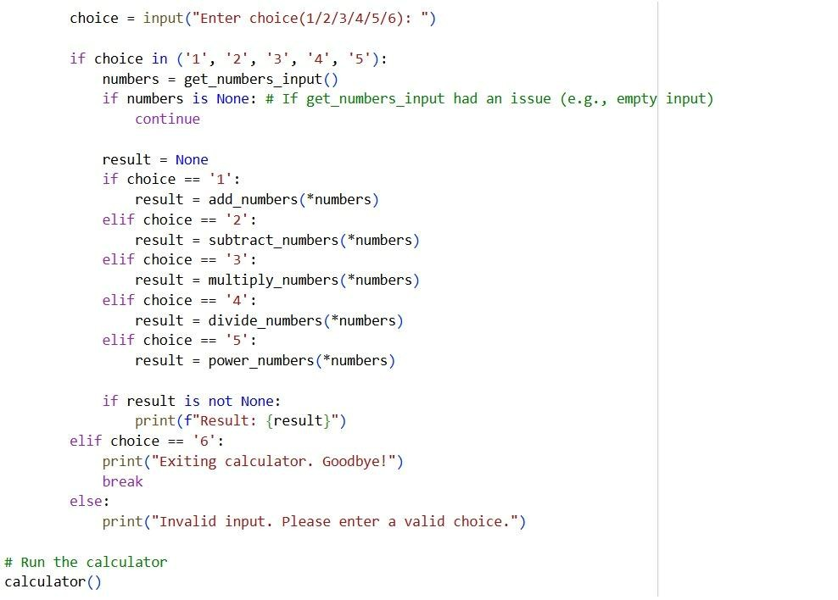

Output:
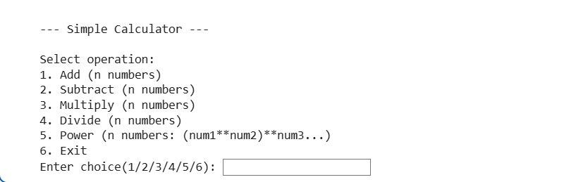
Vs Code:
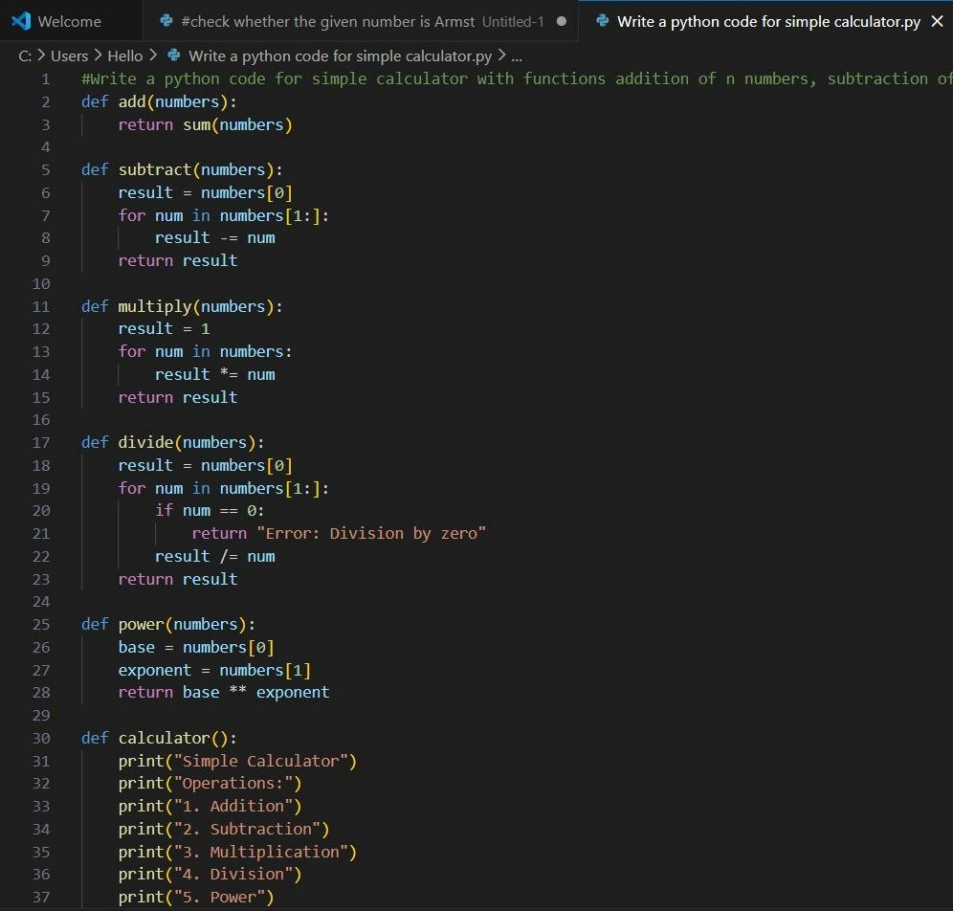
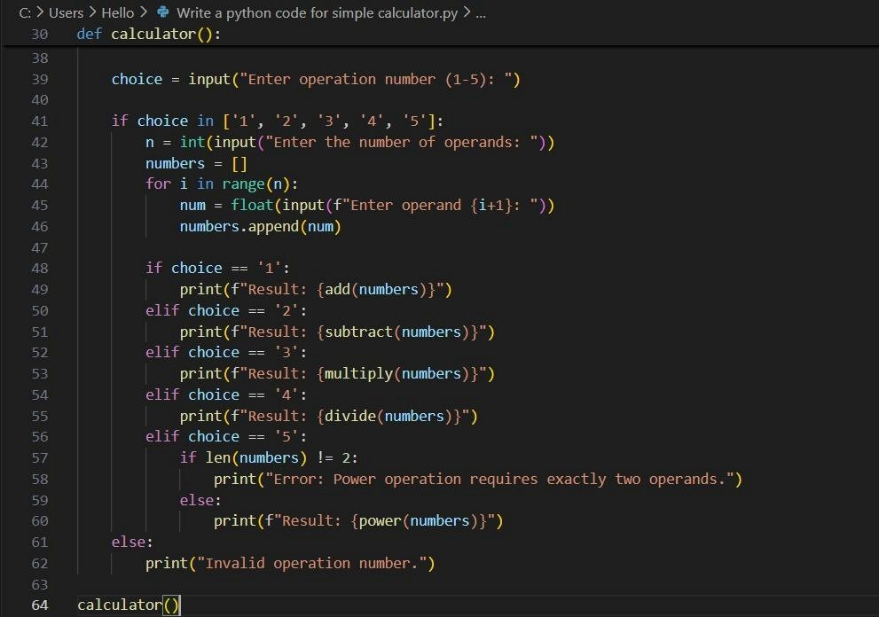

Output :
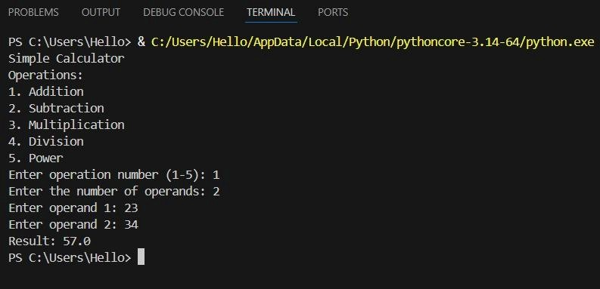
Justification:
By finishing this task the simple basic calculator, The program is easy to understand because each operation is written in a separate function. It can perform calculations on more than two numbers, so it is more useful than a normal calculator. The program checks for errors like wrong input and division by zero, so it runs safely.

Task 4: Armstrong Number Optimization ❖ Scenario:
An existing solution is inefficient.
❖ Task:
Generate an Armstrong number program using Gemini, then improve it using Cursor AI.

Gemini :
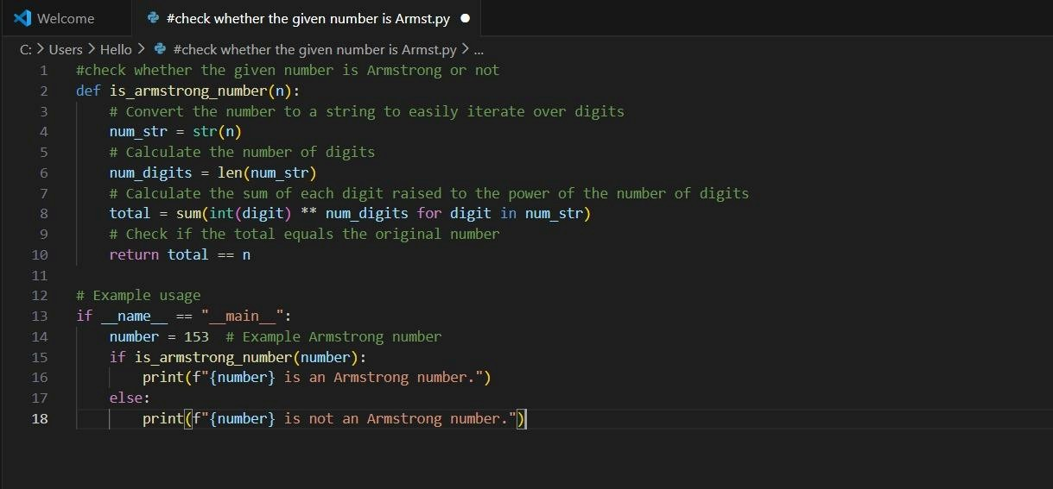

Output:
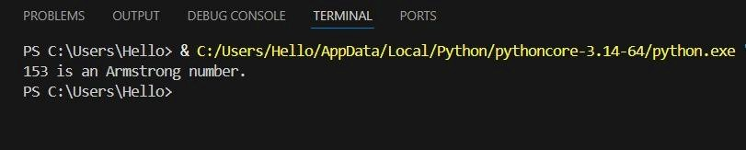

Cursor AI :
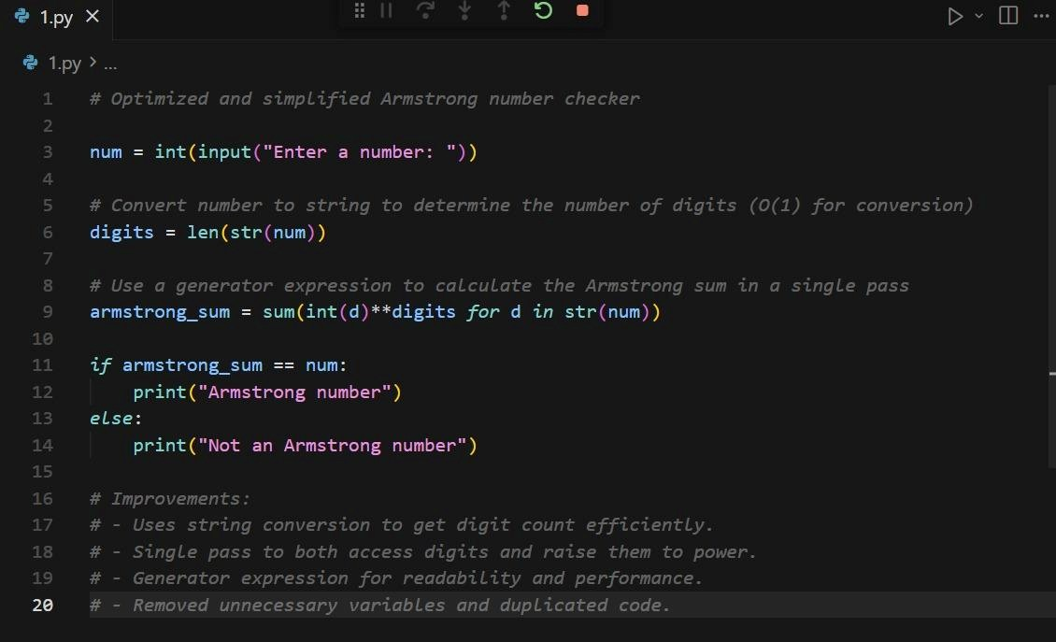
Output :
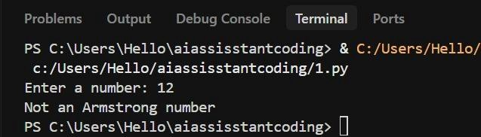

Justification:

In this task, we can clearly observe that, the code given by gemini is a bit complex and has more time complexity which makes code less efficient, as we have optimized it in cursor ai, the code is optimized version with only basic syntax which makes the code easy to understand for anyone. Even though the outputs are same, both the codes given by both gemini and cursor ai are efficient.

