AI ASSISTED CODING - 17.3
Salupala Naveen Yadav
2303A52230
Batch - 42

Task 1 Employee Dataset Cleaning
Task:
Use AI assistance to clean an employee information dataset.
Instructions:
- Handle missing values in salary, designation, and experience
- Remove duplicate employee IDs
- Standardize text values (job titles in lowercase)
- Encode categorical features (designation, employment_type)

Prompt:
Employee Dataset Cleaning . Use AI assistance to clean an employee information dataset. Instructions: • Handle missing values in salary, designation, and experience • Remove duplicate employee IDs • Standardize text values (job titles in lowercase) • Encode categorical features (designation, employment_type) Expected Output: A clean dataset suitable for HR analytics and prediction tasks. Give me code for this dataset and give me proper infomation of the employees and and give me some invalid emplyee information.

Code & output:
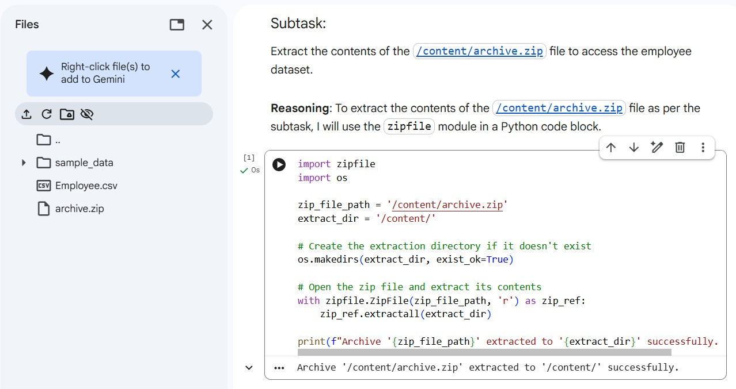

Load Employee Dataset
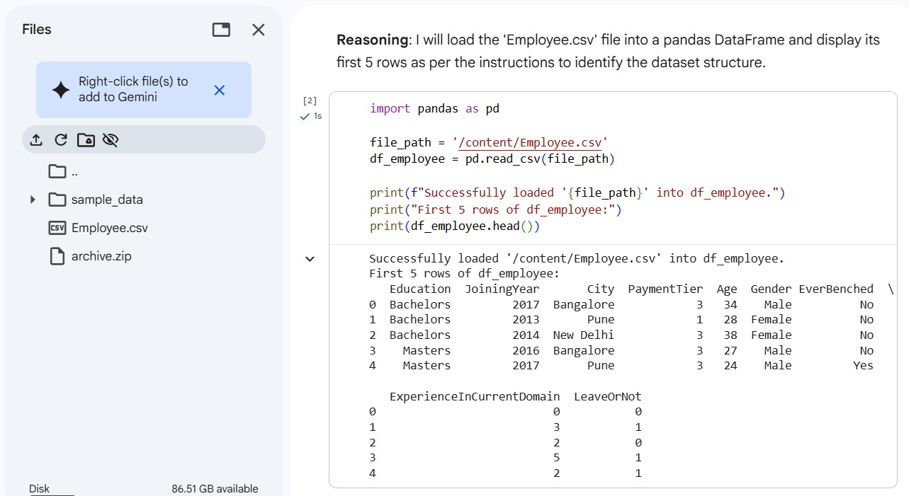

Handle Missing Values
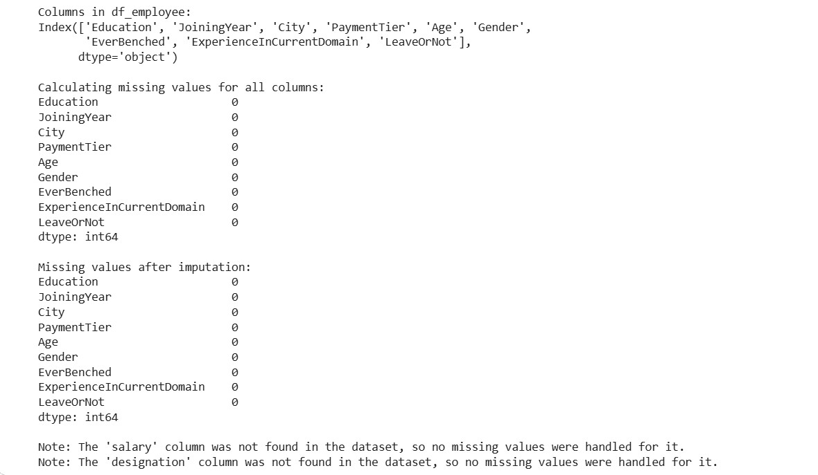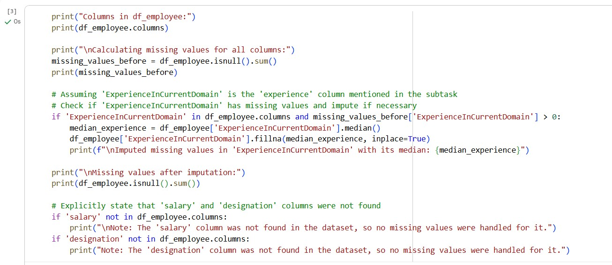

Remove Duplicate Employee IDs
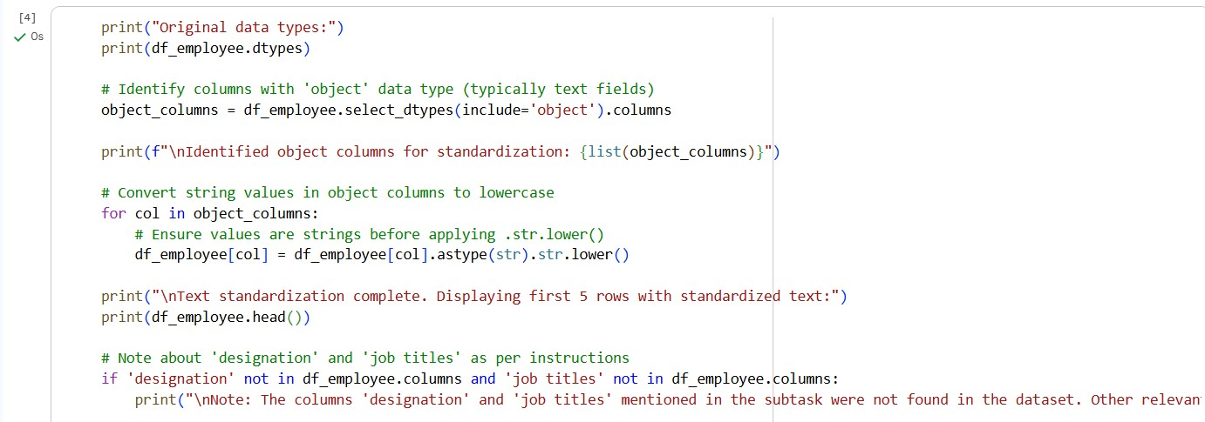
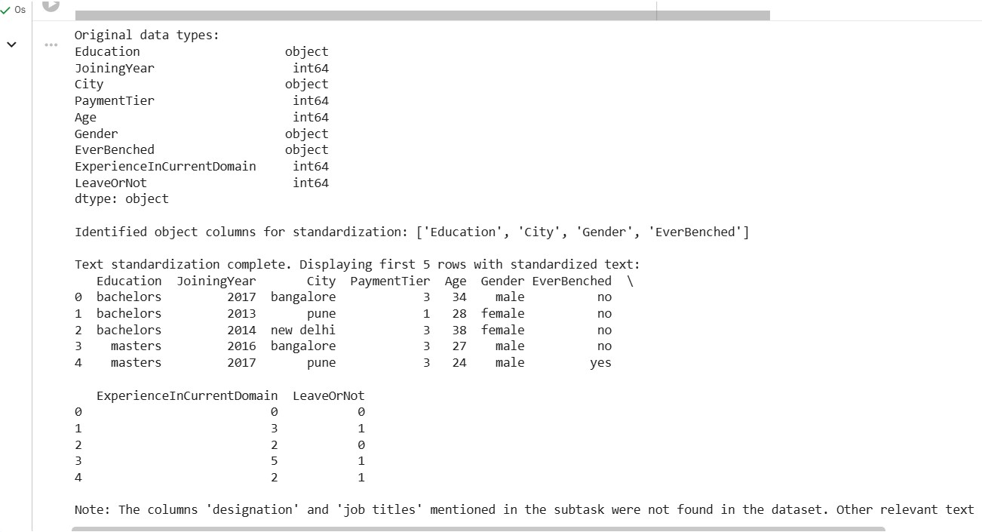

Encode Categorical Features
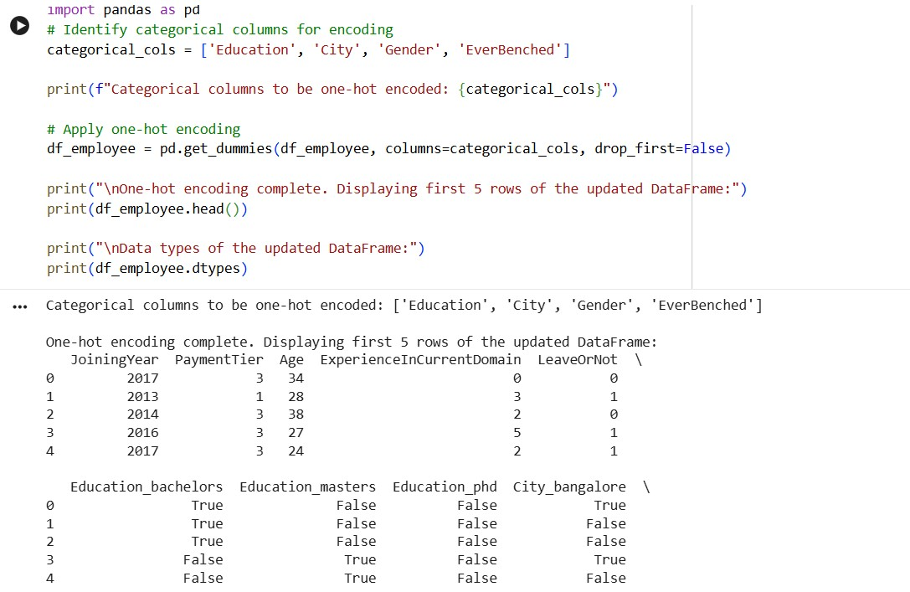
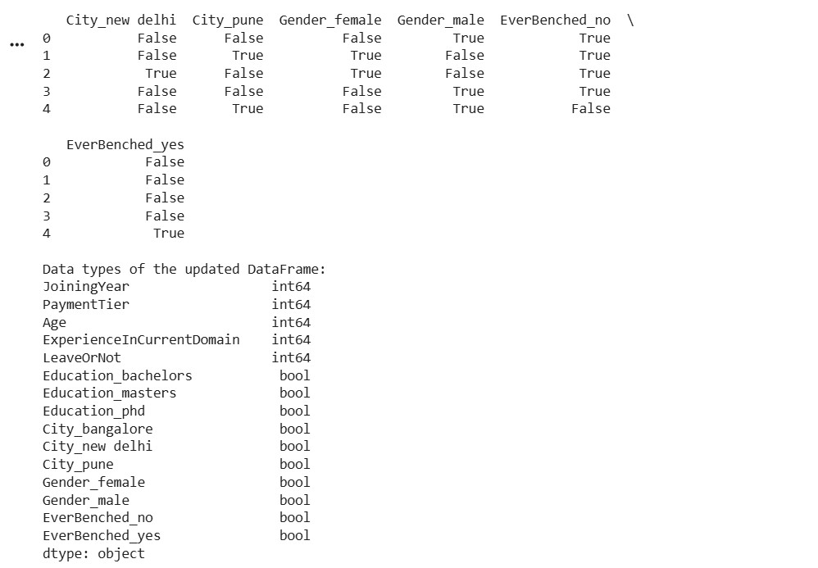

Identify Invalid Employee Information
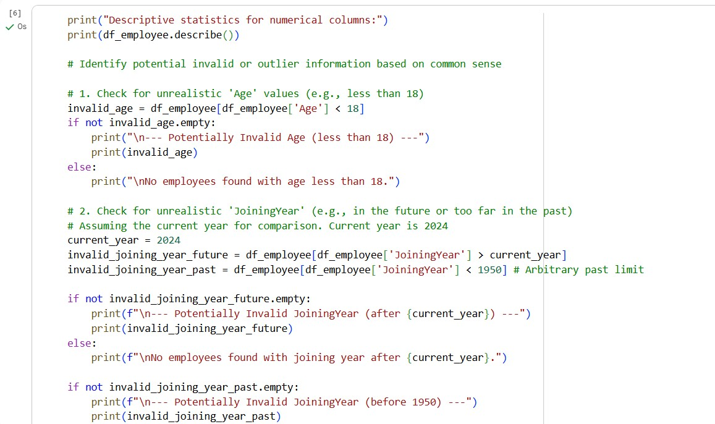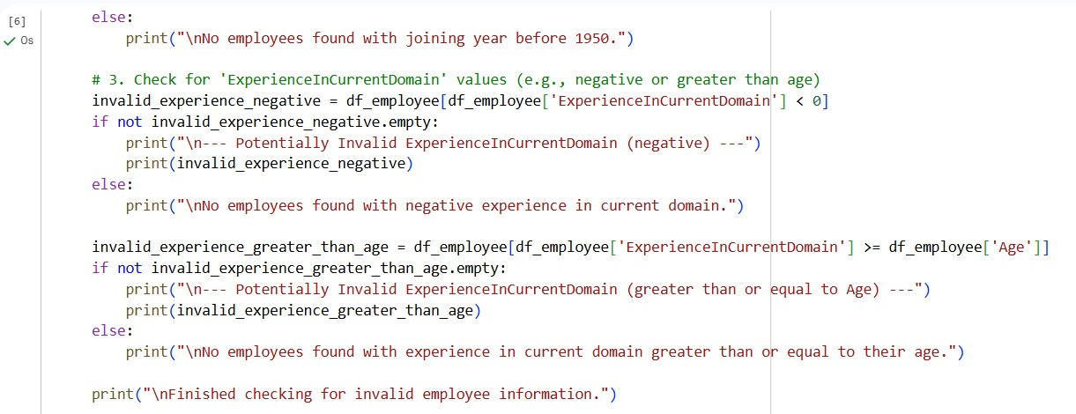
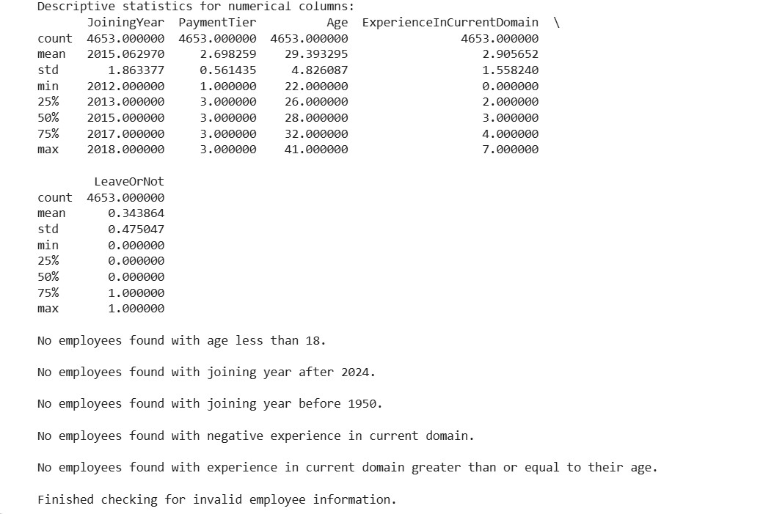

Display Cleaned Dataset Information
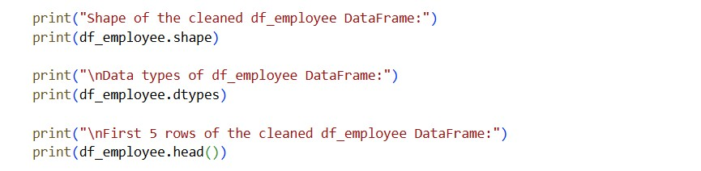

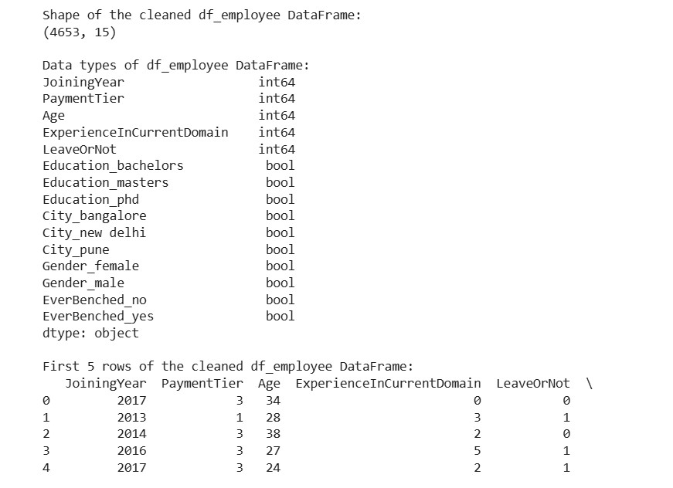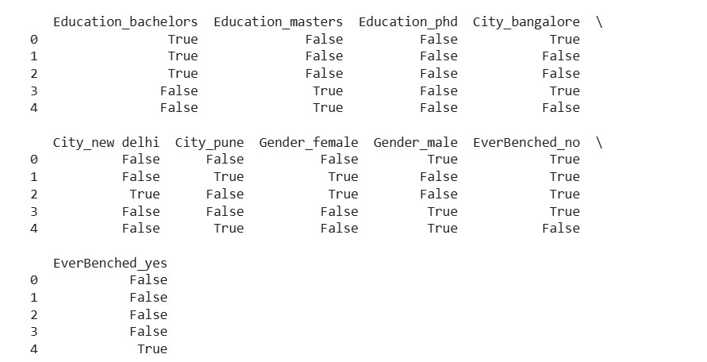

Justification:
- MissingValuesHandling
  - Salary→Median:Salarydistributionsareoftenskewed; median is robust to outliers.
○ Designation→Mode:Mostfrequentjobtitlemaintains categorical consistency.
○ Experience→Mean:Numericalfield;meanpreservesoverall distribution.
- DuplicateRemoval
  - Removingduplicateemployee_idensuresdataintegrityand avoids biased analytics.
- Text Standardization
  - Convertingdesignationstolowercaseeliminatescase-sensitive inconsistencies (e.g., “Manager” vs “manager”).
- CategoricalEncoding
  - Machinelearningmodelsrequirenumericalinputs;encoding converts text into usable numeric form.

Task 2 – Student Performance Data Preprocessing
Task:
Preprocess student performance data using AI assistance.

Prompt:
Preprocess a student performance dataset.

Instructions:
- Convert exam_date column into datetime format
- Extract new features (month, semester, day)
- Normalize total_marks
- Detect and handle outliers in marks using IQR or Z-score

Code & Output
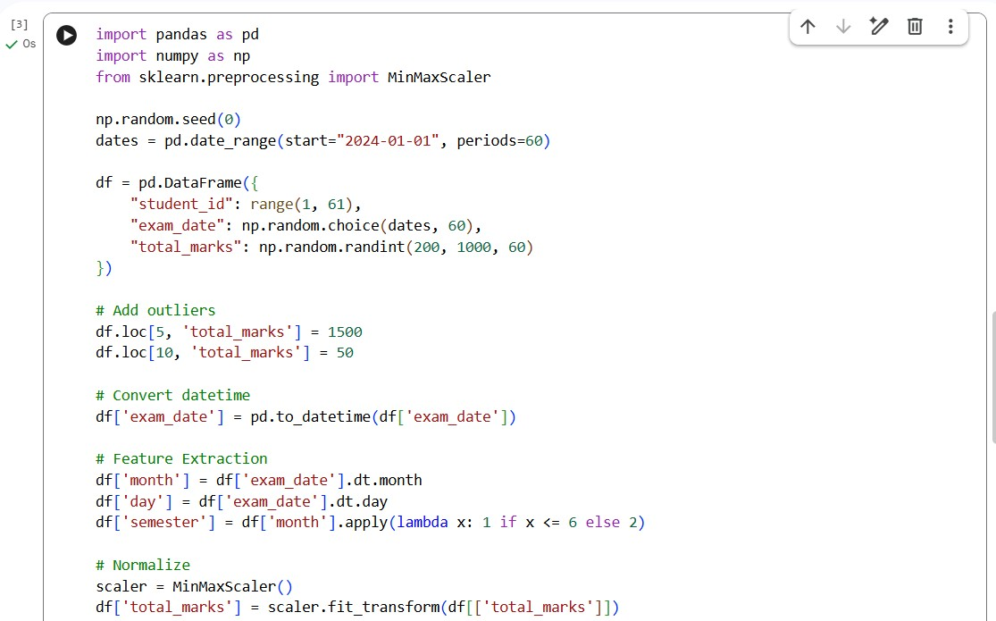
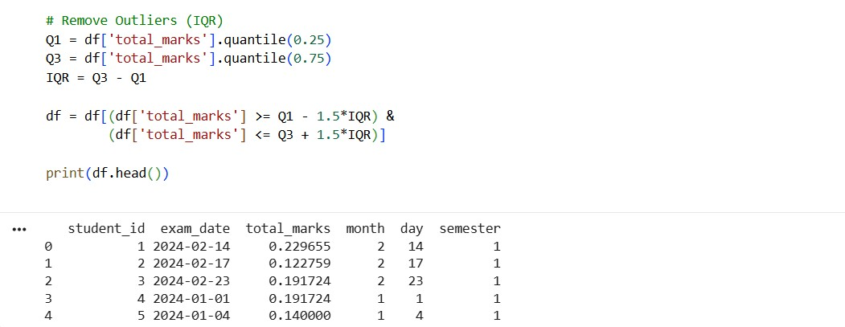

Justification:
Datetime conversion → enables time-based analysis
Feature extraction → captures patterns (semester trends)
MinMax scaling → brings values to 0–1 range
Outlier removal → improves model accuracy

Task 3 – Student Health Data Preparation
Task:
Clean and preprocess student health records using AI scripts.
Prompt:
Prepare a student health dataset for machine learning.
Instructions:
- Handle missing values in height, weight, BMI
- Encode categorical features (medical_condition, fitness_status)
- Scale numerical features using standard scaling
- Split dataset into training and testing sets Code&output:
- 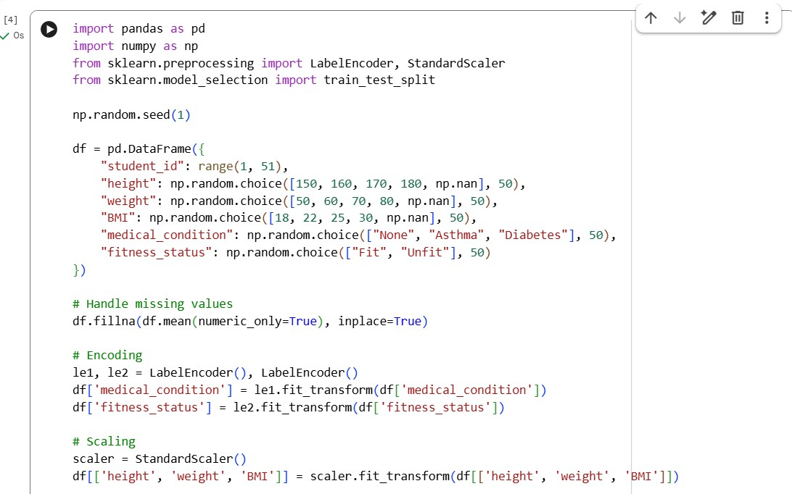
- 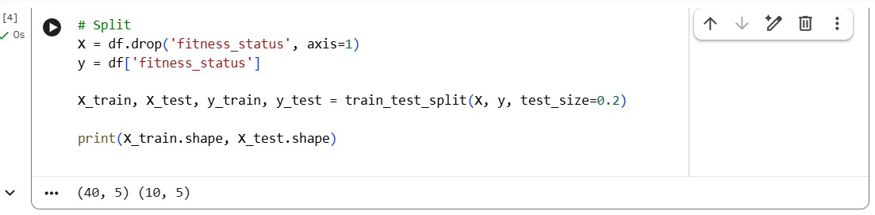

Justification:
Mean imputation → preserves dataset size
Encoding → converts categorical to numeric
Standard scaling → required for ML algorithms
Train-test split → evaluates model performance

Task 4: Real-Time Application: Ride-Sharing Data Cleaning
Scenario:
A ride-sharing company has trip data with errors.
Prompt:
Clean a ride-sharing dataset.
Requirements:
- Standardize pickup and drop locations
- Fill missing fare amounts with median values
- Remove duplicate ride entries
- Normalize driver ratings
- Generate a summary of data improvements

Code:
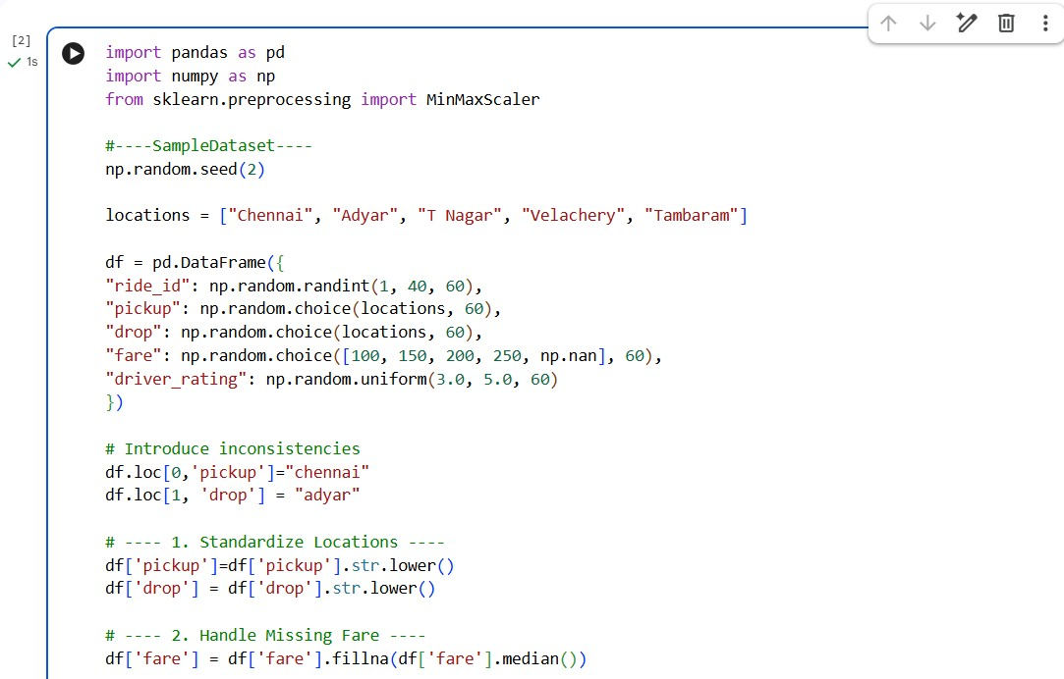
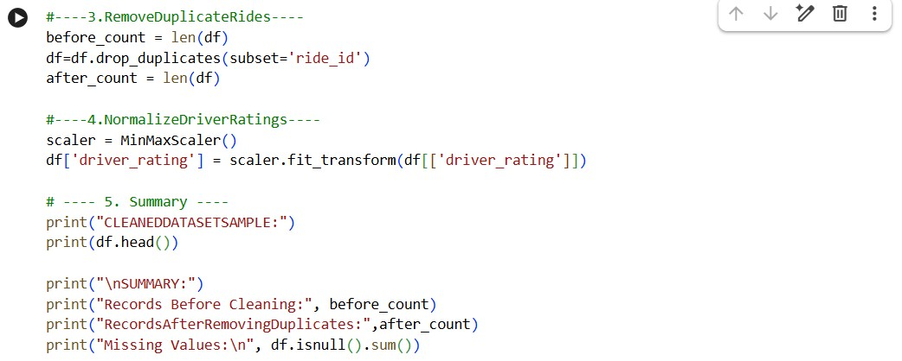

Output:
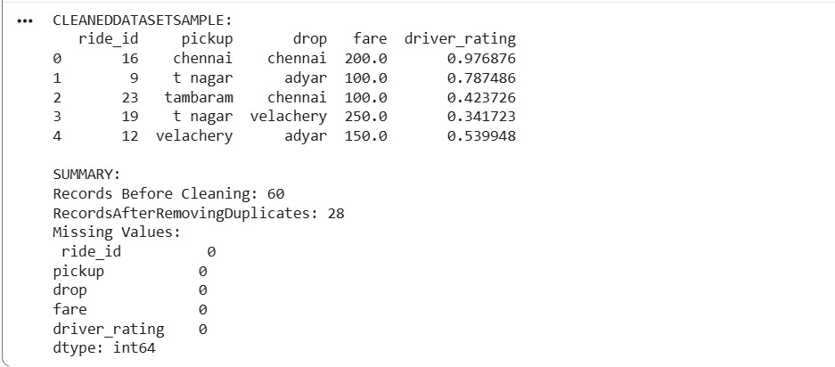

Justification:
Location standardization → avoids duplication issues
Median for fare → robust to extreme values
Duplicate removal → ensures accurate records
Normalization → fair comparison of ratings
Summary → verifies cleaning effectiveness

