Name :S. Naveen Yadav
Hall Ticket No :2303A52230
Batch No : 42

Task 1 – Rapid App Prototyping with AI Task:
Create a quick mobile app prototype using AI in Replit.
Prompt used:
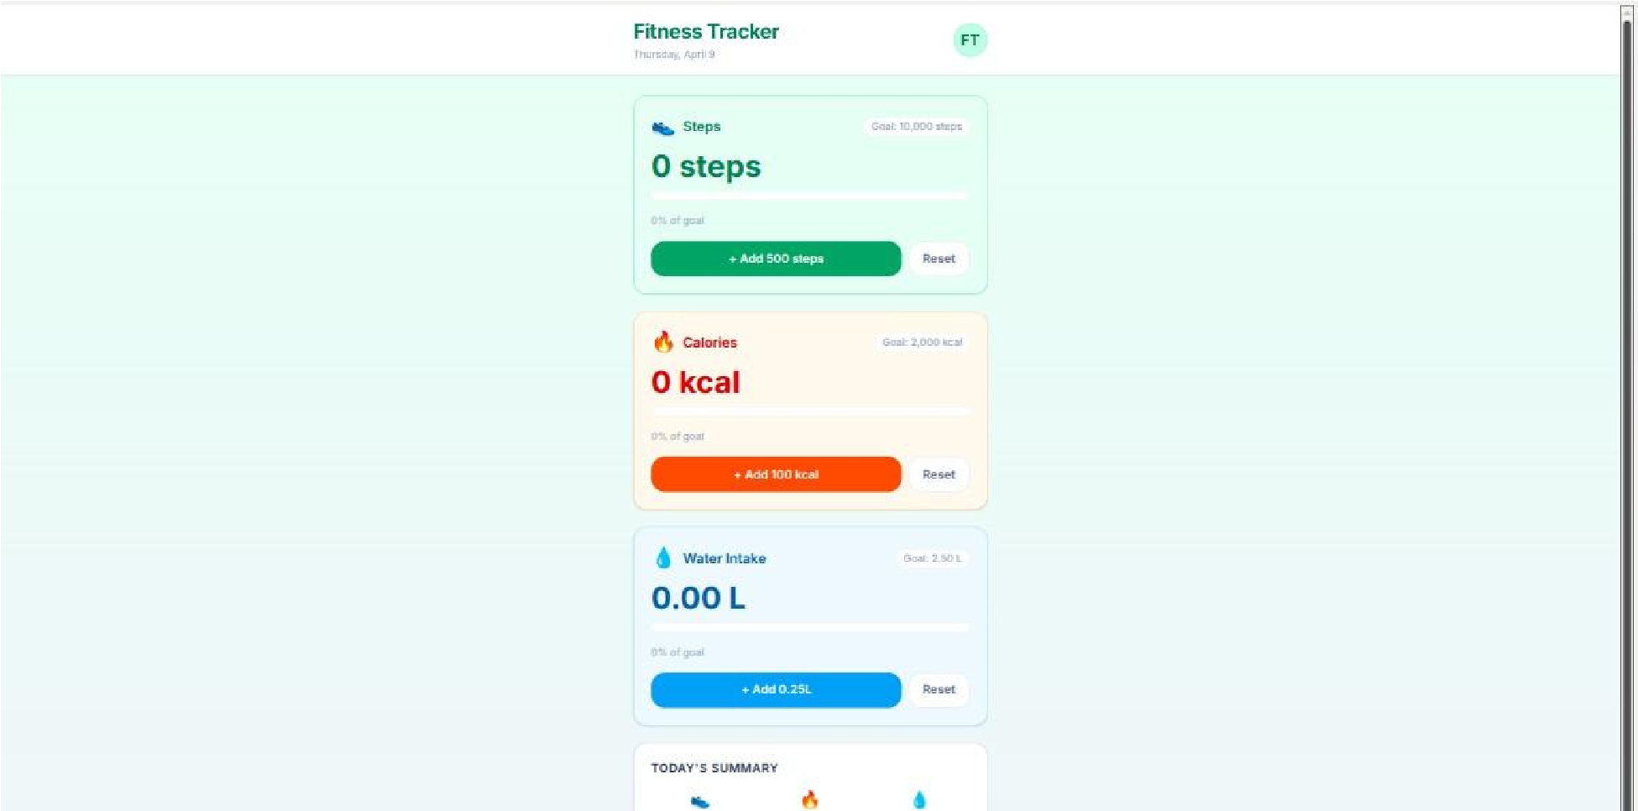
Create a simple mobile-friendly React app UI for a Fitness Tracker.
Include:
- App title "Fitness Tracker"
- Sections: Steps, Calories, Water Intake
- Add placeholder values (e.g., 0 steps, 0 calories, 0L water)
- Use clean layout and basic CSS
- Make it responsive for mobile screens Output:
A simple mobile app interface
AI-generated layout with clearly visible sections
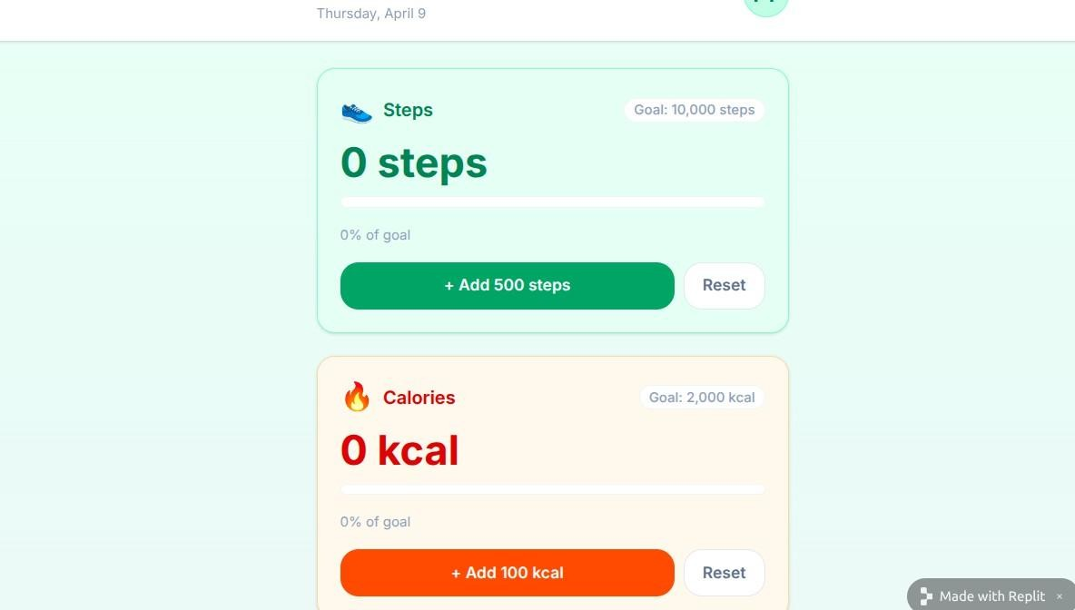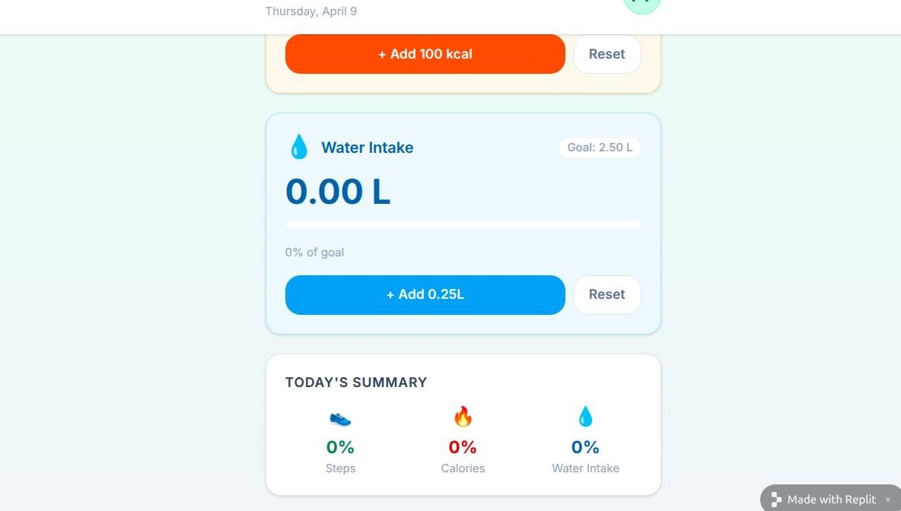

Responsive design for mobile view
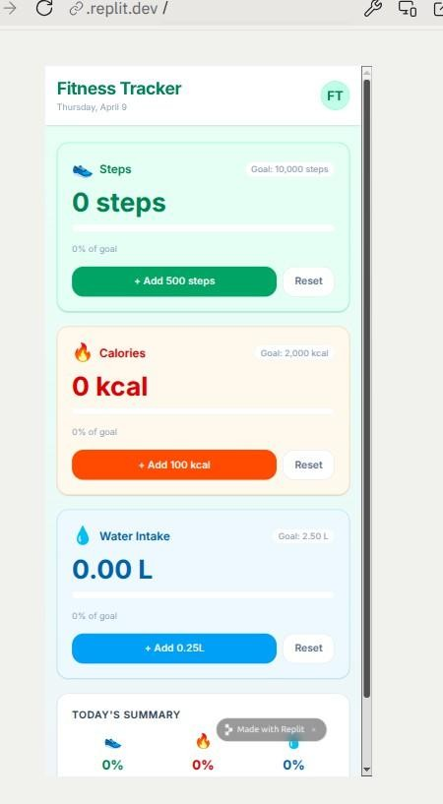

Task 2 – User Input & State Handling Task:
Develop interactive features for user input.
Prompt used:
Enhance the fitness tracker app by:
- Adding input fields for steps, calories, and water intake
- Add buttons to update each value
- Use React useState to manage values
- Update values dynamically on screen - Add validation to allow only numeric input Output:
->Input fields added
->Buttons for updating values
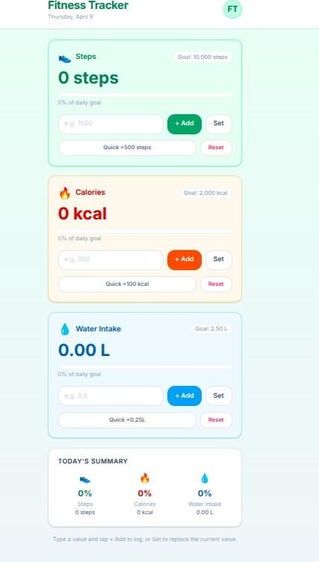

Values update instantly after clicking button
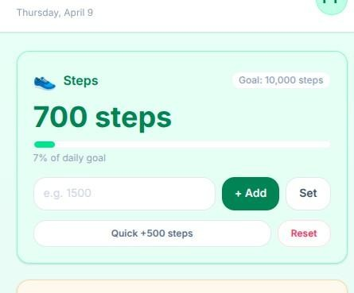

Invalid input (text/symbols) is rejected
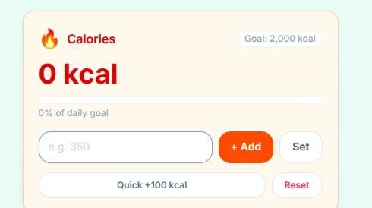
->State is maintained using React Task 3 – Multi-Screen Navigation Task:
Add navigation between multiple screens.
Prompt used:
Add navigation to the app:
- Create 3 screens: Dashboard, Profile, Settings
- Use buttons or tabs for navigation
- Ensure switching screens does not reload the page
- Keep UI consistent across all screens
- Add simple placeholder content in Profile and Settings Output:
Working navigation system
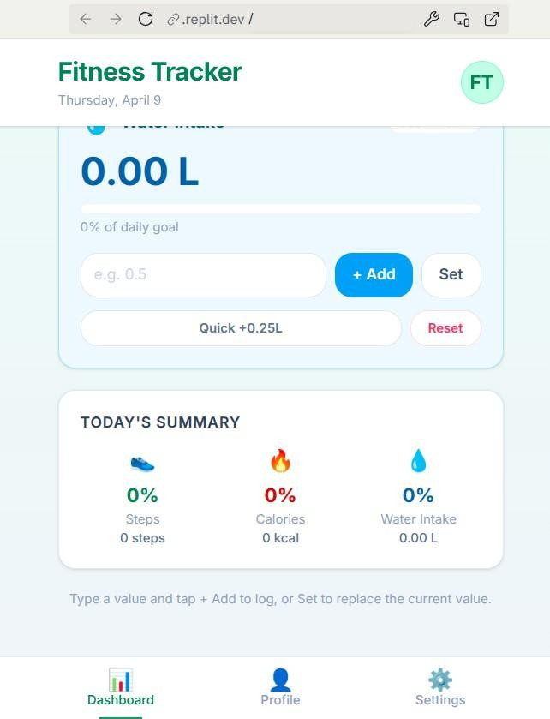
Multiple screens accessible without reload
Clean UI transitions

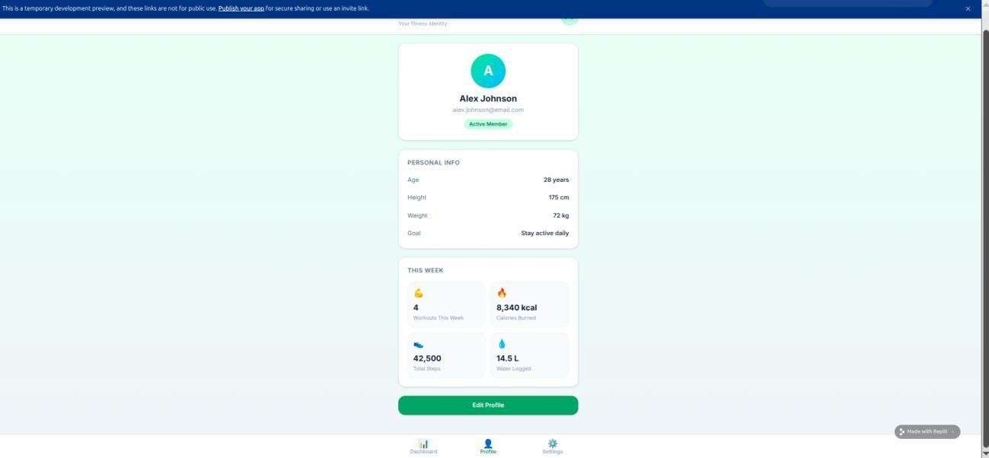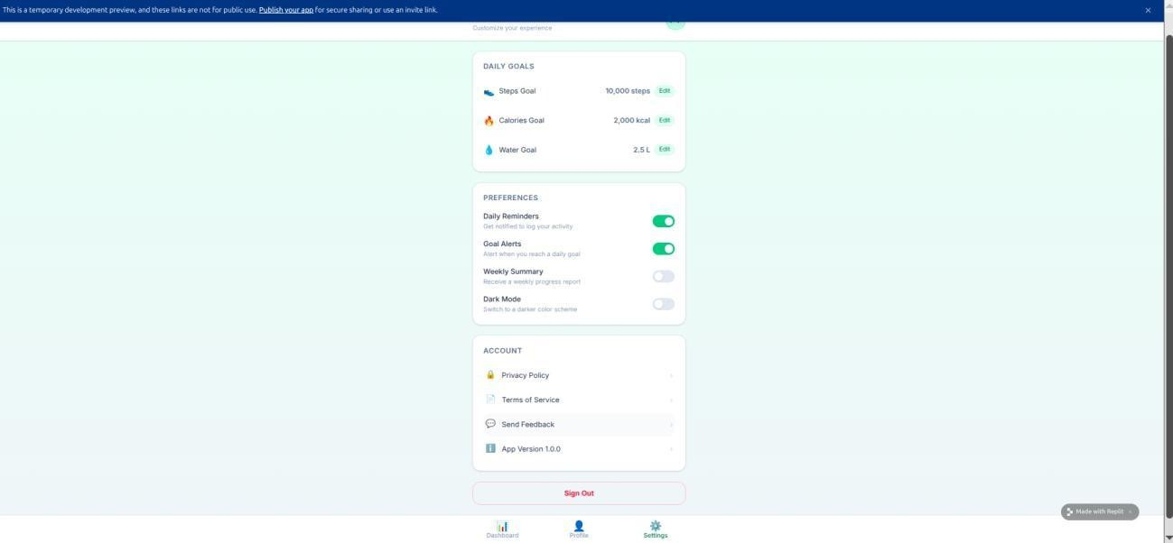
Task 4 – AI-Assisted UI Enhancement & Error Fixing Task:
Improve UI and fix layout issues.
Prompt used:
Improve the UI and fix responsiveness issues:
- Identify alignment problems on small screens
- Improve spacing, font sizes, and layout
- Make buttons and inputs mobile-friendly
- Use better colors and styling
- Ensure all elements align properly on different screen sizes
Output:
Improved UI design
Proper alignment across screen sizes
Cleaner and more readable layout
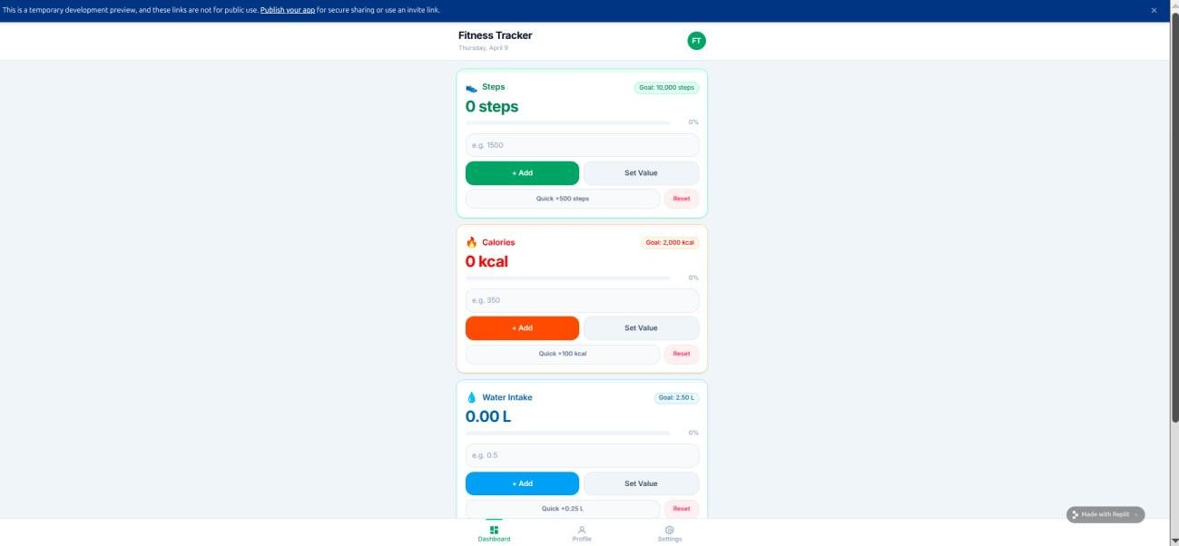

Mobile view
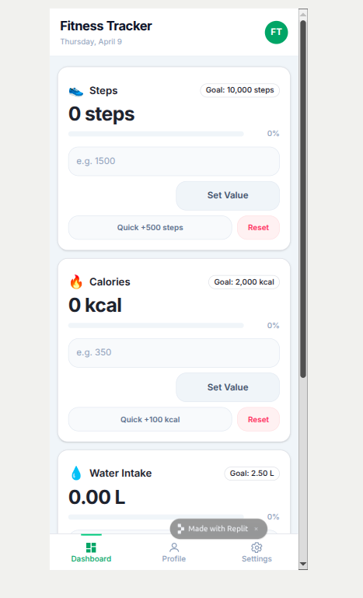
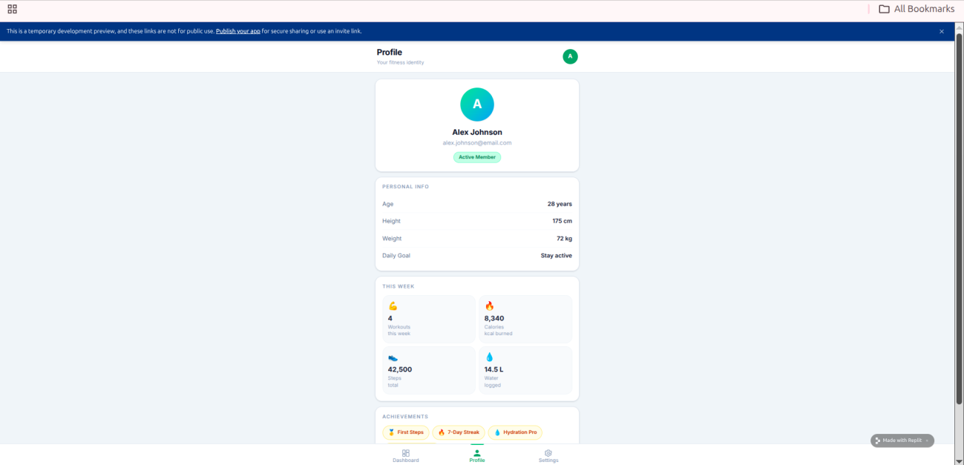

Task 5 – Sharing, Feedback & Iteration Task:
Deploy and refine the app based on feedback.
Prompt used;
Suggest improvements based on user feedback:
- Improve UI clarity and usability
- Fix any bugs in input handling or navigation
- Enhance user experience with small changes - Keep the app simple but more user-friendly App link: https://fit-tracker-ui--shashidhar202.replit.app
Improved version
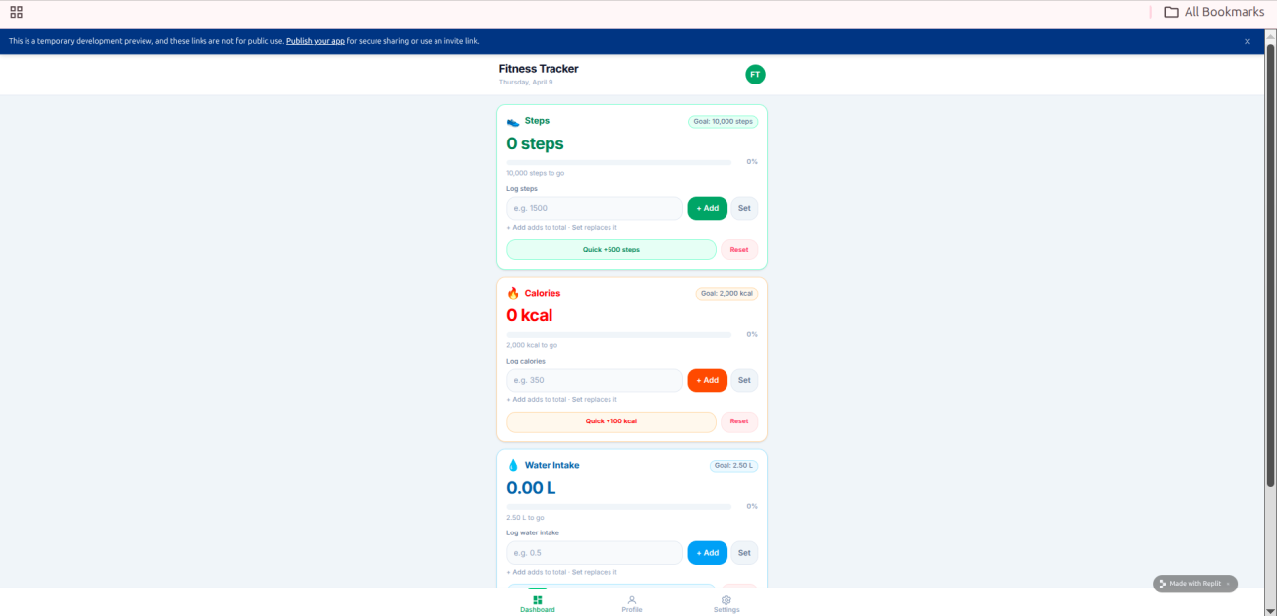

Documented Feedback
User 1 Feedback
UI looks slightly crowded on mobile screens
Buttons are too close to each other
Input field not clearly labeled
User 2 Feedback
Confusion about which button updates which value
Navigation buttons not visually distinct
Water intake unit (L) not clearly understood

Issues Identified (from feedback)
Poor spacing between UI elements
Lack of labels for inputs
Buttons unclear in purpose
Weak visual hierarchy
Minor responsiveness issues

Improvements Implemented
UI Improvements
Added proper spacing between sections and buttons
Increased padding for better touch interaction
Improved font size for readability
Input Enhancements Added labels:
Enter Steps
Enter Calories
Enter Water Intake (Liters)
Button Clarity
Renamed buttons:
Update Steps
Update Calories
Update Water
Navigation Enhancement
Styled navigation buttons (highlight active tab)
Added better alignment and spacing
Responsiveness Fix
Converted layout to column format for mobile
Ensured all elements fit within screen width

Improved Version Summary
Cleaner and more organized UI
Better readability on small screens
Clear input instructions
Improved user interaction
More intuitive navigation
Fully responsive design

Final output:
The application was deployed using Replit and shared with peers for feedback.
Based on user feedback, several improvements were implemented including better spacing, clearer input labels, improved button naming, and enhanced responsiveness. The updated version provides a cleaner UI, improved usability, and a more intuitive user experience.

