Assignment 12.4
Shaik.Sohail
2303A52231
Batch: 44
Task 1: Bubble Sort for Ranking Exam Scores
Code:
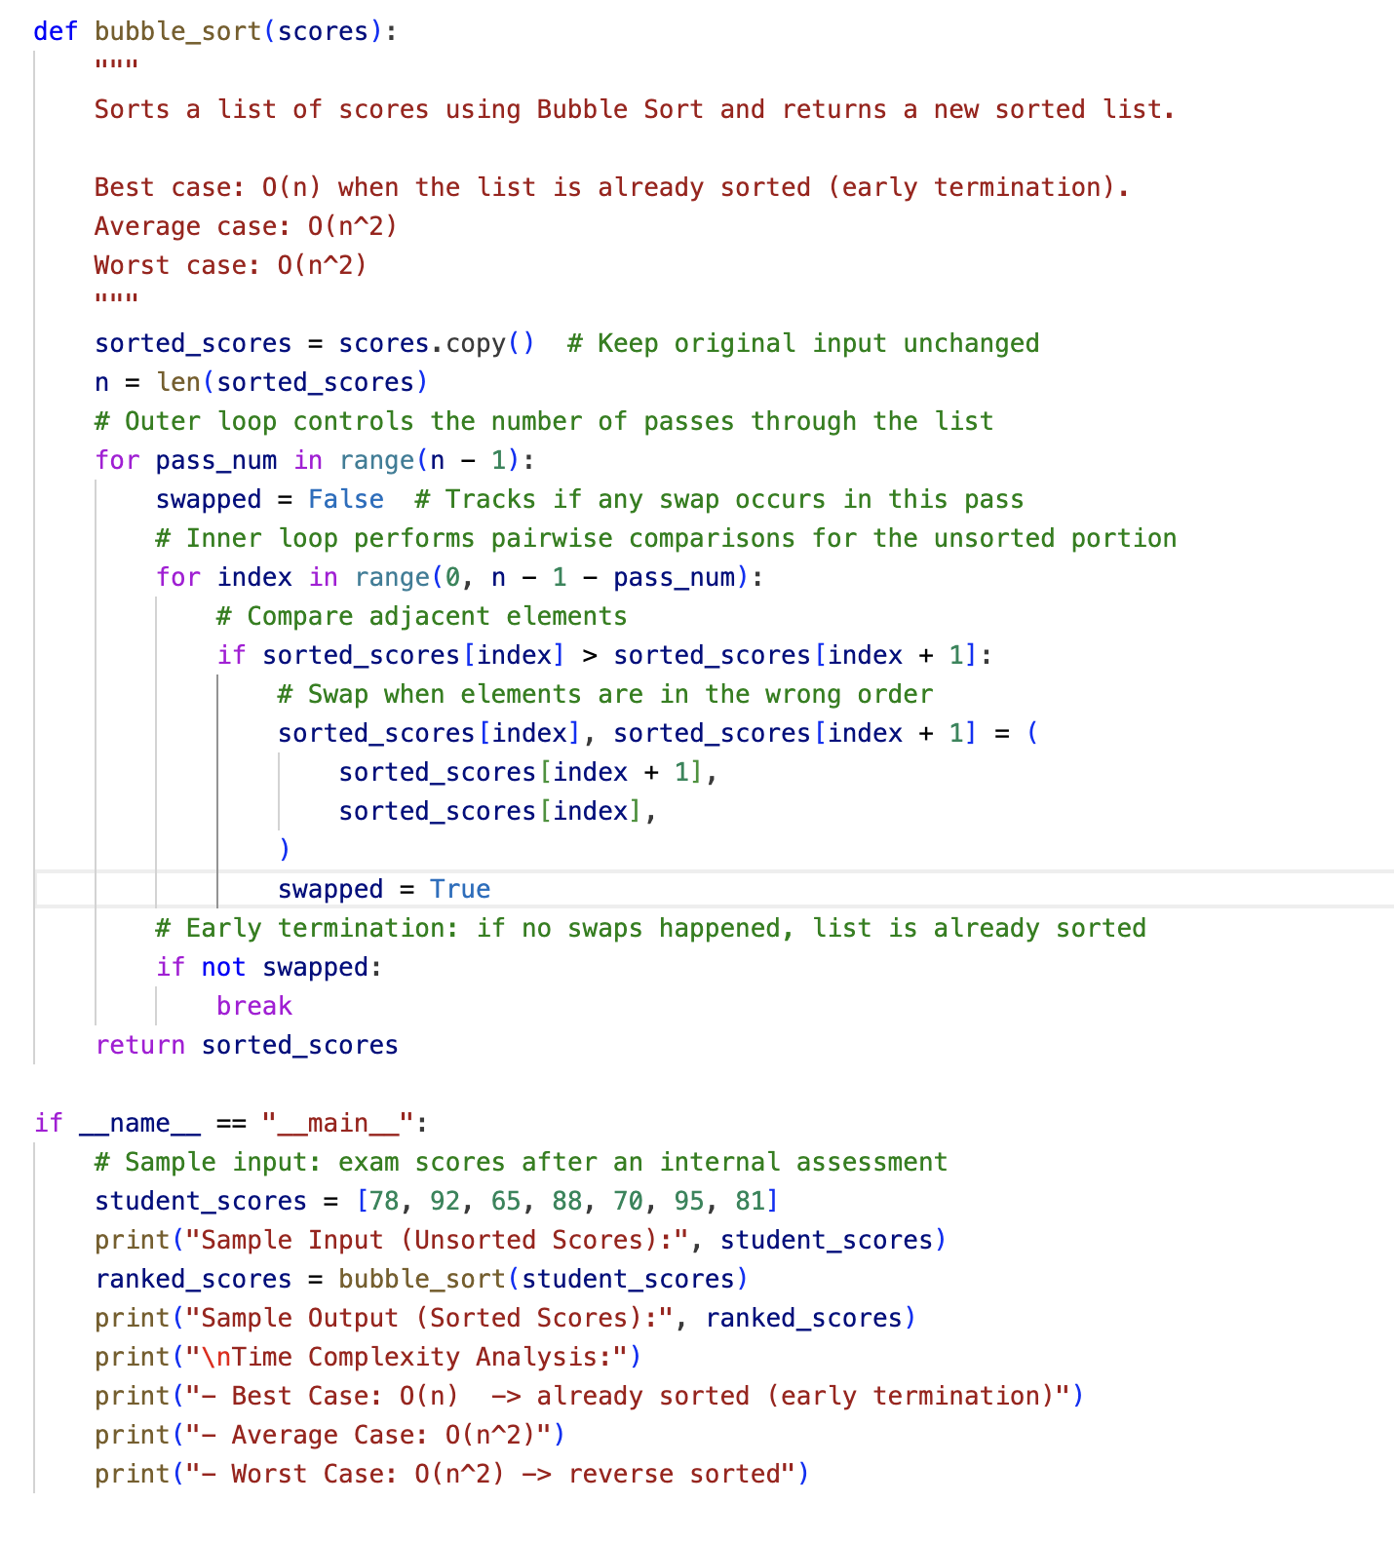

Input & Output:
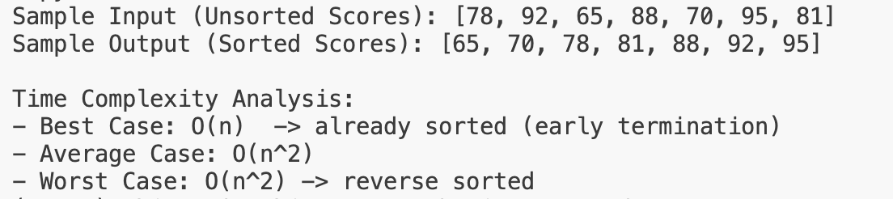

Task 2: Improving Sorting for Nearly Sorted Attendance Records.
Code:
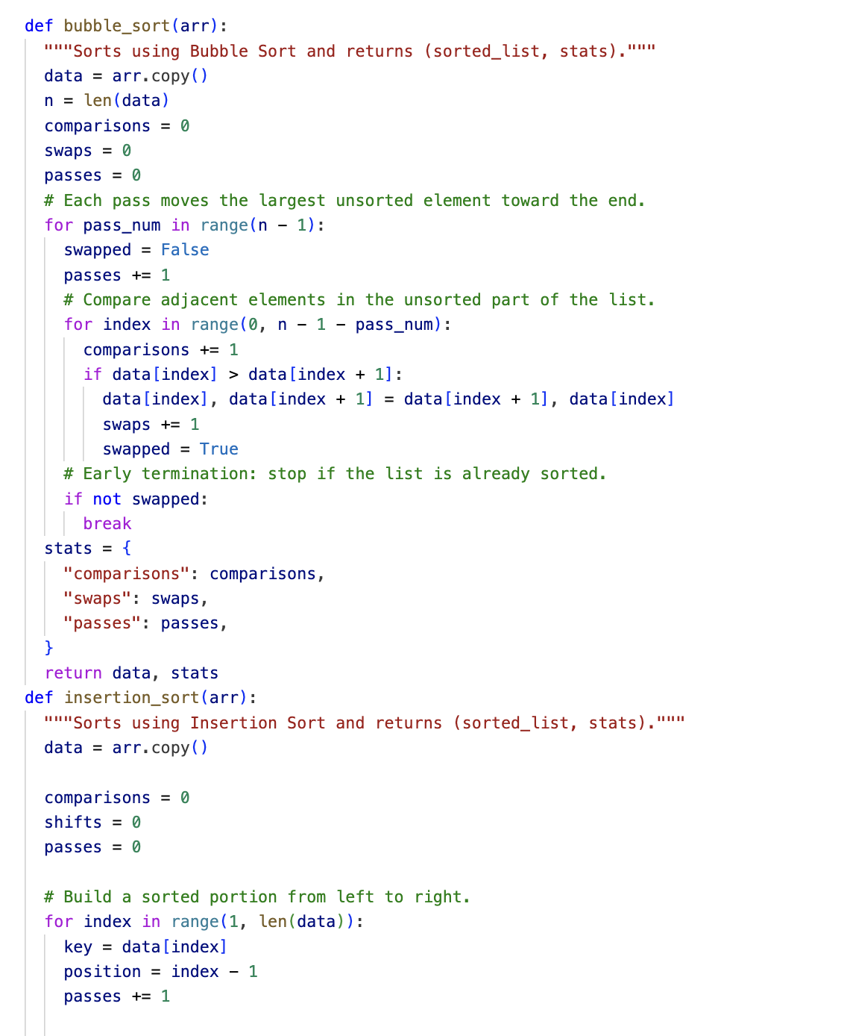
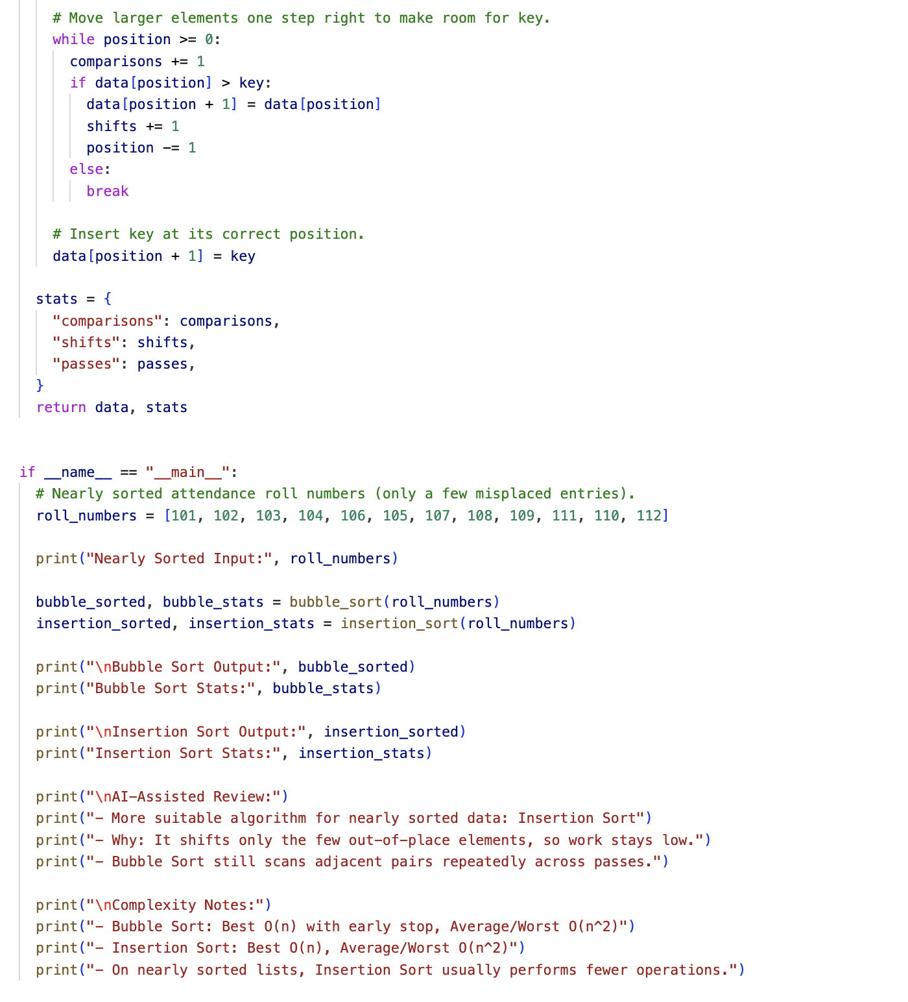
Input & Output:
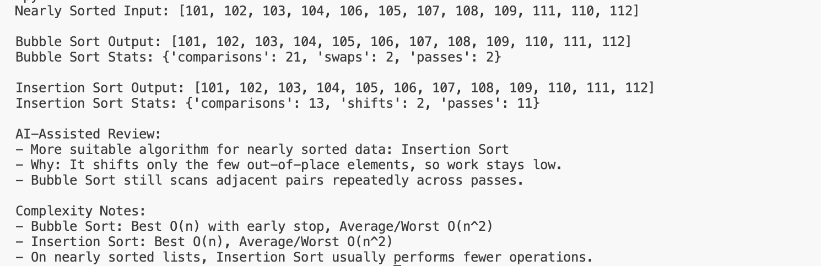
Task 3: Searching Student Records in a Database
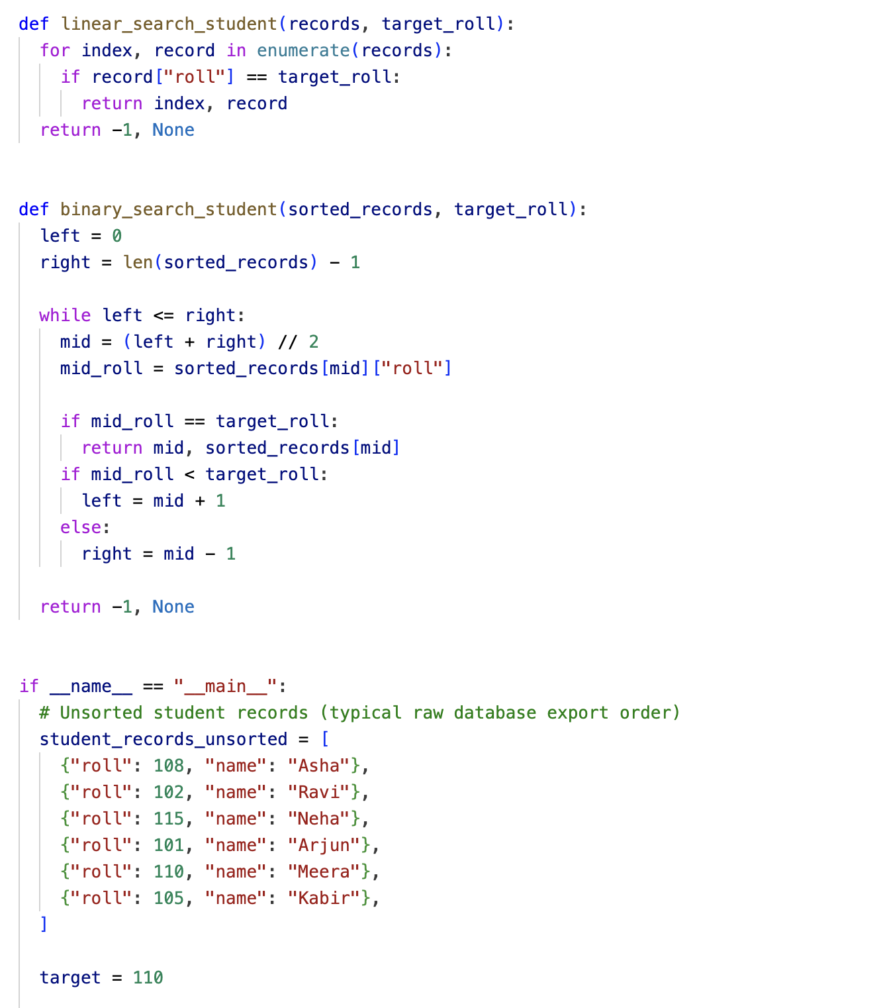

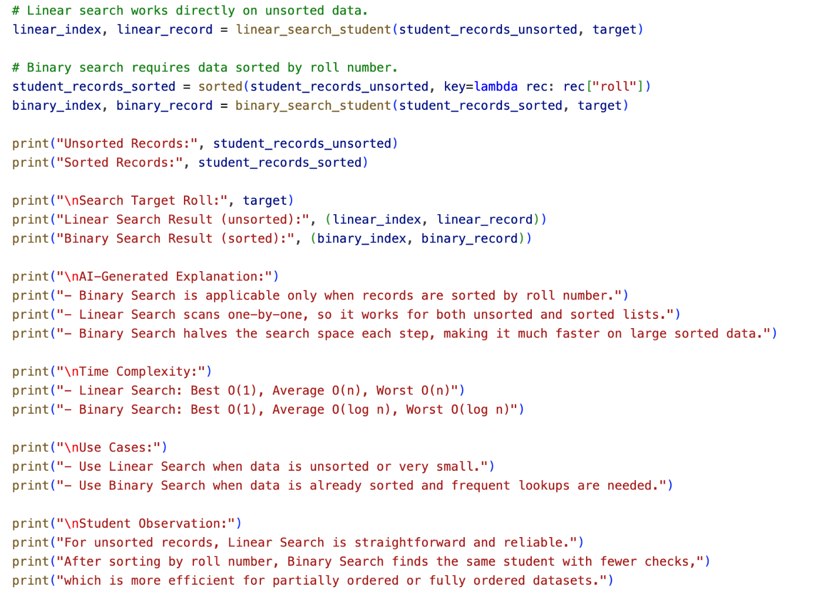

Input & Output:
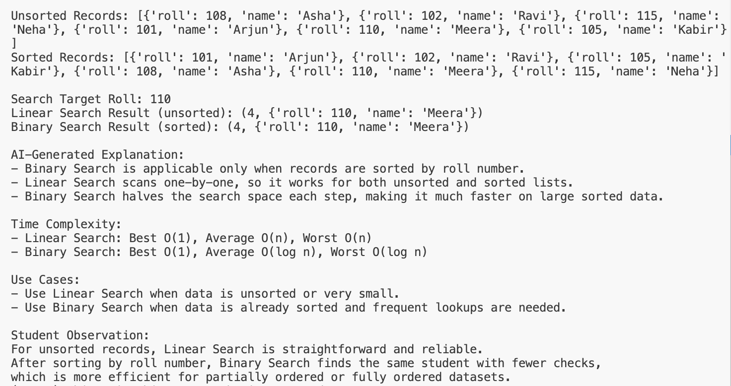
Task 4: Choosing Between Quick Sort and Merge Sort
For Data Processing
Code:
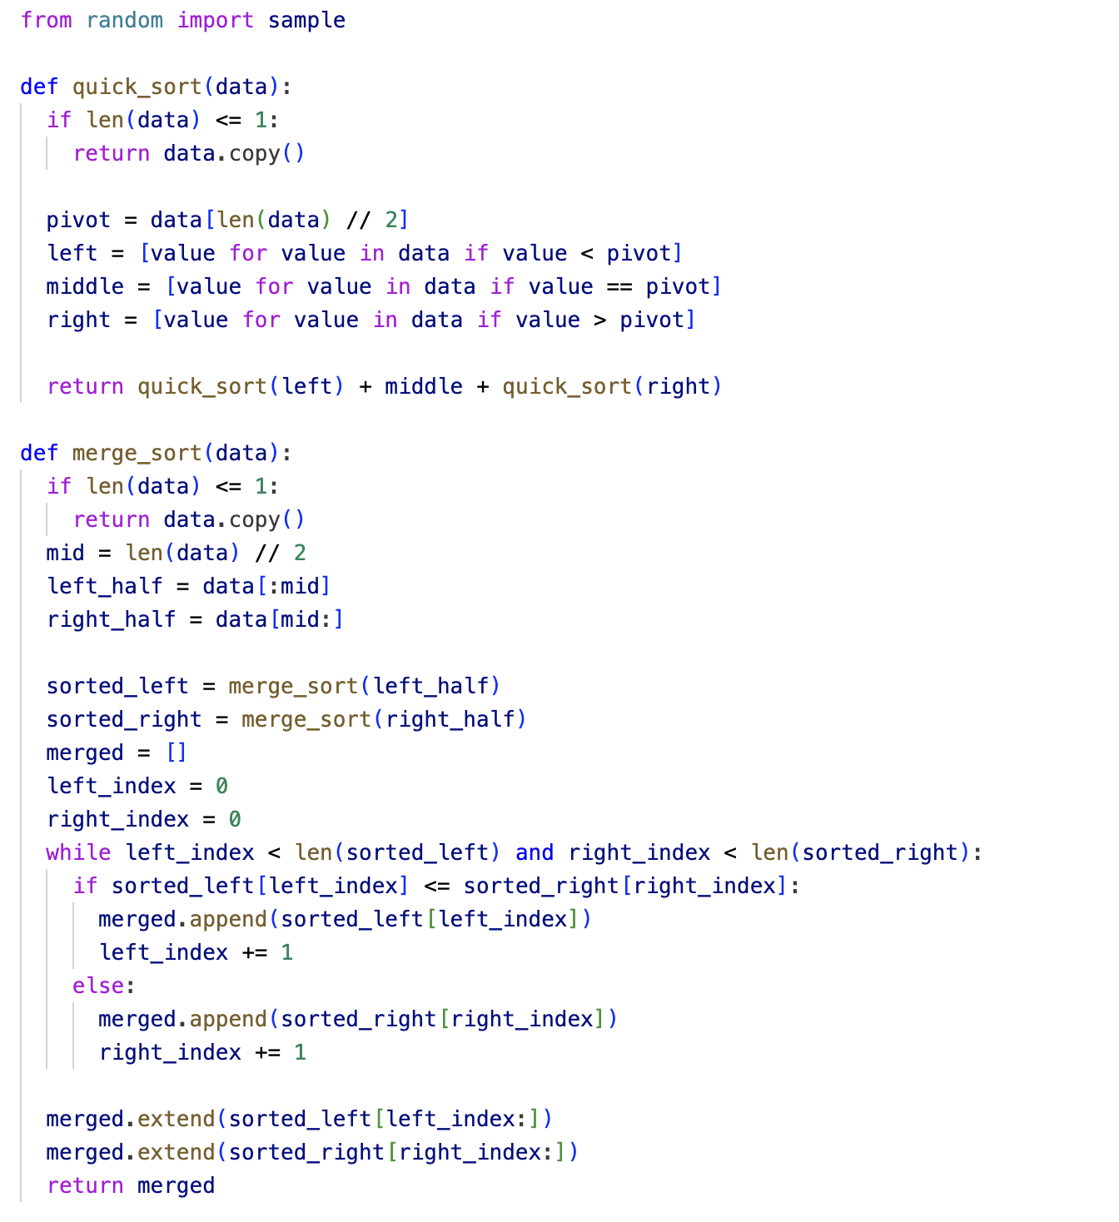
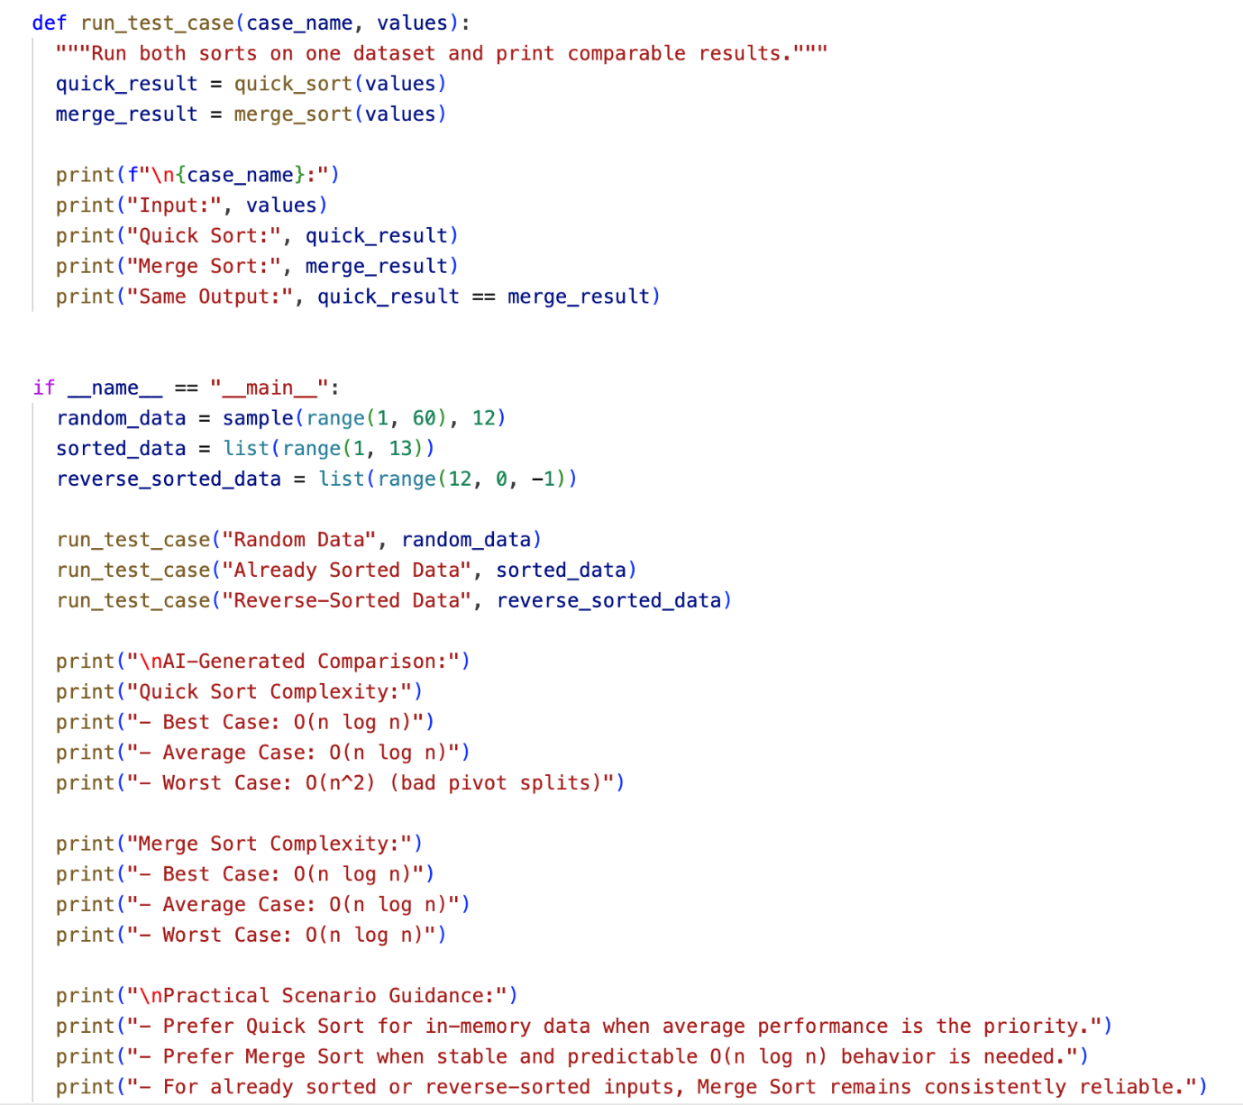

Input & Output:
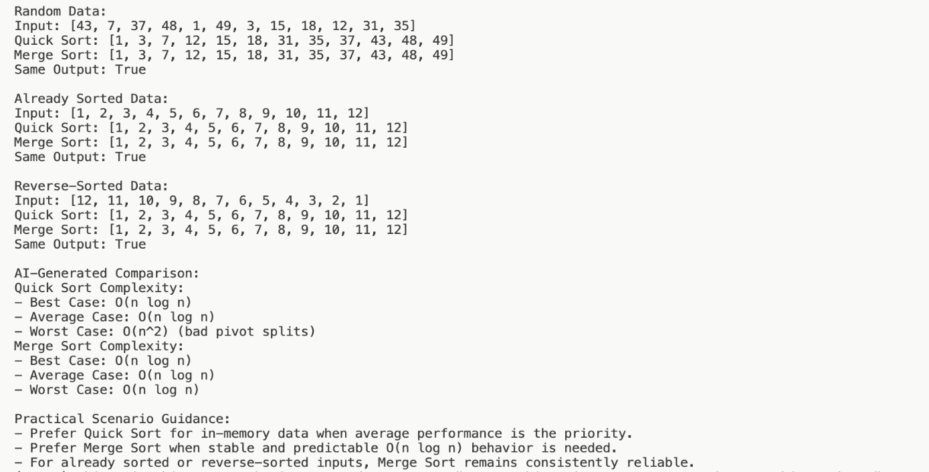
Task 5: Optimizing a Duplicate Detection Algorithm
Code: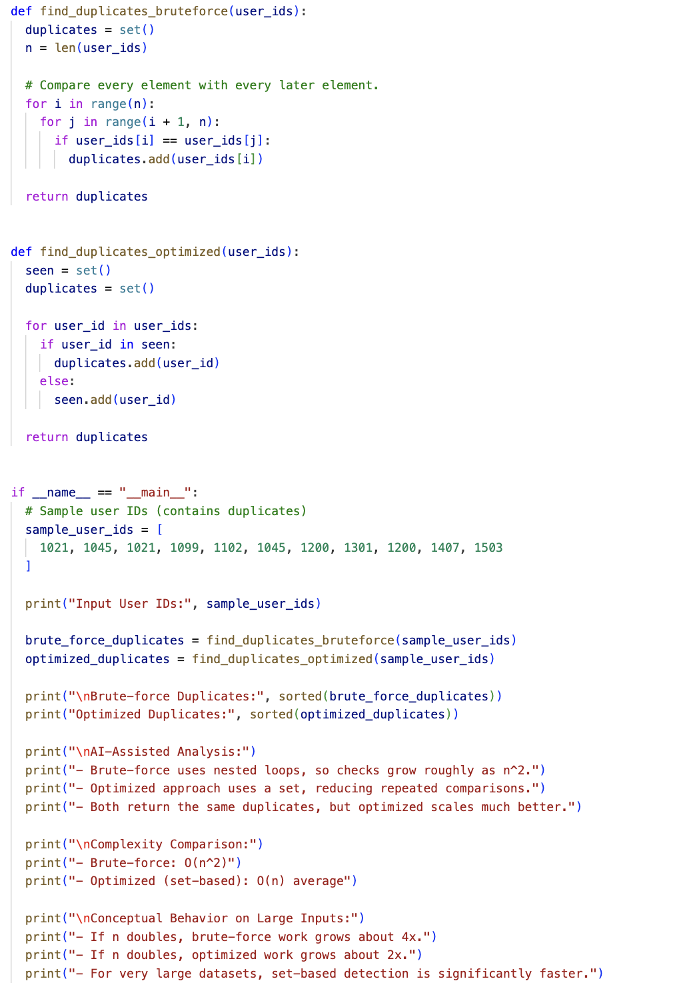
Input & Output:
