AI Assistant Coding
Assignment-2

Name of Student : G.SriSahith
Enrollment No. : 2303A52243
Batch : 37

Task 1: Cleaning Sensor Data
❖ Scenario:
❖ You are cleaning IoT sensor data where negative values are invalid.
❖ Task:
Use Gemini in Colab to generate a function that filters out all negative
numbers from a list.

Prompt:
give me a function that filters out all negative numbers from a list

Code:

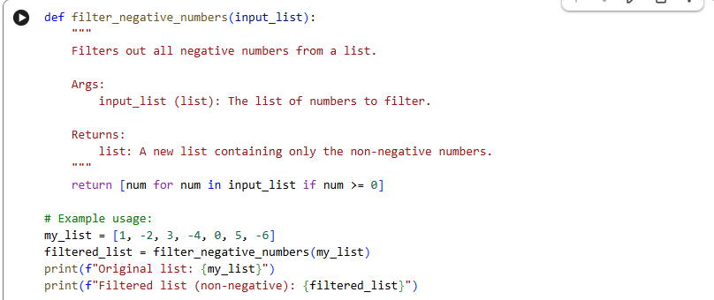
Output:

Justification:
It provides a well-defined function to filter negative numbers, includes docstrings for readability, and demonstrates its usage with an example, making it immediately useful and easy to understand.
Task 2: String Character Analysis
❖ Scenario:
You are building a text-analysis feature.
❖ Task:
Use Gemini to generate a Python function that counts vowels, consonants,
and digits in a string.

Prompt:
generate a function that counts vowels, consonants and digits in a string

Code: 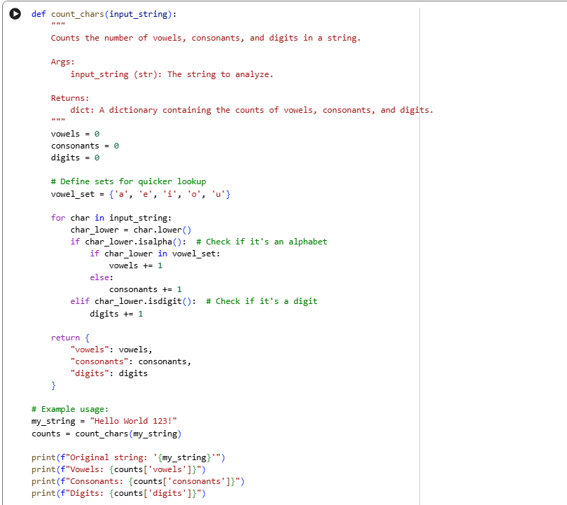

Output:

Justification:
the count_chars function is essential for string analysis, offering a straightforward method to categorize and count characters within a given text. This capability is particularly useful for tasks like data validation, linguistic analysis, or basic text processing where understanding the composition of a string (how many vowels, consonants, or digits it contains) is crucial. It provides clear, structured output, making it easy to integrate into larger applications or data pipelines..

Task 3: Palindrome Check – Tool Comparison
❖ Scenario:
You must decide which AI tool is clearer for string logic.
❖ Task:
Generate a palindrome-checking function using Gemini and Copilot, then
compare the results.

Prompt:
generate a palindrome-checking function

Code:

Google Colab:

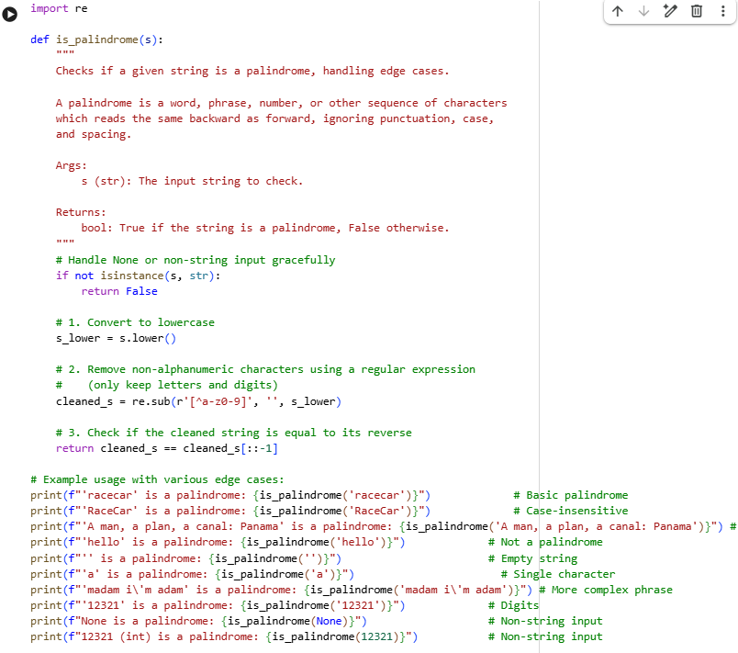

Cursor AI:
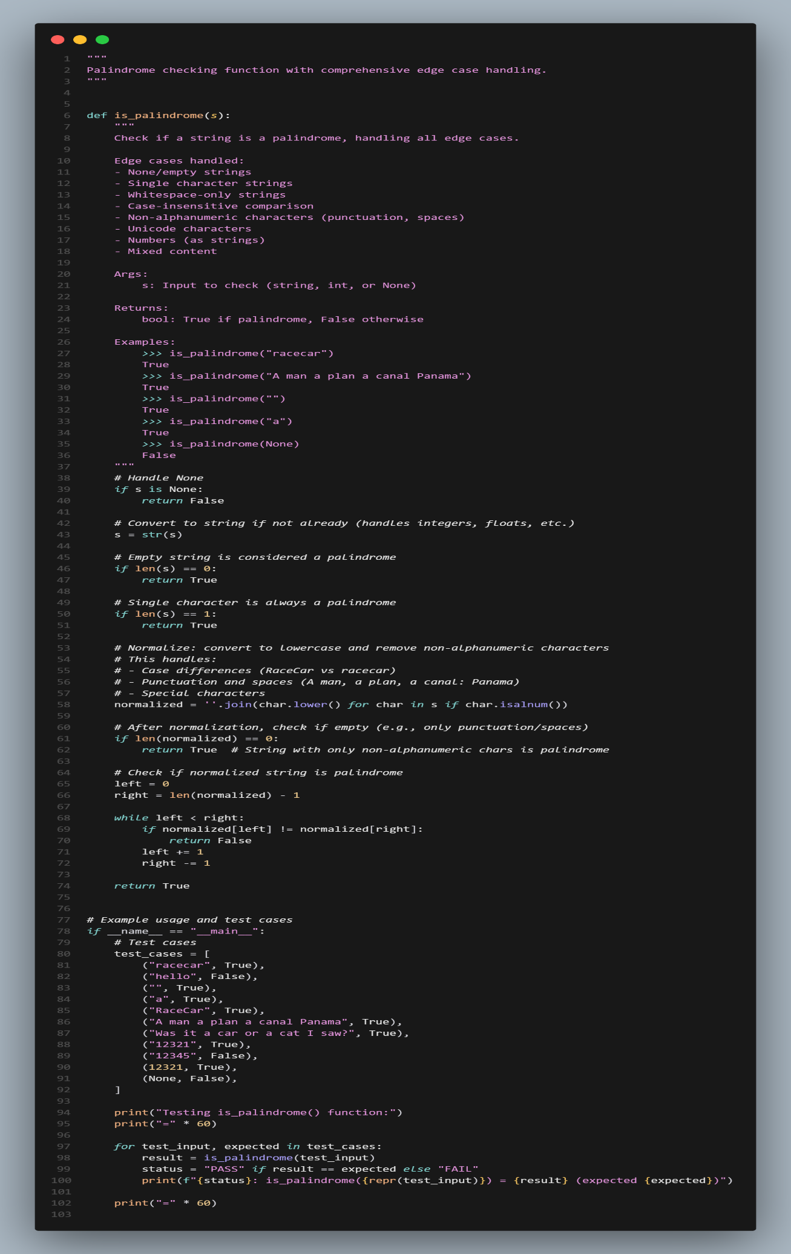

Output:

Google Colab:
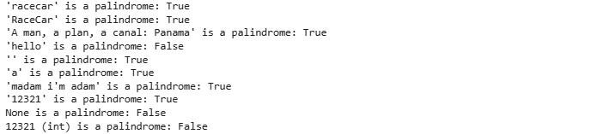
Cursor AI:
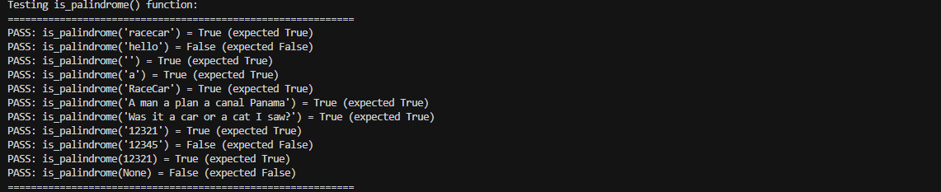

Comaparison:
Feature | Google Colab (Gemini AI) (Regex + Slice) | Cursor AI (Two Pointers)
Code size | Very short | Slightly longer
Readability | Clean & compact | Clear, step-by-step
Palindrome check | s == s[::-1] | Left–right pointers
Edge cases | Basic | Handles more cases
Unicode support | Limited | Better (isalnum)
Best for | Interviews, quick tasks | Learning, production

Justification:
- Google Colab(Gemini AI) feels great when you want something quick and elegant—it’s easy to read and perfect for interviews or short problems.

- Cursor AI takes a more careful, real-world approach, clearly showing each step and handling more edge cases.
If speed and simplicity matter, go with Gemini AI.
If clarity, learning, and robustness matter more, Cursor AI is the better choice.
Task 4: Code Explanation Using AI
❖ Scenario:
You are reviewing unfamiliar code written by another developer.
❖ Task:
Ask Gemini to explain a Python function (prime check OR palindrome
check) line by line.
❖ Expected Output:
➢ Code snippet
➢ AI explanation
➢ Student comments on understanding

Prompt:

generate prime check function and explain the code line by line

Code:

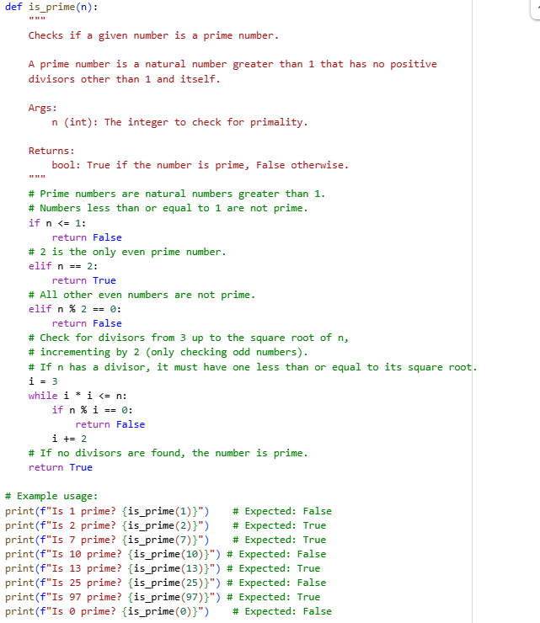

Output:
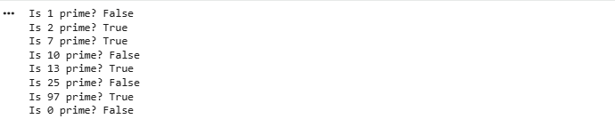

AI Explanation(Line-By-Line):

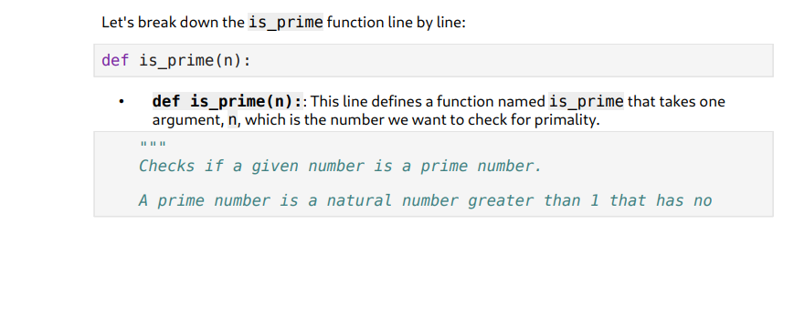
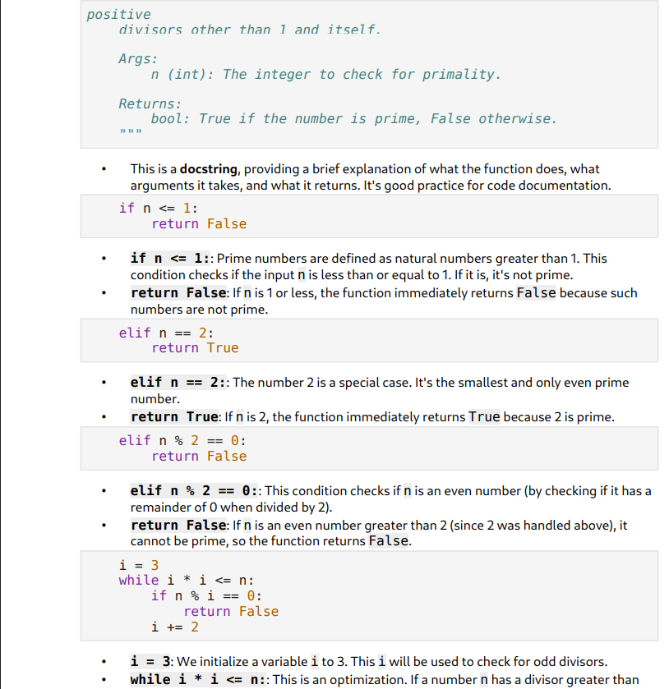

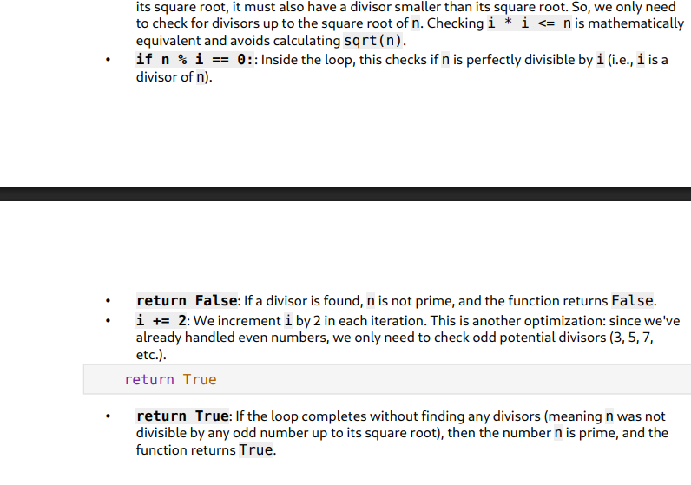
Understanding/Outcome:

I now understand the is_prime function much better! The explanation clearly broke down the logic, especially why numbers less than or equal to 1 are not prime, why 2 is a special case, and the optimization of checking divisors only up to the square root and incrementing by 2. This makes the code efficient and easy to follow.

