Assignment-10.3
NAME:D.Havish
BATCH -42
2303a52253
Problem Statement 1: AI-Assisted Bug Detection
Scenario: A junior developer wrote the following Python function to calculate factorials: def factorial(n):
result = 1 for i in range(1, n): result = result * i return result
Instructions:
- Run the code and test it with factorial(5).
- Use an AI assistant to:
- Identify the logical bug in the code.
- Explain why the bug occurs (e.g., off-by-one error).
- Provide a corrected version.
3. Compare the AI’s corrected code with your own manual fix. 4. Write a brief comparison: Did AI miss any edge cases (e.g., negative numbers, zero)?

Code:
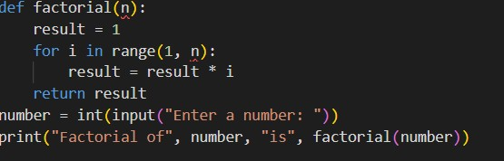

PROMPT: Identify the error in the above code and correct it and explain the bug errors in the above code. Provide me the corrected code and the explanation of the bug errors.
Ai -corrected -code:
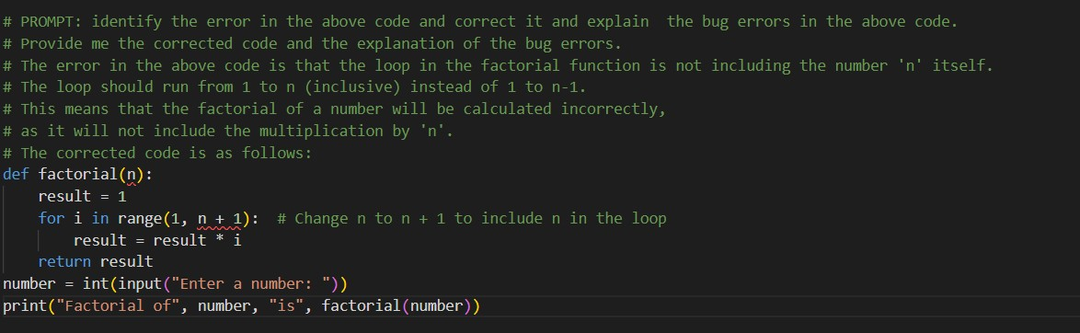
Output:
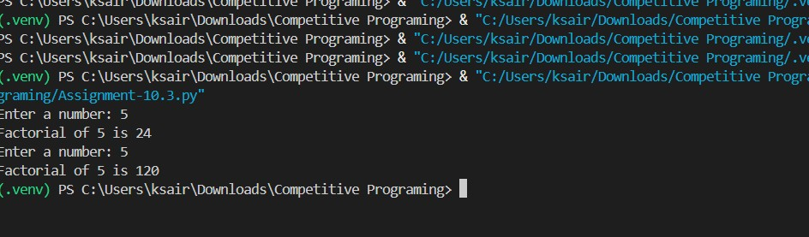
Justification: By changing the loop to run from 1 to n + 1, we ensure that the multiplication includes 'n' itself, which is essential for calculating the correct factorial value.
Problem Statement 2: Task 2 — Improving Readability &
Documentation
Scenario:The following code works but is poorly written: def calc(a, b, c): if c == "add": return a + b elif c == "sub": return a – b elif c == "mul": return a * b
elif c == "div": return a/b 5. Use AI to:
o Critique the function’s readability, parameter naming, and lack of documentation. Rewrite the function with:
- Descriptive function and parameter names.
- A complete docstring (description, parameters, return value, examples).
- Exception handling for division by zero.
- Consideration of input validation.
- Compare the original and AI-improved versions.
- Test both with valid and invalid inputs (e.g., division by zero, non-string operation).

Code:
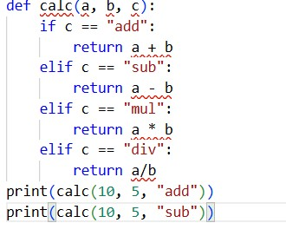
Output:
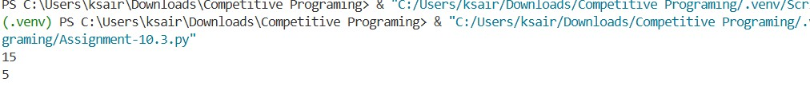
Prompt:Create a python function that makes calculation on add ,sub,div,and mul.It should handle exception handling and return the values and improve the code the original code.

Ai -Corrected code:
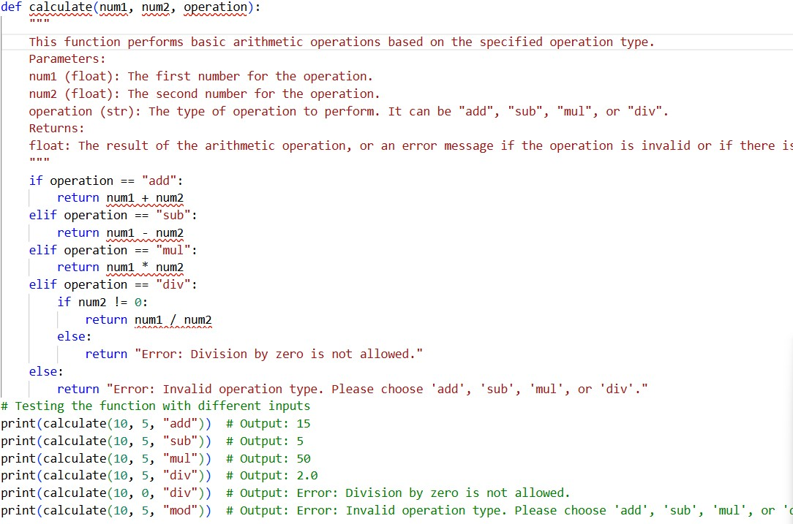

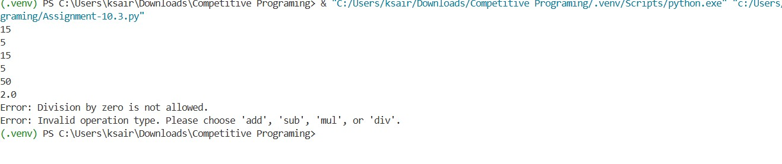
Justification:
The function is designed to be clear and descriptive, with meaningful parameter names and a comprehensive docstring that explains its purpose, parameters, and return value. It also includes error handling for division by zero and invalid operation types, ensuring that it behaves predictably in various scenarios. The function is tested with different inputs to confirm its correctness and robustness.
Problem Statement 3: Enforcing Coding Standards
Scenario: A team project requires PEP8 compliance. A developer submits: def Checkprime(n): for i in range(2, n):
if n % i == 0: return False return True
Instructions:
- Verify the function works correctly for sample inputs.
- Use an AI tool (e.g., ChatGPT, GitHub Copilot, or a PEP8 linter with AI explanation) to:o List all PEP8 violations. o Refactor the code (function name, spacing, indentation,naming).
- Apply the AI-suggested changes and verify functionality is preserved.

Code:
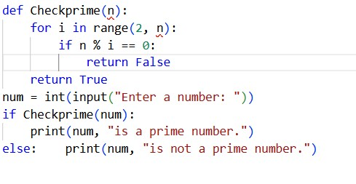
Output:
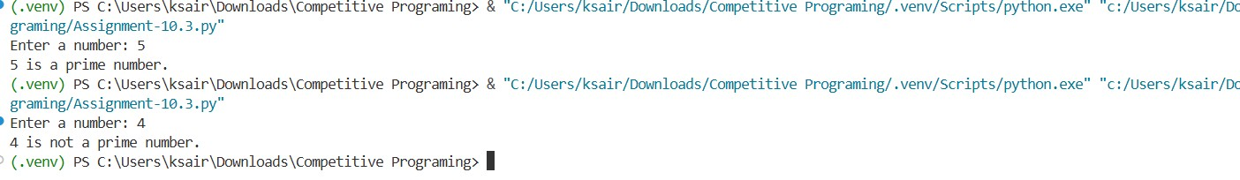
Prompt:
Verify the given Python function using sample inputs. Identify all PEP8 style violations and explain them. Refactor the code to follow PEP8 naming, spacing, and indentation rules, then confirm the refactored code still works correctly.
Ai -Corrected Code:
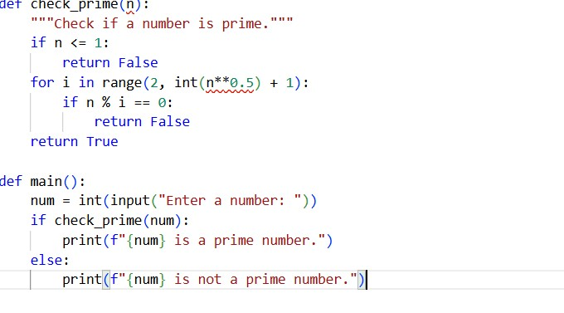

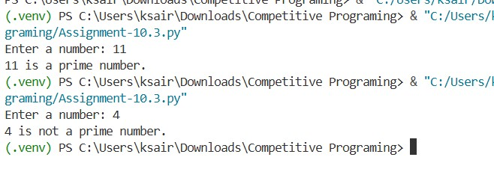
Justification:
The function name is changed to check_prime to follow the convention. Added a docstring to explain the purpose of the function. Added a check for numbers less than or equal to 1, as they are not prime. Used `int(n**0.5) + 1` to optimize the prime checking process, as a number is not prime if it has a divisor less than or equal to its square root.
Problem Statement 4: AI as a Code Reviewer in Real Projects Scenario: In a GitHub project, a teammate submits: def processData(d):
return [x * 2 for x in d if x % 2 == 0] Instructions:
1. Manually review the function for:
- Readability and naming. o Reusability and modularity.
- Edge cases (non-list input, empty list, non-integer elements).
2. Use AI to generate a code review covering:
- Better naming and function purpose clarity.
- Input validation and type hints.
- Suggestions for generalization (e.g., configurable multiplier).
- Refactor the function based on AI feedback.
- Write a short reflection on whether AI should be a standalone reviewer or an assistant.
Code:
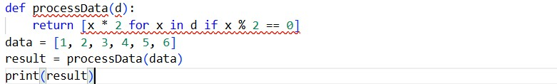
Output:
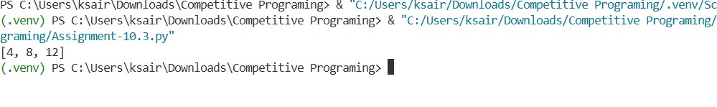
Prompt:
Review the following Python function for readability, naming, reusability, and edge cases. Suggest improvements with better naming, type hints, input validation, and generalization (configurable multiplier). Refactor the code and explain whether AI should be a standalone code reviewer or an assistant.
Ai-Corrected-code:
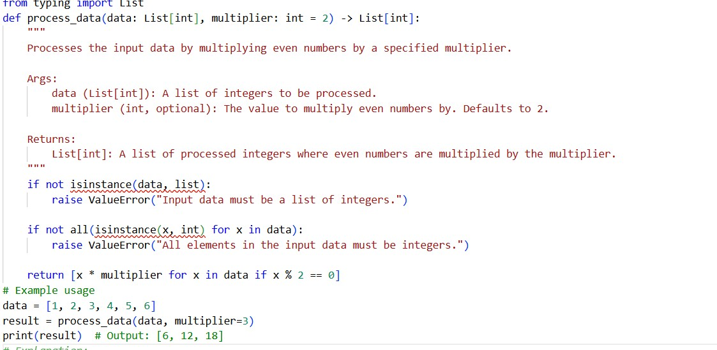
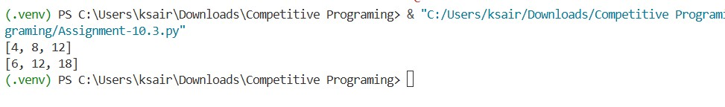
Justification:
The refactored code includes improved naming conventions for better readability, type hints for clarity, and input validation to handle edge cases. The function is now more reusable with a configurable multiplier.
Problem Statement 5: — AI-Assisted Performance Optimization
Scenario: You are given a function that processes a list of integers, but it runs slowly on large datasets: def sum_of_squares(numbers):
total = 0
for num in numbers: total += num ** 2 return total
Instructions:
- Test the function with a large list (e.g., range(1000000)).
- Use AI to:
- Analyze time complexity.
- Suggest performance improvements (e.g., using built-in functions, vectorization with NumPy if applicable). o Provide an optimized version.
- Compare execution time before and after optimization.
- Discuss trade-offs between readability and performance.

Code:
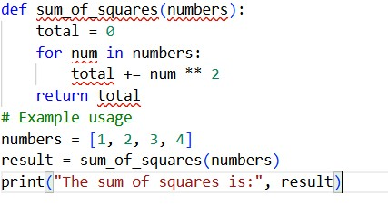
Output:
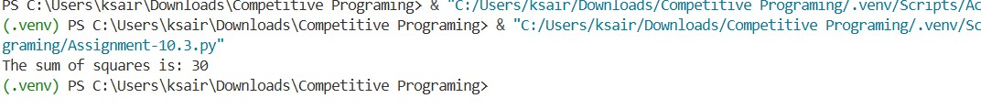
Prompt:
Analyze the time complexity of the given function that computes the sum of squares. Suggest performance optimizations using Python built-ins or NumPy, provide an optimized version, compare execution time, and discuss trade-offs between readability and performance.
Ai -Correcred-code:
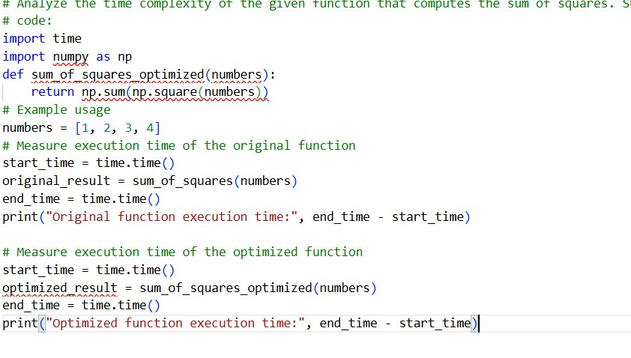
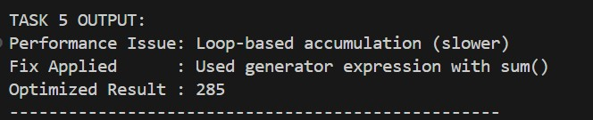
Justification:
Task 5 shows how AI can analyze code performance and suggest faster implementations. It helps optimize functions for large datasets using efficient Python constructs or libraries like NumPy. This demonstrates AI’s role in improving efficiency while maintaining code readability.

