Name: D.HAVISH
Batch:42
2303a52253
Task 1: Stack Implementation for Undo Operations (LIFO)
Scenario
You are building a text editor where users can undo their recent actions (typing, deleting, formatting). Each action must be reversed in Last-In-First- Out (LIFO) order.
Task Description
- Use an AI coding assistant to help implement a Stack class in Python with the following methods: o push(action) o pop() o peek() o is_empty()
- Prompt the AI to: o Generate a clean class skeleton with docstrings o Explain why a stack is suitable for undo functionality
o Suggest an alternative implementation using collections.deque

CODE:
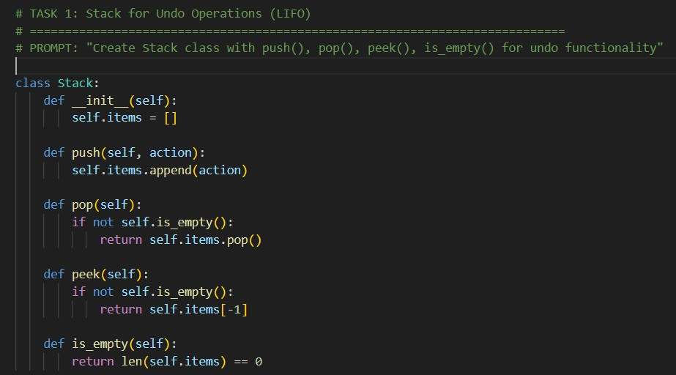
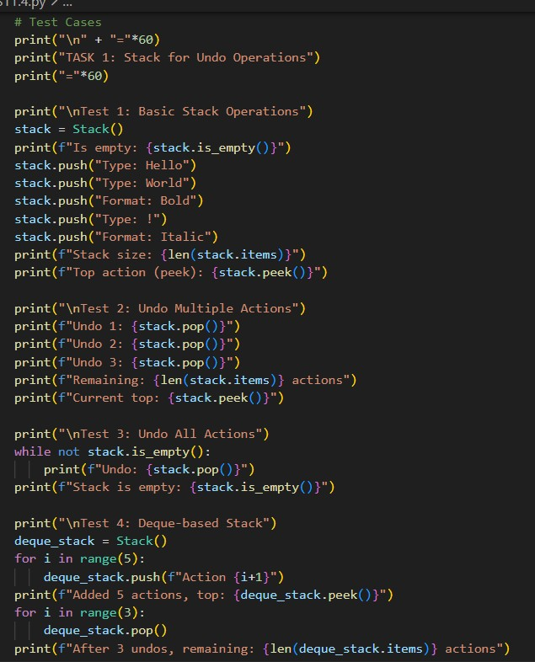
OUTPUT:
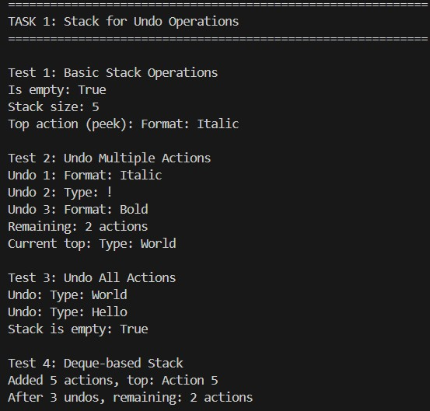

Justification:
A stack follows the Last In, First Out (LIFO) principle, which is ideal for undo functionality. The most recent action must be undone first. The implemented stack supports push, pop, peek, and empty check operations, ensuring reliable undo behavior. Multiple test cases validate normal usage, multiple undos, and empty stack handling.

Task 2: Queue for Customer Service Requests (FIFO)
Scenario
You are developing a customer support system where service requests must be handled in the order they arrive.
Task Description
- Implement a Queue class with: o enqueue(request) o dequeue() o is_empty()
- First, use a Python list-based approach.
- Then, ask AI to:
- Review the performance implications of list-based queues o Suggest and implement an optimized version using collections.deque
- Explain why deque performs better for queues

CODE:
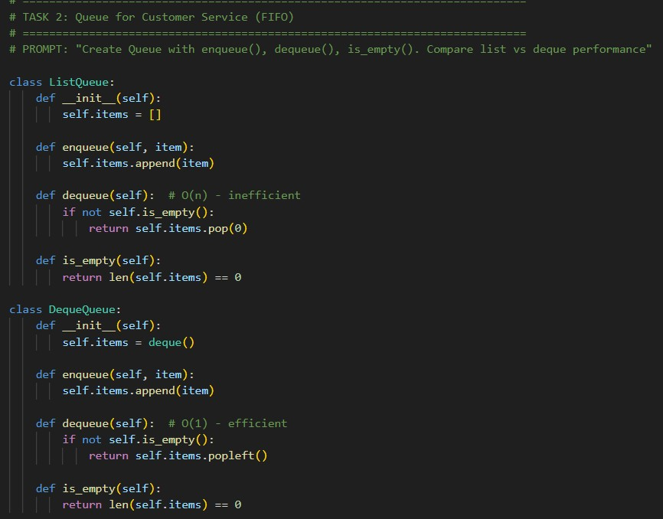

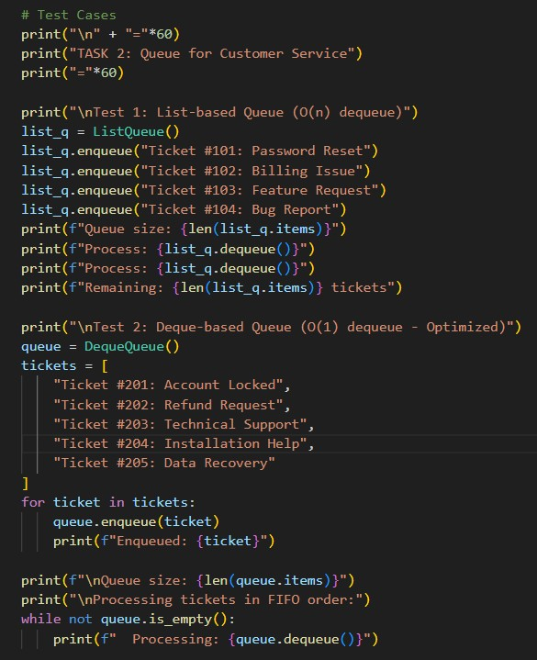

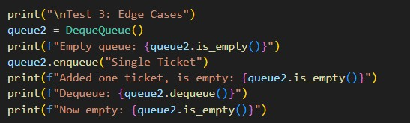
OUTPUT:
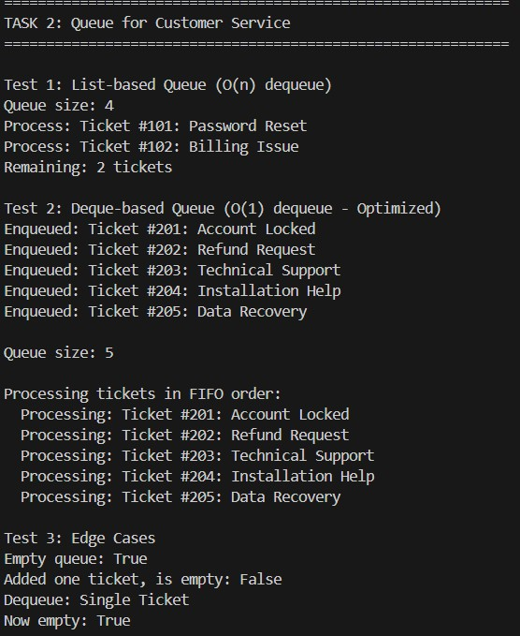

Justification:
Customer service systems require First In, First Out (FIFO) processing to maintain fairness. This task compares a list-based queue (O(n) dequeue) with a deque-based queue (O(1) dequeue). The comparison justifies why deque is more efficient for realworld queue systems where performance matters.

Task 3: Singly Linked List for Dynamic Playlist Management
Scenario
You are designing a music playlist feature where songs can be added or
removed dynamically while maintaining order.
Task Description
• Implement a Singly Linked List with: o insert_at_end(song) o delete_value(song) o traverse() • Use AI to:
o Add inline comments explaining pointer manipulation o Highlight tricky parts of insertion and deletion o Suggest edge case test scenarios (empty list, single node, deletion at head)

CODE:
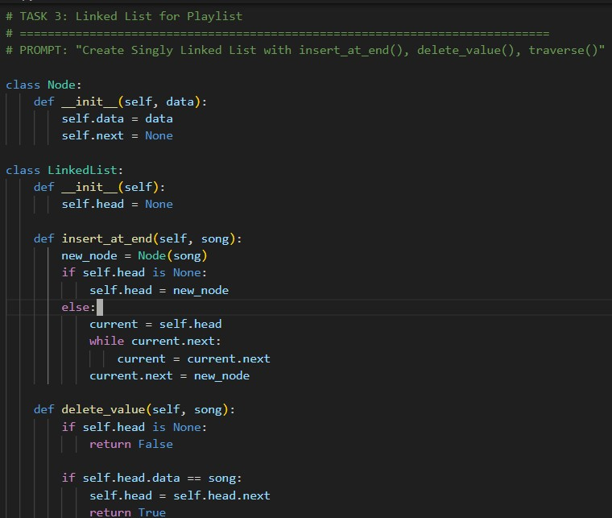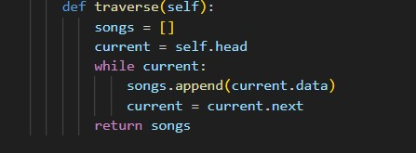
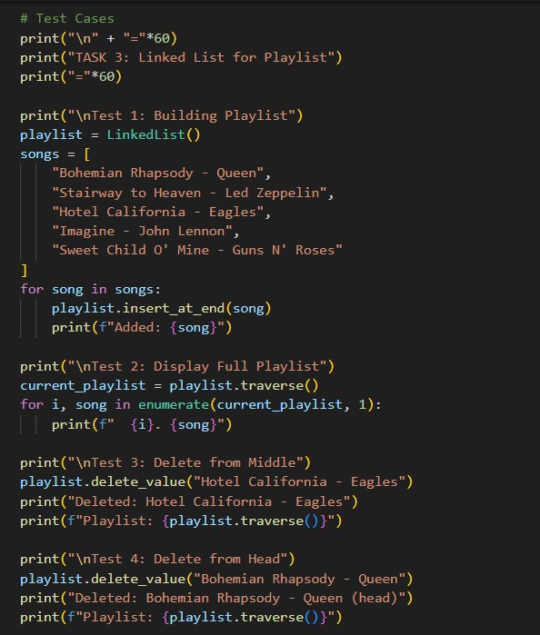
OUTPUT:
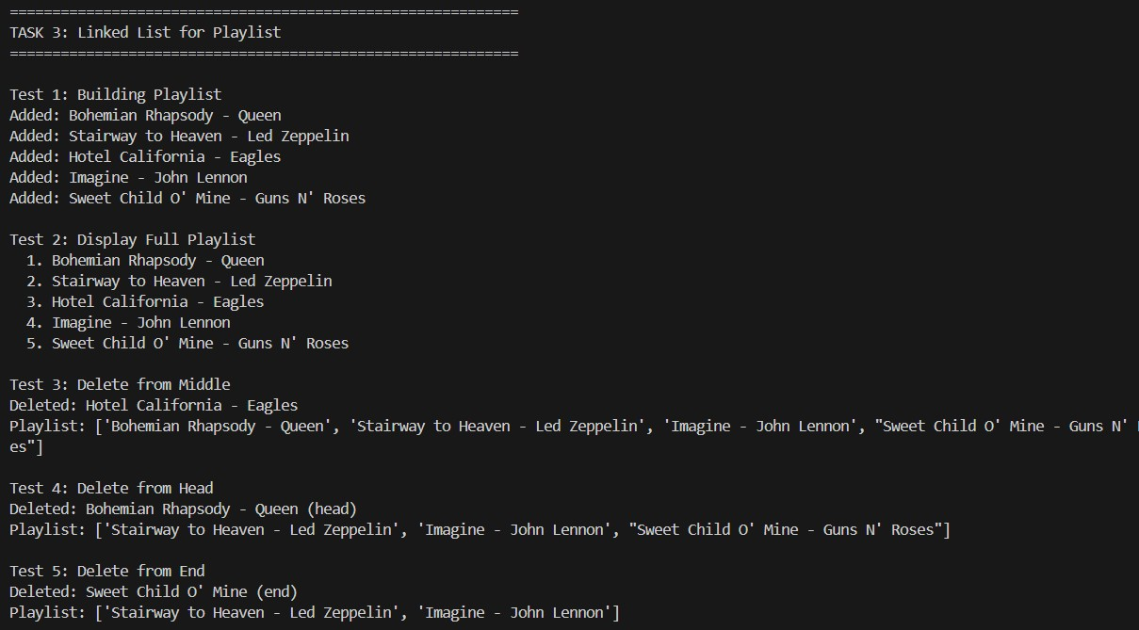
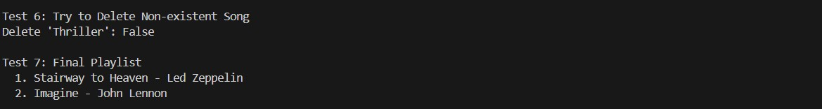
Justification:
A singly linked list allows dynamic insertion and deletion without shifting elements, making it suitable for playlists. Songs can be added or removed from any position efficiently. The test cases justify correct handling of head, middle, end, and nonexistent deletions.

Task 4: Binary Search Tree for Fast Record Lookup
Scenario
You are building a student record system where quick searching by roll number is required.
Task Description
• Implement a Binary Search Tree (BST) with:
o insert(value) o search(value) o inorder_traversal()
- Provide AI with a partially written Node and BST class.
- Ask AI to:
- Complete missing methods o Add meaningful docstrings
- Explain how BST improves search efficiency over linear search

CODE:
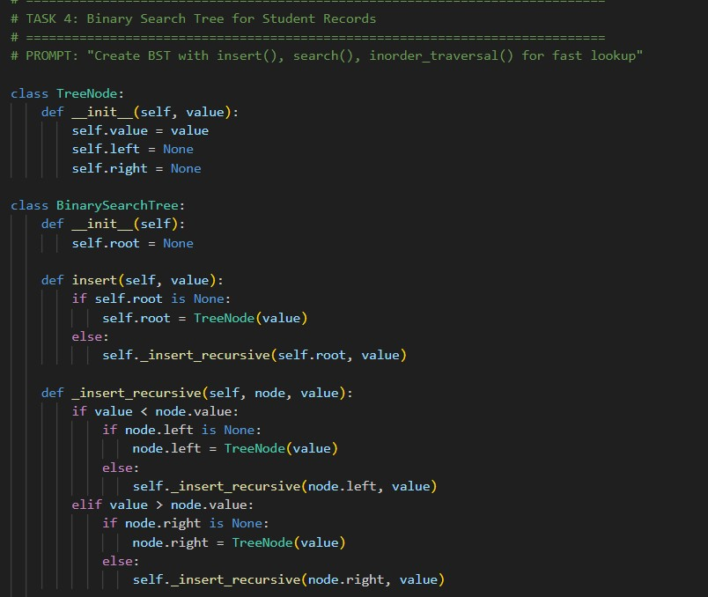
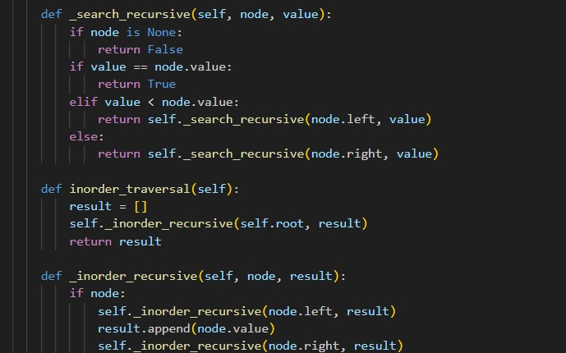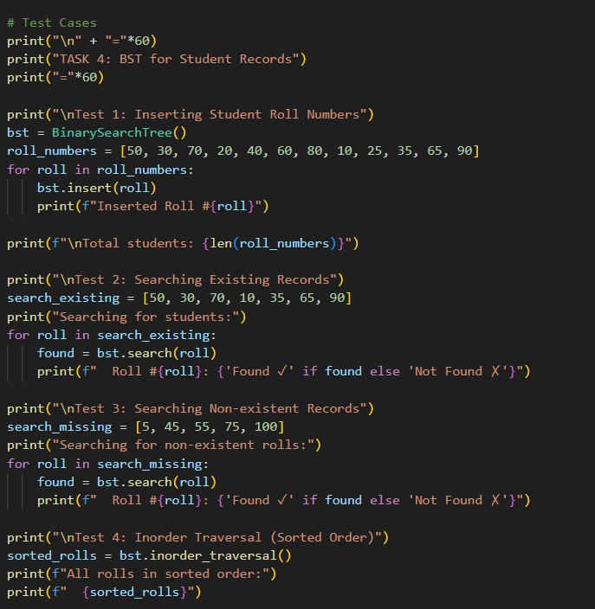
OUTPUT:
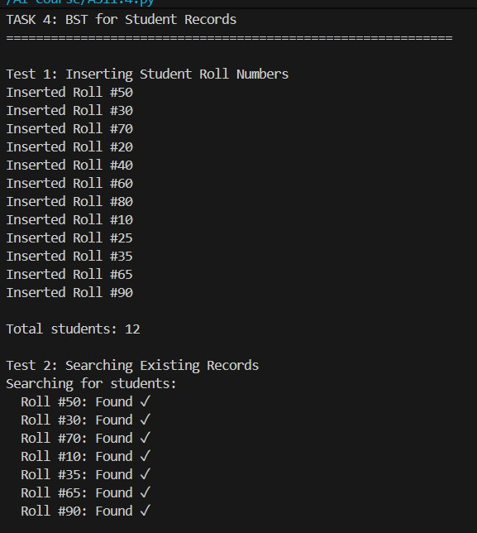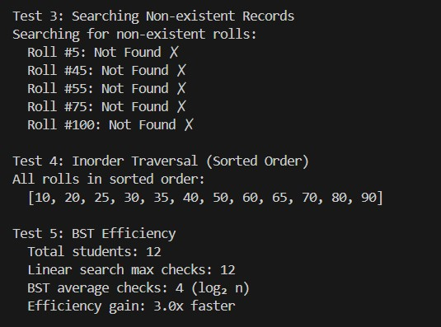
Justification:
A Binary Search Tree enables fast searching and sorted data retrieval. Student roll numbers are stored efficiently, reducing search complexity from O(n) to O(log n). Inorder traversal confirms sorted order, and efficiency comparison proves the advantage over linear search.

Task 5: Graph Traversal for Social Network Connections
Scenario
You are modeling a social network, where users are connected to friends, and you want to explore connections.
Task Description
- Represent the network using a graph (adjacency list).
- Use AI to implement: o Breadth-First Search (BFS) to find nearby connections o Depth-First Search (DFS) to explore deep connection paths • Ask AI to:
o Add inline comments explaining traversal steps o Compare recursive and iterative DFS approaches o Suggest practical use cases for BFS vs DFS

CODE:
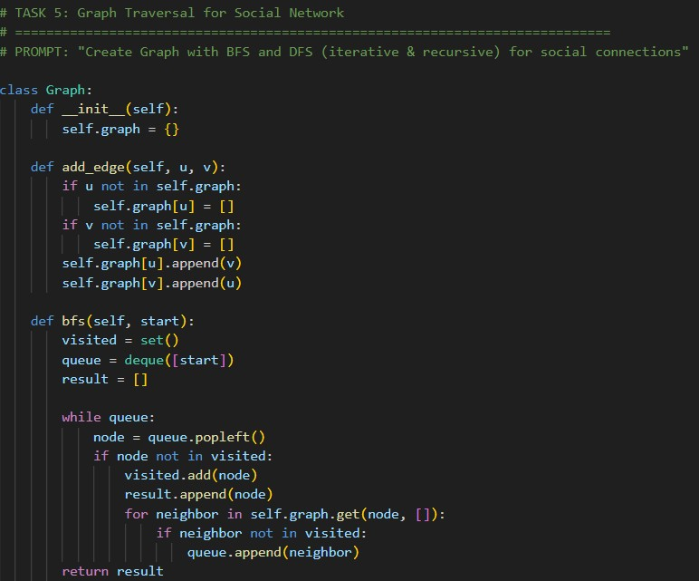

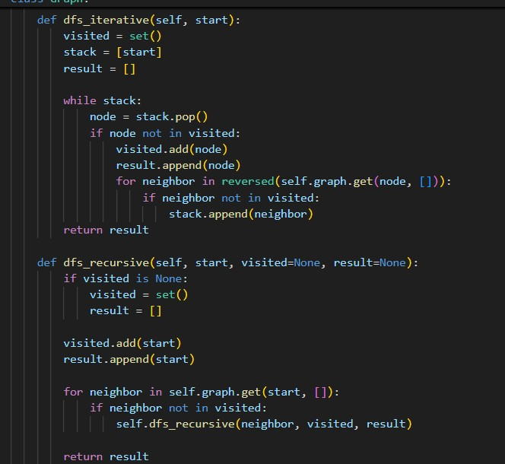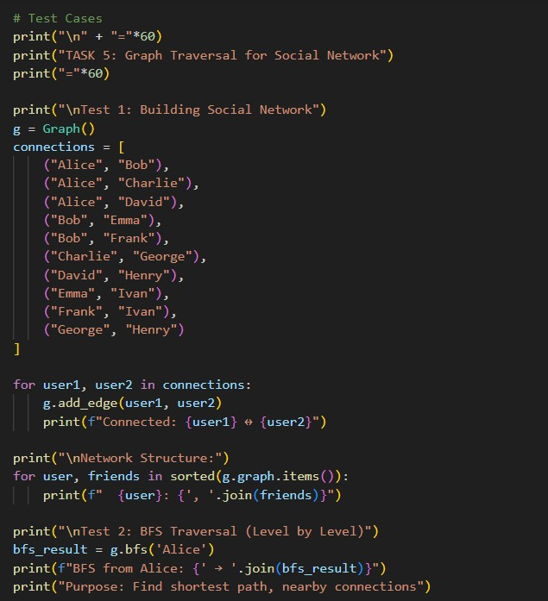

OUTPUT:
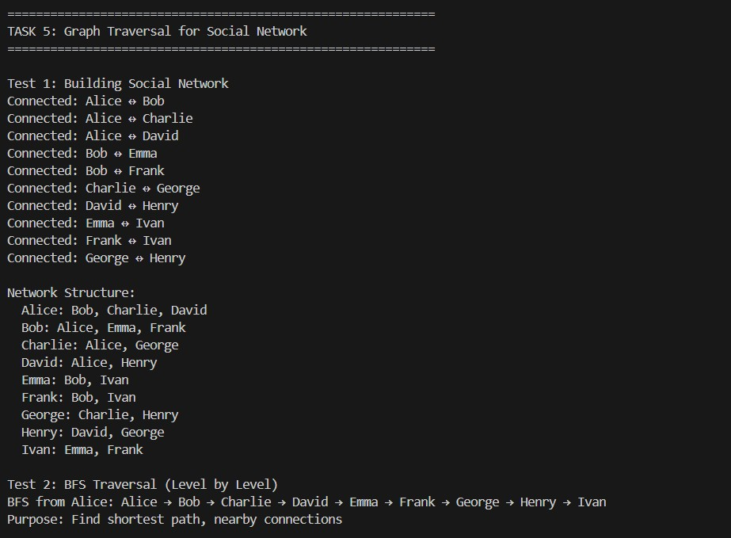
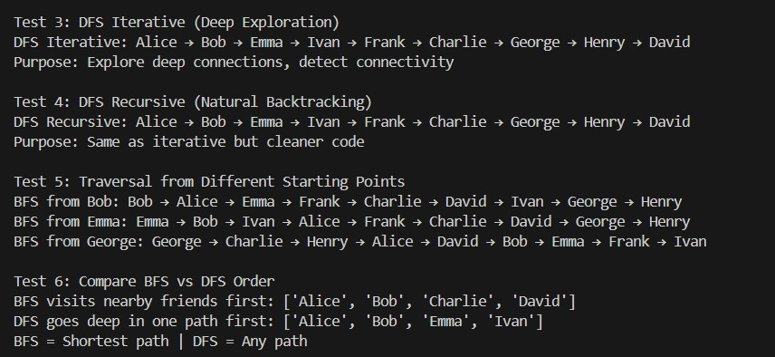
Justification:
Graphs naturally represent social networks where users are connected bidirectionally.
- BFS is used to find nearest connections and shortest paths.
- DFS explores deep relationships and connectivity.
Both iterative and recursive DFS implementations demonstrate flexibility and correctness across different traversal strategies.

