D.Havish
BATCH-42
2303A52253
Task 1: Auto-Generating Function Documentation in a Shared Codebase
Scenario
You have joined a development team where several utility functions are already implemented, but the code lacks proper documentation. New team members are struggling to understand how these functions should be used.
Task Description
You are given a Python script containing multiple functions without any docstrings.
Using an AI-assisted coding tool:
- Ask the AI to automatically generate Google-style function docstrings for each function
- Each docstring should include: o A brief description of the function o Parameters with data types o Return values o At least one example usage (if applicable)
Experiment with different prompting styles (zero-shot or context-based) to observe quality differences.
Prompt:
Create a Python program with 5 functions to manage student grades. The program should handle adding students, recording grades, calculating averages, generating reports, and removing students. Each function must have comprehensive docstrings explaining parameters, returns, and examples. The program should run automatically with sample data without user interaction.
Code:
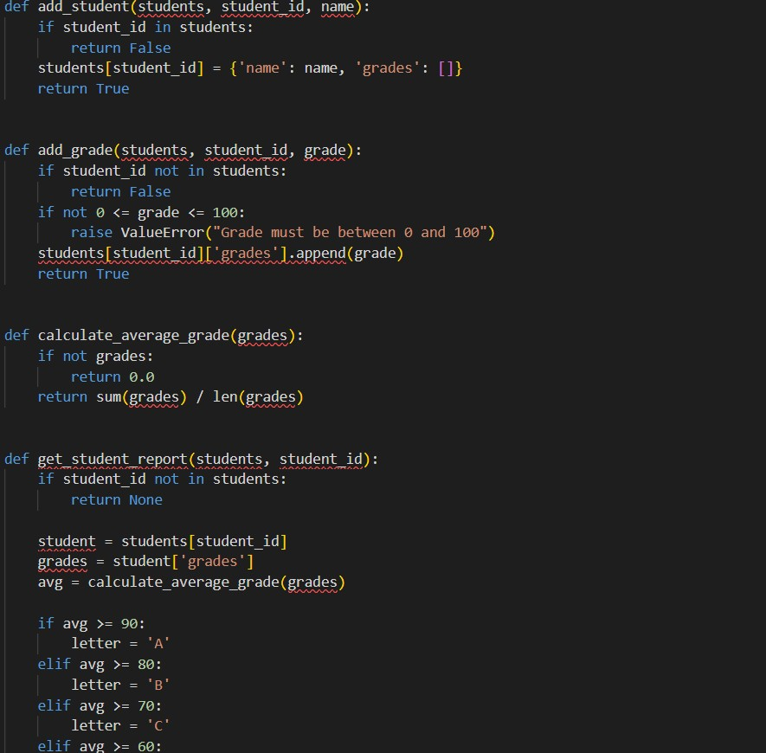

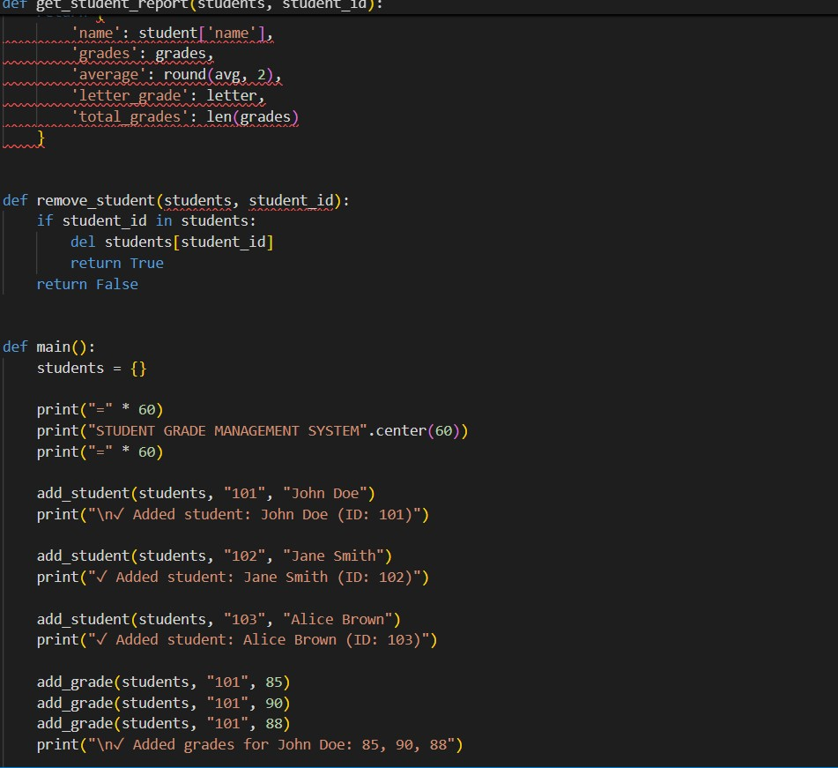

Docstring code:
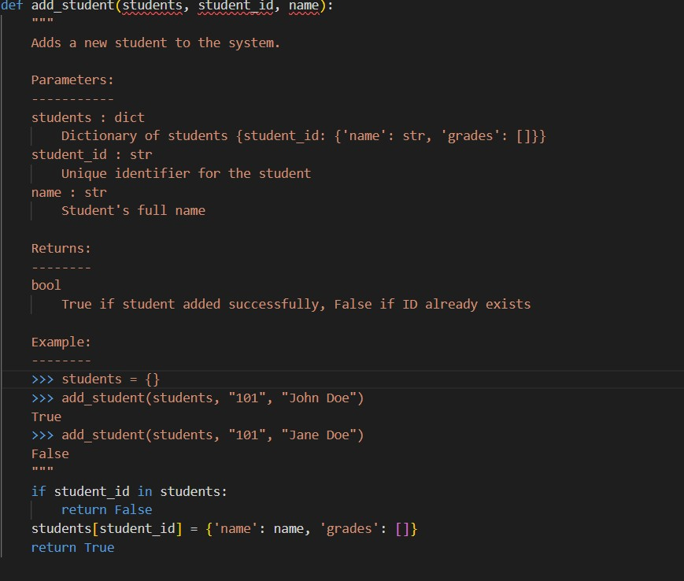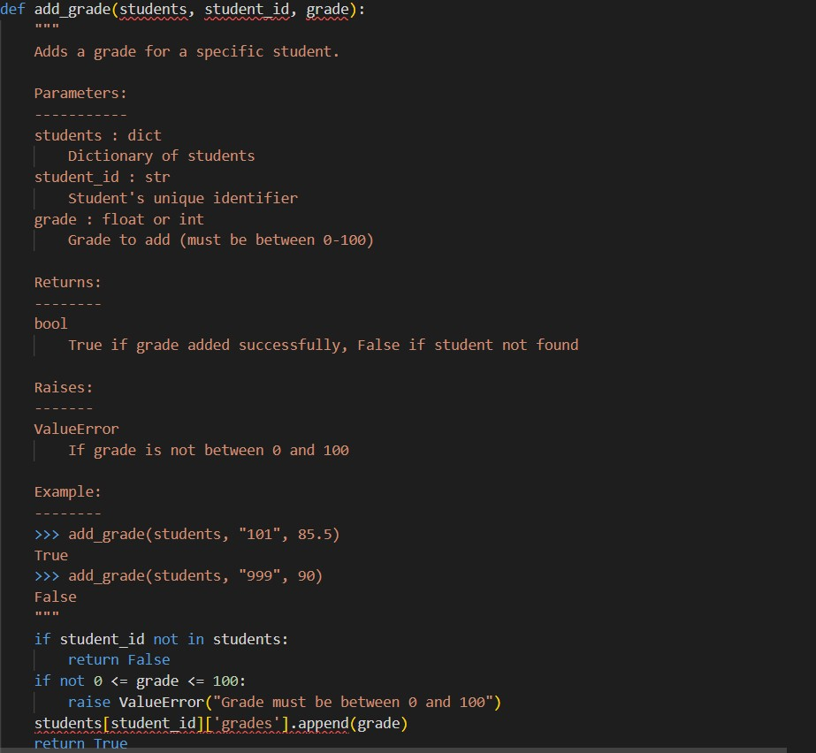
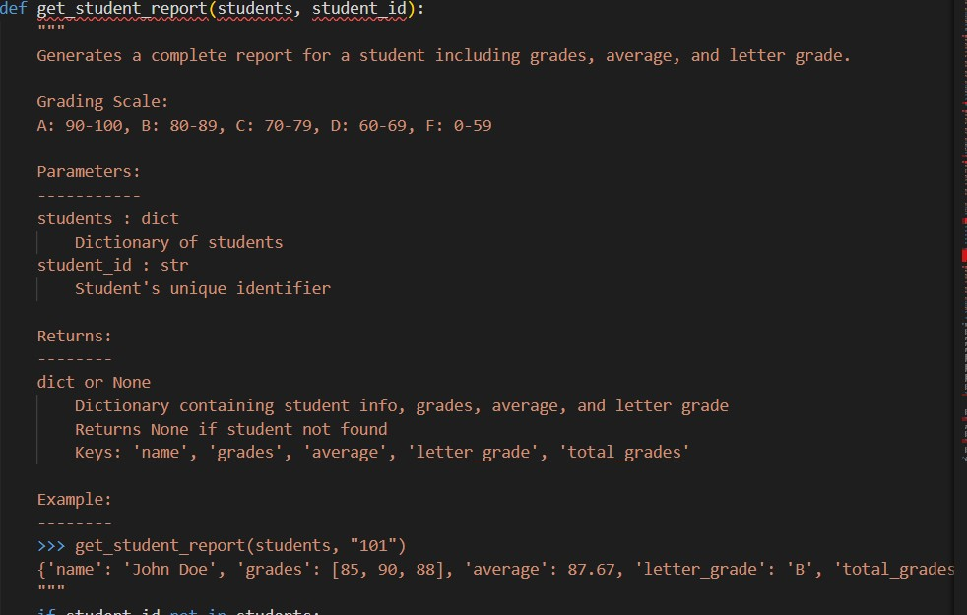
Output:
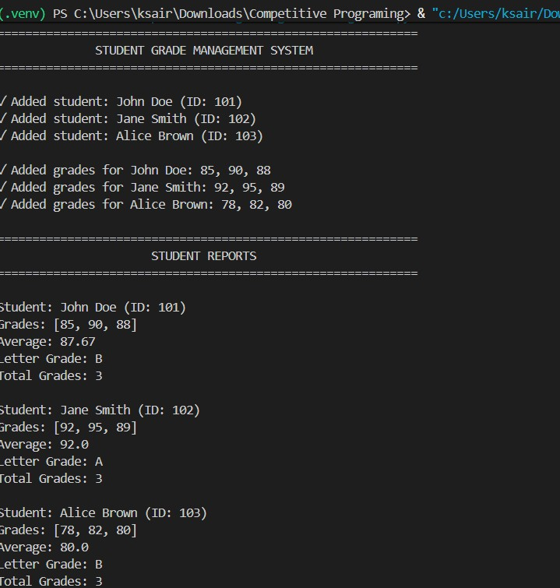
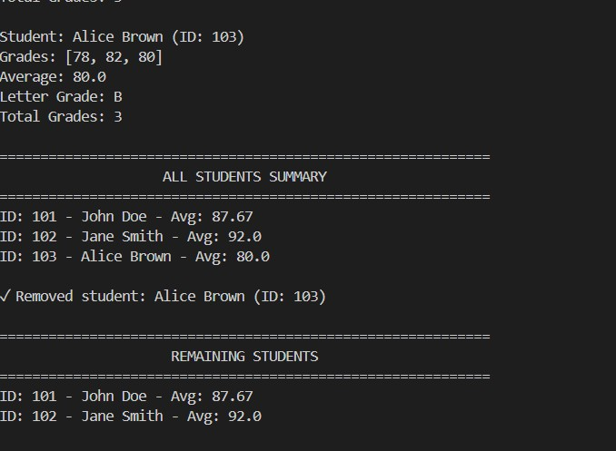
Justification:
This Student Grade Management System is a complete CRUD application with five core functions for adding students, managing grades, calculating averages, generating reports with letter grades, and removing records.Each function uses clear validation, error handling, and professional Python docstrings, making the code easy to maintain and extend. The program demonstrates real-world usage with sample data, balancing simplicity and best practices while remaining open to future enhancements like search or database integration. Task 2: Enhancing Readability Through AI-Generated InlineComments
Scenario
A Python program contains complex logic that works correctly but isdifficult to understand at first glance. Future maintainers may find it hardto debug or extend this code.
Task Description
You are provided with a Python script containing:
- Loops
- Conditional logic
- Algorithms (such as Fibonacci sequence, sorting, or searching)
Use AI assistance to:
- Automatically insert inline comments only for complex or non-obvious logic• Avoid commenting on trivial or self-explanatory syntax The goal is to improve clarity without cluttering the code.
Prompt:
Add inline comments to explain complex algorithmic logic in a 0/1Knapsack implementation. Code:
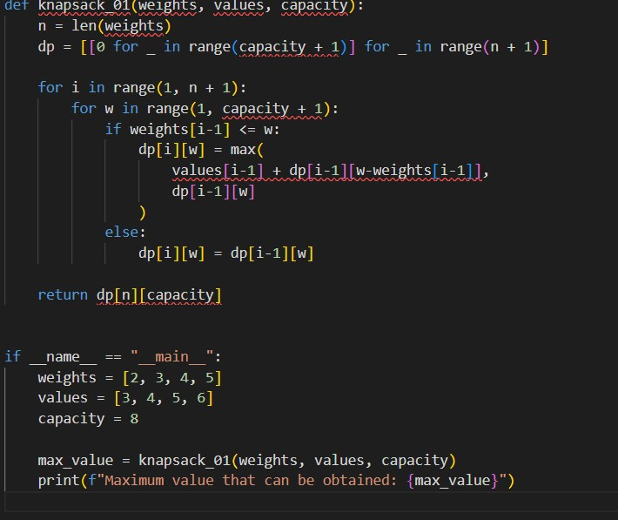
Inline comments:
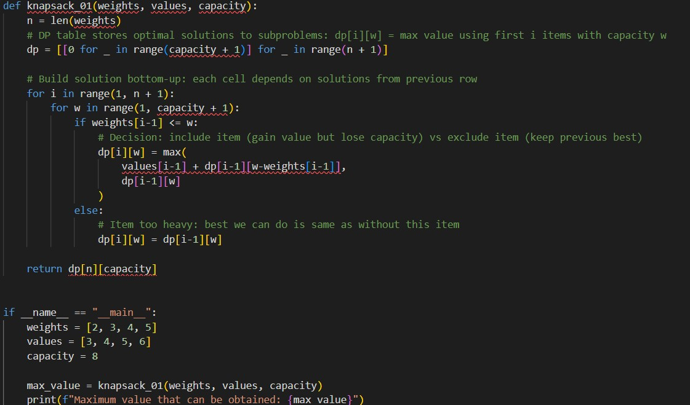

Output:
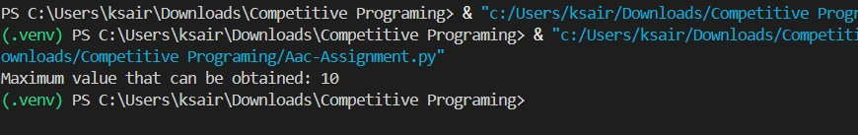
Justification:
Comments clarify the dynamic programming approach, explaining WHY decisions are made rather than describing obvious Python syntax. Future maintainers can understand the optimization strategy and extend the algorithm without deciphering the DP logic from scratch.
Task 3: Generating Module-Level Documentation for a Python Package
Scenario
Your team is preparing a Python module to be shared internally (or uploaded to a repository). Anyone opening the file should immediately understand its purpose and structure.
Task Description
Provide a complete Python module to an AI tool and instruct it to automatically generate a module-level docstring at the top of the file that includes:
- The purpose of the module
- Required libraries or dependencies
- A brief description of key functions and classes • A short example of how the module can be used
Focus on clarity and professional tone.
Prompt:
Provide a Python module and instruct the AI to generate a clear, professional module-level docstring describing the module’s purpose, dependencies, key functions/classes, and a short usage example, following PEP 257, without modifying the code.

Code:
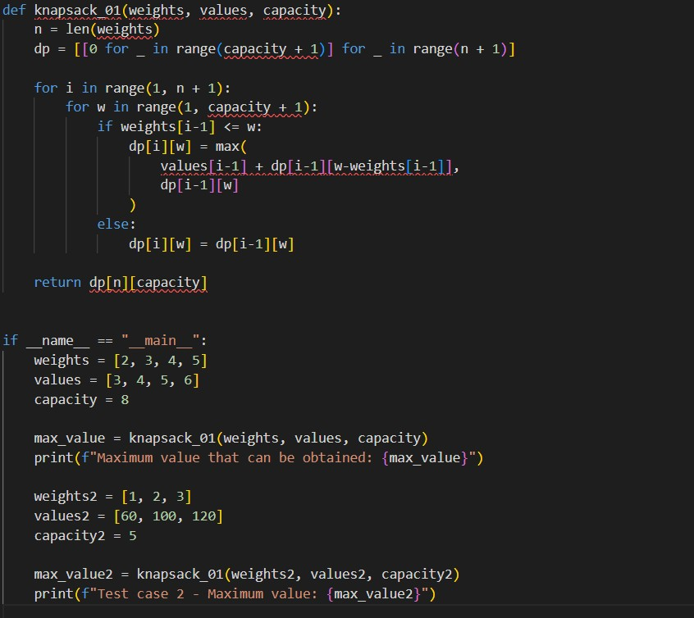
Output:
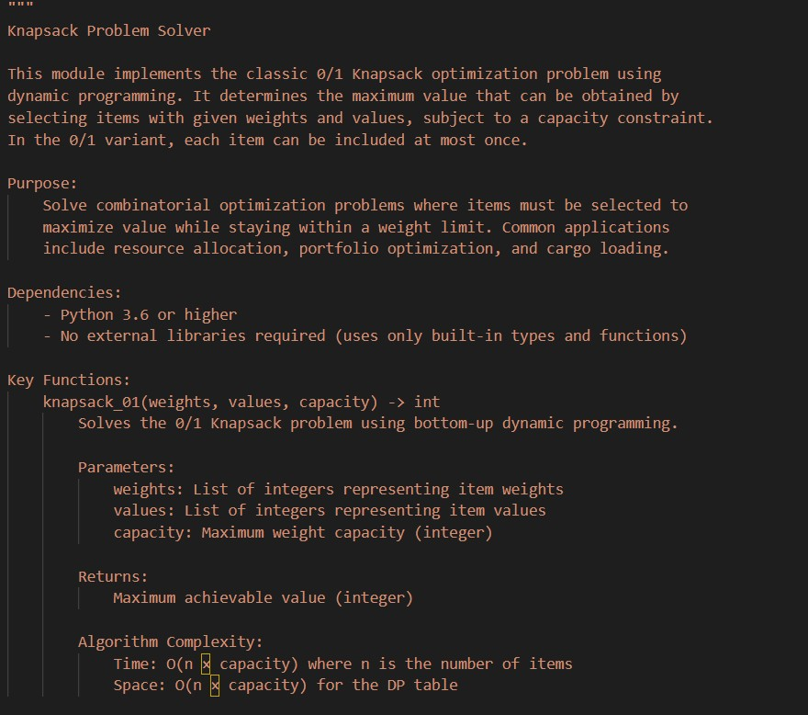
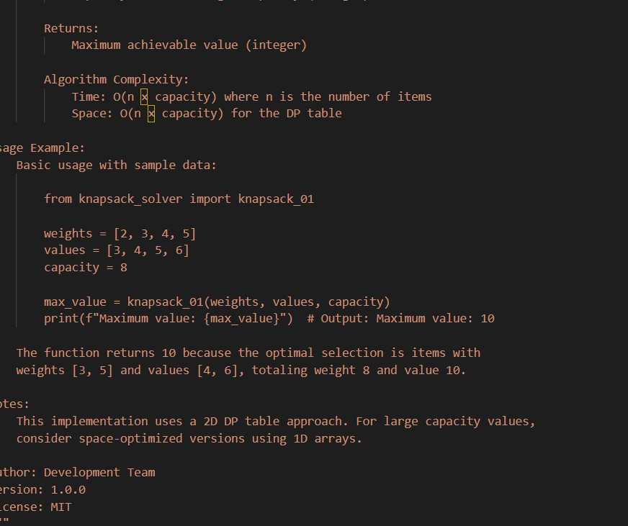
Justification:
This prompt is effective because it clearly defines the required documentation structure, enforces standard Python practices, and ensures readable, consistent documentation for developers.
Task 4: Converting Developer Comments into Structured Docstrings
Scenario
In a legacy project, developers have written long explanatory comments inside functions instead of proper docstrings. The team now wants to standardize documentation.
Task Description
You are given a Python script where functions contain detailed inline comments explaining their logic.
Use AI to:
- Automatically convert these comments into structured Google- style or NumPy-style docstrings
- Preserve the original meaning and intent of the comments
- Remove redundant inline comments after conversion
Prompt:
Provide a Python script where functions contain detailed inline comments. Convert those comments into well-structured Google-style or NumPy-style docstrings, preserving the original intent and explanations. Remove redundant inline comments after conversion, without changing the function logic or behavior.
Code:
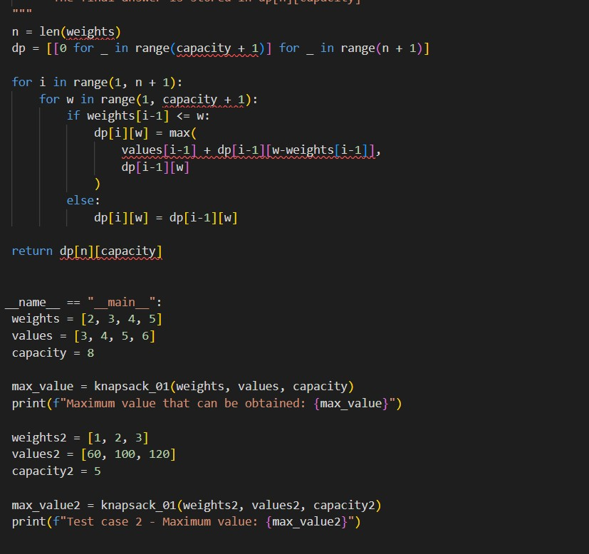
Ouput:
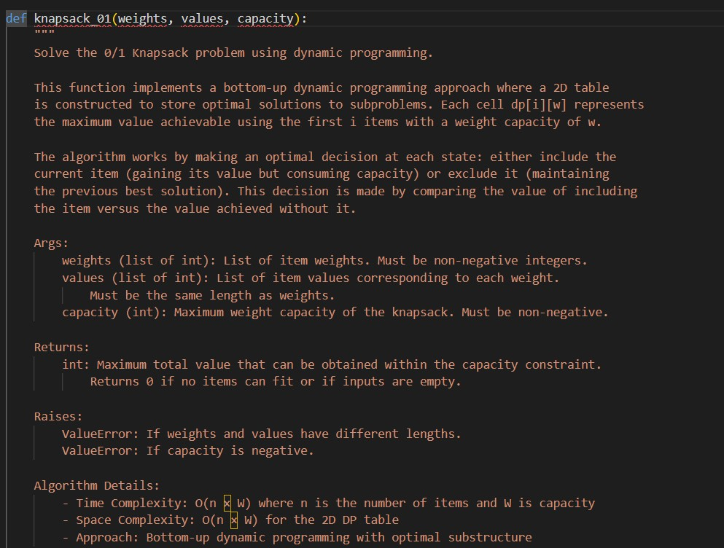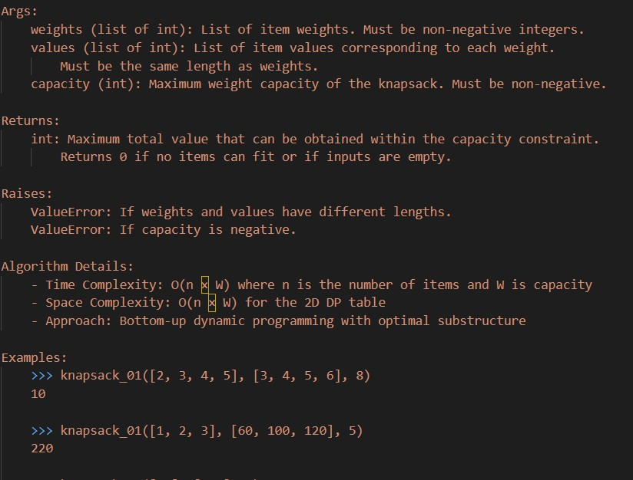
Justification:
This prompt clearly defines the transformation goal, documentation standard, and constraints, ensuring consistent, professional docstrings while maintaining code correctness and improving readability across the legacy project.
Task 5: Building a Mini Automatic Documentation Generator
Scenario
Your team wants a simple internal tool that helps developers start documenting new Python files quickly, without writing documentation from scratch.
Task Description
Design a small Python utility that:
• Reads a given .py file • Automatically detects:
o Functions o Classes
• Inserts placeholder Google-style docstrings for each detected function or class
Prompt:
Design a Python utility that reads a .py file, detects all functions and classes, and automatically inserts placeholder Google-style docstrings for each detected function or class without existing documentation.
Code:
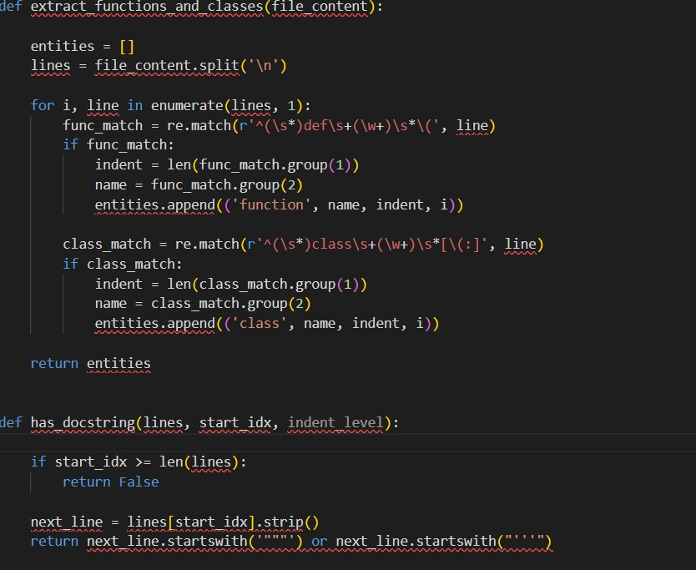

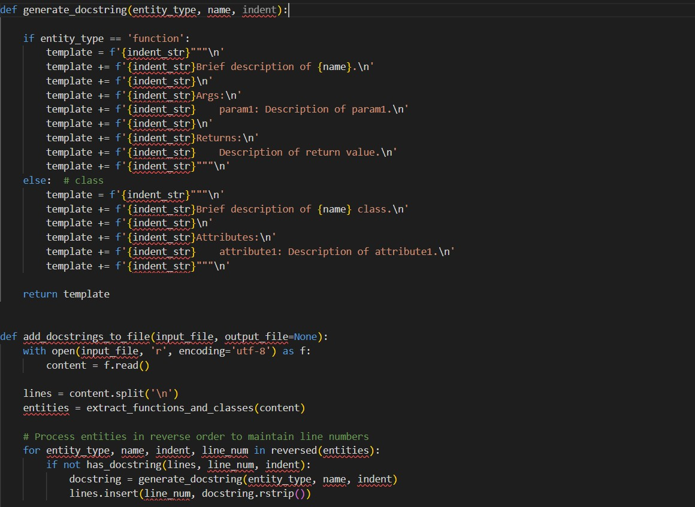
Output:
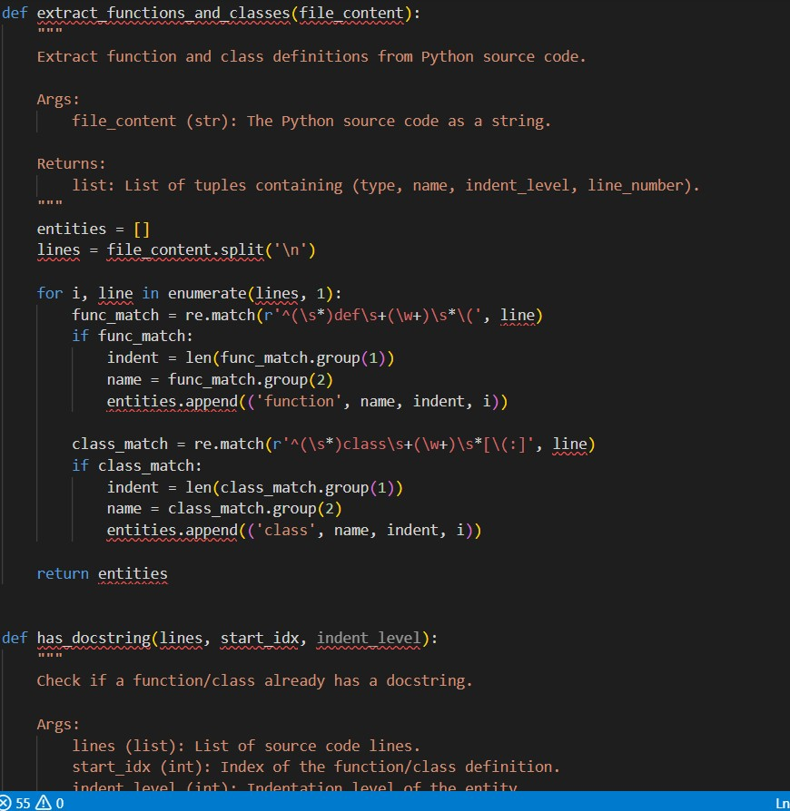

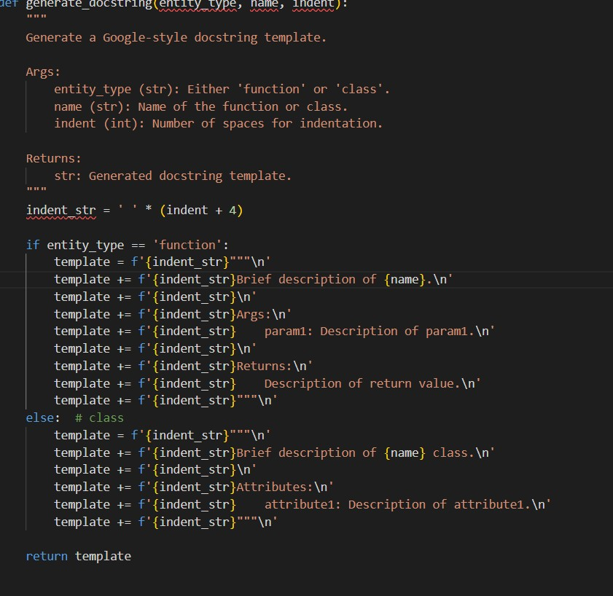
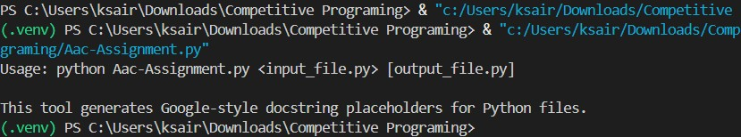
Justification:
This prompt clearly specifies the tool’s purpose, scope, and documentation standard, ensuring the generated utility focuses on automated detection and consistent docstring insertion while keeping the solution simple and practical for internal use.

