ASSIGNMENT-11.1

G. Srinidhi
2303A52285
Batch - 43

Data Structures with AI: Implementing Fundamental Structures
Task Description #1 – Stack Implementation
Task: Use AI to generate a Stack class with push, pop, peek, and is_empty
methods.
Sample Input Code:
class Stack:
pass
Expected Output:
• A functional stack implementation with all required methods and docstrings.
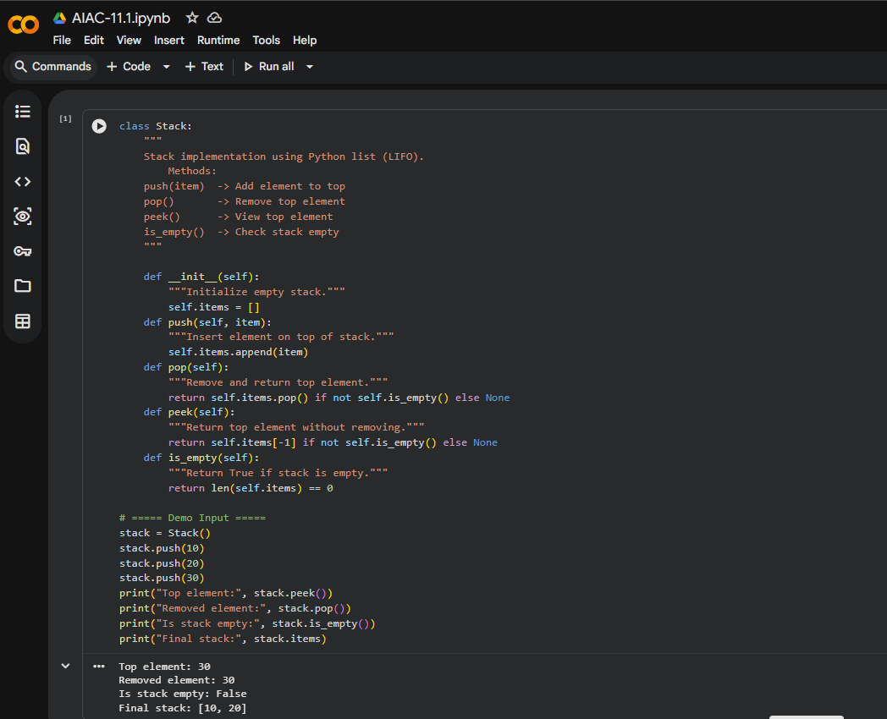

Task Description #2 – Queue Implementation
Task: Use AI to implement a Queue using Python lists.
Sample Input Code:
class Queue:
pass
Expected Output:
• FIFO-based queue class with enqueue, dequeue, peek, and size methods.

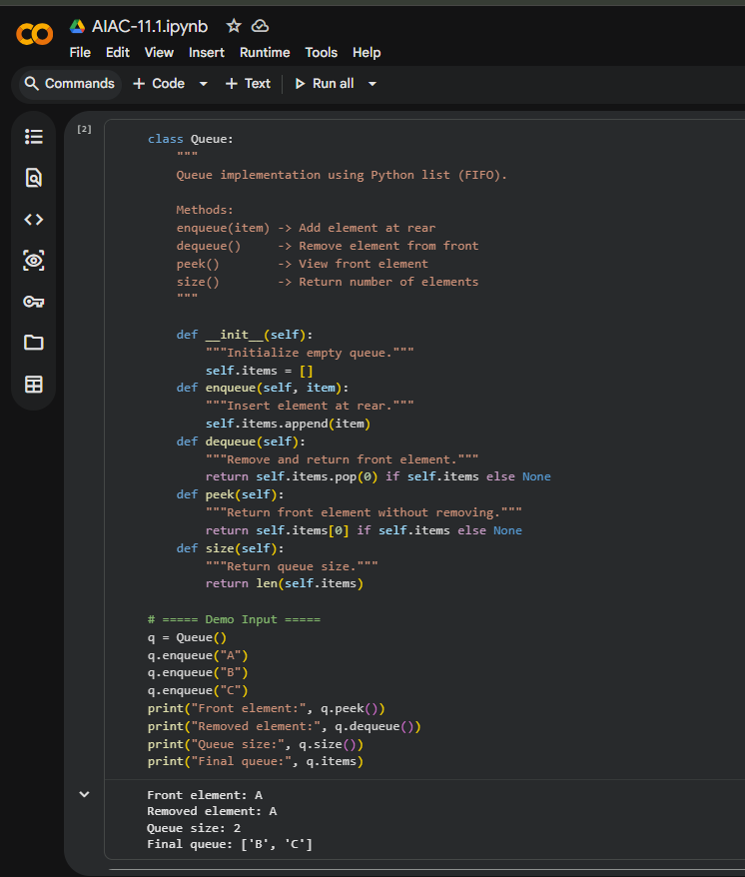

Task Description #3 – Linked List
Task: Use AI to generate a Singly Linked List with insert and display methods.
Sample Input Code:
class Node:
pass
class LinkedList:
pass
Expected Output:
• A working linked list implementation with clear method documentation.
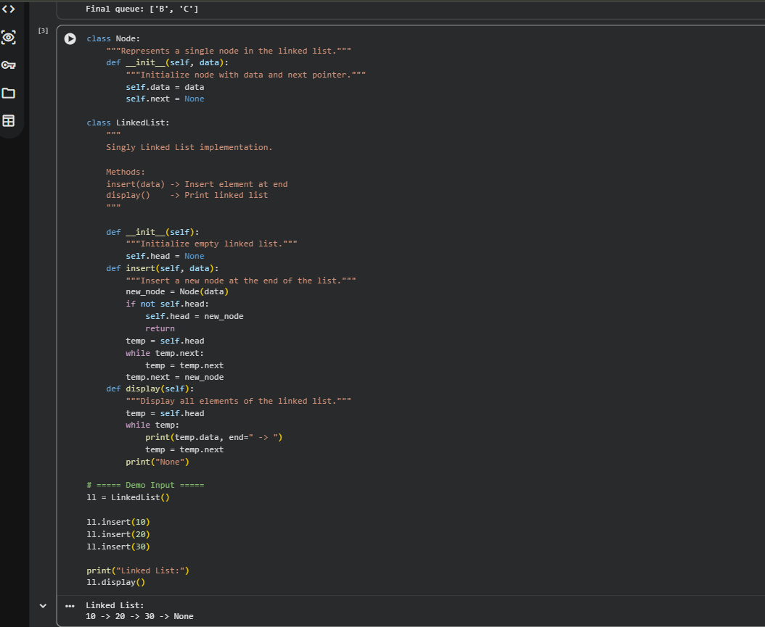

Task Description #4 – Binary Search Tree (BST)
Task: Use AI to create a BST with insert and in-order traversal methods.
Sample Input Code:
class BST:
pass
Expected Output:
• BST implementation with recursive insert and traversal methods
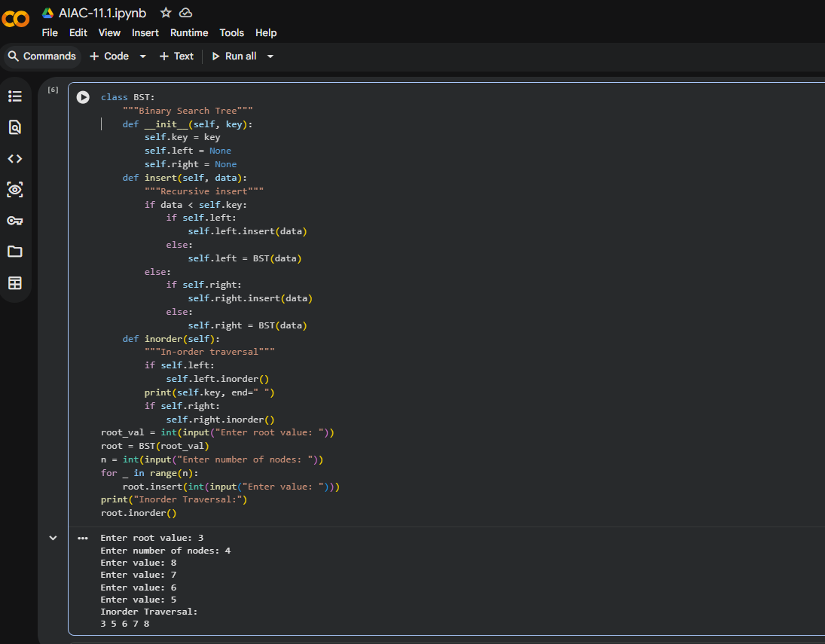

Task Description #5 – Hash Table
Task: Use AI to implement a hash table with basic insert, search, and delete methods.
Sample Input Code:
class Hash Table:
pass
Expected Output:
• Collision handling using chaining, with well-commented methods.
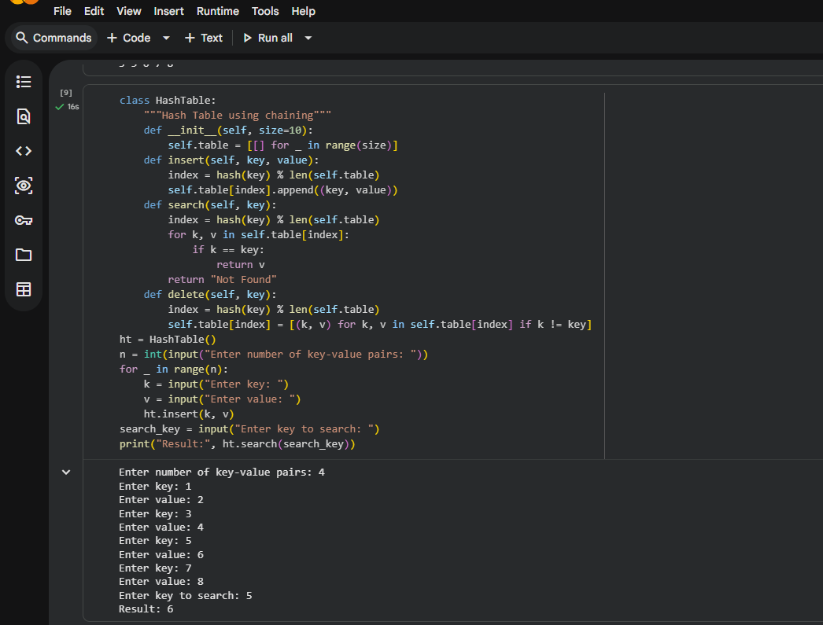

Task Description #6 – Graph Representation
Task: Use AI to implement a graph using an adjacency list.
Sample Input Code:
class Graph:
pass
Expected Output:
• Graph with methods to add vertices, add edges, and display connections.
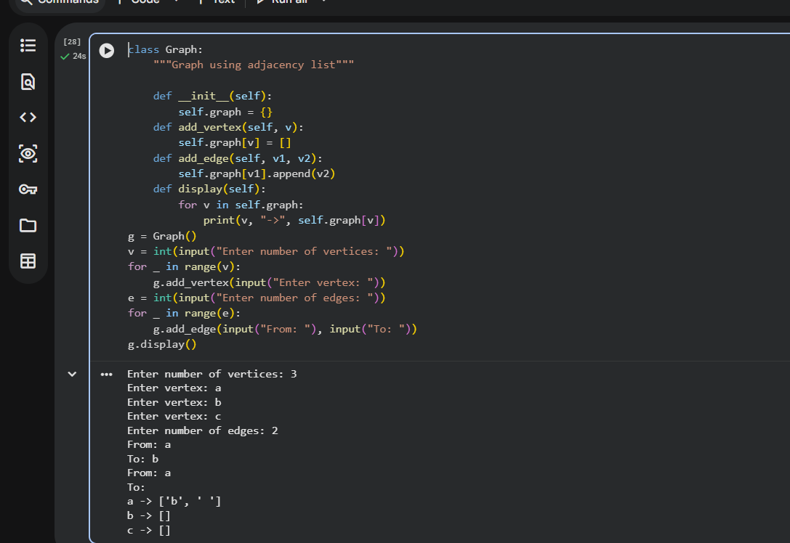

Task Description #7 – Priority Queue
Task: Use AI to implement a priority queue using Python’s heap q module.
Sample Input Code:
class Priority Queue:
pass
Expected Output:
• Implementation with enqueue (priority), dequeue (highest priority), and display methods.
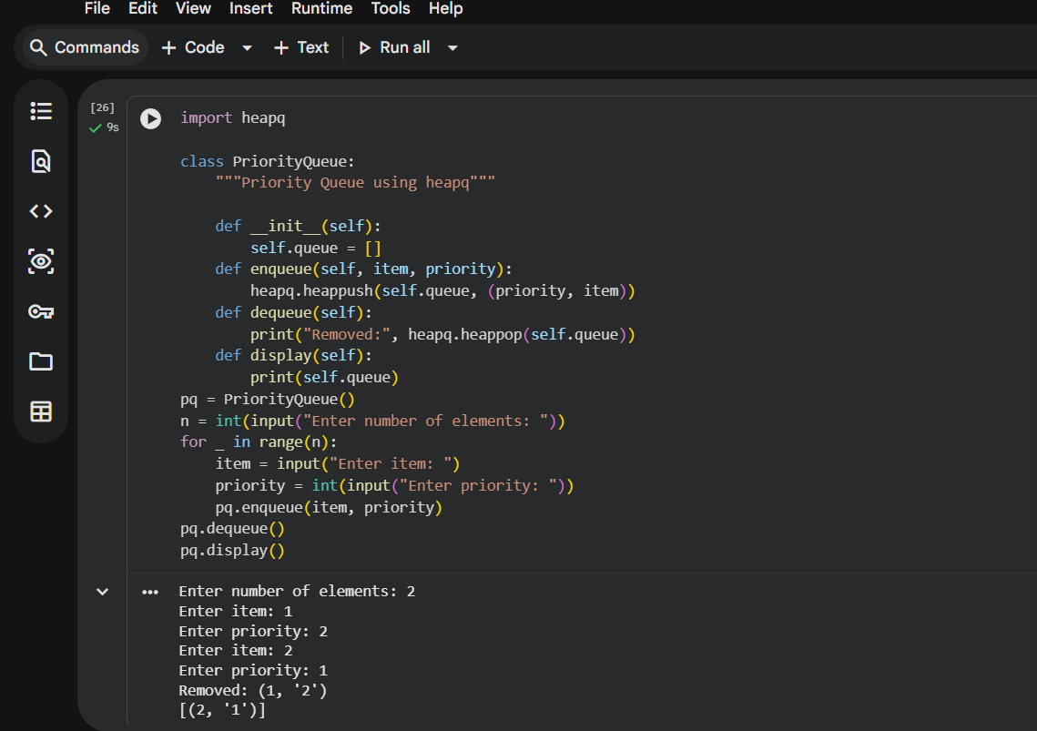

Task Description #8 – Deque
Task: Use AI to implement a double-ended queue using
collections. deque.
Sample Input Code:
class Deque DS:
pass
Expected Output:
• Insert and remove from both ends with docstrings.
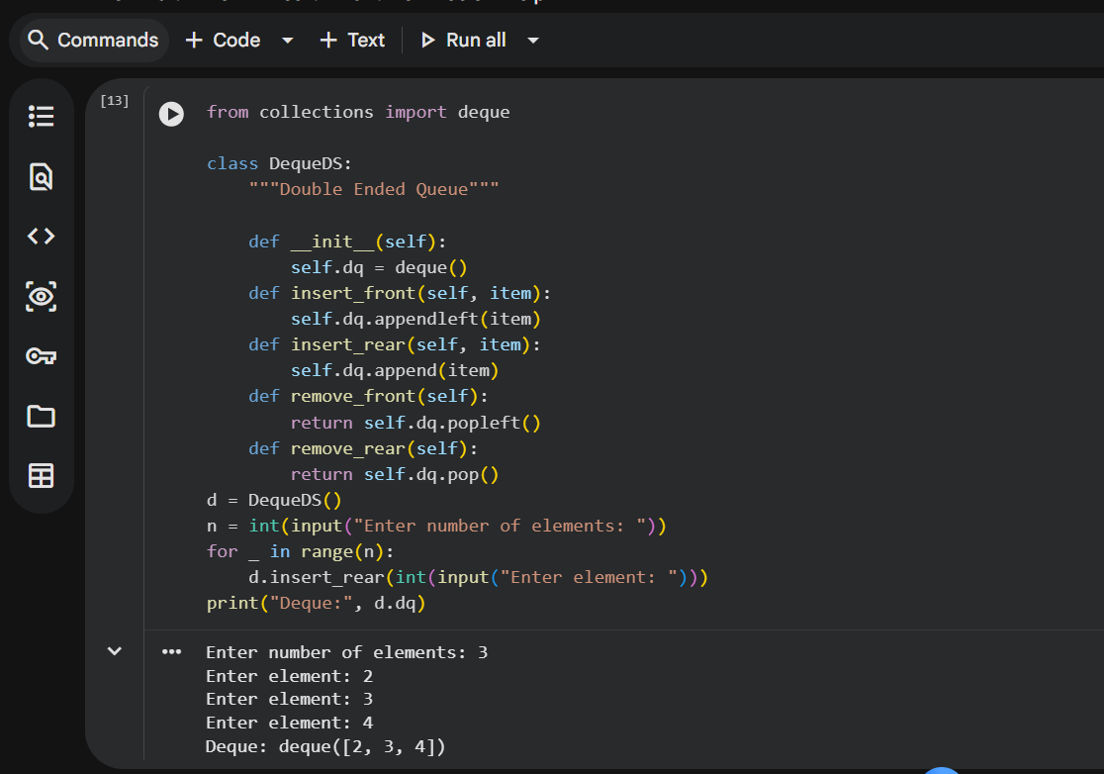

Task Description #9 Real-Time Application Challenge – Choose the
Right Data Structure
Scenario:
Your college wants to develop a Campus Resource Management System that handles:
1. Student Attendance Tracking – Daily log of students entering/exiting the campus.
2. Event Registration System – Manage participants in events with quick search and removal.
3. Library Book Borrowing – Keep track of available books and their due dates.
4. Bus Scheduling System – Maintain bus routes and stop connections.
5. Cafeteria Order Queue – Serve students in the order they arrive.
Student Task:
• For each feature, select the most appropriate data structure from the list below:
o Stack
o Queue
o Priority Queue
o Linked List
o Binary Search Tree (BST)
o Graph
o Hash Table
o Deque
• Justify your choice in 2–3 sentences per feature.
• Implement one selected feature as a working Python program with AI-assisted code generation.
Expected Output:
• A table mapping feature → chosen data structure → justification.
• A functional Python program implementing the chosen feature with comments and docstrings.
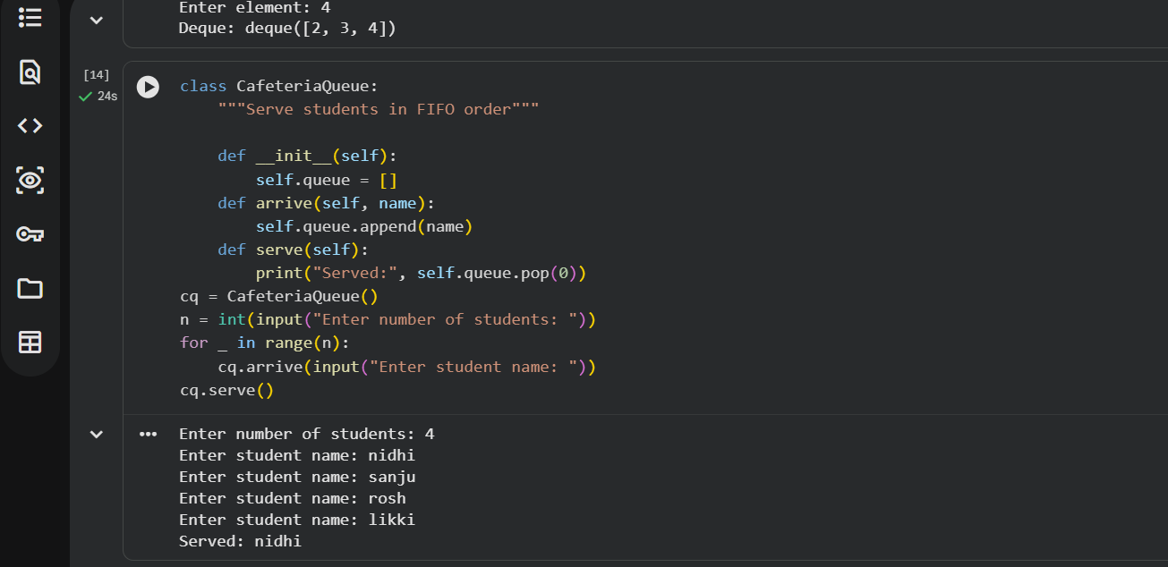

Task Description #10: Smart E-Commerce Platform – Data Structure
Challenge
An e-commerce company wants to build a Smart Online Shopping System
with:
1. Shopping Cart Management – Add and remove products dynamically.
2. Order Processing System – Orders processed in the order they are placed.
3. Top-Selling Products Tracker – Products ranked by sales count.
4. Product Search Engine – Fast lookup of products using product ID.
5. Delivery Route Planning – Connect warehouses and delivery locations.
Student Task:
• For each feature, select the most appropriate data structure from
the list below:
o Stack
o Queue
o Priority Queue
o Linked List
o Binary Search Tree (BST)
o Graph
o Hash Table
o Deque
• Justify your choice in 2–3 sentences per feature.
• Implement one selected feature as a working Python program with AI-assisted code generation.
Expected Output:
• A table mapping feature → chosen data structure → justification.
• A functional Python program implementing the chosen feature with comments and docstrings.
