ASSIGNMENT-5.4

G.Srinidhi
2303A52285
Batch : 43

Lab 5: Ethical Foundations – Responsible AI Coding Practices
Task Description #1:
• Prompt GitHub Copilot to generate a Python script that collects user data (e.g., name, age, email). Then, ask Copilot to add comments on how to anonymize or protect this data.
Expected Output #1:
• A script with inline Copilot-suggested code and comments explaining how to safeguard or anonymize user information (e.g., hashing emails, not storing data unencrypted).
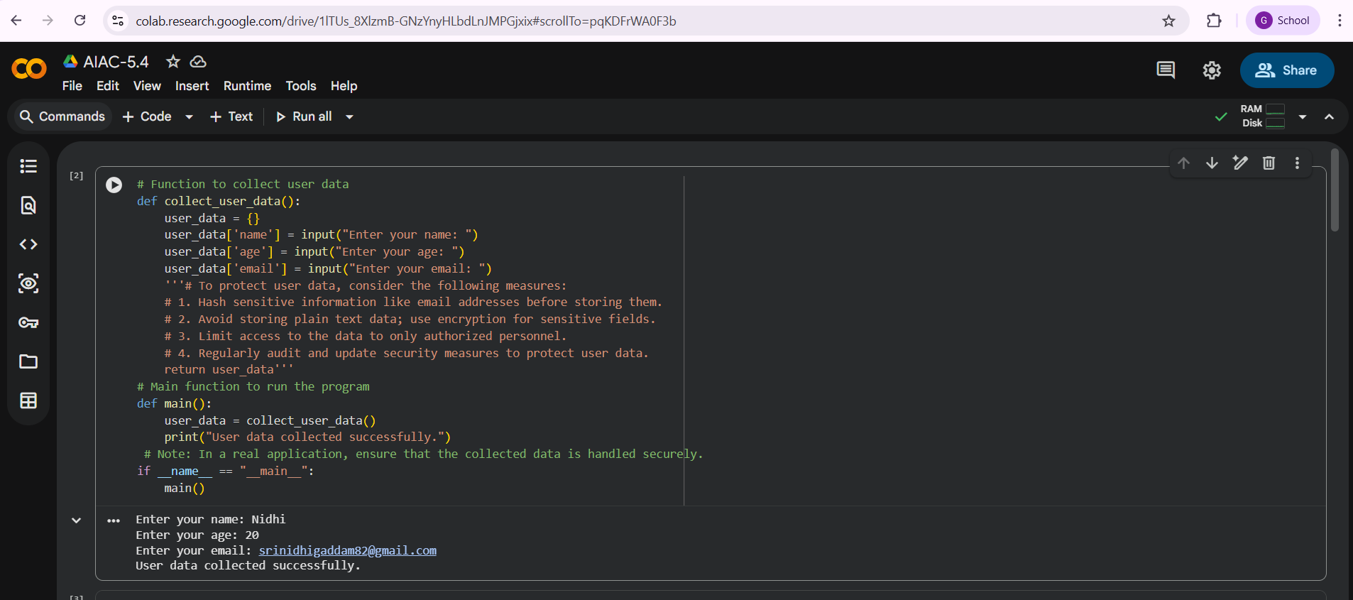

Task Description #2:
• Ask Copilot to generate a Python function for sentiment analysis. Then prompt Copilot to identify and handle potential biases in the data.
Expected Output #2:
• Copilot-generated code with additions or comments addressing bias mitigation strategies (e.g., balancing dataset, removing offensive terms).
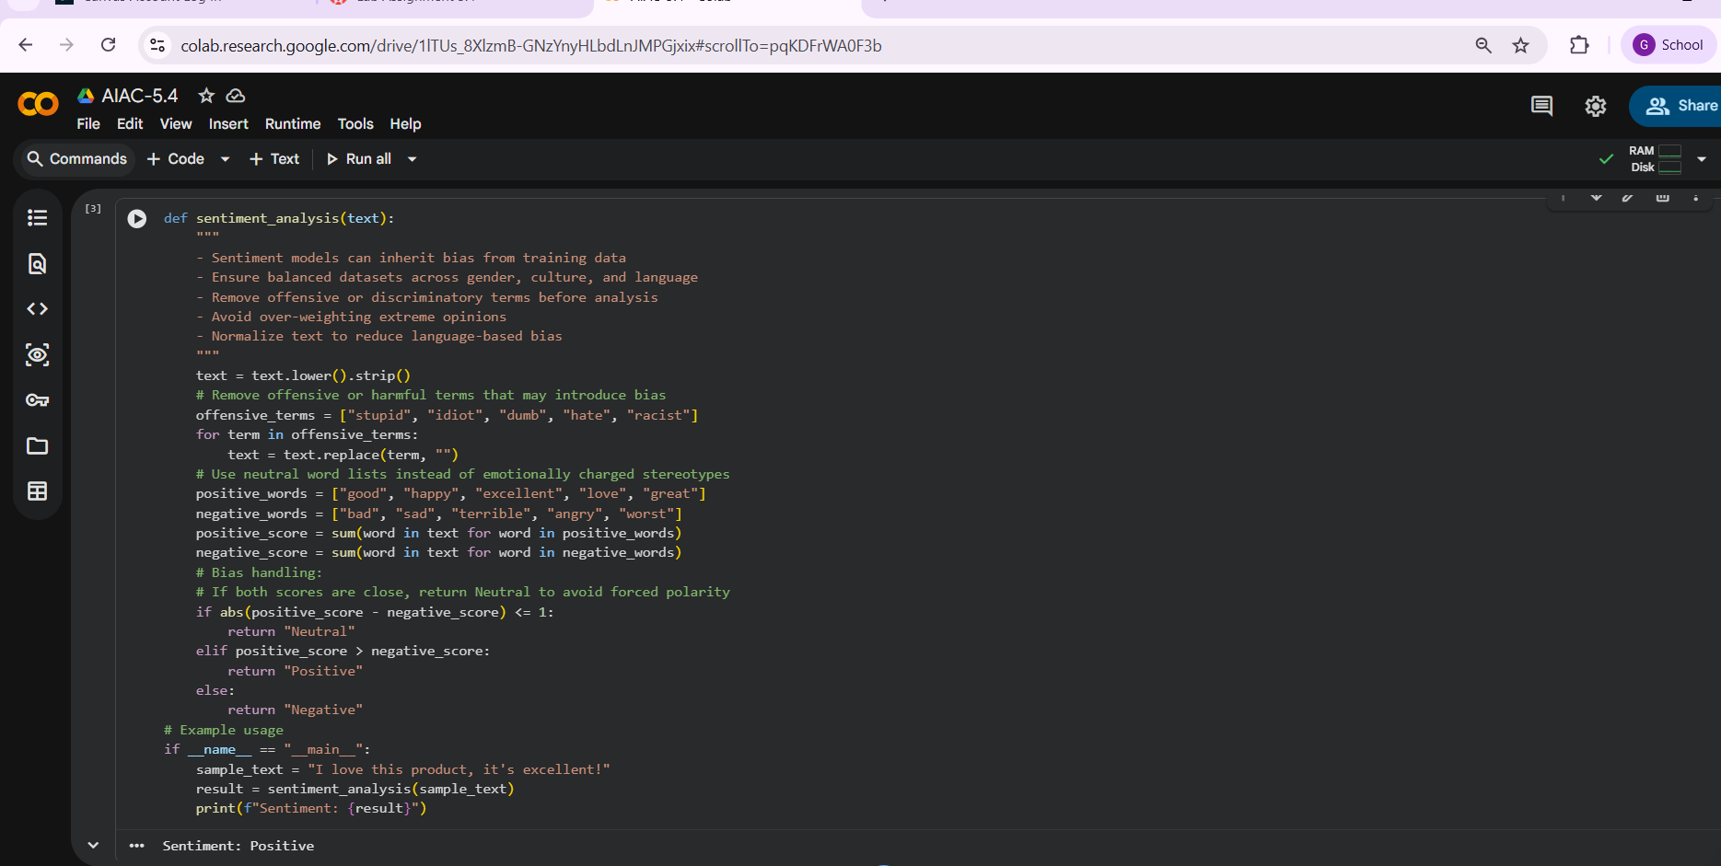

Task Description #3:
• Use Copilot to write a Python program that recommends products based on user history. Ask it to follow ethical guidelines like transparency and fairness.
Expected Output #3:
• Copilot suggestions that include explanations, fairness checks (e.g., avoiding favoritism), and user feedback options in the code.
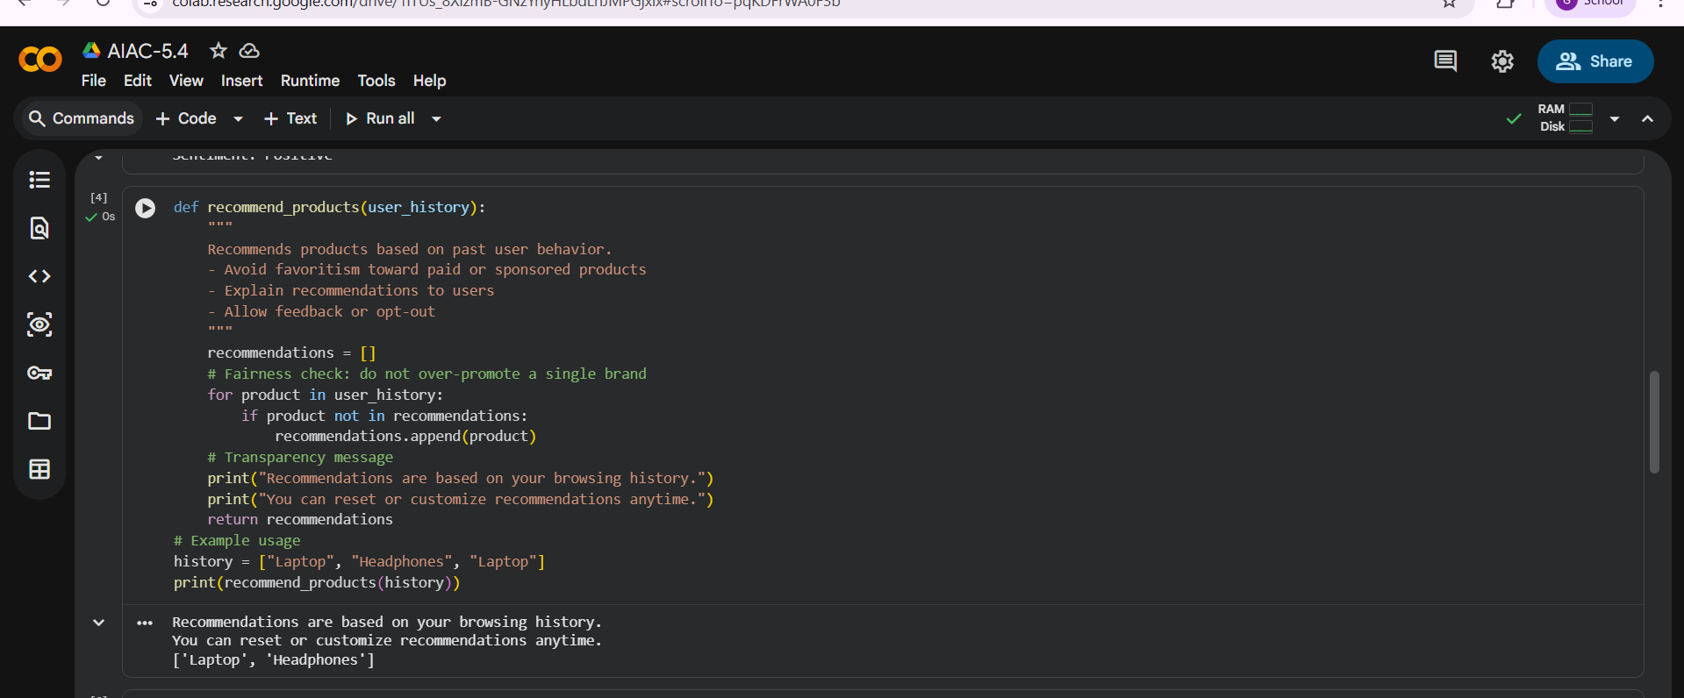

Task Description #4:
• Prompt Copilot to generate logging functionality in a Python web application. Then, ask it to ensure the logs do not record sensitive information.
Expected Output #4:
• Logging code that avoids saving personal identifiers (e.g., passwords, emails), and includes comments about ethical logging practices.
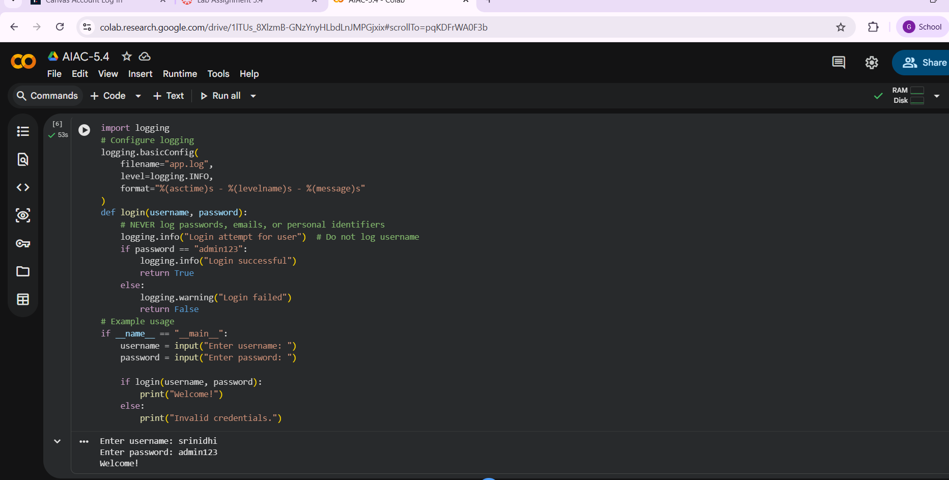

Task Description #5:
• Ask Copilot to generate a machine learning model. Then, prompt it to add documentation on how to use the model responsibly (e.g., explainability, accuracy limits).
Expected Output #5:
• Copilot-generated model code with a README or inline documentation suggesting responsible usage, limitations, and fairness considerations.
