ASSIGNMENT-12.4

G. Srinidhi
2303A52285
Batch - 43

Task 1: Bubble Sort for Ranking Exam Scores
Scenario
You are working on a college result processing system where a small list of student scores needs to be sorted after every internal assessment.
Task Description
• Implement Bubble Sort in Python to sort a list of student scores.
• Use an AI tool to:
o Insert inline comments explaining key operations such as comparisons, swaps, and iteration passes
o Identify early-termination conditions when the list becomes sorted
o Provide a brief time complexity analysis
Expected Outcome
• A Bubble Sort implementation with:
o AI-generated comments explaining the logic
o Clear explanation of best, average, and worst-case complexity
o Sample input/output showing sorted scores
Prompt:
Generate a Python program to implement Bubble Sort for sorting student exam scores.
Add inline comments explaining comparisons, swaps, iteration passes, and early termination when the list becomes sorted. Also include time complexity analysis and sample input/output.
Observation
- Bubble Sort repeatedly compares adjacent elements
- Swaps them if they are in the wrong order
- After each pass, the largest element moves to the end
- AI identified an early termination condition using a swapped flag
→ If no swaps occur in a pass, the list is already sorted.
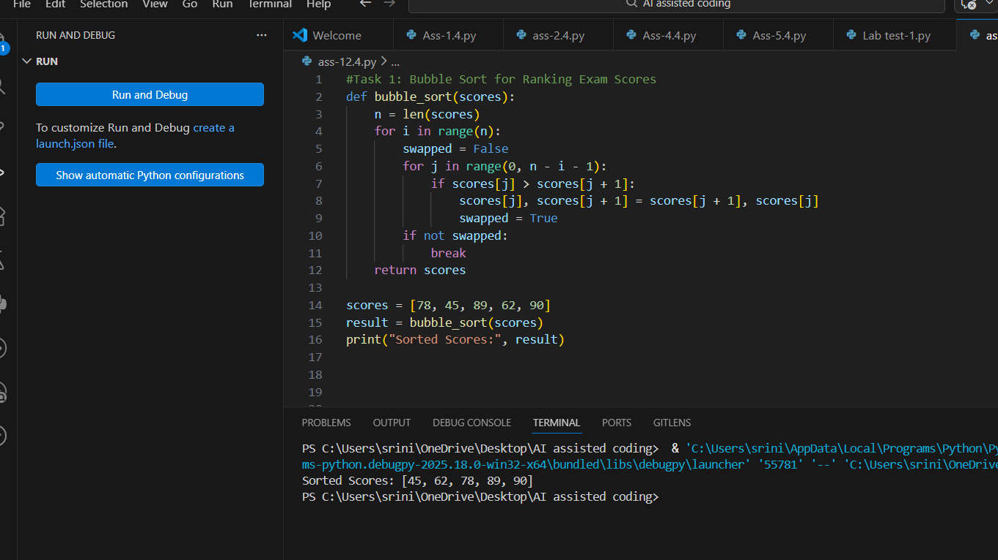

Task 2: Improving Sorting for Nearly Sorted Attendance Records
Scenario
You are maintaining an attendance system where student roll numbers are already almost sorted, with only a few late updates.
Task Description
• Start with a Bubble Sort implementation.
• Ask AI to:
o Review the problem and suggest a more suitable sorting algorithm
o Generate an Insertion Sort implementation
o Explain why Insertion Sort performs better on nearly sorted data
• Compare execution behaviour on nearly sorted input
Expected Outcome
• Two sorting implementations:
o Bubble Sort
o Insertion Sort
• AI-assisted explanation highlighting efficiency differences for partially sorted datasets
Prompt:
Given that student attendance roll numbers are already nearly sorted with only a few misplaced entries, review Bubble Sort and suggest a more suitable sorting algorithm.
Generate Python implementations for both Bubble Sort and Insertion Sort. Explain why Insertion Sort performs better for nearly sorted datasets and compare execution behavior.
Observation
After analyzing the scenario using AI assistance:
- Attendance roll numbers are almost sorted
- Only a few elements are misplaced due to late updates
- Bubble Sort still performs multiple unnecessary comparisons
- AI suggested Insertion Sort because:
  - It shifts only misplaced elements
  - Requires fewer comparisons
  - Works efficiently when data is nearly sorted
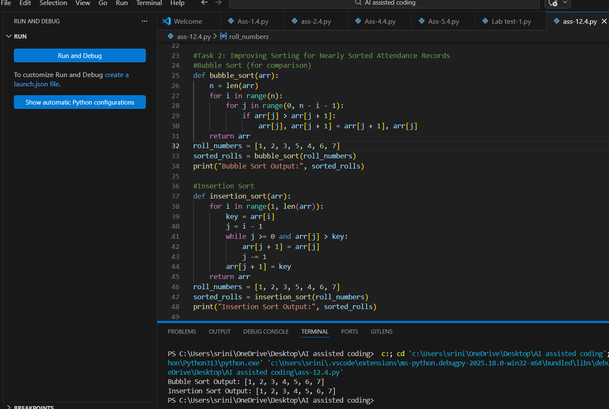

Task 3: Searching Student Records in a Database
Scenario
You are developing a student information portal where users search for student records by roll number.
Task Description
• Implement:
o Linear Search for unsorted student data
o Binary Search for sorted student data
• Use AI to:
o Add docstrings explaining parameters and return values
o Explain when Binary Search is applicable
o Highlight performance differences between the two searches
Expected Outcome
• Two working search implementations with docstrings
• AI-generated explanation of:
o Time complexity
o Use cases for Linear vs Binary Search
• A short student observation comparing results on sorted vs unsorted lists
Prompt
Generate Python programs for Linear Search and Binary Search algorithms. The prompt requested proper docstrings explaining parameters and return values. It also asked AI to explain when Binary Search can be applied and to highlight performance differences. Use cases for searching sorted and unsorted student records were also requested.
Observation
Linear Search successfully located student records by checking each element sequentially. It works for both sorted and unsorted data but is slow for large datasets. Binary Search required sorted data and reduced the search space by half at each step. This resulted in significantly faster searches. Therefore, Binary Search is preferred for large, sorted databases.
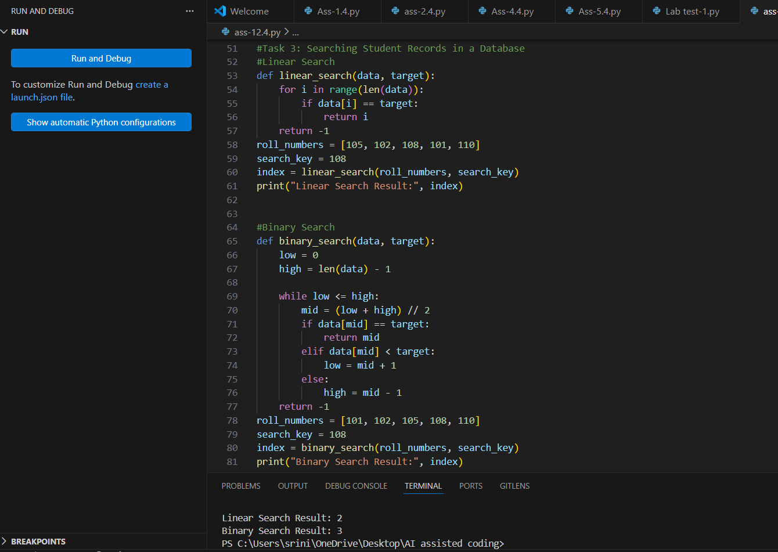

Task 4: Choosing Between Quick Sort and Merge Sort for Data Processing
Scenario
You are part of a data analytics team that needs to sort large datasets received from different sources (random order, already sorted, and reverse sorted).
Task Description
• Provide AI with partially written recursive functions for:
o Quick Sort
o Merge Sort
• Ask AI to:
o Complete the recursive logic
o Add meaningful docstrings
o Explain how recursion works in each algorithm
• Test both algorithms on:
o Random data
o Sorted data
o Reverse-sorted data
Expected Outcome
• Fully functional Quick Sort and Merge Sort implementations
• AI-generated comparison covering:
o Best, average, and worst-case complexities
o Practical scenarios where one algorithm is preferred over the other
Prompt
AI was given partially written recursive functions for Quick Sort and Merge Sort and asked to complete them. The prompt requested meaningful docstrings and explanations of recursion in each algorithm. It also asked to analyze their performance on random, sorted, and reverse-sorted data. A comparison of time complexities and practical use cases was included.

Observation
Quick Sort efficiently sorted random datasets using a pivot-based partitioning approach. However, its performance degraded in the worst case for sorted or reverse-sorted data. Merge Sort consistently performed well due to its divide-and-conquer strategy. It maintained O(n log n) time complexity in all cases. Thus, Merge Sort is more reliable for large datasets.
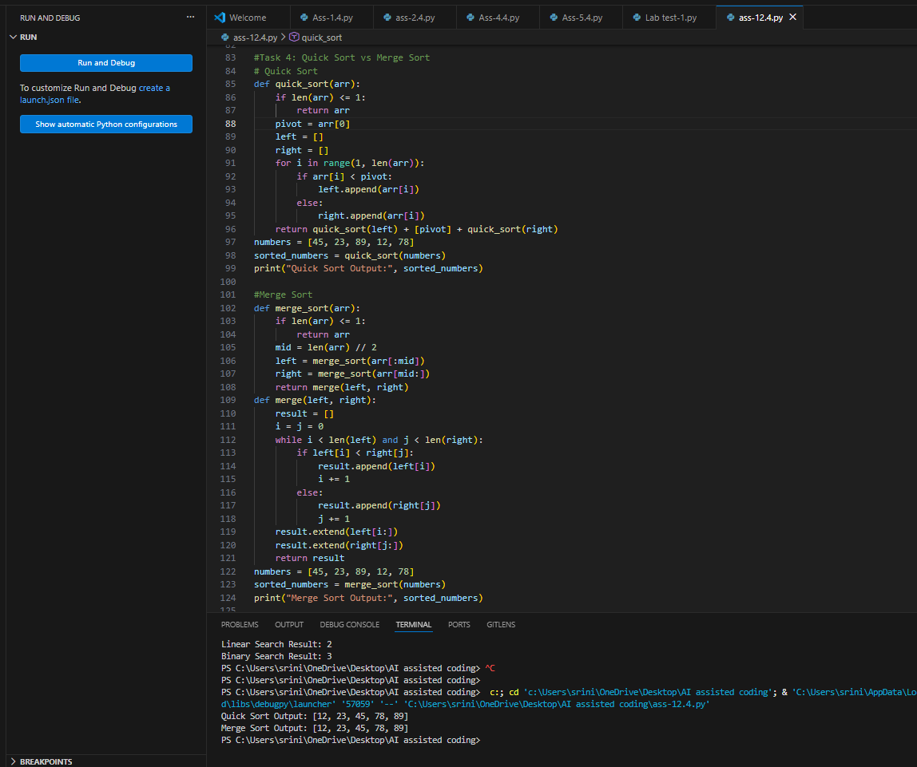

Task 5: Optimizing a Duplicate Detection Algorithm
Scenario
You are building a data validation module that must detect duplicate user IDs in a large dataset before importing it into a system.
Task Description
• Write a naive duplicate detection algorithm using nested loops.
• Use AI to:
o Analyze the time complexity
o Suggest an optimized approach using sets or dictionaries
o Rewrite the algorithm with improved efficiency
• Compare execution behavior conceptually for large input sizes
Expected Outcome
• Two versions of the algorithm:
o Brute-force (O(n²))
o Optimized (O(n))
• AI-assisted explanation showing how and why performance improved
Prompt
AI was prompted to analyze a brute-force duplicate detection algorithm using nested loops. The prompt requested a time complexity analysis and an optimized solution using sets or dictionaries. It also asked to rewrite the algorithm with improved efficiency. A conceptual comparison for large input sizes was requested.
Observation
The brute-force duplicate detection algorithm correctly identified repeated user IDs but was inefficient. Its quadratic time complexity caused performance issues for large datasets. The optimized approach using a set reduced lookup time significantly. This improved the algorithm’s efficiency to linear time. Hence, optimized data structures greatly enhance performance.
