ASS-14.1
NAME : M . Sanjana
HTNO:-2303A52292
BATCH:-43
Task 1 – Portfolio Website Design
Prompt: Design a responsive personal portfolio website using HTML, CSS, and JavaScript with sections for About Me, Projects, and Contact. Use modern colors, good typography, Flexbox/Grid layout, and smooth scrolling navigation.
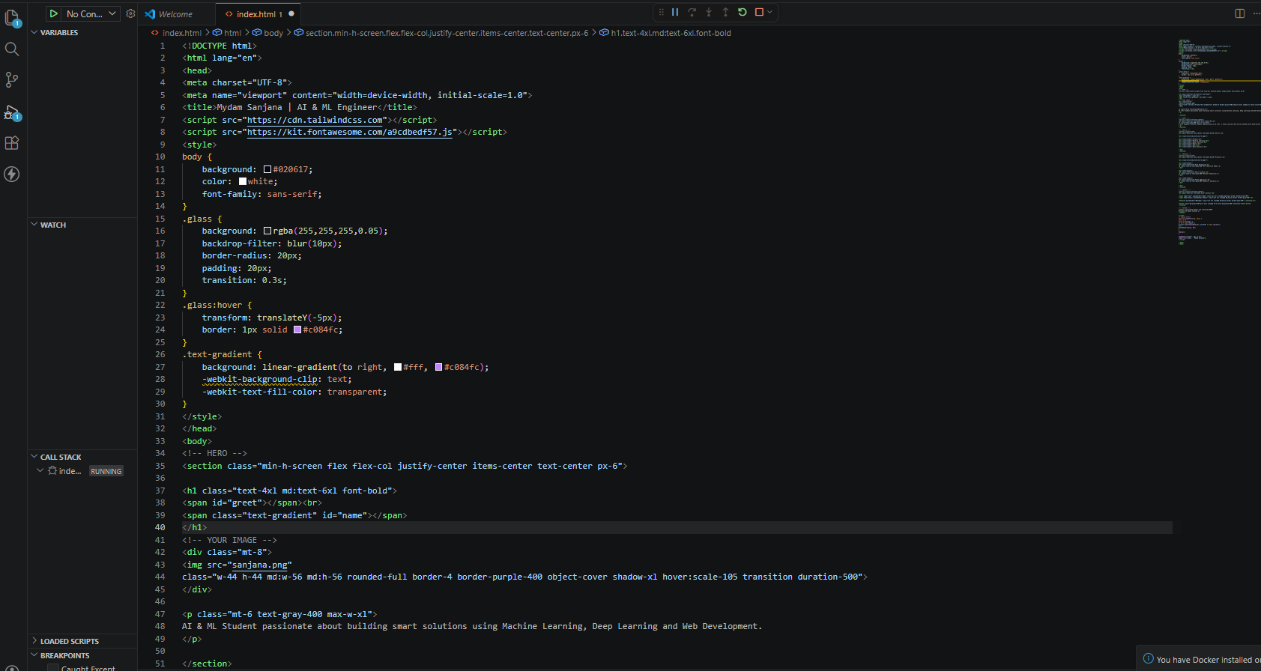
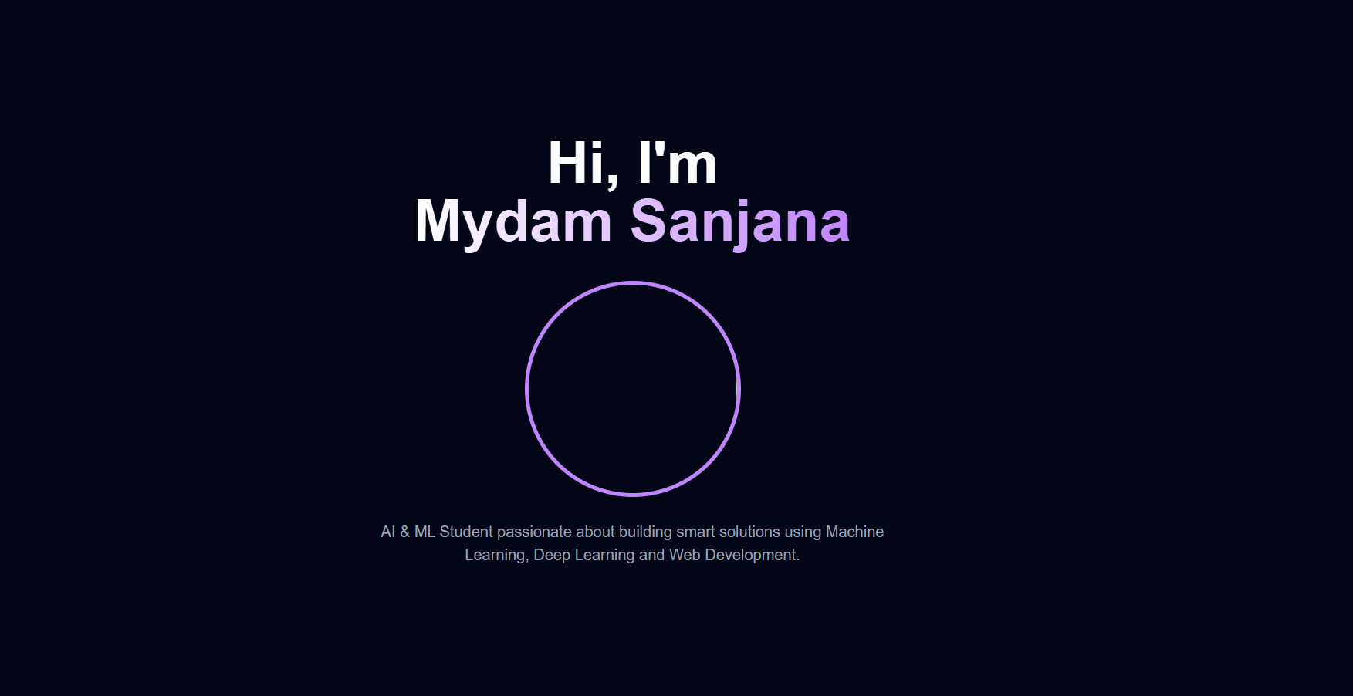
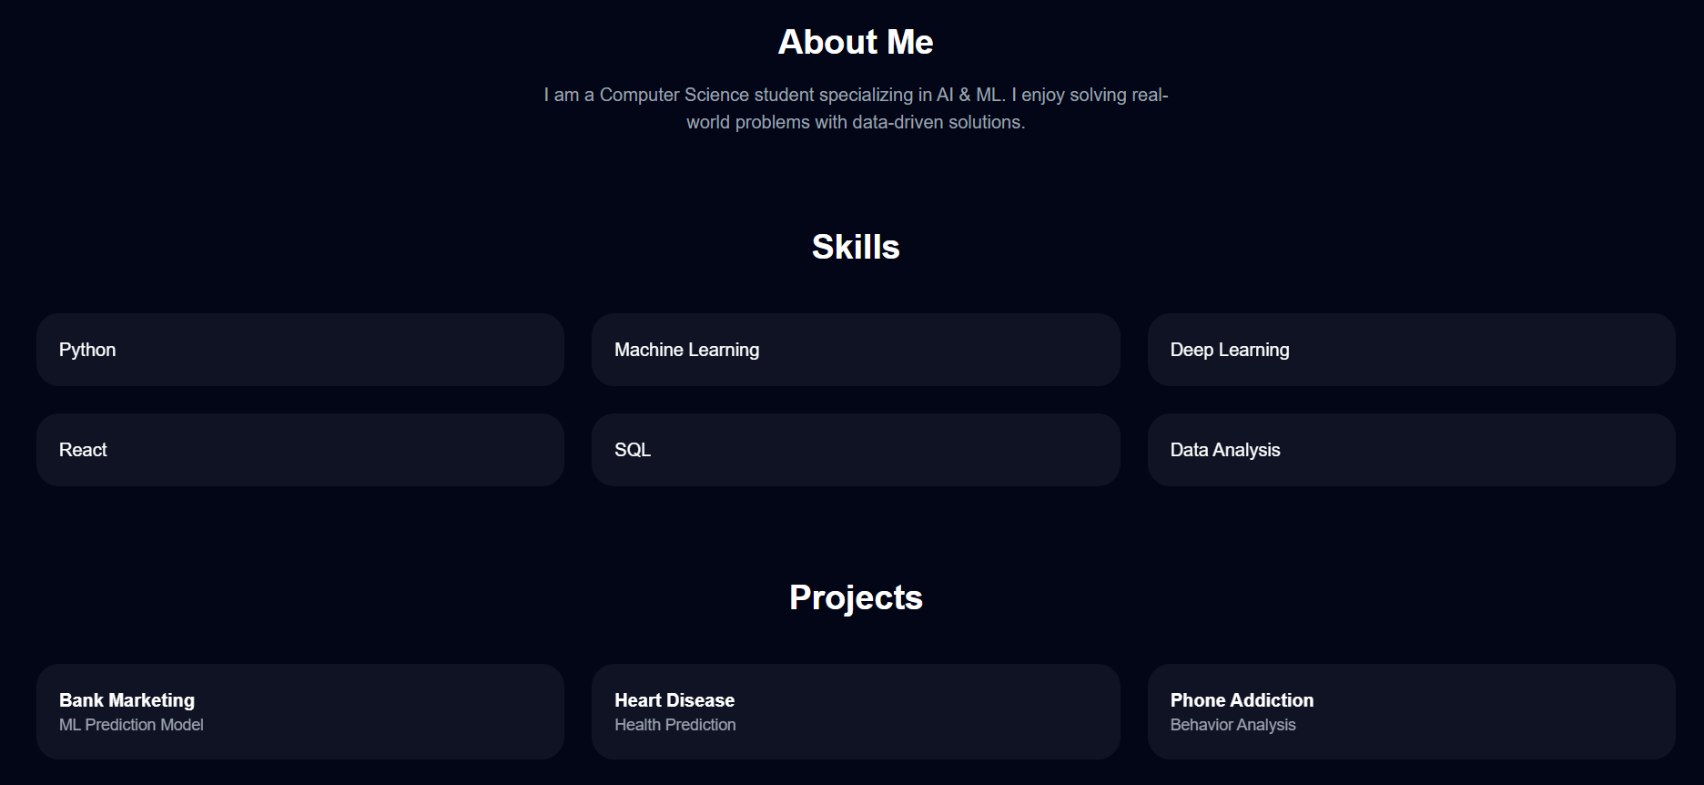
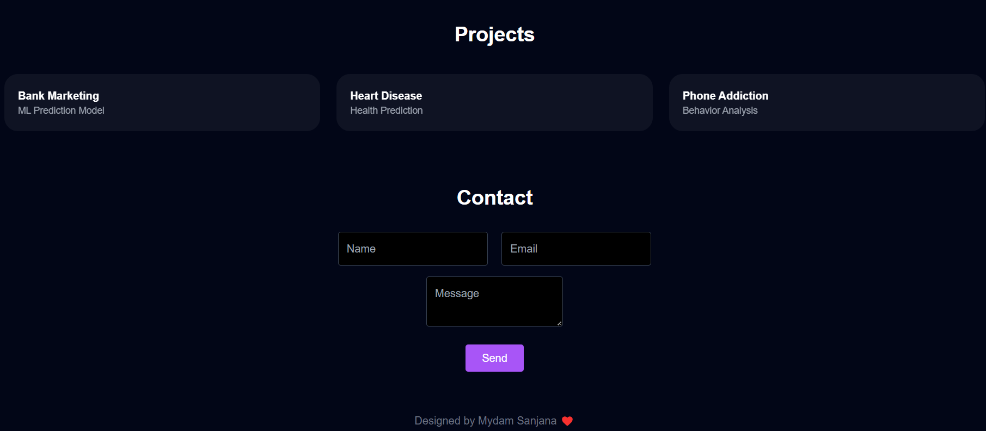
Observation: The website was successfully created with AI support, which helped in layout design, color selection, and responsiveness. Smooth navigation and structured sections improved user experience. AI reduced development time and produced a clean, professional interface.

Task 2 – Online Store Product Page
Prompt: Design a responsive online store product page using HTML, CSS, and JavaScript. Display product image, title, price, and an "Add to Cart" button. Use BEM methodology for styling, add hover effects, and show an alert when the button is clicked.
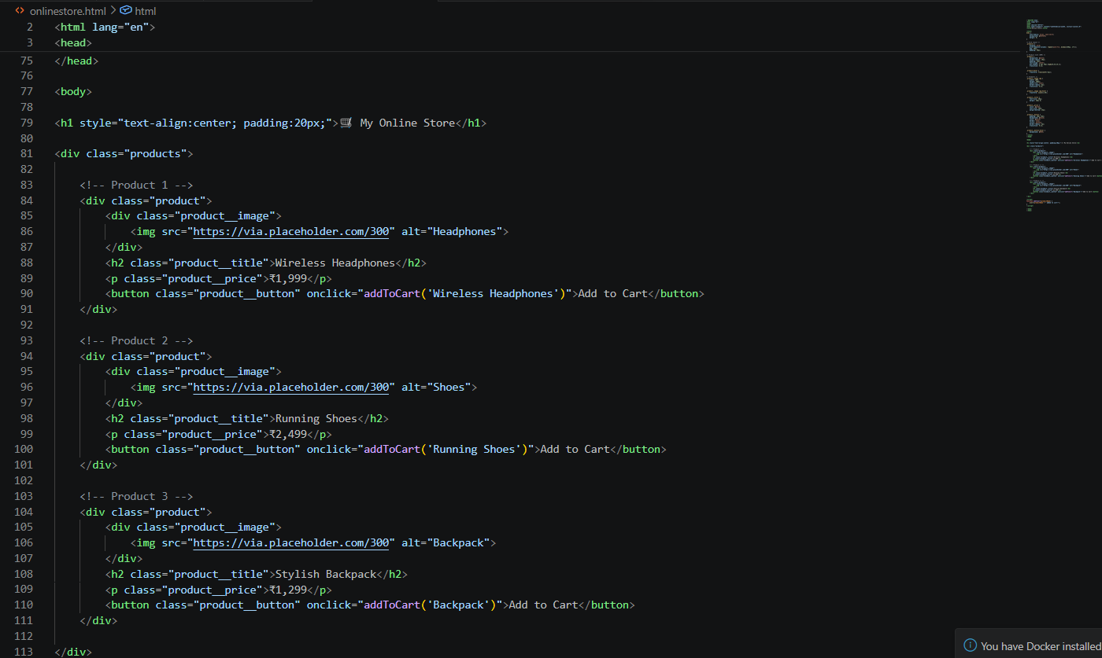
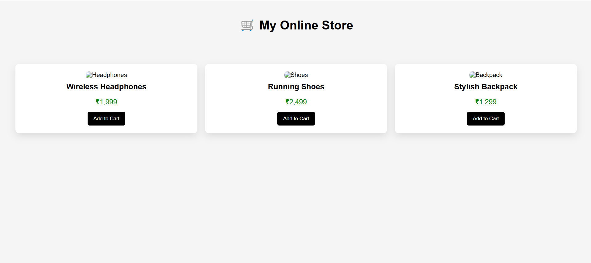
Observation: The product page was created using AI assistance with proper BEM structure for clean and reusable code. The layout is responsive and adapts to different devices. Hover effects improved visual appeal, and the "Add to Cart" alert added basic interactivity. AI made the design faster and more organized.

Task 3 – Event Registration Form
Prompt: Design an event registration form using HTML, CSS, and JavaScript. Collect name, email, phone number, and session selection. Add validation, accessibility with labels/ARIA, and style it professionally.
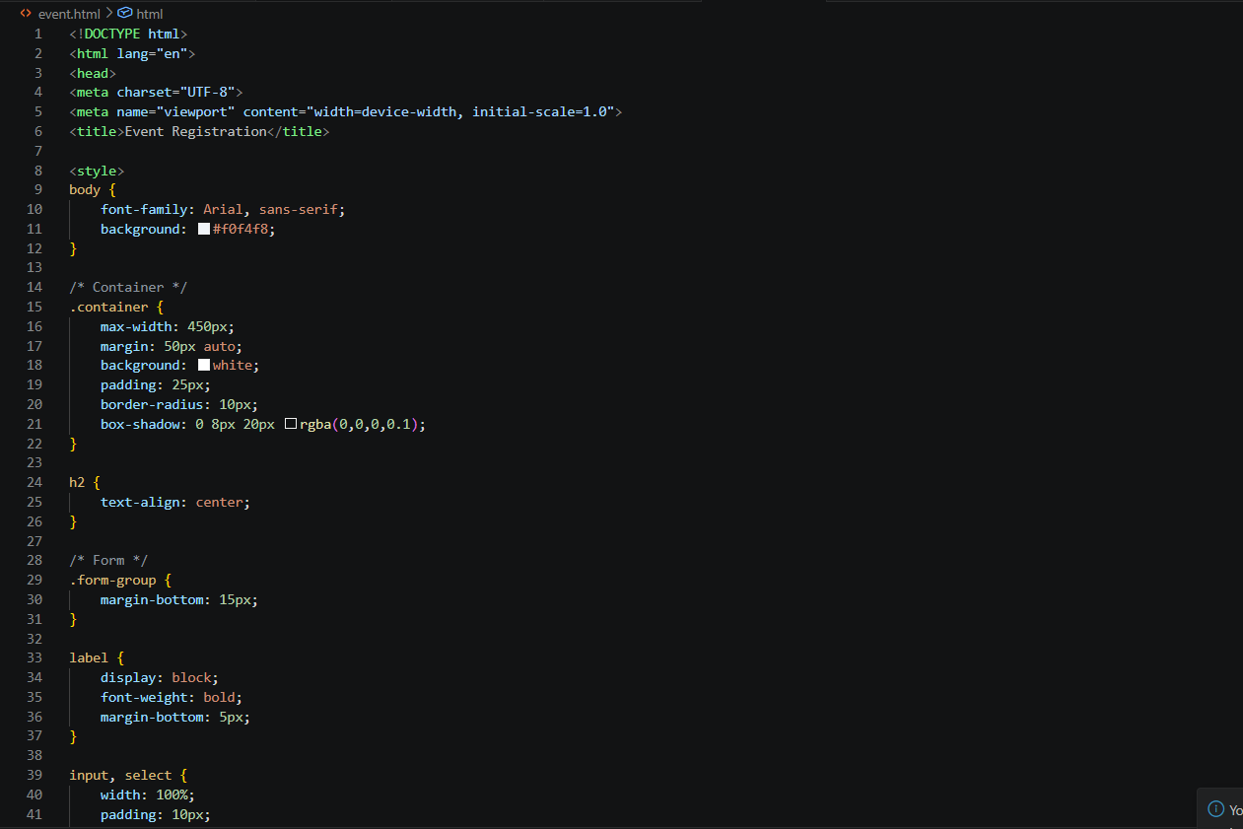
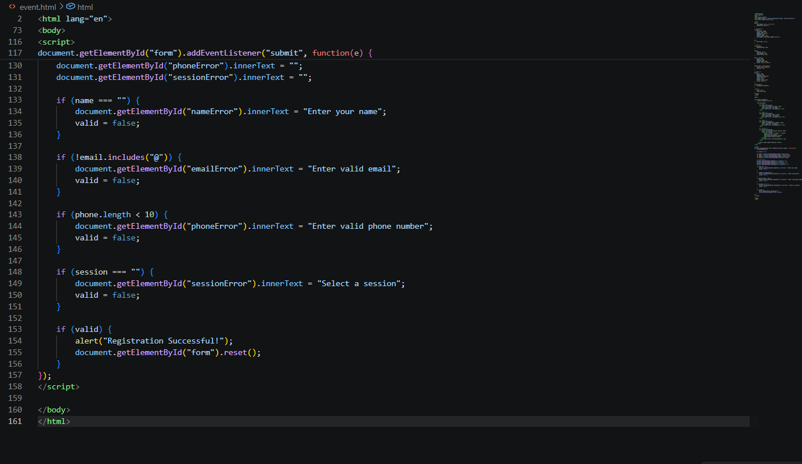
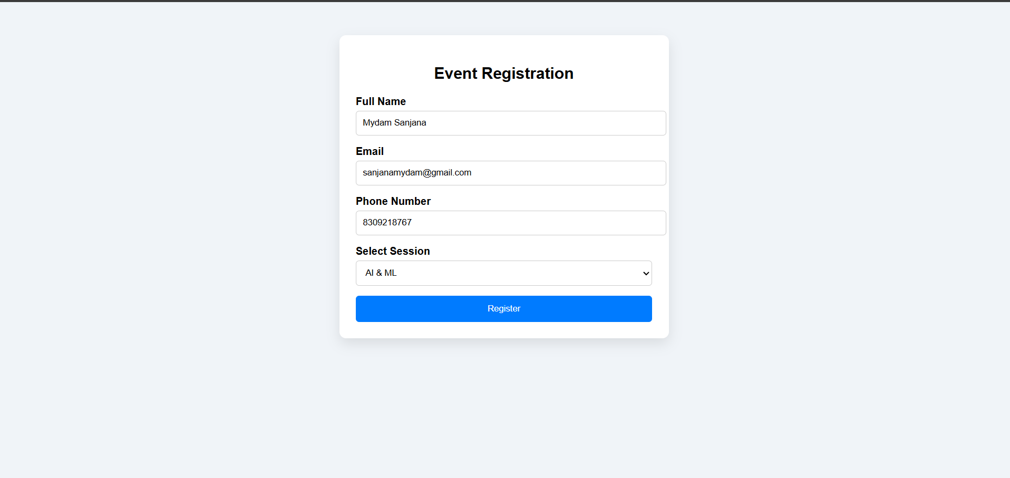
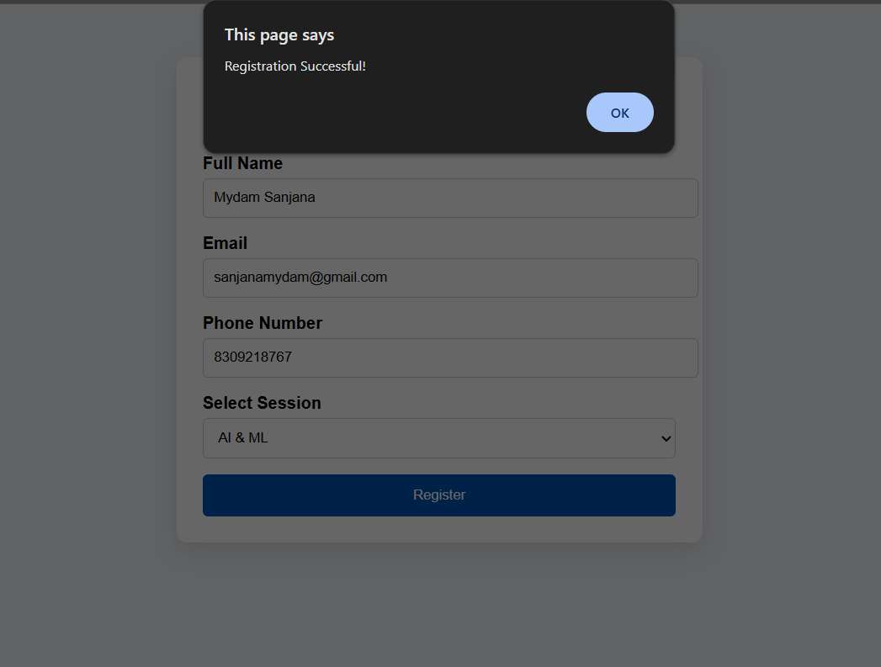
Observation: The form was created with proper validation to ensure correct user input. Accessibility features like labels and ARIA improved usability. The professional styling enhanced user experience. AI helped in building a clean and functional form quickly.

Task 4 – Resume Website
Prompt: Create a one-page resume website with sections for Profile Summary, Skills, Education, and Experience. Use CSS Grid for layout, modern typography, and smooth scrolling navigation
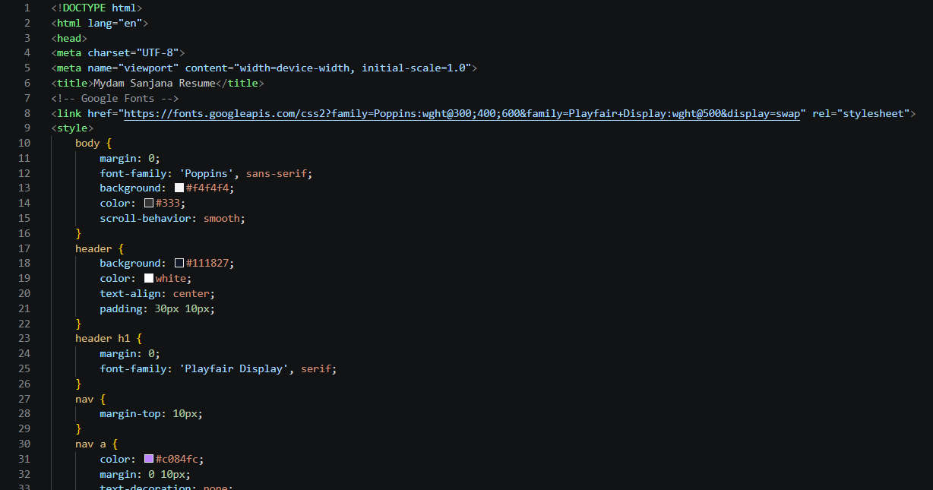
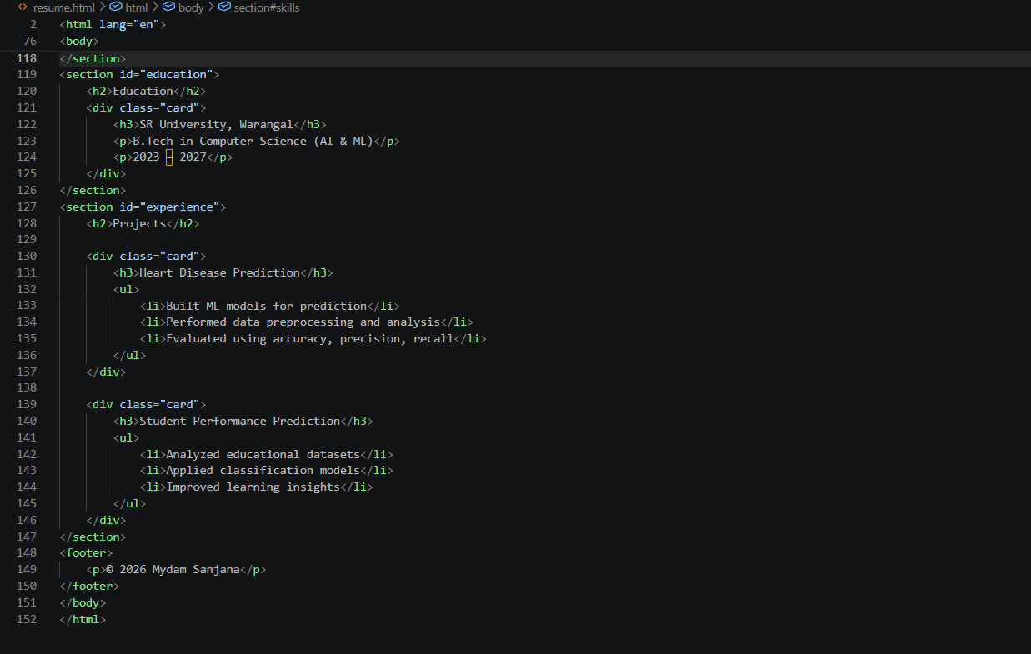
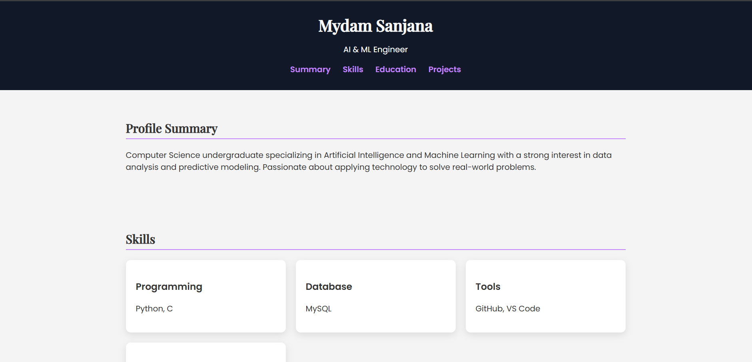
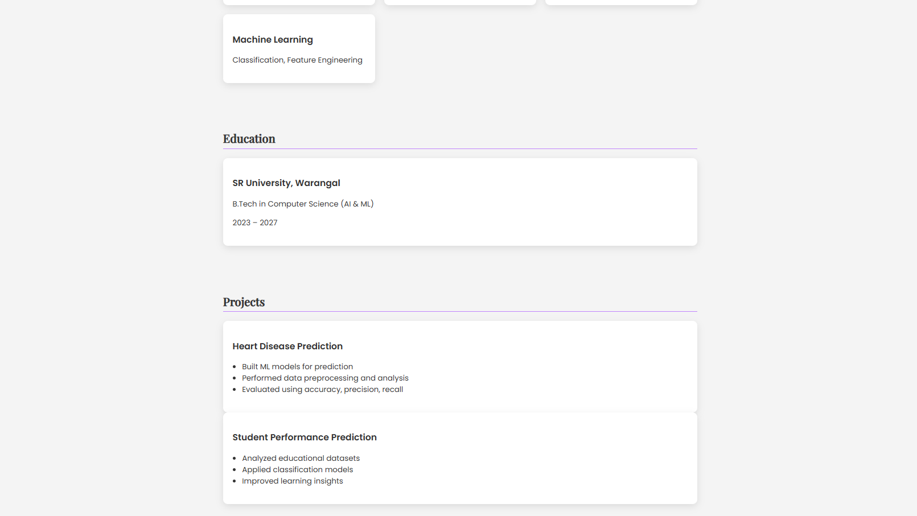
Observation: The resume website was structured clearly using CSS Grid for alignment. Typography improved readability and professional appearance. Smooth scrolling enhanced navigation between sections. AI simplified layout design and styling.
Task 5 – Restaurant Menu Page
Prompt: Design a restaurant menu page displaying item name, description, and price. Use a food-friendly color palette, responsive card layout, and hover effects.
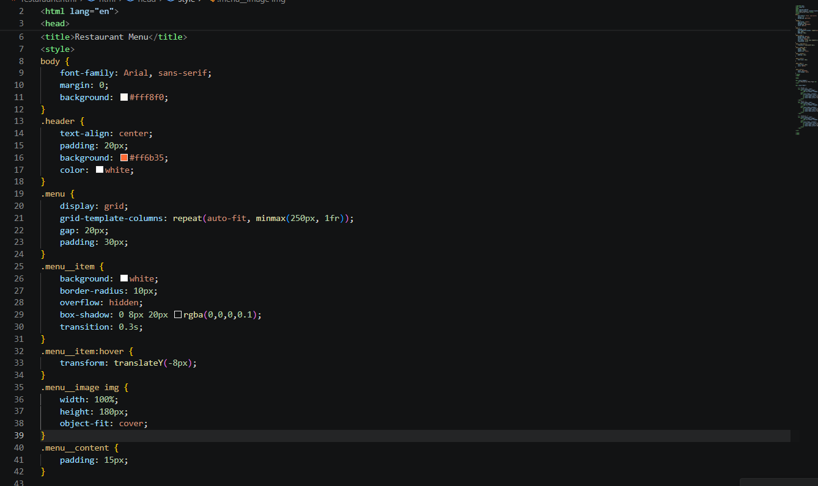
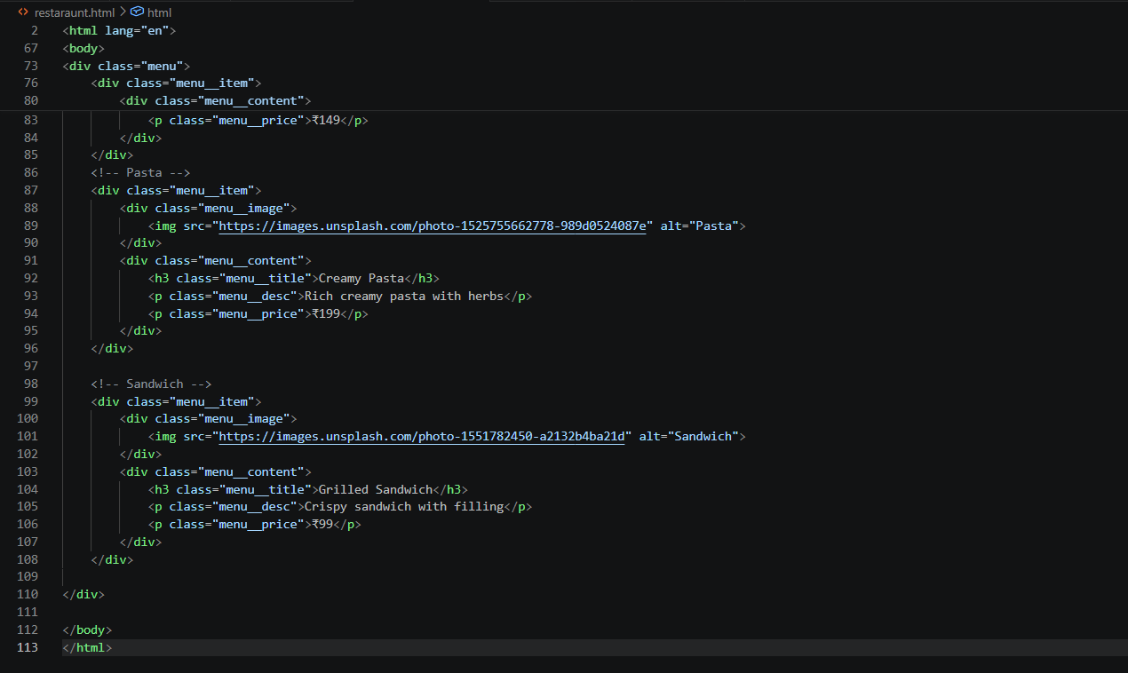
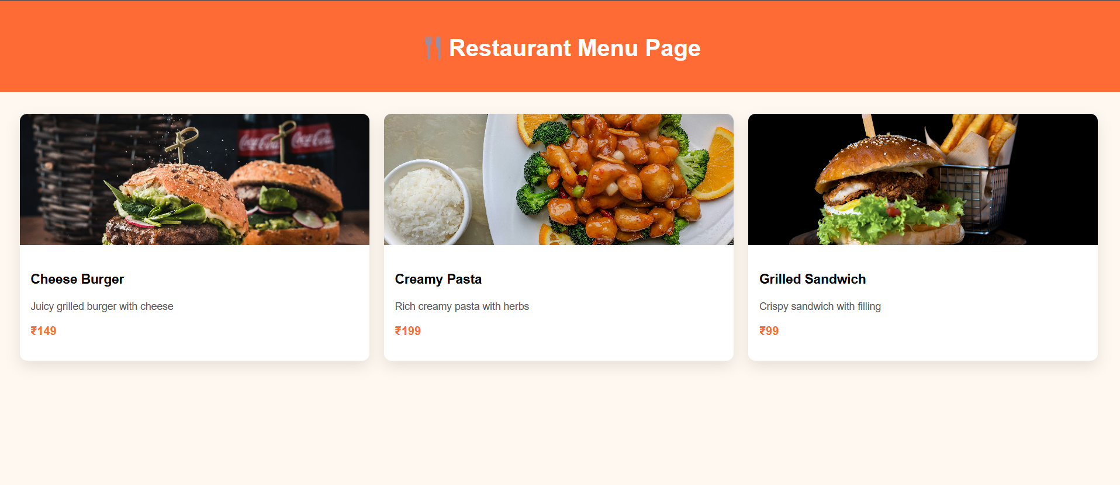Observation: The menu page was designed with attractive colors suitable for food presentation. Card-based layout ensured responsiveness across devices. Hover effects added interactivity and visual appeal. AI made the design modern and user-friendly.

