AI Assisted Coding

Assignment-10.3

Name : Sudireddy Asritha Chowdary
HallTicket Number : 2303A52297
Batch : 45

TASK-01-

Prompt : '''
refactor a given Python script that contains multiple repeated code blocks.
Prompt AI to identify duplicate logic and replace it with functions or classes.
Ensure the refactored code maintains the same output.
Add docstrings to all functions.
'''
print("Area of Rectangle:", 5 * 10)
print("Perimeter of Rectangle:", 2 * (5 + 10))
print("Area of Rectangle:", 7 * 12)
print("Perimeter of Rectangle:", 2 * (7 + 12))
print("Area of Rectangle:", 10 * 15)
print("Perimeter of Rectangle:", 2 * (10 + 15))

CODE--

def calculate_rectangle_metrics(length: int, width: int) -> None:
"""
Calculate and display the area and perimeter of a rectangle.
Args:
length: The length of the rectangle
width: The width of the rectangle
"""
area = length * width
perimeter = 2 * (length + width)
print(f"Area of Rectangle: {area}")
print(f"Perimeter of Rectangle: {perimeter}")
# Calculate metrics for three rectangles
calculate_rectangle_metrics(5, 10)
calculate_rectangle_metrics(7, 12)
calculate_rectangle_metrics(10, 15)

OUTPUT--

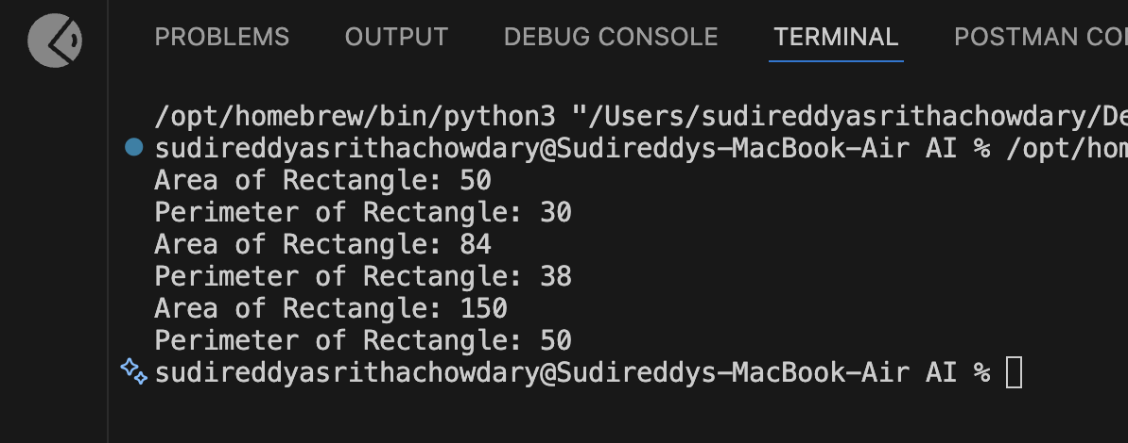

Justification :

# 1. The `calculate_rectangle_metrics` function computes the area and perimeter of a rectangle given its length and width, which is a fundamental geometric calculation.
# 2. The function takes two parameters (length and width) and prints the results in a clear format, making it easy for users to understand the output.
# 3. The function is called three times with different dimensions to demonstrate its functionality and to provide multiple examples of rectangle metrics.

TASK-02

Prompt:
'''
refactor a legacy script where multiple calculations are embedded directly inside the main code block.
Identify repeated or related logic and extract it into reusable functions.
Ensure the refactored code is modular, easy to read, and documented with docstrings.
'''
price = 250
tax = price * 0.18
total = price + tax
print("Total Price:", total)

price = 500
tax = price * 0.18
total = price + tax
print("Total Price:", total)

CODE--

def calculate_total_price(price: float, tax_rate: float = 0.18) -> float:
"""
Calculate the total price including tax.
Args:
price: The base price of the item
tax_rate: The tax rate as a decimal (default: 0.18 for 18%)
Returns:
The total price including tax
"""
tax = price * tax_rate
return price + tax

# Calculate total price for multiple items
prices = [250, 500]
for price in prices:
total = calculate_total_price(price)
print(f"Total Price: {total}")

OUTPUT--

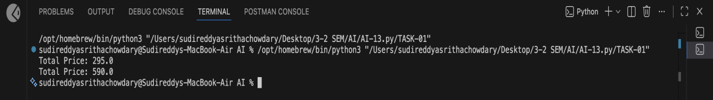

TASK-03

Prompt:

Refactor this Python script that uses repeated if–elif–else grading logic into an object-oriented solution. Create a class named GradeCalculator with a method calculate_grade(self, marks) that returns the correct grade string based on marks (A, B, C, D, Fail). Include proper docstrings for both the class and method, and show example usage by calling the method for different student marks.

CODE--

class GradeCalculator:
"""
A class to calculate student grades based on marks.
This class provides a method to determine letter grades (A, B, C, D, Fail)
based on numerical marks using predefined grading thresholds.
"""
def __init__(self):
"""Initialize the GradeCalculator with grading thresholds."""
self.thresholds = {
'A': 90,
'B': 80,
'C': 70,
'D': 60,
'Fail': 0
}
def calculate_grade(self, marks: int) -> str:
"""
Calculate the grade for a given marks value.
Args:
marks: An integer representing the student's marks (0-100)
Returns:
A string representing the grade: 'A', 'B', 'C', 'D', or 'Fail'
"""
for grade, threshold in self.thresholds.items():
if marks >= threshold:
return grade
return 'Fail'
# Example usage
calculator = GradeCalculator()
print(calculator.calculate_grade(95)) # Output: A
print(calculator.calculate_grade(85)) # Output: B
print(calculator.calculate_grade(75)) # Output: C
print(calculator.calculate_grade(65)) # Output: D
print(calculator.calculate_grade(55)) # Output: Fail

OUTPUT--

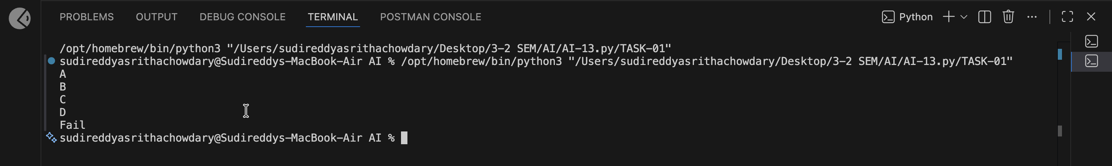
Justification :

# 1. The `GradeCalculator` class is designed to calculate grades based on numerical marks.
# 2. The `calculate_grade` method iterates through predefined thresholds and returns the appropriate grade.
# 3. If marks are below the lowest threshold (0), it returns 'Fail'.
# 4. The example usage demonstrates how to use the class and its method with different mark values.

TASK-04

TASK-11

Prompt:

“””Refactor the given poorly structured Python script into a clean, modular, and reusable implementation.
A Harshad (Niven) number is a number that is divisible by the sum of its digits.”””

CODE--

"""
Harshad (Niven) Number Checker
A Harshad number is a positive integer that is divisible by the sum of its digits.
Example: 18 is a Harshad number because 1 + 8 = 9, and 18 % 9 == 0
"""
def calculate_digit_sum(number: int) -> int:
"""
Calculate the sum of digits of a given number.
Args:
number: An integer (positive or negative)
Returns:
The sum of the absolute digits of the number
"""
return sum(int(digit) for digit in str(abs(number)))
def is_harshad(number: int) -> bool:
"""
Check if a number is a Harshad (Niven) number.
A Harshad number is divisible by the sum of its digits.
Only positive integers can be Harshad numbers.
Args:
number: An integer to check
Returns:
True if the number is a Harshad number,False otherwise”””
if number <= 0:
return False
digit_sum = calculate_digit_sum(number)
if digit_sum == 0:
return False
return number % digit_sum == 0
def main():
"""Main function to handle user interaction."""
try:
num = int(input("Enter a number: "))
result = is_harshad(num)
print(result)
except ValueError:
print("Invalid input. Please enter a valid integer.")
if __name__ == "__main__":
main()

OUTPUT--

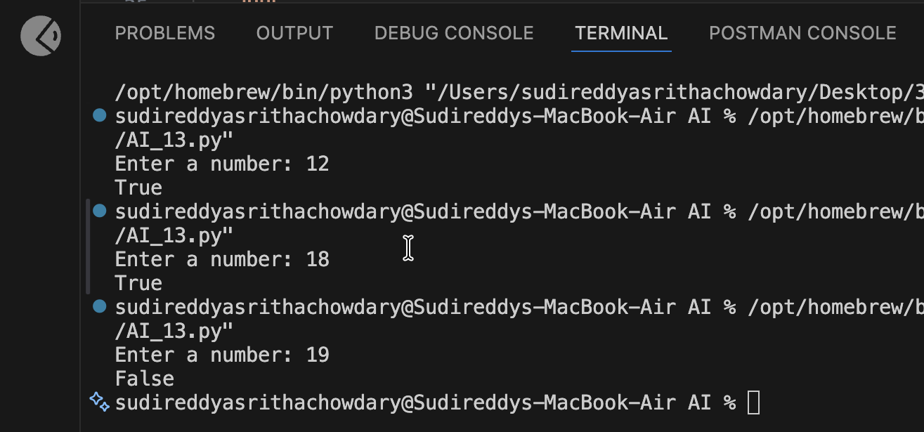

Justification :

# 1. The `calculate_digit_sum` function computes the sum of the digits of a number, which is essential for determining if a number is a Harshad number.
# 2. The `is_harshad` function checks if the number is positive, calculates the digit sum, and checks if the number is divisible by that sum.
# 3. The `main` function handles user input and displays the result, ensuring that the program is user-friendly and can handle invalid input gracefully.

TASK-12

Prompt:

Task 12 – Refactoring the Factorial Trailing Zeros Program
Refactor the given poorly structured Python script into a clean, modular, and efficient implementation.
The program calculates the number of trailing zeros in n! (factorial of n).

CODE--

def count_trailing_zeros(n: int) -> int:
"""
Calculate the number of trailing zeros in n! (factorial of n).
Trailing zeros are produced by factors of 10, which come from pairs of 2 and 5.
Since there are always more factors of 2 than 5, we count multiples of 5.
Args:
n: A non-negative integer
Returns:
The number of trailing zeros in n!
Returns 0 if n is negative
"""
if n < 0:
return 0
count = 0
power_of_5 = 5
while power_of_5 <= n:
count += n // power_of_5
power_of_5 *= 5
return count
def main():
"""Main function to handle user interaction."""
try:
num = int(input("Enter a number: "))
result = count_trailing_zeros(num)
print(f"Trailing zeros in {num}!: {result}")
except ValueError:
print("Invalid input. Please enter a valid integer.")
if __name__ == "__main__":
main()

OUTPUT--

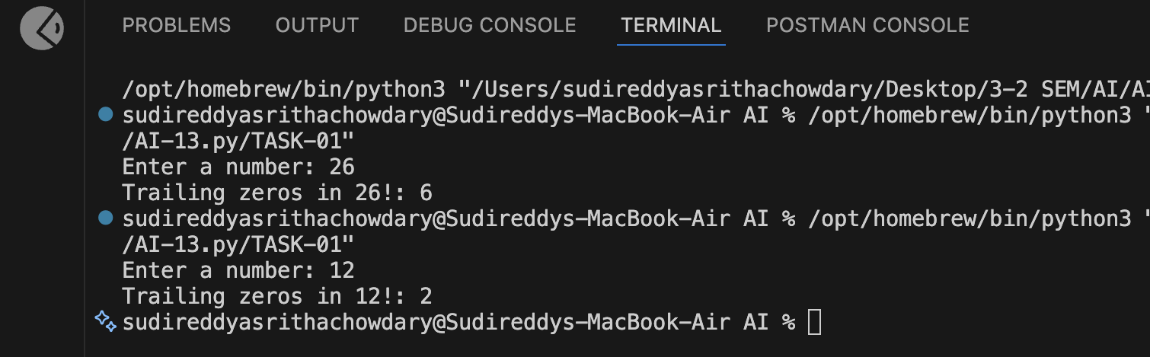

Justification :

