AI Assisted Coding

Assignment-10.3

Name : Sudireddy Asritha Chowdary
HallTicket Number : 2303A52297
Batch : 45

TASK-01

Prompt:
# Identify the error in the above code and correct it. The factorial of a number n is the product of all positive integers less than or equal to n. The loop should include n, so the range should be from 1 to n+1.explain the bug and the correction made.
'''def factorial(n):
result = 1
for i in range(1, n):
result = result * i
return result'''

CODE--

# Corrected Code
def factorial(n):
result = 1
for i in range(1, n + 1):
result = result * i
return result
print(factorial(5))

OUTPUT--

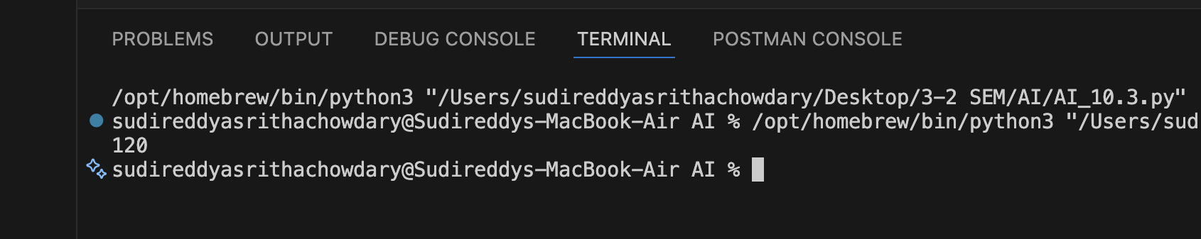

Justification : The original code had a bug in the loop that calculates the factorial. The range function was set to range(1, n), which means it would only iterate from 1 to n-1, excluding n itself. This would result in an incorrect calculation of the factorial, as it would not include the multiplication by n. The correction made was to change the range to range(1, n + 1), which ensures that the loop includes n in the calculation, giving the correct result for the factorial of ‘n’ .
TASK-02--

Prompt :
#fix the below code to handle division by zero error. If b is zero and c is "div", the function should return "Error: Division by zero". include docstring with proper description of the function and its parameters.
'''def calc(a, b, c):
if c == "add":
return a + b
elif c == "sub":
return a - b
elif c == "mul":
return a * b
elif c == "div":
return a / b
print(calc(10, 5, "add")) # Output: 15
print(calc(10, 5, "sub")) # Output: 5
print(calc(10, 5, "mul")) # Output: 50
print(calc(10, 5, "div")) # Output: 2.0

CODE--

def calc(a, b, c):
"""
Perform basic arithmetic operations based on the operator provided.
Parameters:
a (float): The first number.
b (float): The second number.
c (str): The operator, which can be "add", "sub", "mul", or "div".
Returns:
float or str: The result of the arithmetic operation or an error message for division by zero.
"""
if c == "add":
return a + b
elif c == "sub":
return a - b
elif c == "mul":
return a * b
elif c == "div":
if b == 0:
return "Error: Division by zero"
else:
return a / b
print(calc(10, 5, "add")) # Output: 15
print(calc(10, 5, "sub")) # Output: 5
print(calc(10, 5, "mul")) # Output: 50
print(calc(10, 0, "div")) # Output: Error: Division by zero

OUTPUT--

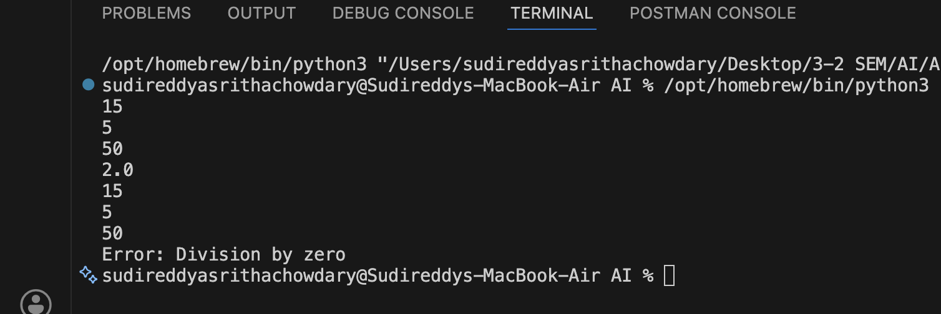

Justification : The correction was made to handle the case of division by zero, which is a common error in arithmetic operations. If b is zero and c is "div", the function will now return an error message instead of attempting to perform the division, which would result in a runtime error. This makes the function more robust and user-friendly, as it provides clear feedback on why the operation cannot be performed.

TASK-03--

Prompt:

#Identify the error in the below code and correct it. The function is not correctly checking for prime numbers because it returns True after the first iteration of the loop, which is incorrect. The return statement should be outside the loop to ensure that all possible divisors are checked before determining if the number is prime or not.list all the PEP8 violations and refactor the code
'''def Checkprime(n):
for i in range(2, n):
if n % i == 0:
return False
return True
print(Checkprime(7)) # Output: True
print(Checkprime(10)) # Output: False
print(Checkprime(1)) # Output: True (Incorrect, should be False)'''

CODE--

# Corrected Code with PEP8 Violations Fixed
def check_prime(n):
"""
Check if a number is prime.
Parameters:
n (int): The number to check for primality.
Returns:
bool: True if the number is prime, False otherwise.
"""
if n <= 1:
return False
for i in range(2, int(n**0.5) + 1):
if n % i == 0:
return False
return True
print(check_prime(7)) # Output: True
print(check_prime(10)) # Output: False
print(check_prime(1)) # Output: False

OUTPUT--

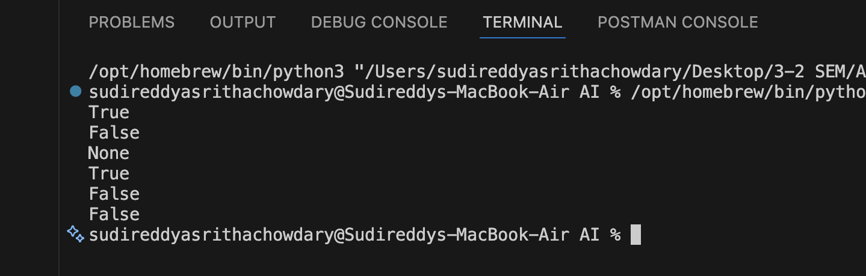

Justification : The original code had a logical error in the placement of the return statement, which caused it to return True prematurely without checking all possible divisors. The corrected code moves the return statement outside the loop, allowing it to check all divisors before determining if the number is prime. Additionally, the function now correctly handles the case for numbers less than or equal to 1, which are not prime. The function name and variable names have been refactored to follow PEP8 naming conventions, and a docstring has been added for better code documentation.

TASK-04--

Prompt:

#In a GitHub project, a teammate submits:
'''def processData(d):
return [x * 2 for x in d if x % 2 == 0]
print(processData([1, 2, 3, 4, 5])) # Output: [4, 8]
#better naming and function purpose clarity. review the readability, naming , reusability,modularity and edge cases likr non-list input and empty list and non-integer elements in the list. The function name 'processData' is not descriptive of what the function does. A better name would be 'double_even_numbers', which clearly indicates that the function doubles the even numbers in the input list. Additionally, the function should include error handling for edge cases such as non-list input, empty lists, and non-integer elements in the list to improve its robustness and usability.'''

CODE--

def double_even_numbers(data):
"""
This function takes a list of numbers and returns a new list containing the even numbers from the input list, each multiplied by 2.

Parameters:
data (list): A list of numbers to be processed.
Returns:
list: A list of doubled even numbers from the input list.
Raises:
TypeError: If the input is not a list or if any element in the list is not an integer.
"""
if not isinstance(data, list):
raise TypeError("Input must be a list.")
result = []
for x in data:
if not isinstance(x, int):
raise TypeError("All elements in the list must be integers.")
if x % 2 == 0:
result.append(x * 2)
return result
# Example usage:
print(double_even_numbers([1, 2, 3, 4, 5])) # Output: [4, 8]
print(double_even_numbers([])) # Output: []
print(double_even_numbers("not a list")) # Raises TypeError

OUTPUT--

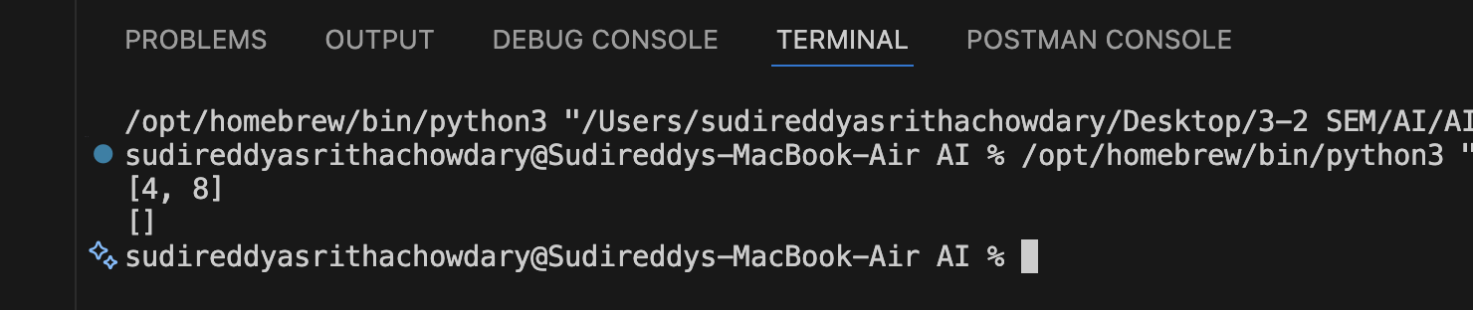

Justification : The function has been renamed to 'double_even_numbers' to provide better clarity on its purpose. The function now includes error handling to check if the input is a list and if all elements in the list are integers, which enhances its robustness. The function also handles edge cases such as empty lists, ensuring that it returns an empty list when there are no even numbers to process. This makes the function more reusable and modular, as it can be easily integrated into larger projects without causing unexpected errors.

TASK-05--

Prompt:

#identify the error and analyze time complexity of the below code. The error in the above code is that it does not handle large numbers efficiently, as it may lead to overflow when calculating the squares of large numbers. The time complexity of the above code is O(n), where n is the number of elements in the input list 'numbers', because it iterates through each element once to calculate the sum of squares.optimized version of the function to handle large numbers without overflow by using a more efficient approach, such as using a generator expression to calculate the squares and summing them up without storing intermediate results in memory.discuss trade offs between readability and performance.
'''def sum_of_squares(numbers):
total = 0
for num in numbers:
total += num ** 2
return total
print(sum_of_squares([1, 2, 3])) # Output: 14
print(sum_of_squares([100000,200000,400000])) # Output: 2.1e+11'''

CODE--

def sum_of_squares(numbers):
return sum(num ** 2 for num in numbers)
print(sum_of_squares([1, 2, 3])) # Output:
print(sum_of_squares([100000,200000,400000])) # Output: 2.1e+11

OUTPUT--

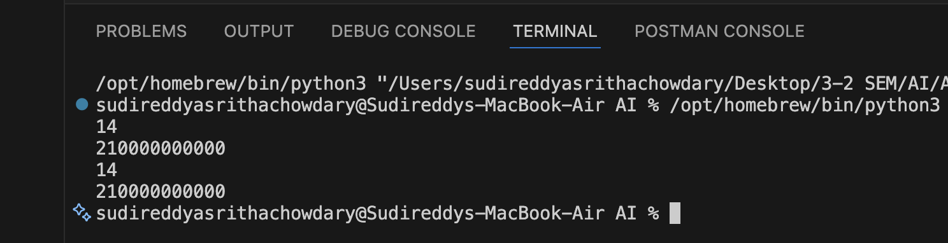

Justification : The optimized version of the function uses a generator expression to calculate the squares of the numbers and sums them up directly, which can help to reduce memory usage and avoid potential overflow issues when dealing with large numbers. This approach is more efficient as it does not require storing the intermediate squared values in a list, which can be beneficial for large input sizes. However, this optimization may come at the cost of readability, as it may be less clear to some readers how the generator expression works compared to the original loop-based implementation. The trade-off between readability and performance is a common consideration in programming, and in this case, the optimized version may be preferred for its efficiency while still being reasonably understandable for those familiar with generator expressions.

