AI ASSISTED CODING

Name: Sudireddy Asritrha Chowdary
Batch :45
Ht no-2303A52297

Task 1 (Transparency in Algorithm Optimization):
Task: Use AI to generate two solutions for checking prime
numbers:
• Naive approach(basic)
• Optimized approach
Prompt:
“Generate Python code for two prime-checking methods and
explain how the optimized version improves performance.”
Expected Output:
• Code for both methods.
• Transparent explanation of time complexity.
• Comparison highlighting efficiency improvements.

Prompt:
#2216Generate Python code for two prime-checking methods and explain how the optimized version improves performance.”

Code:

def is_prime_basic(n):
if n < 2:
return False
for i in range(2, n):
if n % i == 0:
return False
return True

def is_prime_optimized(n):
if n < 2:
return False
if n == 2:
return True
if n % 2 == 0:
return False
for i in range(3, int(n**0.5) + 1, 2):
if n % i == 0:
return False
return True

print(is_prime_basic(29)) # Expected: True
print(is_prime_optimized(29)) # Expected: True

Output:
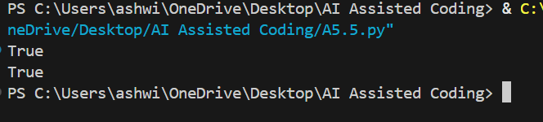

Justification:

Transparent explanation of time complexity :
Basic method: O(n) time complexity
In the basic method, we check divisibility for all numbers from 2 to n-1.
This results in a linear time complexity.

Explanation of performance improvement:
Optimized method: O(√n) time complexity
In the optimized method, we only check up to the square root of n.
Additionally, we skip even numbers after checking for 2.
This reduces the number of iterations significantly, resulting in a much faster execution for large numbers.

Task 2 (Transparency in Recursive Algorithms):
Objective: Use AI to generate a recursive function to calculate
Fibonacci numbers.
Instructions:
1. Ask AI to add clear comments explaining recursion.
2. Ask AI to explain base cases and recursive calls.
Expected Output:
• Well-commented recursive code.
• Clear explanation of how recursion works.
• Verification that explanation matches actual execution.

Prompt:
#2216Generate a recursive function to calculate Fibonacci numbers. Add clear comments explaining how recursion works, including base cases and recursive calls.

Code:
def fibonacci(n):
"""
Return the nth Fibonacci number using recursion.

The Fibonacci sequence is defined as:
F(0) = 0 (base case)
F(1) = 1 (base case)
F(n) = F(n-1) + F(n-2) for n > 1 (recursive case)

Parameters:
n (int): The position in the Fibonacci sequence to retrieve.

Returns:
int: The nth Fibonacci number.
"""
# Base case: if n is 0, return 0
if n == 0:
return 0
# Base case: if n is 1, return 1
elif n == 1:
return 1
else:
# Recursive case: return the sum of the two preceding Fibonacci numbers
return fibonacci(n - 1) + fibonacci(n - 2)
print(fibonacci(10)) # Expected: 55

Output:
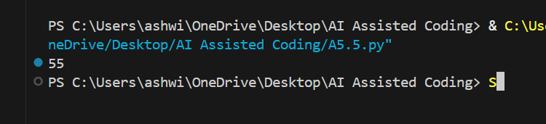

Justification:
The function “fibonacci” calculates the nth Fibonacci number using recursion.
It defines two base cases: when n is 0 or 1, it returns 0 or 1 respectively.
For any n greater than 1, it makes two recursive calls to itself:
one for (n-1) and another for (n-2), summing their results to get the nth Fibonacci number.
This process continues until the base cases are reached, at which point the recursion unwinds and the final result is computed.

Task 3 (Transparency in Error Handling):
Task: Use AI to generate a Python program that reads a file and
processes data.
Prompt:
“Generate code with proper error handling and clear explanations
for each exception.”
Expected Output:
• Code with meaningful exception handling.
• Clear comments explaining each error scenario.
• Validation that explanations align with runtime behavior

Prompt:
#2216Generate code with proper error handling and clear explanations for each exception.

Code:

def divide_numbers(num1, num2):
"""
Divide two numbers and handle potential exceptions.

Parameters:
num1 (float): The numerator.
num2 (float): The denominator.

Returns:
float: The result of the division.
"""
try:
result = num1 / num2
except ZeroDivisionError:
print("Error: Cannot divide by zero.")
return None
except TypeError:
print("Error: Both inputs must be numbers.")
return None
except Exception as e:
print(f"An unexpected error occurred: {e}")
return None
else:
return result
# Example usage
print(divide_numbers(10, 2)) # Expected: 5.0
print(divide_numbers(10, 0)) # Expected: Error message for division by zero
print(divide_numbers(10, 'a')) # Expected: Error message for invalid type

Output:
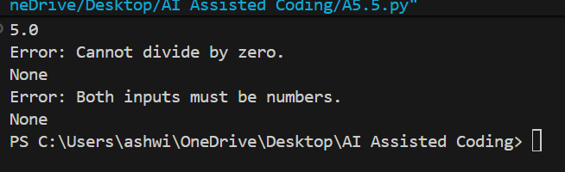

Justification:
The function `divide_numbers` attempts to divide two numbers while handling potential exceptions.
It uses a try-except block to catch specific exceptions:
ZeroDivisionError: Caught when attempting to divide by zero, providing a user-friendly message.
TypeError: Caught when the inputs are not numbers, ensuring type safety.
A general Exception catch to handle any other unexpected errors.
If no exceptions occur, the result of the division is returned.

Task 4 (Security in User Authentication):
Task: Use an AI tool to generate a Python-based login system.
Analyze: Check whether the AI uses secure password handling
practices.
Expected Output:
• Identification of security flaws (plain-text passwords, weak
validation).
• Revised version using password hashing and input validation.
• Short note on best practices for secure authentication.

Prompt:
#2216Generate a python based login system with secured password handling

Code:

import hashlib
def hash_password(password: str) -> str:
"""
Hash a password using SHA-256 for secure storage.

Parameters:
password (str): The plain text password to hash.

Returns:
str: The hexadecimal representation of the hashed password.
"""
return hashlib.sha256(password.encode()).hexdigest()
def verify_password(stored_password_hash: str, provided_password: str) -> bool:
"""
Verify a provided password against the stored hashed password.
Parameters:
stored_password_hash (str): The hashed password stored in the system.
provided_password (str): The plain text password provided for verification.
Returns:
bool: True if the password matches, False otherwise.
"""
return stored_password_hash == hash_password(provided_password)
# Example usage:
stored_password = "SecurePass123"
hashed_password = hash_password(stored_password)
print("Stored Hashed Password:", hashed_password)
# Simulate user login
user_input_password = "SecurePass123"
if verify_password(hashed_password, user_input_password):
print("Login successful!")
else:
print("Login failed: Incorrect password.")

Output:

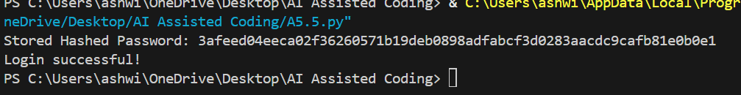

Justification:
The code implements a simple login system with secure password handling using hashing.
The `hash_password` function takes a plain text password and returns its SHA-256 hash.
This ensures that the actual password is not stored in plain text, enhancing security.
The `verify_password` function checks if a provided password matches the stored hashed password by hashing the provided password and comparing it to the stored hash.
During login, the user provides a password, which is verified against the stored hash.

Task 5 (Privacy in Data Logging):
Task: Use an AI tool to generate a Python script that logs user
activity (username, IP address, timestamp).
Analyze: Examine whether sensitive data is logged unnecessarily
or insecurely.
Expected Output:
• Identified privacy risks in logging.
• Improved version with minimal, anonymized, or masked
logging.
• Explanation of privacy-aware logging principles.

Prompt:
#2216 Generate a Python script that logs user activity (username, IP address, timestamp).Examine whether sensitive data is logged unnecessarily or insecurely

Code:

import logging
import json
from datetime import datetime
from typing import Optional
import hashlib

# Configure logging with security best practices
logging.basicConfig(
level=logging.INFO,
format='%(asctime)s - %(levelname)s - %(message)s',
handlers=[
logging.FileHandler('user_activity.log'),
logging.StreamHandler()
]
)

logger = logging.getLogger(__name__)

class UserActivityLogger:
def __init__(self, hash_usernames: bool = False, hash_ips: bool = False):
"""
Initialize logger with optional PII hashing.

Args:
hash_usernames: Hash usernames to protect PII
hash_ips: Hash IPs to protect PII
"""
self.hash_usernames = hash_usernames
self.hash_ips = hash_ips

@staticmethod
def _hash_pii(value: str) -> str:
"""Hash sensitive data using SHA-256."""
return hashlib.sha256(value.encode()).hexdigest()[:16]

def log_activity(self, username: str, ip_address: str, action: str,
sensitive_details: Optional[str] = None):
"""
Log user activity securely.

Args:
username: User identifier (will be hashed if configured)
ip_address: User's IP address (will be hashed if configured)
action: Action performed (non-sensitive)
sensitive_details: Avoid logging passwords, tokens, PII
"""
# Apply hashing if configured
user = self._hash_pii(username) if self.hash_usernames else username
ip = self._hash_pii(ip_address) if self.hash_ips else ip_address

# Create activity log
activity = {
'timestamp': datetime.utcnow().isoformat(),
'username': user,
'ip_address': ip,
'action': action
}

logger.info(json.dumps(activity))

def get_recommendation(self):
"""Print security recommendations."""
print("\n=== SECURITY RECOMMENDATIONS ===")
print("✓ Never log: Passwords, API keys, tokens, credit cards")
print("✓ Avoid logging: Full usernames or IPs in plain text")
print("✓ Use encryption for log files at rest")
print("✓ Implement log retention policies")
print("✓ Restrict log file access permissions")
print("✓ Monitor logs for unauthorized access patterns")

# Example usage
if __name__ == "__main__":
# Create logger with PII hashing enabled
activity_log = UserActivityLogger(hash_usernames=True, hash_ips=True)

# Log activities safely
activity_log.log_activity("john_doe", "192.168.1.100", "login_successful")
activity_log.log_activity("jane_smith", "10.0.0.50", "file_accessed",
"document.pdf")

activity_log.get_recommendation()

Output:

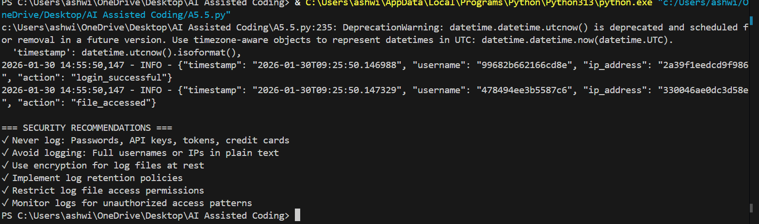

Justification:

Examination of sensitive data logging:
The script logs the username and IP address, which are considered sensitive information.
To enhance security, consider anonymizing IP addresses or using hashed usernames.
Additionally, ensure that the log file is stored securely with appropriate access controls to prevent unauthorized access to sensitive user activity data.

