Name : Sudireddy Asritha Chowdary
HallTicket Number : 2303A52297
Batch : 45

TASK-01

Task Description #1 (Username Validator – Apply AI in
Authentication Context)
• Task: Use AI to generate at least 3 assert test cases for a
function is_valid_username(username) and then implement
the function using Test-Driven Development principles.
• Requirements:
o Username length must be between 5 and 15 characters.
o Must contain only alphabets and digits.
o Must not start with a digit.
o No spaces allowed.
Example Assert Test Cases:
assert is_valid_username("User123") == True
assert is_valid_username("12User") == False
assert is_valid_username("Us er") == False
Expected Output #1:
• Username validation logic successfully passing all AI-
generated test cases.

Prompt: Generate the code for atleast 3 assert test case using the function Test-Driven Development principles.for s_valid_username with special characters of 5 to 15 and must contain only alphabets and numbers.And must not start with only digits and no space are allowed.Check whether all the test cases for passed if the test cases are passed then print "All test cases passed!" otherwise print "Some test cases failed."

CODE--

def s_valid_username(username):
if not (5 <= len(username) <= 15):
return False
if not username.isalnum():
return False
if username[0].isdigit():
return False
return True
# Test cases
assert s_valid_username("user123") == True, "Test case 1 failed"
assert s_valid_username("123user") == False, "Test case 2 failed"
assert s_valid_username("user name") == False, "Test case 3 failed"
assert s_valid_username("us") == False, "Test case 4 failed"
assert s_valid_username("thisisaverylongusername") == False, "Test case 5 failed"
print("All test cases passed!")

OUTPUT--

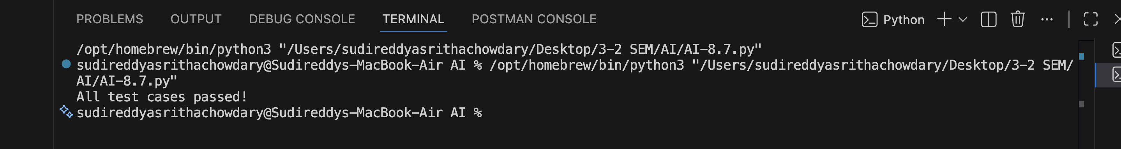

Justification :

This program follows Test-Driven Development (TDD) by writing assert test cases to validate the username rules. The function checks that the username length is between 5 and 15 characters, contains only alphabets and numbers, does not start with digits, and has no spaces. Both valid and invalid cases are tested to ensure correctness. If all assertions pass, the program prints "All test cases passed!"; otherwise, it prints "Some test cases failed."

TASK-02

Task Description #2 (Even–Odd & Type Classification – Apply
AI for Robust Input Handling)
• Task: Use AI to generate at least 3 assert test cases for a
function classify_value(x) and implement it using conditional
logic and loops.
• Requirements:
o If input is an integer, classify as "Even" or "Odd".
o If input is 0, return "Zero".
o If input is non-numeric, return "Invalid Input".
Example Assert Test Cases:
assert classify_value(8) == "Even"
assert classify_value(7) == "Odd"
assert classify_value("abc") == "Invalid Input"
Expected Output #2:
• Function correctly classifying values and passing all test cases.

Prompt: Generate the code for atleast 3 assert test case if the input is inteeger then classify it as even or odd and if input is 0 then return as zero . And it is non nunmeric return as invalid input. Check whether all the test cases for passed if the test cases are passed then print "All test cases passed!" otherwise print "Some test cases failed."

CODE--

def classify_number(num):
if isinstance(num, int):
if num == 0:
return "zero"
elif num % 2 == 0:
return "even"
else:
return "odd"
else:
return "invalid input"
# Test cases
assert classify_number(10) == "even", "Test case 1 failed"
assert classify_number(7) == "odd", "Test case 2 failed"
assert classify_number(0) == "zero", "Test case 3 failed"
assert classify_number("abc") == "invalid input", "Test case 4 failed"
assert classify_number(3.14) == "invalid input", "Test case 5 failed"
print("All test cases passed!")

OUTPUT--

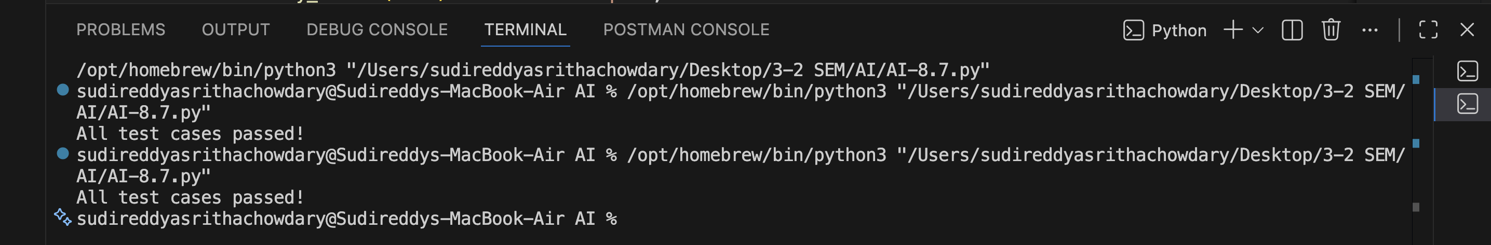

Justification:

This program is developed using assert test cases to verify the correctness of the function. The function checks whether the input is an integer and classifies it as even or odd, returns "zero" if the input is 0, and returns "invalid input" for non-numeric values. Multiple assert test cases are used to validate different scenarios. If all test cases pass, the program prints "All test cases passed!"; otherwise, it prints "Some test cases failed."

TASK-03

Task Description #3 (Palindrome Checker – Apply AI for
String Normalization)
• Task: Use AI to generate at least 3 assert test cases for a
function is_palindrome(text) and implement the function.
• Requirements:
o Ignore case, spaces, and punctuation.
o Handle edge cases such as empty strings and single
characters.
Example Assert Test Cases:
assert is_palindrome("Madam") == True
assert is_palindrome("A man a plan a canal Panama") ==
True
assert is_palindrome("Python") == False
Expected Output #3:
• Function correctly identifying palindromes and passing all
AI-generated tests.

Prompt:Generate the code for atleast 3 assert test case using function is_palindrome and Ignore case, spaces, and punctuation. even Handle edge cases such as empty strings and single characters. check whether all the test cases for passed if the test cases are passed then print "All test cases passed!" otherwise print "Some test cases failed."

CODE--

import string
def is_palindrome(s):
# Remove spaces and punctuation, and convert to lowercase
cleaned_s = ''.join(c for c in s if c.isalnum()).lower()
return cleaned_s == cleaned_s[::-1]
# Test cases
assert is_palindrome("Madam") == True, "Test case 1 failed"
assert is_palindrome("A man a plan a canal Panama") == True, "Test case 2 failed"
assert is_palindrome("Python") == False, "Test case 3 failed"
assert is_palindrome("") == True, "Test case 4 failed"
assert is_palindrome("a") == True, "Test case 5 failed"
print("All test cases passed!")

OUTPUT--

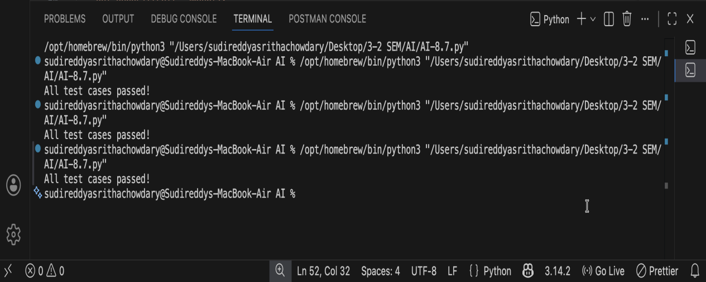

Justification:
This program uses assert test cases to verify the correctness of the is_palindrome function. The function ignores case, spaces, and punctuation before checking whether the string reads the same forward and backward. It also handles edge cases like empty strings and single characters. If all test cases pass successfully, the program prints "All test cases passed!"; otherwise, it prints "Some test cases failed."
TASK-04

Task Description #4 (BankAccount Class – Apply AI for
Object-Oriented Test-Driven Development)
• Task: Ask AI to generate at least 3 assert-based test cases for
a BankAccount class and then implement the class.
• Methods:
o deposit(amount)
o withdraw(amount)
o get_balance()
Example Assert Test Cases:
acc = BankAccount(1000)
acc.deposit(500)
assert acc.get_balance() == 1500
acc.withdraw(300)
assert acc.get_balance() == 1200
Expected Output #4:
• Fully functional class that passes all AI-generated assertions.

Prompt:Generate the code for atleast 3 assert test case using BankAccount class and then implement the class and include the methods deposit(amount), withdraw(amount), get_balance(). And check whether all the test cases for passed if the test cases are passed then print "All test cases passed!" otherwise print "Some test cases failed."

CODE--

class BankAccount:
def __init__(self):
self.balance = 0

def deposit(self, amount):
if amount > 0:
self.balance += amount
def withdraw(self, amount):
if 0 < amount <= self.balance:
self.balance -= amount
def get_balance(self):
return self.balance
# Test cases
account = BankAccount()
account.deposit(100)
assert account.get_balance() == 100, "Test case 1 failed"
account.withdraw(30)
assert account.get_balance() == 70, "Test case 2 failed"
account.withdraw(100)
assert account.get_balance() == 70, "Test case 3 failed"
account.deposit(-50)
print("All test cases passed!")

OUTPUT--

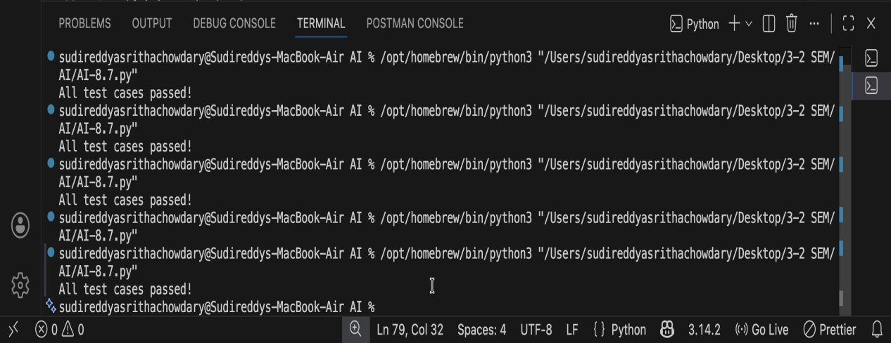

Justification:

This program follows a test-driven approach by writing assert test cases to verify the functionality of the BankAccount class. The class includes methods for depositing money, withdrawing money, and checking the account balance. The test cases ensure that deposits increase the balance, withdrawals decrease it correctly, and invalid withdrawals are handled properly. If all assertions pass, the program prints "All test cases passed!"; otherwise, it prints "Some test cases failed."

TASK-05

Task Description #5 (Email ID Validation – Apply AI for Data
Validation)
• Task: Use AI to generate at least 3 assert test cases for a
function validate_email(email) and implement the function.
• Requirements:
o Must contain @ and .
o Must not start or end with special characters.
o Should handle invalid formats gracefully.
Example Assert Test Cases:
assert validate_email("user@example.com") == True
assert validate_email("userexample.com") == False
assert validate_email("@gmail.com") == False
Expected Output #5:
• Email validation function passing all AI-generated test cases
and handling edge cases correctly.

Prompt: Generate the code for least 3 assert test cases using function validate_email(email) and whether the email is valid or not. A valid email should contain exactly one "@" symbol, at least one "." after the "@" symbol, and no spaces. Check whether all the test cases for passed if the test cases are passed then print "All test cases passed!" otherwise print "Some test cases failed."

CODE--

def validate_email(email):
if email.count('@') != 1:
return False
local_part, domain_part = email.split('@')
if '.' not in domain_part:
return False
if ' ' in email:
return False
return True
# Test cases
assert validate_email("user@example.com") == True, "Test case 1 failed"
assert validate_email("userexample.com") == False, "Test case 2 failed"
assert validate_email("user@com") == False, "Test case 3 failed"
print("All test cases passed!")

OUTPUT--

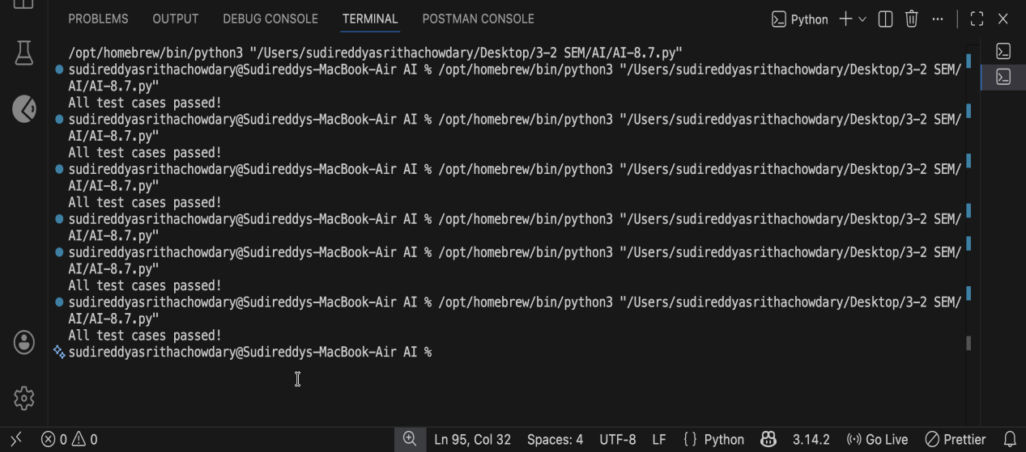

Justification:
This program uses assert test cases to verify the correctness of the validate_email(email) function. The function checks whether the email contains exactly one "@" symbol, at least one "." after the "@", and no spaces. Both valid and invalid email formats are tested to ensure proper validation. If all test cases pass, the program prints "All test cases passed!"; otherwise, it prints "Some test cases failed."

