Name: Sudireddy Asritha Chowdary
Roll Number: 2303A52297
Batch: 45

TASK-01
Prompt-- Generate the code for student information the class should include the attributes as name, roll number and branch and the method has to display the details of the student.

CODE--
class Student:
def __init__(self, name, roll_number, branch):
self.name = name
self.roll_number = roll_number
self.branch = branch

def display_details(self):
print(f"Name: {self.name}")
print(f"Roll Number: {self.roll_number}")
print(f"Branch: {self.branch}")
return self.name, self.roll_number, self.branch
# Example usage:
student1 = Student("Chowdary", "101", "Computer Science")
student1.display_details()
student2 = Student("Reddy", "102", "Mechanical Engineering")
student2.display_details()

OUTPUT--
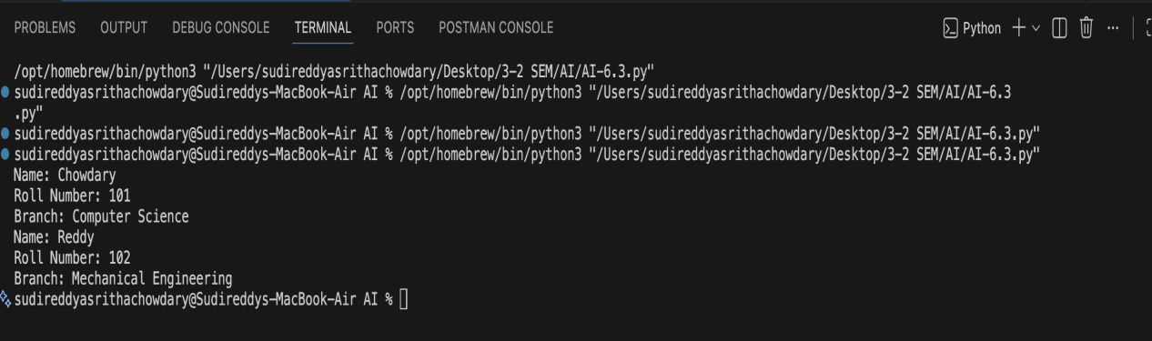

Justification: The given prompt is designed to introduce the basics of object-oriented programming in Python by modeling student information using a class. It requires defining attributes such as name, roll number, and branch to store student details in an organized manner. The prompt also includes a method to display these details, helping learners understand how methods access and use class data. Overall, it promotes clear, structured coding and strengthens understanding of classes and methods through a real-world example.

TASK-02
Prompt-- # Generate the code to print first 10 multiples of a number using for loop and while loop and also explain the difference between for loop and while loop with example.

CODE--
# Function to print first 10 multiples using for loop
def print_multiples_for(number):
print(f"First 10 multiples of {number} (using for loop):")
for i in range(1, 11):
multiple = number * i
print(f"{number} × {i} = {multiple}")
# Sample input
print_multiples_for(5)
print()
# Function to print first 10 multiples using while loop
def print_multiples_while(number):
print(f"First 10 multiples of {number} (using while loop):")
i = 1
while i <= 10:
multiple = number * i
print(f"{number} × {i} = {multiple}")
i += 1
# Sample input
print_multiples_while(5)
print()
# Comparison
print("Comparison:")
print("FOR LOOP: Best when iteration count is known. More readable, cleaner syntax.")
print("WHILE LOOP: Best when condition-based loops are needed. Requires manual counter management.")
print("Use for loops for fixed iterations; use while loops for dynamic conditions.")

OUTPUT--
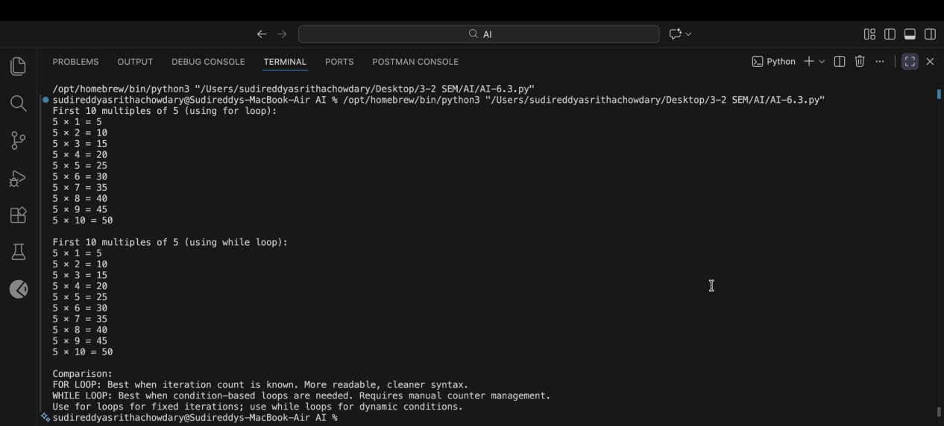
Justification-- his prompt is designed to demonstrate the use of looping structures in Python by generating the first 10 multiples of a number. It requires implementing the logic using both for and while loops to help understand different loop controls. By explaining the difference between the two loops with examples, learners can clearly see when each loop is more suitable. Overall, it strengthens the understanding of iteration and loop selection.

TASK-03
Prompt--Generate the code using the nested if elif else conditional statments to classify the age group of child,teenger,adult and senior citizen and generate the same classification using alternative conditional structures (e.g.,simplified conditions or dictionary-based logic) and explain how the conditions work in both cases.

INPUT--
def classify_age_nested_if(age):
if age < 0:
return "Invalid age"
elif age < 13:
return "Child"
elif age < 20:
return "Teenager"
elif age < 65:
return "Adult"
else:
return "Senior Citizen"
def classify_age_dict(age):
age_groups = {
(0, 12): "Child",
(13, 19): "Teenager",
(20, 64): "Adult",
(65, float('inf')): "Senior Citizen"
}
for (min_age, max_age), group in age_groups.items():
if min_age <= age <= max_age:
return group
return "Invalid age"
# Example usage
age = 25
print(f"Age {age} is classified as: {classify_age_nested_if(age)}")
print(f"Age {age} is classified as: {classify_age_dict(age)}")
# Explanation of nested if-elif-else vs dictionary-based approach
print("\nExplanation:")
print("Nested if-elif-else approach:")
print("- Easy to understand and implement.")
print("- Each condition is checked sequentially until a match is found.")
print("- Can be less efficient for many conditions.")
print("\nDictionary-based approach:")
print("- More scalable and maintainable for many categories.")
print("- Uses key-value pairs for mapping conditions to results.")
print("- Faster lookup times in large datasets.")

OUPUT--
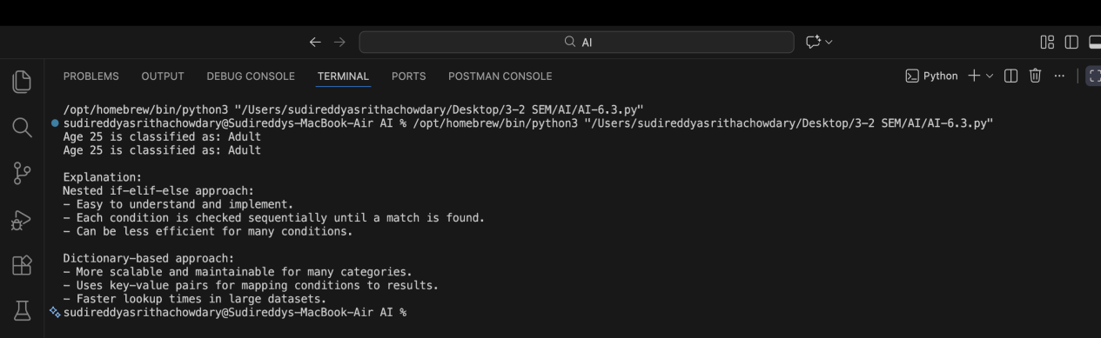
Justification -- This prompt focuses on understanding conditional statements in Python by classifying people into different age groups. It first uses nested if–elif–else statements to show traditional decision-making logic. Then, it introduces an alternative approach such as simplified conditions or dictionary-based logic to improve clarity. Explaining both methods helps compare readability, efficiency, and logical flow.
TASK-04
Prompt--Generate the code using for and while loop to calculate the sum of n natural numbers and suggest the alternative implementation for while loop using and using mathematical formula. Explain and compare the both approaches.

CODE--
# Function to calculate sum of n natural numbers using for loop
def sum_natural_for(n):
total = 0
for i in range(1, n + 1):
total += i
return total
# Function to calculate sum of n natural numbers using while loop
def sum_natural_while(n):
total = 0
i = 1
while i <= n:
total += i
i += 1
return total
# Function to calculate sum using mathematical formula (n*(n+1)/2)
def sum_natural_formula(n):
return n * (n + 1) // 2
# Example usage
n = 10
print(f"Sum of first {n} natural numbers using for loop: {sum_natural_for(n)}")
print(f"Sum of first {n} natural numbers using while loop: {sum_natural_while(n)}")
print(f"Sum of first {n} natural numbers using formula: {sum_natural_formula(n)}")
# Explanation and comparison of approaches:
print("\nExplanation and Comparison:")
print("FOR LOOP:")
print("- Iterates through each number from 1 to n.")
print("- Simple and readable.")
print("- Time complexity: O(n)")
print("\nWHILE LOOP:")
print("- Uses a counter variable to iterate through numbers.")
print("- Requires manual management of the counter.")
print("- Time complexity: O(n)")
print("\nMATHEMATICAL FORMULA:")
print("- Uses the formula n*(n+1)/2 for direct calculation.")
print("- Most efficient approach.")
print("- Time complexity: O(1)")

OUTPUT--
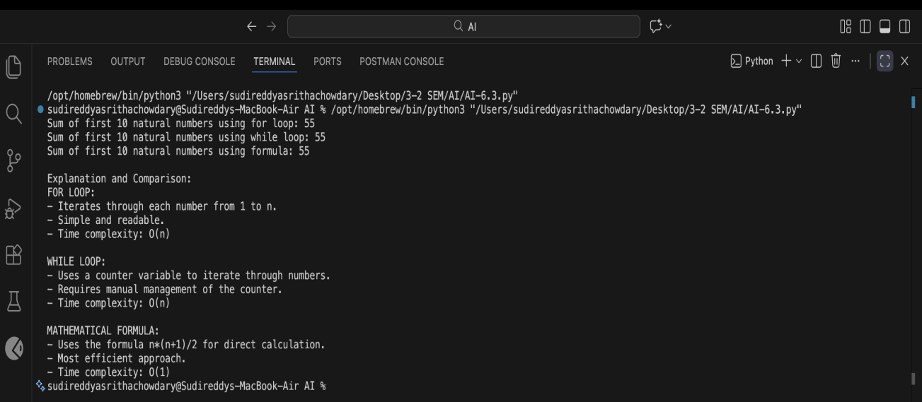

Justification-- This prompt aims to teach loop-based calculations by finding the sum of the first n natural numbers using both for and while loops. It also introduces an alternative approach using a mathematical formula, helping learners understand how the same problem can be solved without loops. By comparing these approaches, students can learn about performance, simplicity, and appropriate use cases. This improves problem-solving and optimization skills.

TASK-05
Prompt--Generate a code to create a Bank Account class with methods such as deposit(), withdraw(),and check_balance().

CODE--
class BankAccount:
def __init__(self, account_holder, initial_balance=0):
self.account_holder = account_holder
self.balance = initial_balance

def deposit(self, amount):
if amount > 0:
self.balance += amount
print(f"Deposited: ${amount:.2f}")
else:
print("Deposit amount must be positive.")
def withdraw(self, amount):
if amount > 0:
if amount <= self.balance:
self.balance -= amount
print(f"Withdrew: ${amount:.2f}")
else:
print("Insufficient balance.")
else:
print("Withdrawal amount must be positive.")
def check_balance(self):
print(f"Current balance: ${self.balance:.2f}")
return self.balance
# Example usage:
account = BankAccount("John Doe", 1000)
account.check_balance()
account.deposit(500)
account.withdraw(200)
account.check_balance()

OUTPUT--

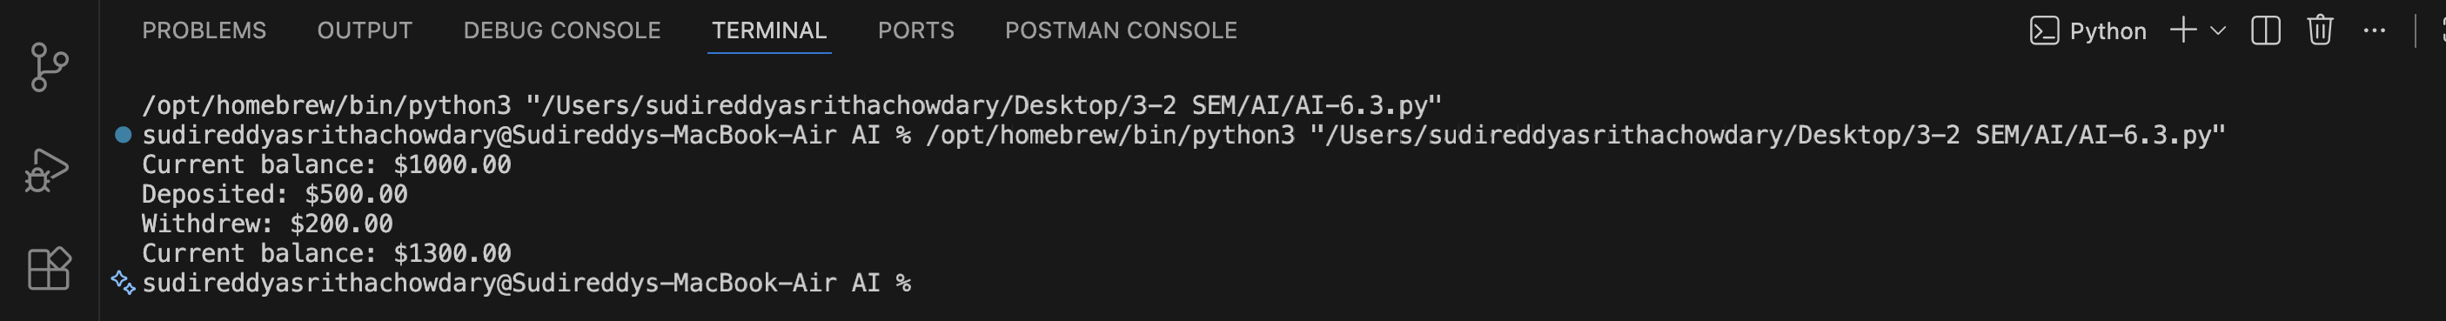
Justification--This prompt introduces object-oriented programming concepts by creating a Bank Account class in Python. It includes methods such as deposit, withdraw, and check_balance to simulate real-world banking operations. Through this prompt, learners understand how data and behavior are combined in a class. It also helps in practicing class design, method definition, and code organization.

