Name: Sudireddy Asritha Chowdary
Roll Number: 2303A52297
Batch: 45

Assignment Number: 4.5
Problem-1
Task-1:
Prompt: Classify the following email into one of the categories: Billing, Technical Support, Feedback, Others.
Email: “I was charged twice for my subscription this month.”
give structured python code
Code:
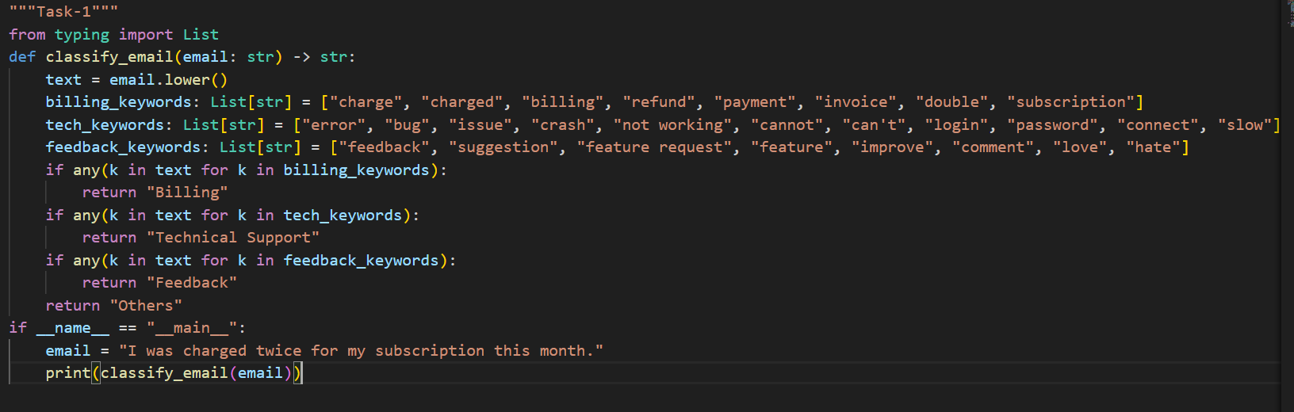
Output:
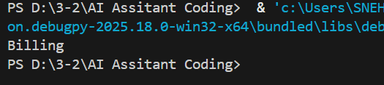

Task-2:
Prompt: Classify the following email into one of the categories: Billing, Technical Support, Feedback, Others.
Example:
Email: “My payment failed but the amount was deducted.”
Category: Billing

Now classify:
Email: “The app crashes whenever I try to upload a file.”
Give me structured python code

Code:
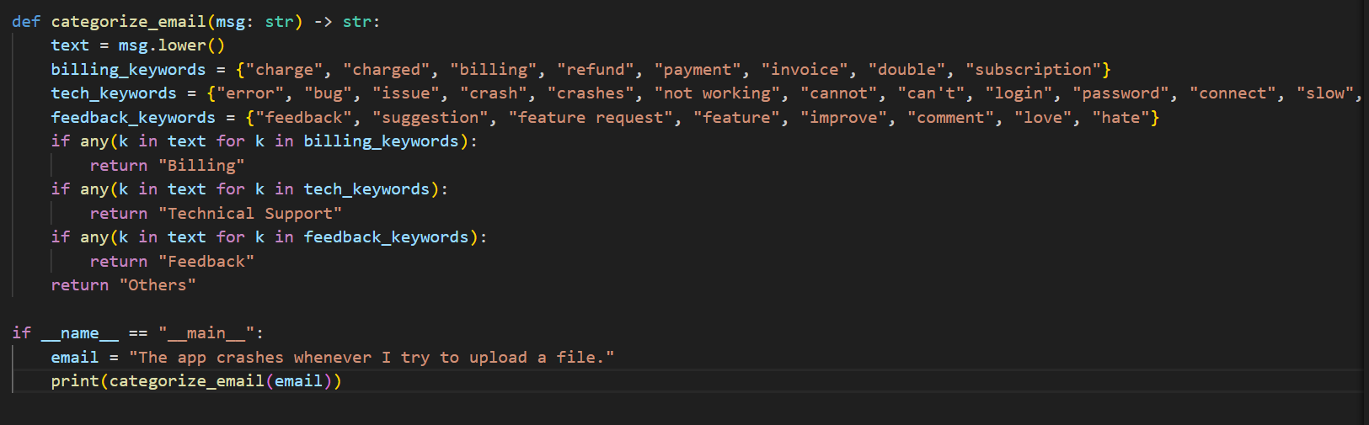
Output:
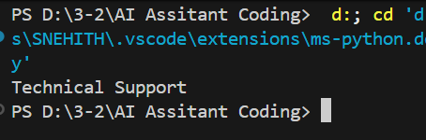
Task-3:
Prompt: Classify the following email into one of the categories: Billing, Technical Support, Feedback, Others.
Examples:
Email: “I was charged twice for my subscription.” → Billing
Email: “The app crashes when I open it.” → Technical Support
Email: “I love the new update.” → Feedback
Email: “What are your support working hours?” → Others
Now classify:
Email: “Invoice amount does not match my usage.”
Give A structured python code
Code:
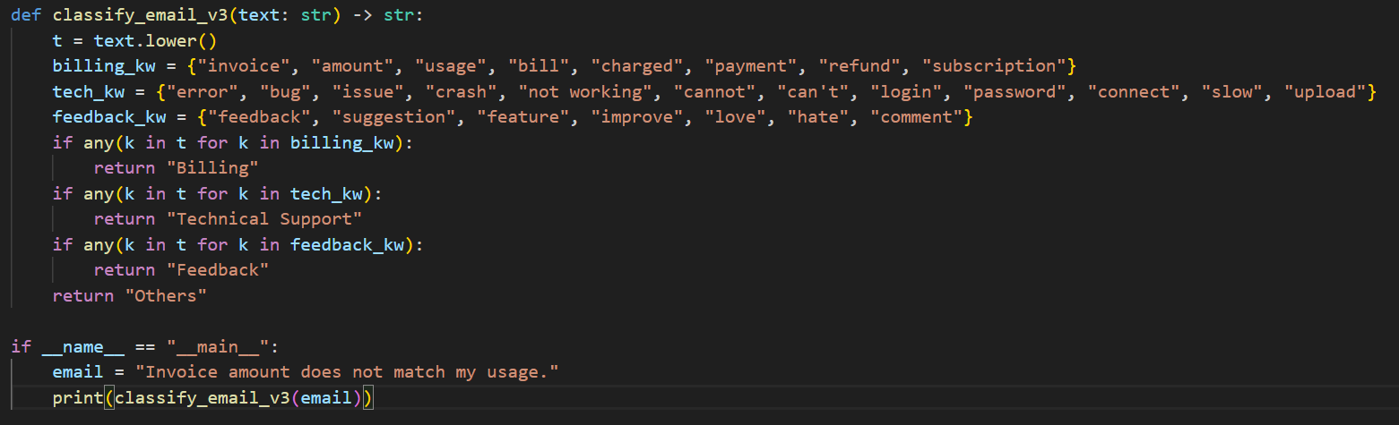
Output:
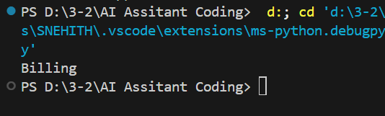

Problem-2
Task-1:
Prompt: Classify the following travel query into one of the categories:
Flight Booking, Hotel Booking, Cancellation, General Travel Info.
Query: “Cancel my flight scheduled for next Monday.”
Give a structured python code
Code:
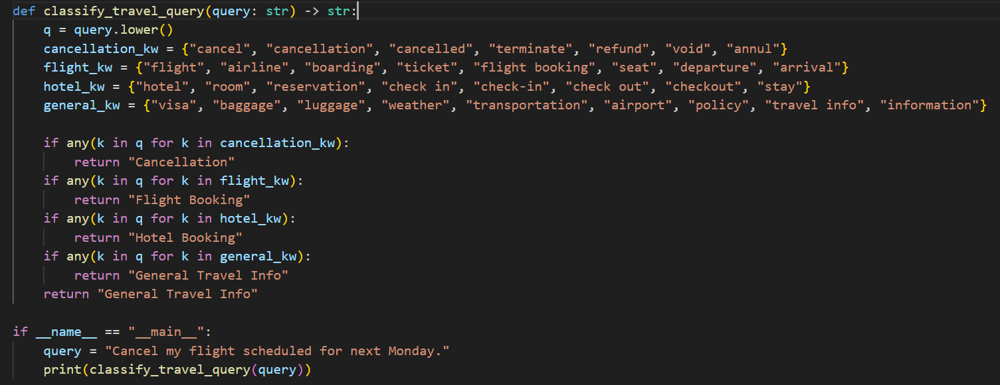
Output:
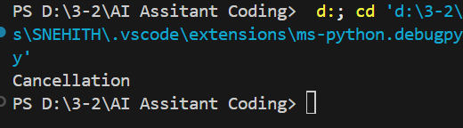
Task-2:
Prompt: Classify the following travel query into one of the categories:
Flight Booking, Hotel Booking, Cancellation, General Travel Info.
Example:
Query: “I want to book a flight from Delhi to Mumbai.”
Category: Flight Booking
Now classify:
Query: “Book a hotel near the airport in Chennai.”
Give a structured python code
Code:
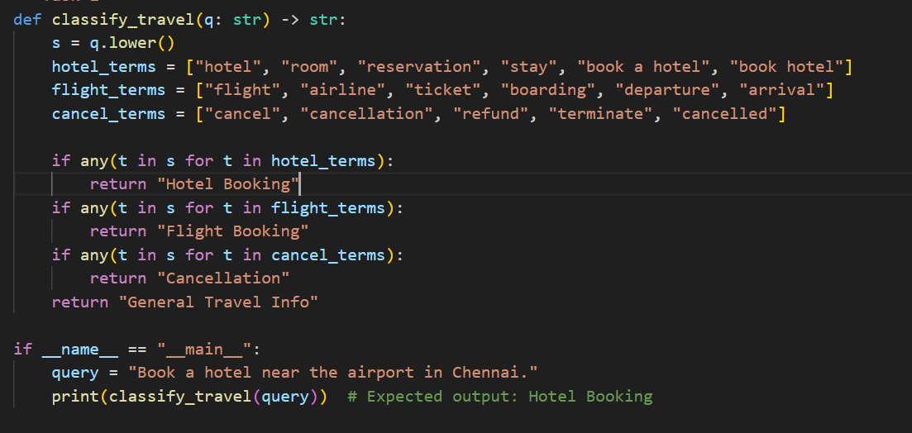
Output:
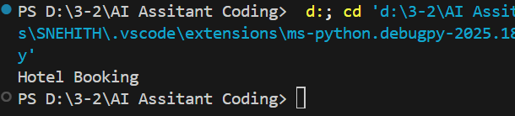

Task-3:
Prompt: Classify the following travel query into one of the categories:
Flight Booking, Hotel Booking, Cancellation, General Travel Info.
Examples:
Query: “Find me a flight to Bangalore.” → Flight Booking
Query: “Book a 5-star hotel in Goa.” → Hotel Booking
Query: “Cancel my hotel reservation.” → Cancellation
Query: “Do I need a visa for Singapore?” → General Travel Info
Now classify:
Query: “What is the best season to visit Manali?”
Give a structured python code
Code:
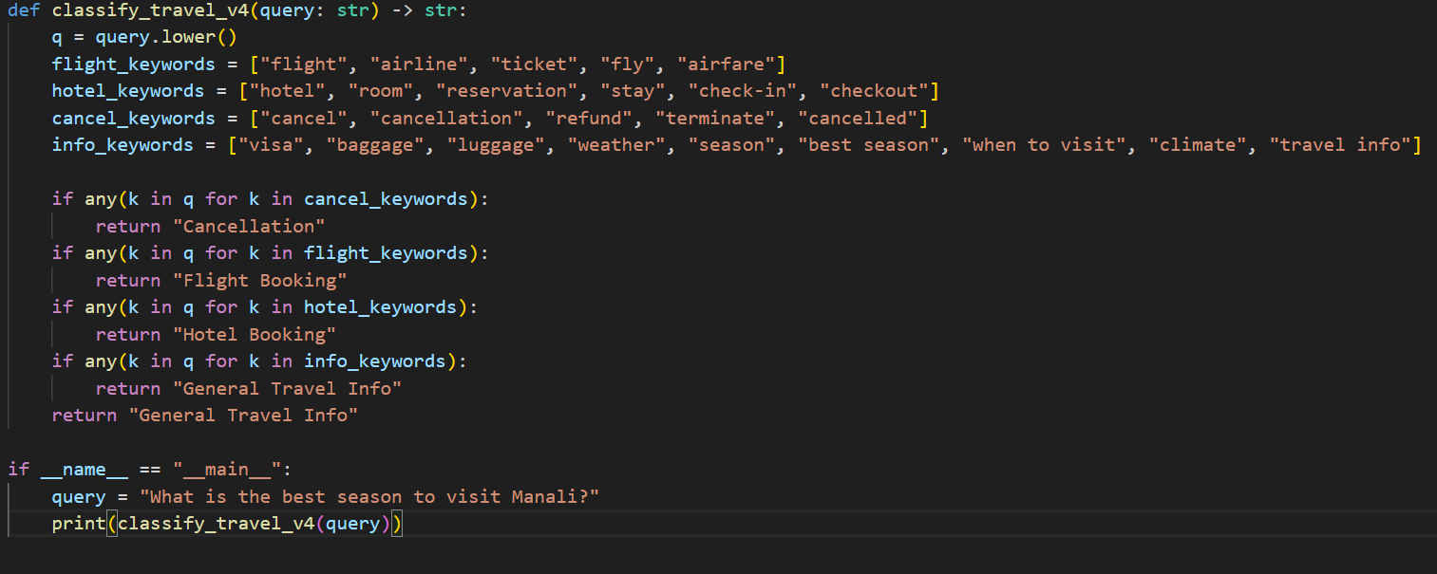
Output:
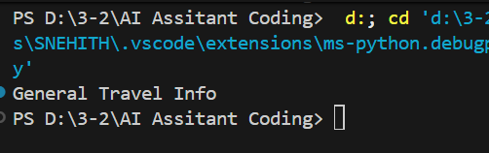

Problem-3:
Task-1:
Prompt: Classify the following programming question into one of the categories:
Syntax Error, Logic Error, Optimization, Conceptual Question.
Query: “My program runs but gives the wrong output.”
Give a structured Python code
Code:
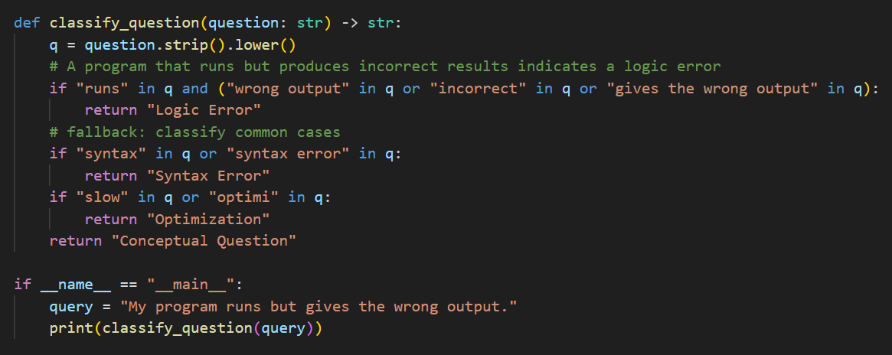
Output:
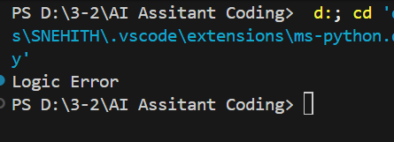
Task-2:
Prompt: Classify the following programming question into one of the categories:
Syntax Error, Logic Error, Optimization, Conceptual Question.
Example:
Query: “I get a SyntaxError: unexpected indent.”
Category: Syntax Error
Now classify:
Query: “This code works but is very slow for large inputs.”
Give a structured Python code
Code:
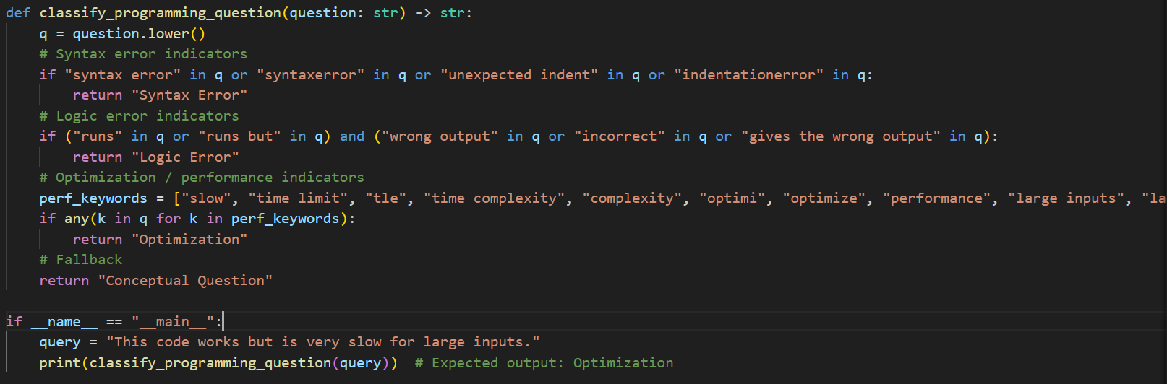
Output:
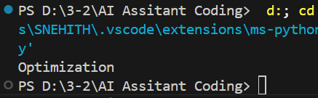

Task-3:
Prompt: Classify the following programming question into one of the categories:
Syntax Error, Logic Error, Optimization, Conceptual Question.
Examples:
- Query: “I missed a colon in my if statement.” → Syntax Error
- Query: “The output is incorrect even though there are no errors.” → Logic Error
- Query: “How can I make this algorithm faster?” → Optimization
- Query: “What is recursion in programming?” → Conceptual Question
Now classify:
Query: “My loop never stops executing.”
Give me a Structured Python code
Code:
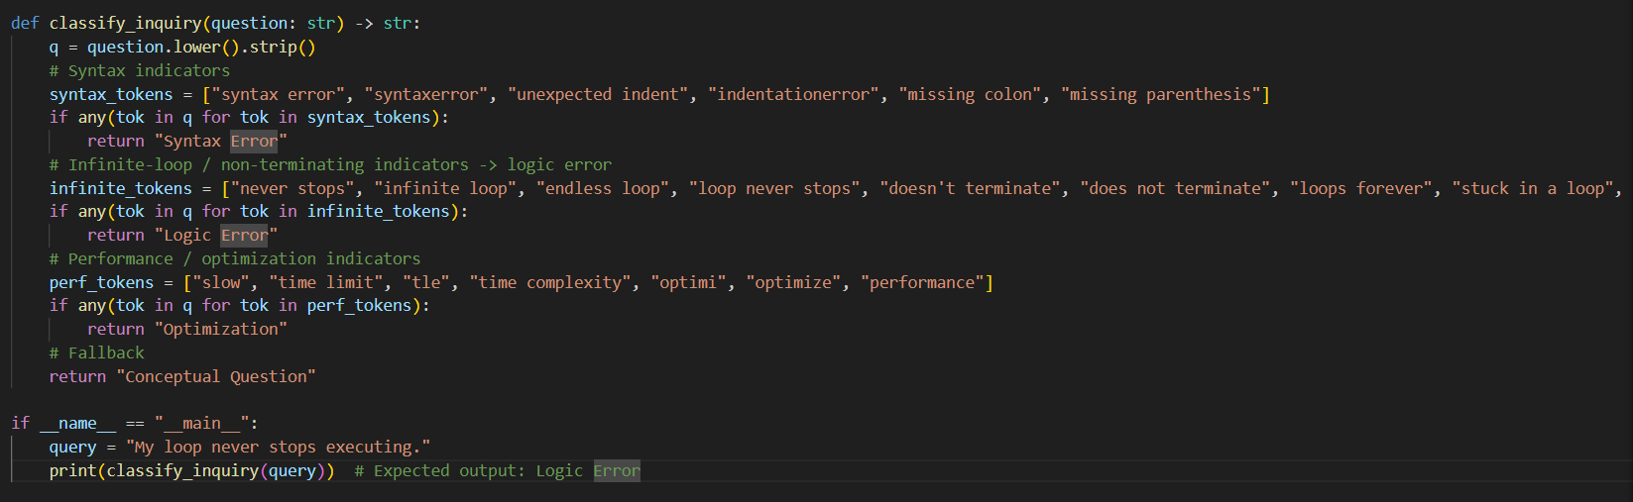
Output:
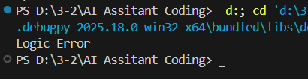

Problem-4:
Task-1:
Prompt: Classify the following social media post into one of the categories:
Promotion, Complaint, Appreciation, Inquiry.
Post: “Worst service ever, my order arrived damaged.”
Give a structured python code
Code:
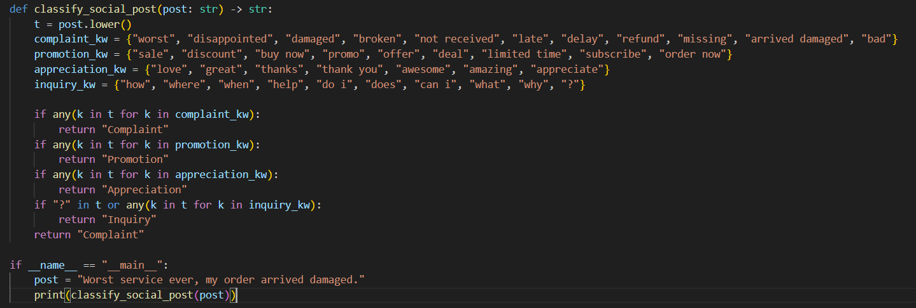
Output:
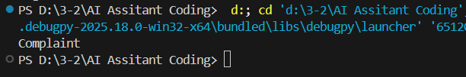
Task-2:
Prompt: Classify the following social media post into one of the categories:
Promotion, Complaint, Appreciation, Inquiry.
Example:
Post: “Limited-time offer on premium plans!”
Category: Promotion
Now classify:
Post: “Still waiting for my refund after two weeks.”
Give a structured python code
Code:
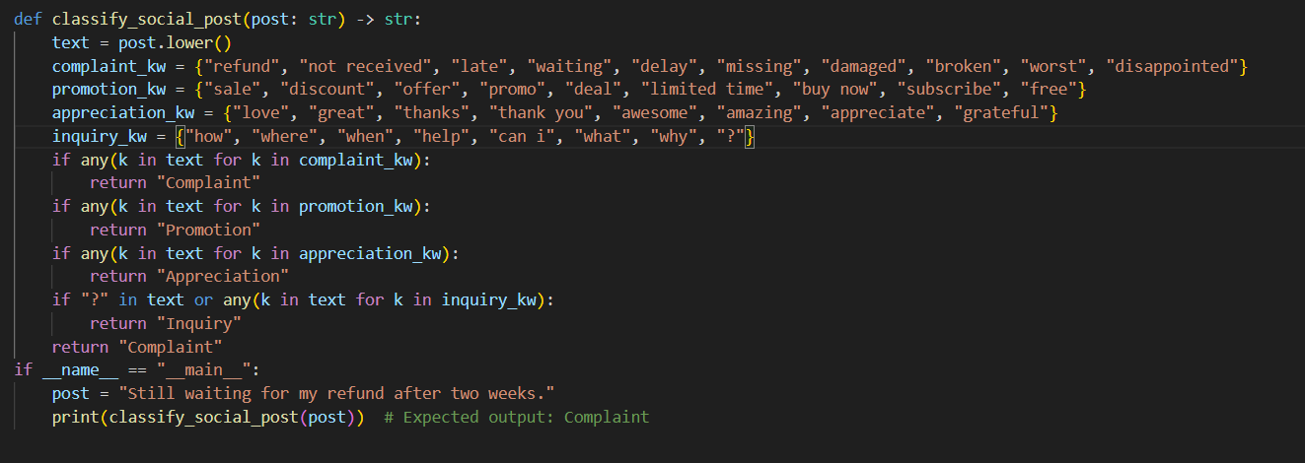
Output:
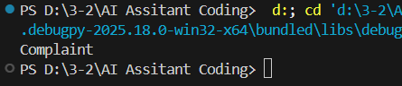
Task-3:
Prompt: Classify the following social media post into one of the categories:
Promotion, Complaint, Appreciation, Inquiry.
Examples:
Post: “Flat 50% off on all products!” → Promotion
Post: “My package arrived broken and late.” → Complaint
Post: “Great service, really impressed!” → Appreciation
Post: “When will this be back in stock?” → Inquiry
Now classify:
Post: “Thanks a lot for resolving my issue so fast ”
Give a structured python code
Code:
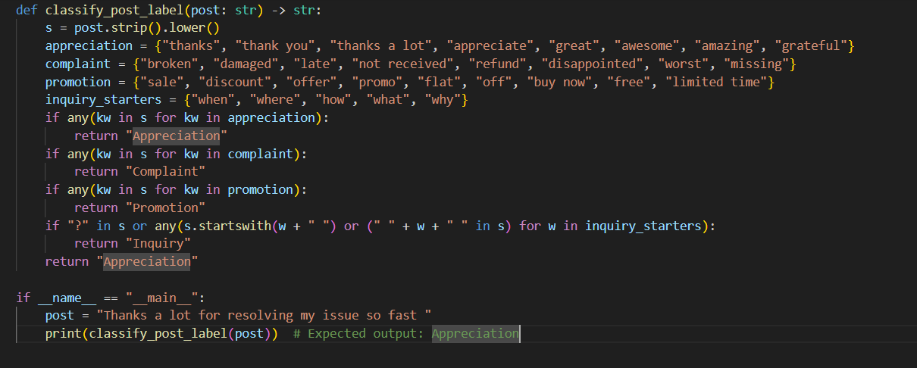
Output:
