Name : Sudireddy Asritha Chowdary
HallTicket Number : 2303A52297
Batch : 45

TASK-01

Prompt : Generate a python program that takes a string as input and prints its reverse, using direct logic in the main code only, without any user-defined functions.

CODE--

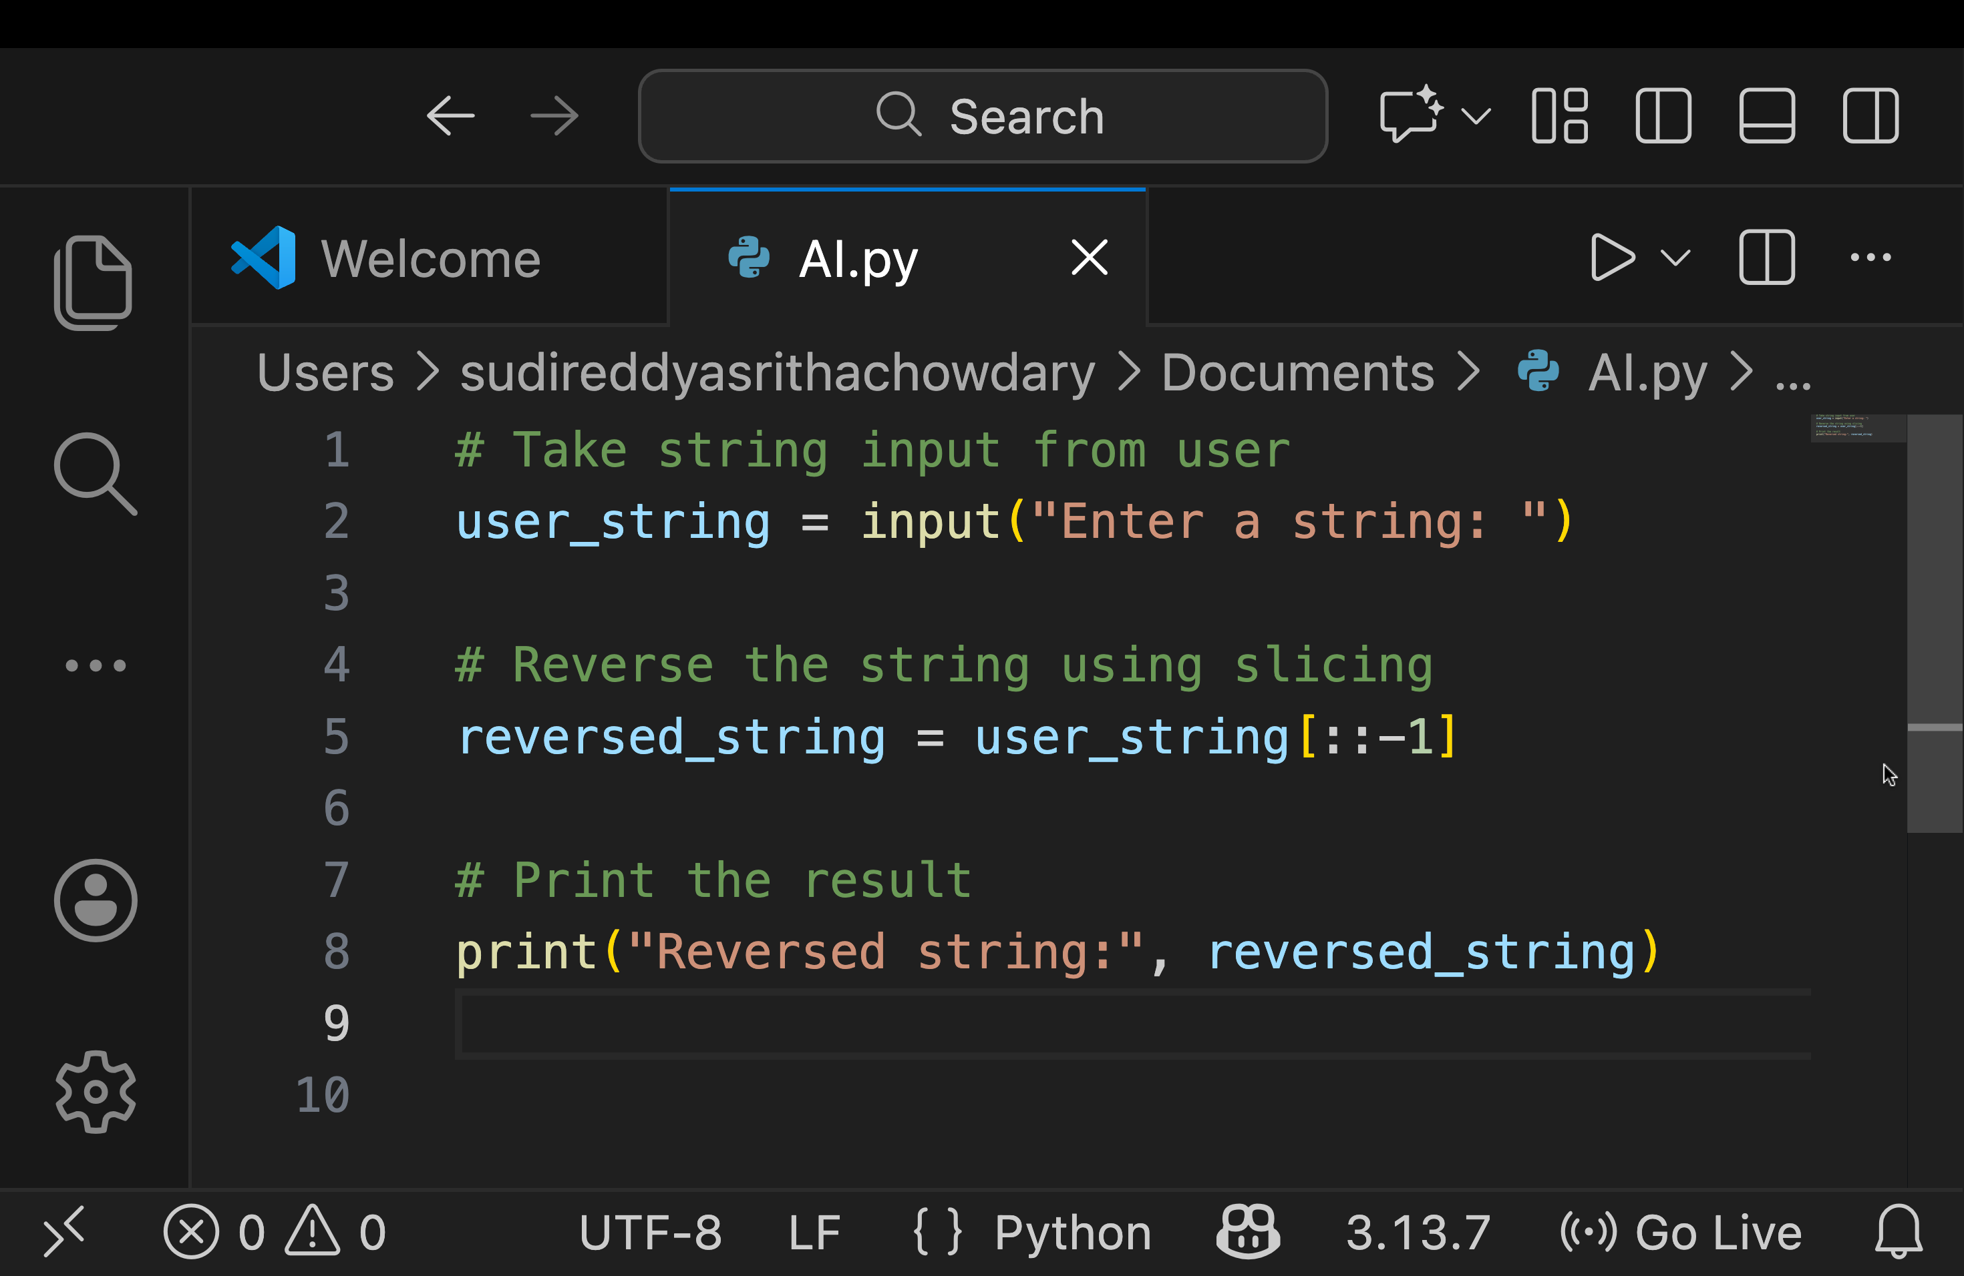

OUTPUT--

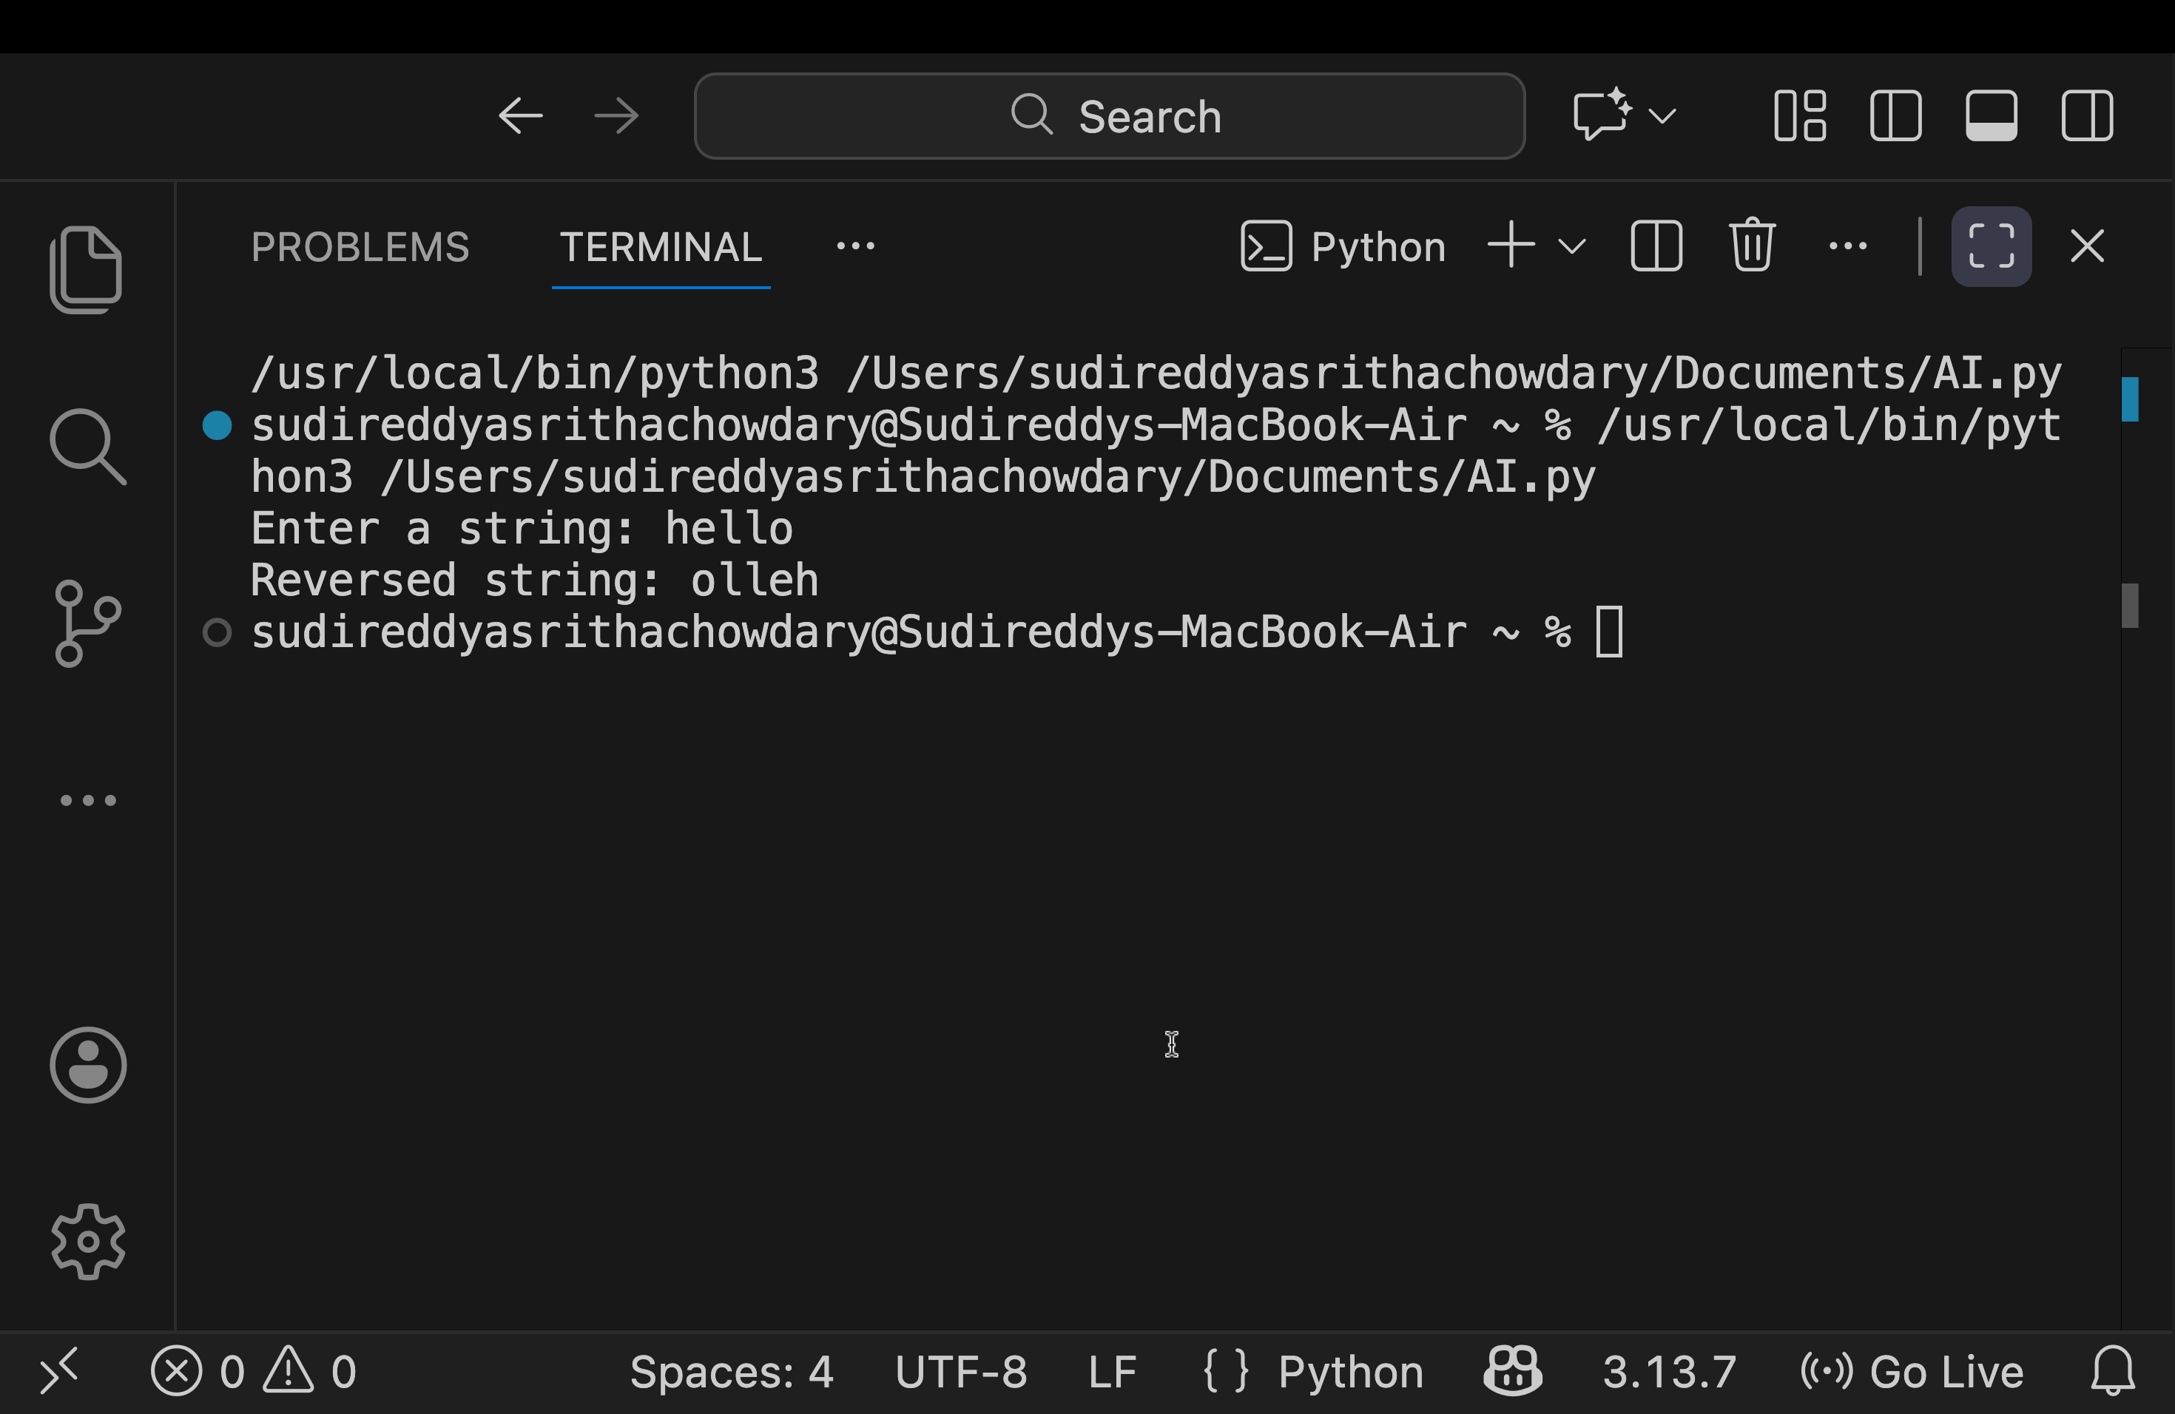
Justification: This prompt is useful because it checks how AI handles different ways of solving the same problem. It encourages comparing manual logic with built-in features and understanding their performance and use cases. This reflects real-world programming decisions and improves algorithmic thinking.

TASK-02

Prompt : Generate the Python string reversal program by simplifying the logic, removing unnecessary variables, and improving readability, while keeping the functionality the same.

CODE--

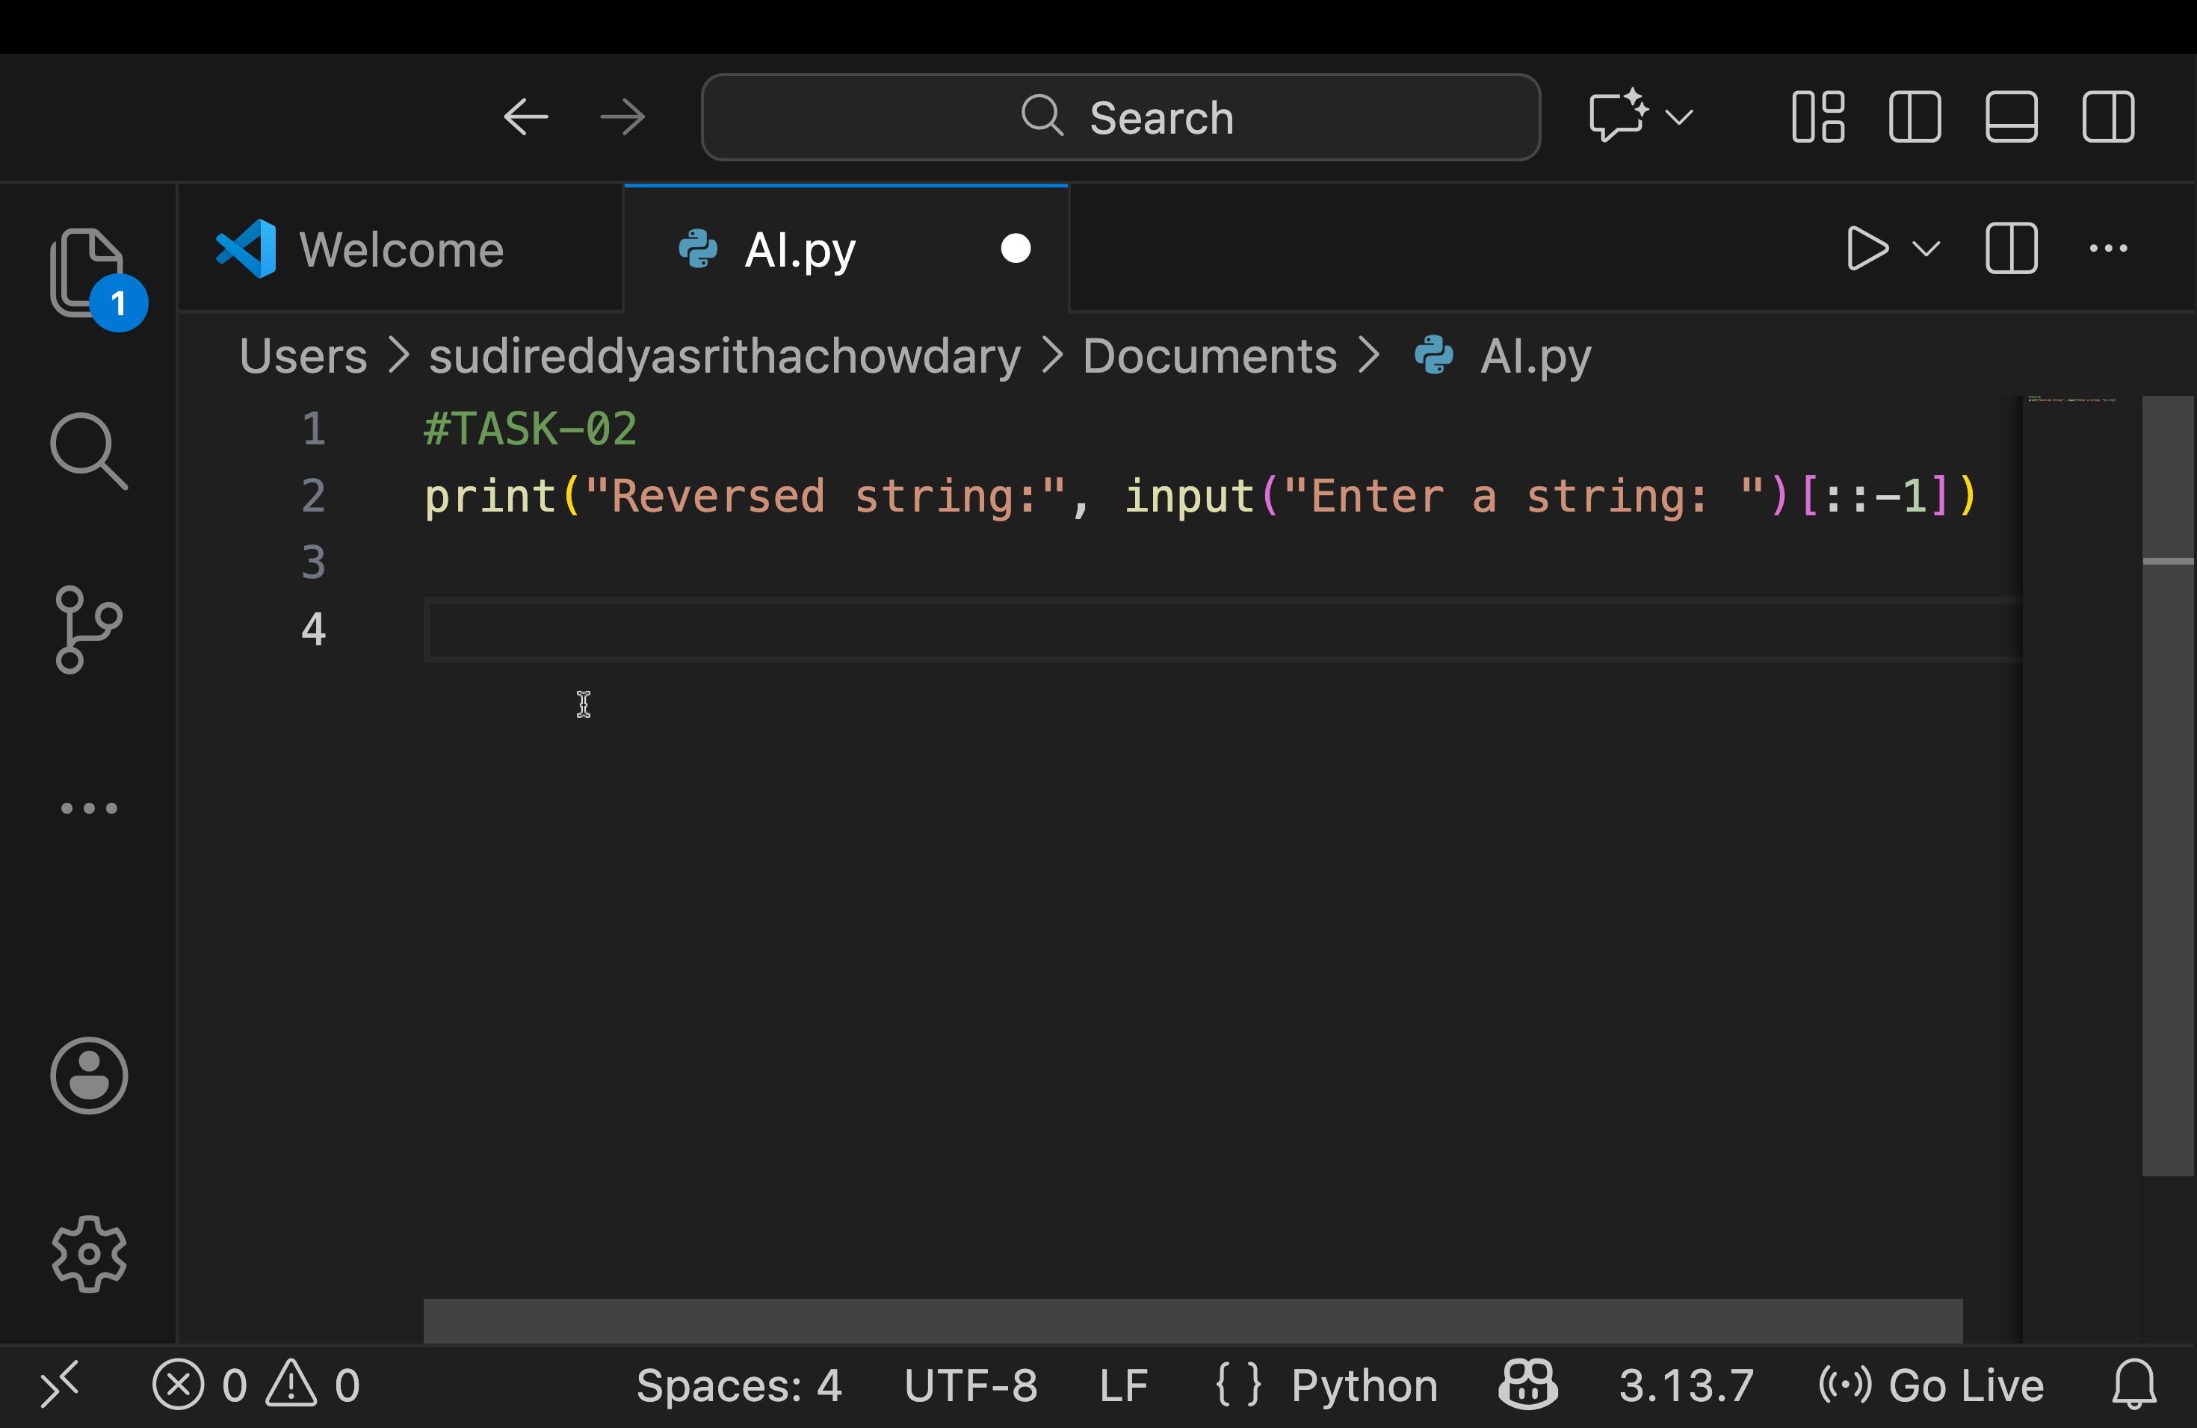

OUTPUT--
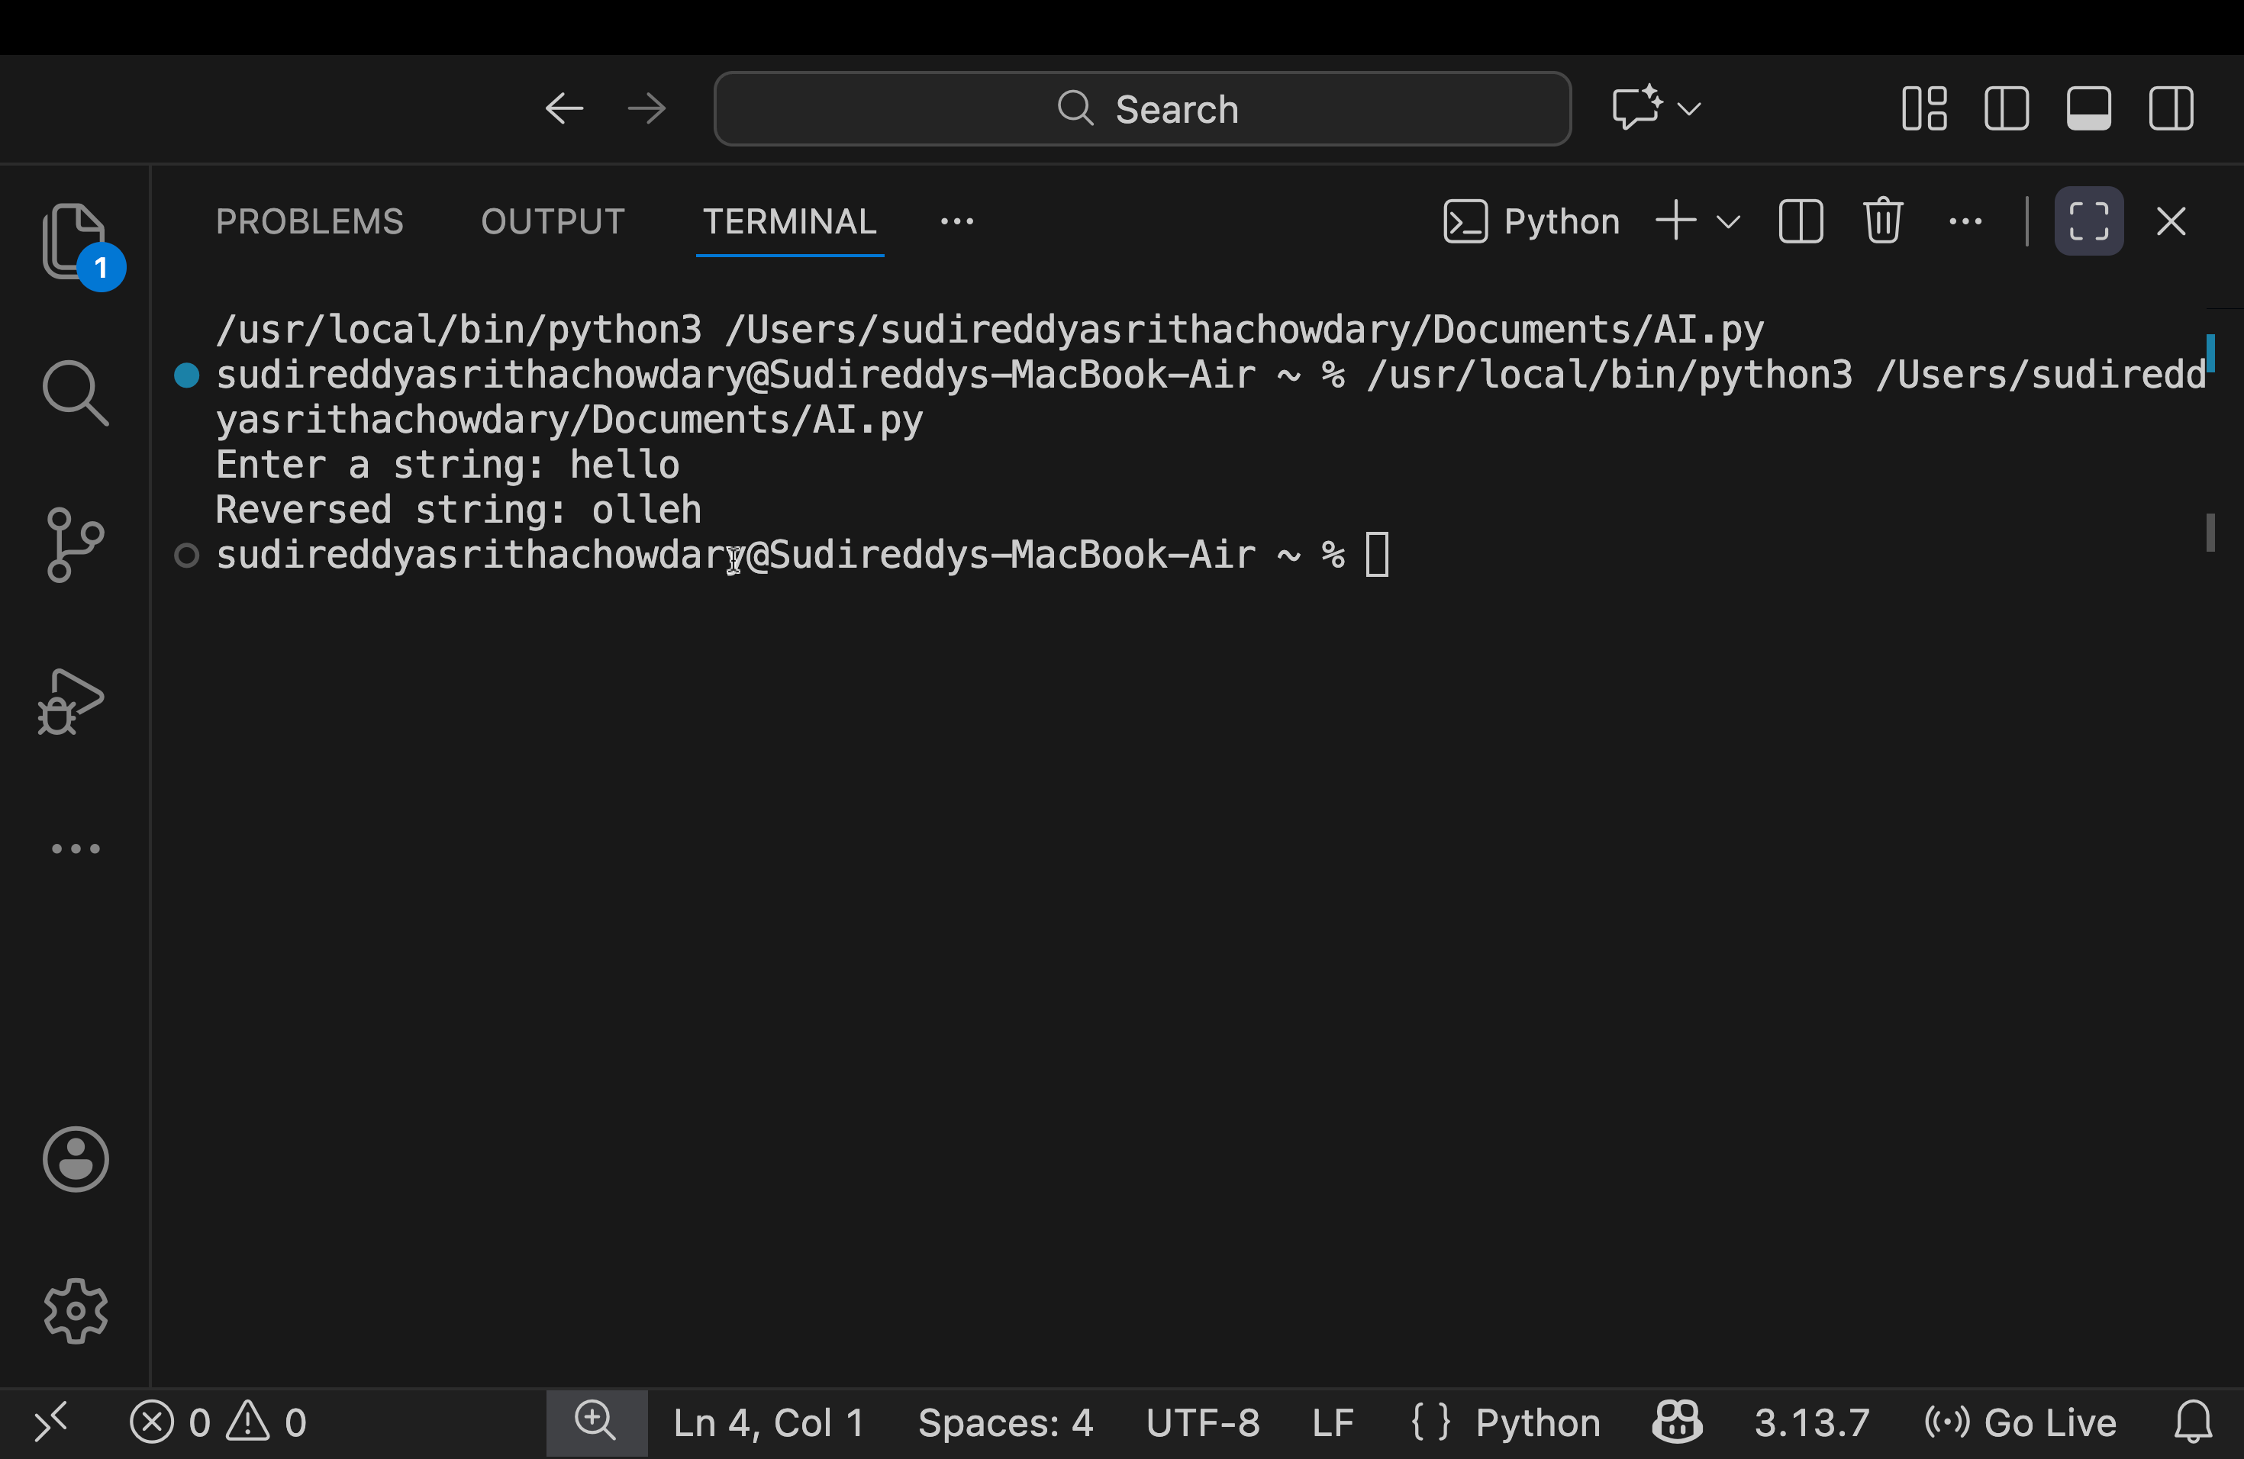

Justification : Improving code quality without changing the program’s behavior. Simplifying logic and removing unnecessary variables makes the code easier to read and understand. Improved readability helps reduce errors and makes maintenance easier in the long run. It also encourages writing clean, efficient code that follows good programming practices. Overall, the task promotes writing optimized and professional-level Python code.

TASK-03

Prompt : Write a Python program that defines a user-defined function to reverse a string. The function should take a string as input, return the reversed string, and include clear, meaningful comments. Use the function in the main program to accept user input and display the output.

CODE--

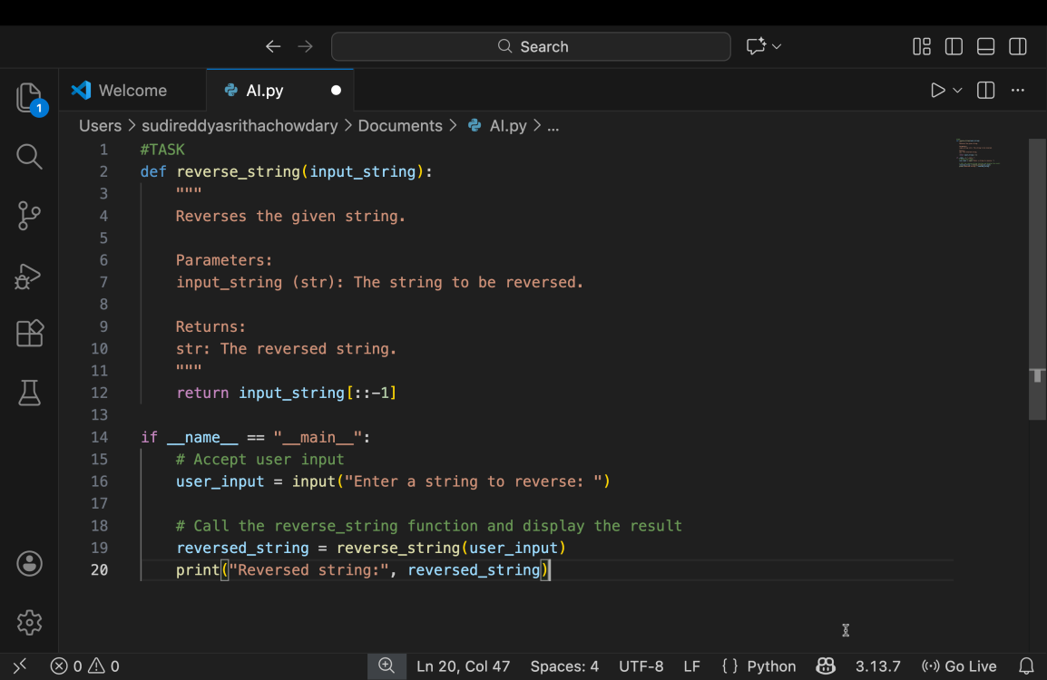

OUTPUT--

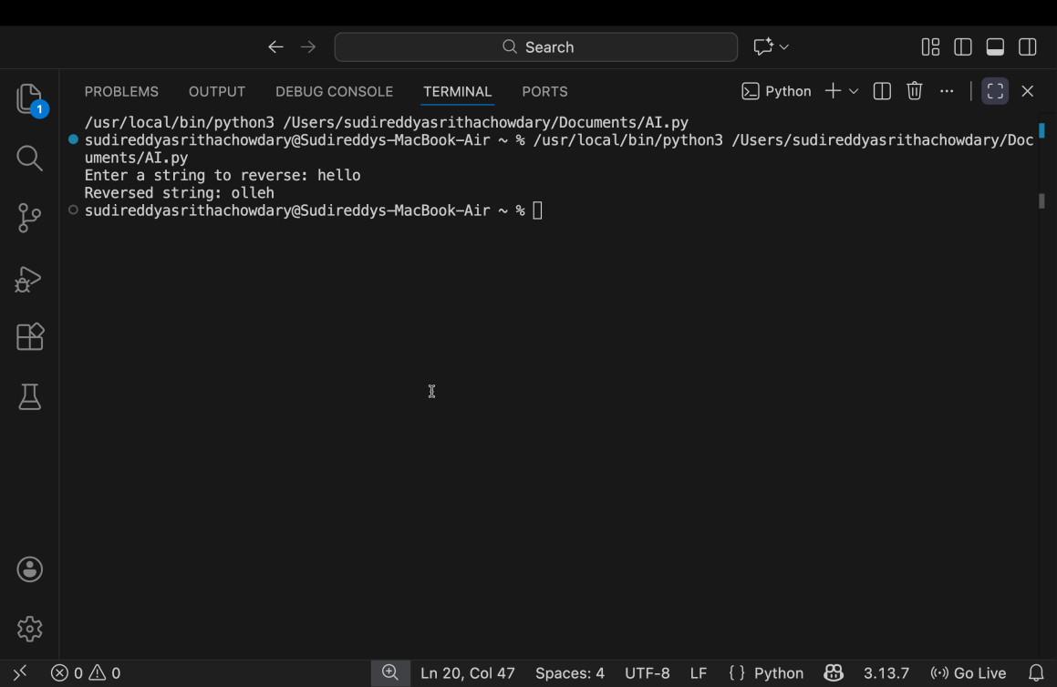

Justification: It encourages the use of user-defined functions, which improves code structure and modularity. Separating the string reversal logic into a function makes the program easier to understand, reuse, and maintain. Accepting user input in the main program demonstrates practical, real-world usage. Adding meaningful comments helps explain the logic clearly, especially for beginners. Overall, the task promotes clean coding practices and better program organization.
.

TASK-04
Prompt: Write a detailed Python-based analytical report comparing two string reversal programs:
- Procedural approach (without functions)
- Modular approach (with a user-defined function)
3.Analyze and explain differences based on:Code clarity (readability, simplicity)
- Reusability (how easily the code can be used elsewhere)
- Ease of debugging (how simple it is to identify and fix errors)
- Suitability for large-scale applications (scalability, maintainability) Include:Side-by-side code snippets for both approachesA comparison table highlighting pros and consExplanatory notes for each criterionExample inputs and outputs to illustrate differences
Format the output clearly for easy understanding and code review.
CODE:
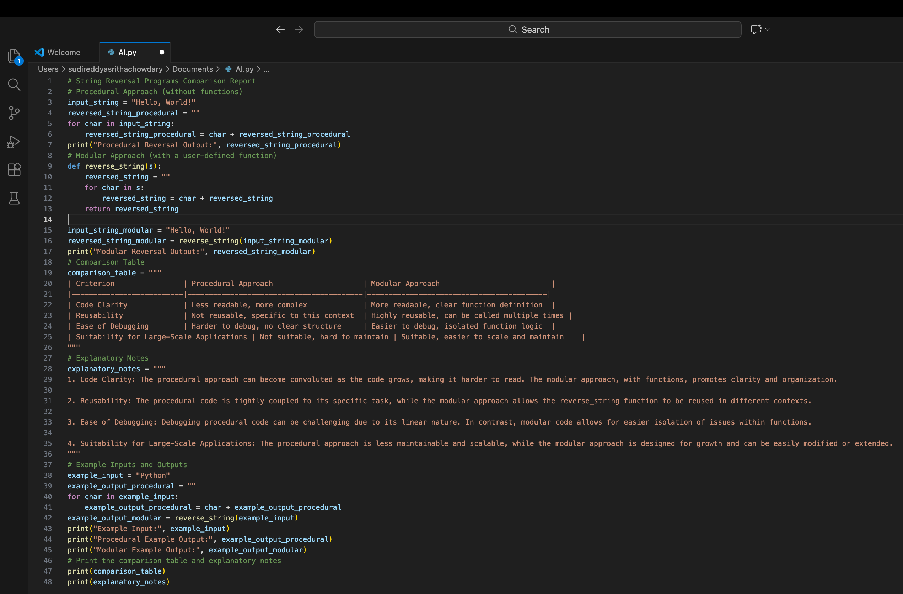
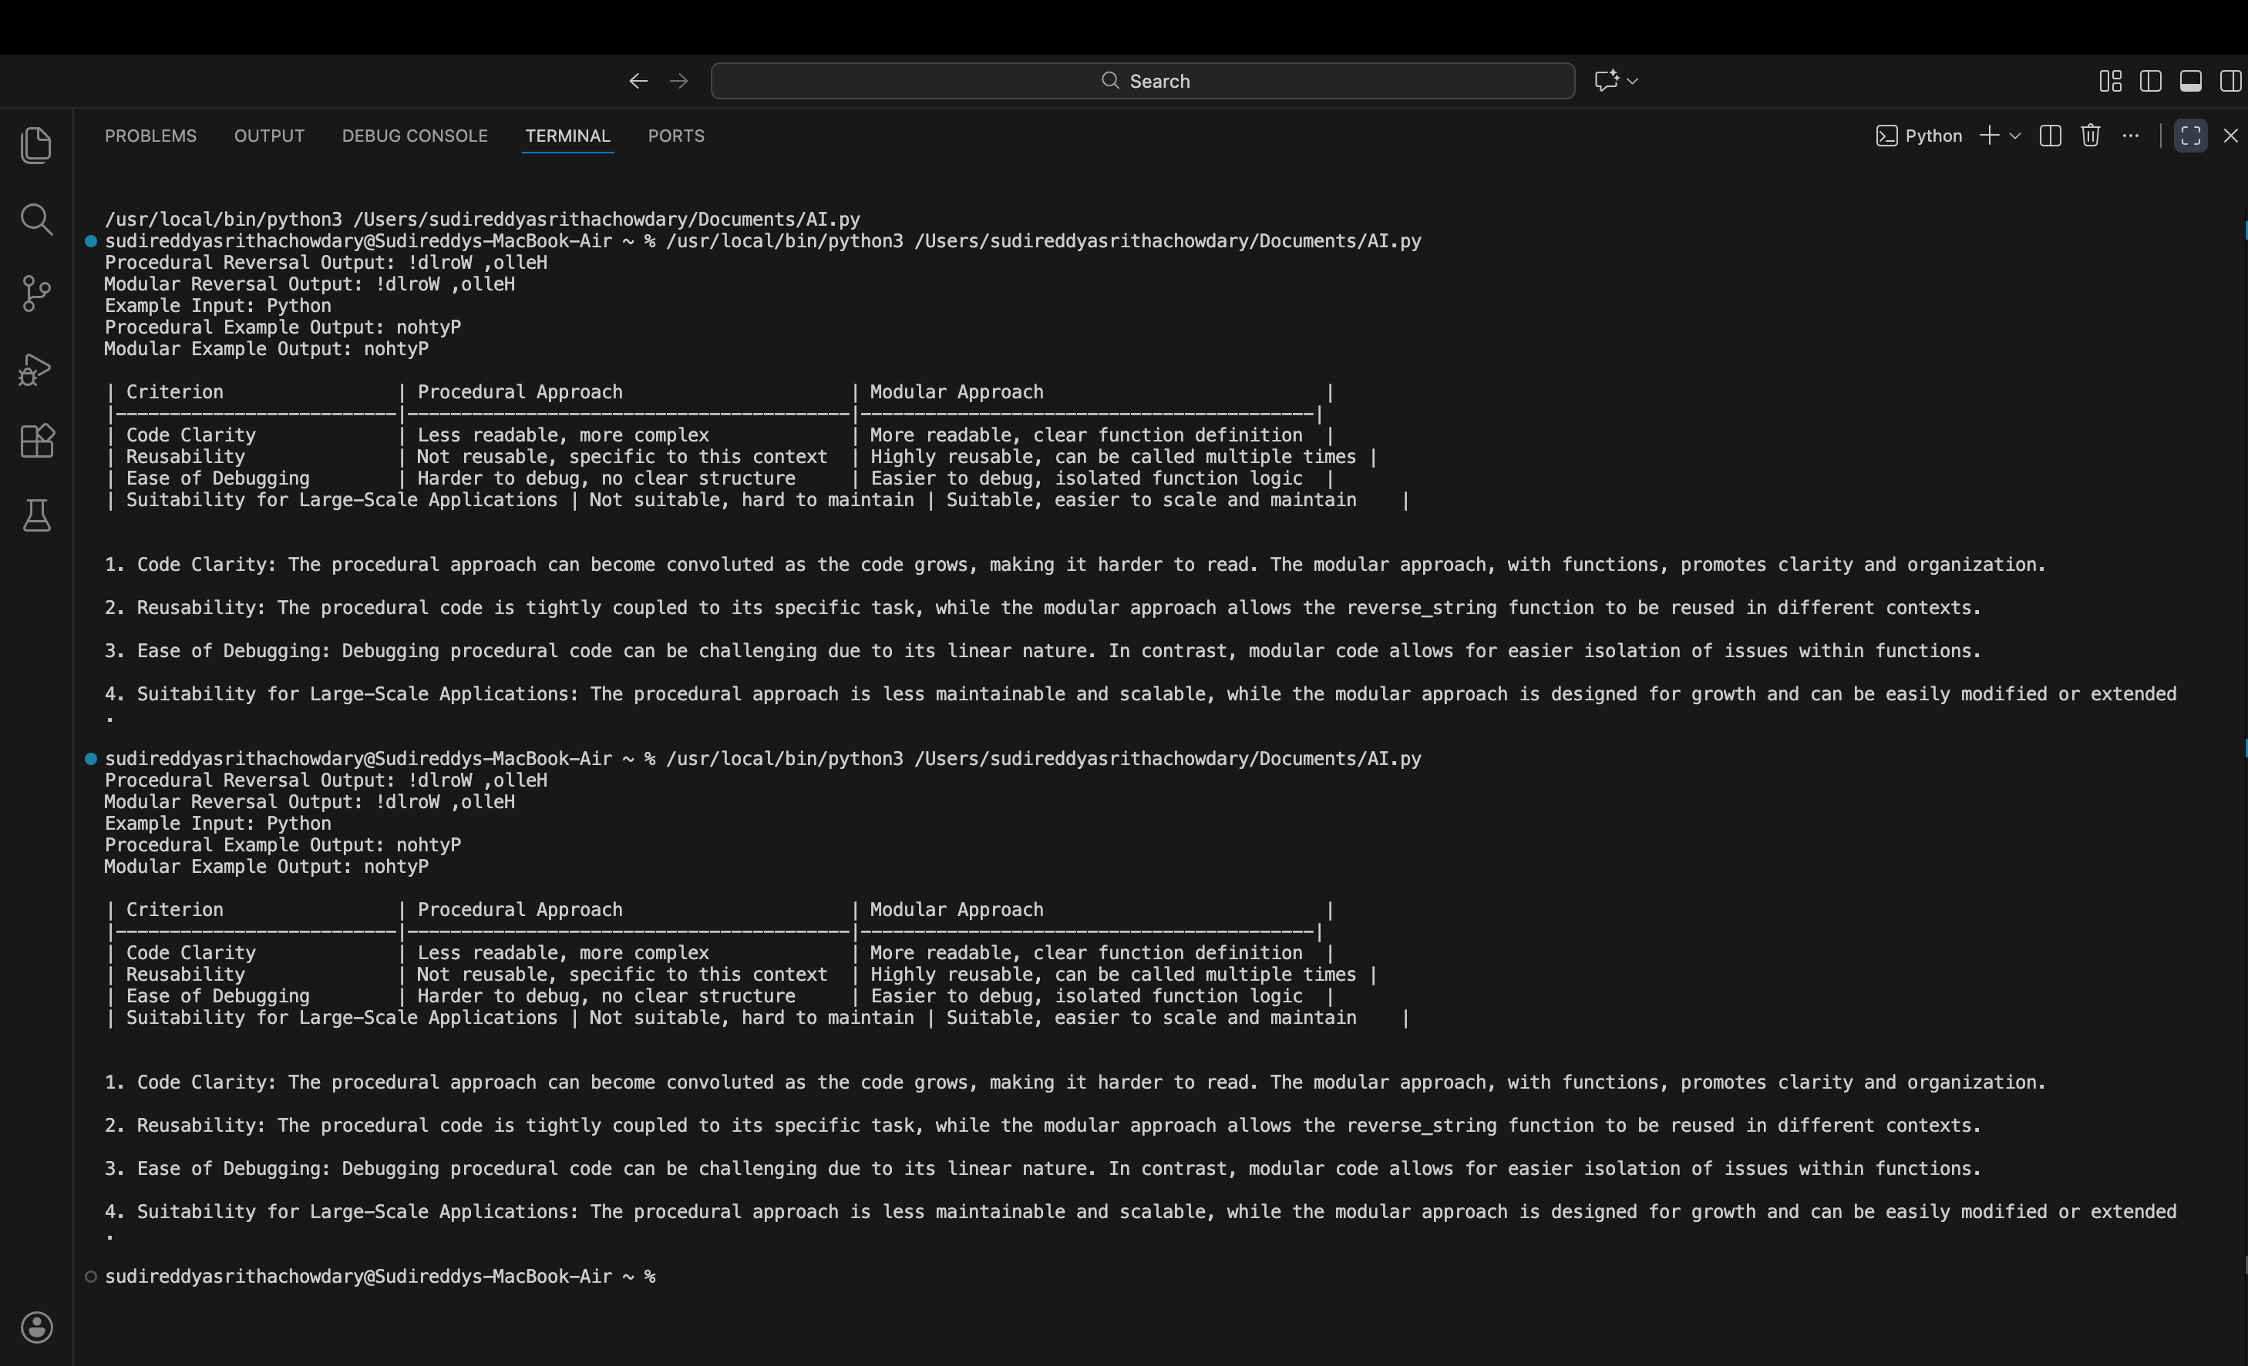

Justification: It lacks reusability because the logic is written only for a specific task. The modular approach improves code clarity by organizing logic inside a function. It allows the same function to be reused with different inputs, reducing redundancy. Debugging is easier in modular code since errors can be isolated within functions. Therefore, the modular approach is more suitable for large-scale and real-world applications.

CASE-05
Prompt: Generate two Python programs to reverse a string using different algorithmic approaches:Loop-based (iterative) approach without using built-in reverse functions. Built-in / slicing-based approach using Python string slicing.After implementing both approaches, provide detailed comparison that includes:Execution flow of each method. Time complexity,Performance considerations for large input strings.Scenarios where each approach is most appropriate.Ensure both implementations produce correct output and include clear comments explaining the logic.
INPUT--

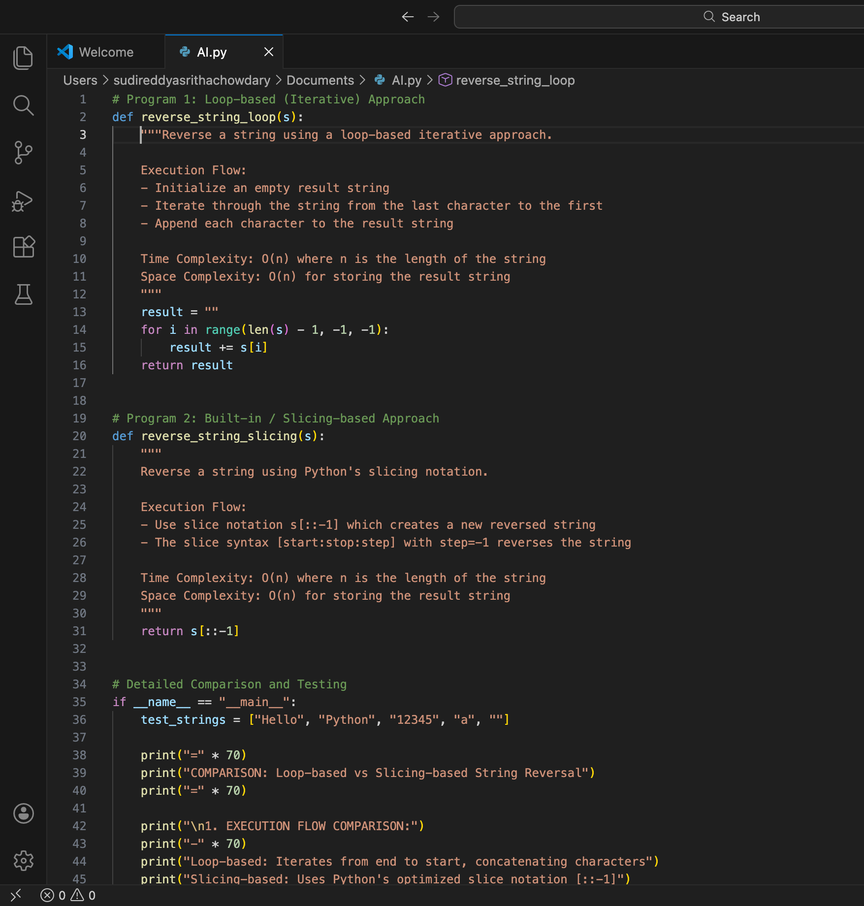

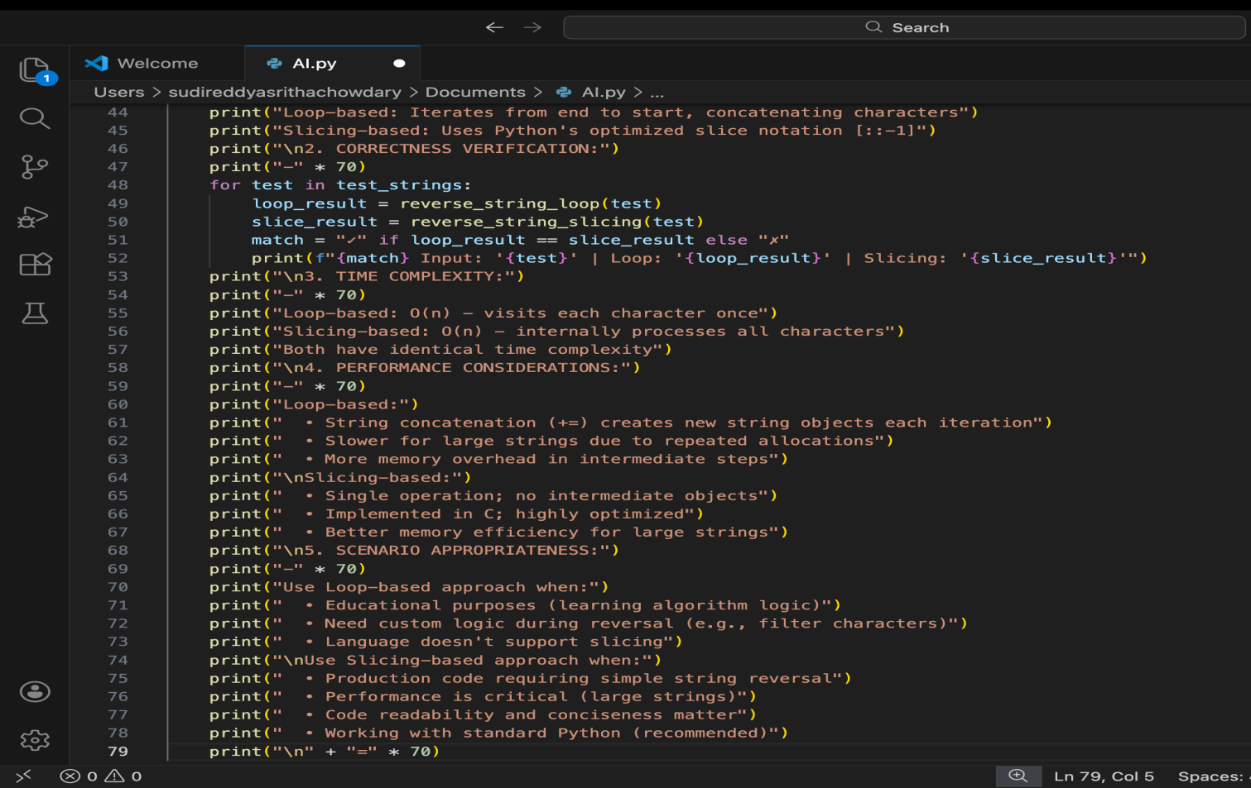

OUTPUT--

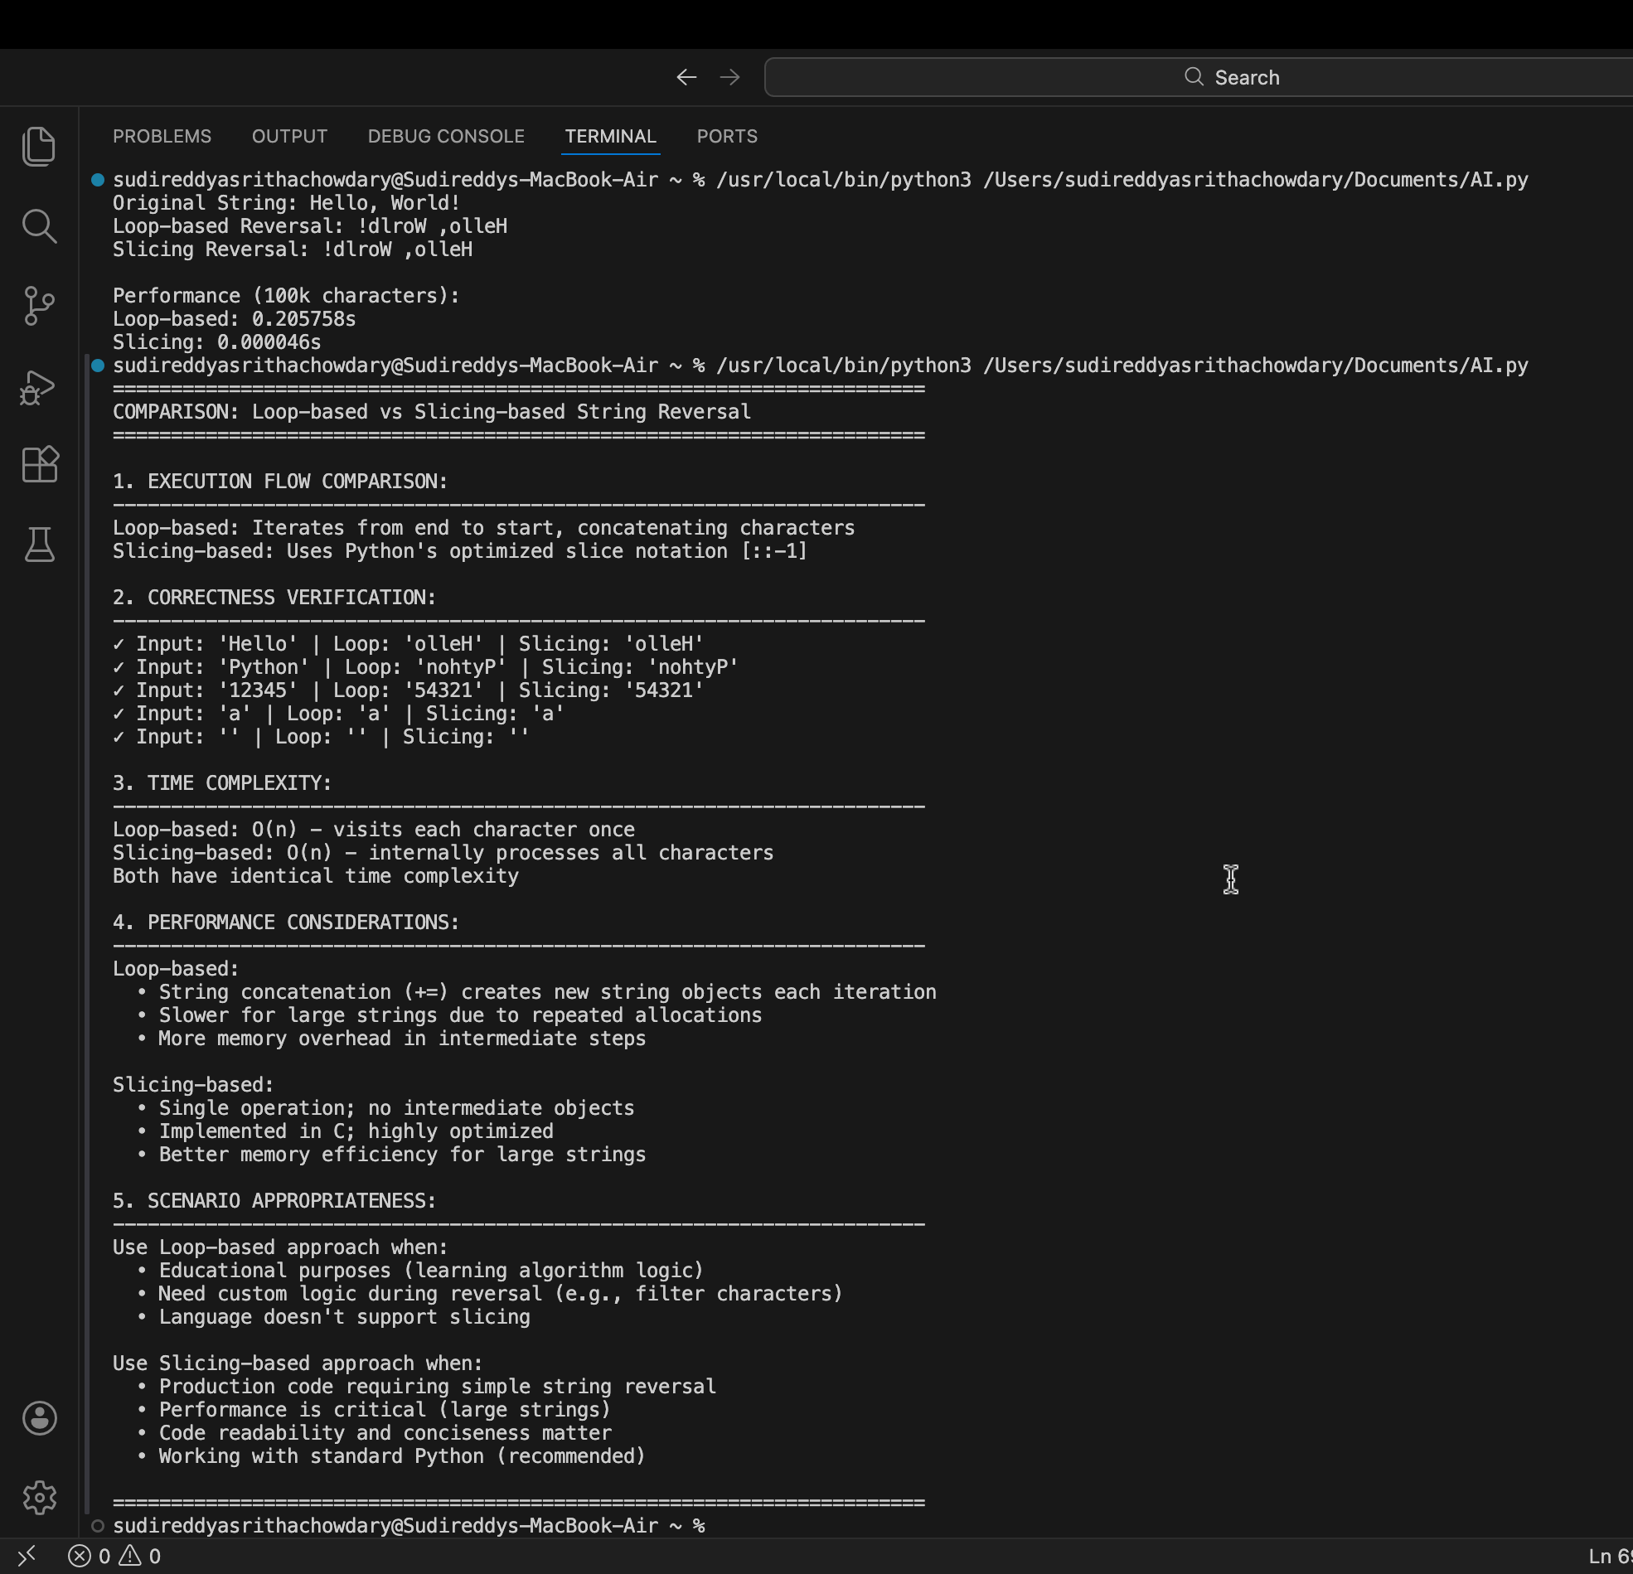

Justification: Using different algorithmic approaches to solve the same problem helps evaluate how AI handles alternative logic paths. The loop-based approach demonstrates step-by-step execution and strengthens understanding of control flow and algorithm design. The slicing-based approach highlights the use of built-in language features for concise and efficient solutions. Comparing both methods allows analysis of execution flow, time complexity, and performance for large inputs. This comparison also helps identify when readability and speed are preferred over manual logic. Hence, the task promotes deeper insight into algorithm selection and optimization.

