AI Assisted Coding

Name: Sudireddy Asritha Chowdary
Ht no : 2303A52297
Batch :45

Lab 4: Advanced Prompt Engineering – Zero-shot, One-shot, and Few-shot
Techniques

Task 1: Zero-Shot Prompting – Leap Year Check
Scenario
Zero-shot prompting involves giving instructions without providing examples.
Task Description
Use zero-shot prompting to instruct an AI tool to generate a Python function that:
• Accepts a year as input
• Checks whether the given year is a leap year
• Returns an appropriate result
Note: No input-output examples should be provided in the prompt.
Expected Output
• AI-generated leap year checking function
• Correct logical conditions
• Sample input and output
• Screenshot of AI-generated response (if required)

Prompt:
#generate a python code that checks if a given year is a leap year or not

Code:
def is_leap_year(year):
if (year % 4 == 0 and year % 100 != 0) or (year % 400 == 0):
return True
return False
# Example usage
year = int(input("Enter a year: "))
if is_leap_year(year):
print(f"{year} is a leap year.")
else:
print(f"{year} is not a leap year.")

Output:
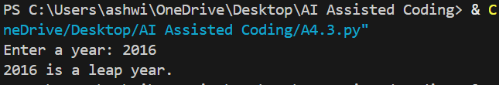
Justification:
A year is a leap year if it is divisible by 4 but not divisible by 100, or if it is
Divisible by 400. The function is_leap_year() applies these conditions using logical operators to return True or False. Based on the returned value, the program prints whether the entered year is a leap year or not.

Task 2: One-Shot Prompting – Centimeters to Inches Conversion
Scenario
One-shot prompting guides AI using a single example.
Task Description
Use one-shot prompting by providing one input-output example to generate a Python
function that:
• Converts centimeters to inches
• Uses the correct mathematical formula
Example provided in prompt:
Input: 10 cm → Output: 3.94 inches
Expected Output
• Python function with correct conversion logic
• Accurate calculation
• Sample test cases and outputs

Prompt:
#generate a python code Converts centimeters to inches , by using the correct mathematical formula
# Input: 10 cm → Output: 3.94 inches

Code:

def cm_to_inches(cm):
inches = cm / 2.54
return round(inches, 2)
# Example usage
cm_value = float(input("Enter length in centimeters: "))
inches_value = cm_to_inches(cm_value)
print(f"{cm_value} cm is equal to {inches_value} inches.")

Output:

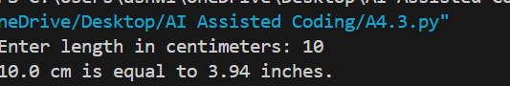
Justification :
This program converts a given length from centimeters to inches using the standard conversion formula (1 inch = 2.54 cm).
The function cm_to_inches() takes the input value in centimeters and divides it by 2.54 to get the result in inches.
The output is rounded to two decimal places to match the expected accuracy

Task 3: Few-Shot Prompting – Name Formatting
Scenario
Few-shot prompting improves accuracy by providing multiple examples.
Task Description
Use few-shot prompting with 2–3 examples to generate a Python function that:
• Accepts a full name as input
• Formats it as “Last, First”
Example formats:
• "John Smith" → "Smith, John"
• "Anita Rao" → "Rao, Anita"
Expected Output
• Well-structured Python function
• Output strictly following example patterns
• Correct handling of names
• Sample inputs and outputs

Prompt:

#Generate a well structured python function that accepts a full name as input Formats it as “Last, First”
#Example formats:"John Smith" → "Smith, John"
"Anita Rao" → "Rao, Anita"

Code:

def format_name(full_name: str) -> str:
"""
Format a full name as "Last, First".
Assumes the input is a string with at least a first and last name.
"""
parts = full_name.strip().split()
if len(parts) < 2:
raise ValueError("Input must contain at least a first and last name.")
first_name = parts[0]
last_name = parts[-1]
return f"{last_name}, {first_name}"
# Example usage
print(format_name("John Smith")) # Expected: "Smith, John"
print(format_name("Anita Rao")) # Expected: "Rao, Anita"

Output:

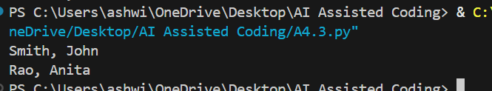

Justification:

This program formats a full name into the required “Last, First” format by using string operations.
Few-shot prompting is applied by providing multiple example name formats, which guides the AI to follow the same pattern.
The function splits the input name into parts and correctly selects the first and last names.

Task 4: Comparative Analysis – Zero-Shot vs Few-Shot
Scenario
Different prompt strategies may produce different code quality.
Task Description
• Use zero-shot prompting to generate a function that counts vowels in a string
• Use few-shot prompting for the same problem
• Compare both outputs based on:
o Accuracy
o Readability
o Logical clarity
Expected Output
• Two vowel-counting functions
• Comparison table or short reflection paragraph
• Conclusion on prompt effectiveness

Prompt:
Zero-shot
#Generate a Python function that counts the number of vowels in a given string.

Code:

def count_vowels(input_string):
vowels = "aeiouAEIOU"
count = 0
for char in input_string:
if char in vowels:
count += 1
return count
# Example usage
user_input = input("Enter a string: ")
vowel_count = count_vowels(user_input)
print(f"The number of vowels in the given string is: {vowel_count}")

Output:

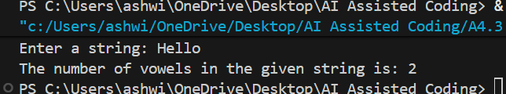

Prompt:
Few-Shot
'''Generate a Python function that counts vowels in a string.
Examples:
Input: "hello" → Output: 2
Input: "Python" → Output: 1'''

Code:

def count_vowels(input_string):
vowels = "aeiouAEIOU"
count = 0
for char in input_string:
if char in vowels:
count += 1
return count
# Example usage
user_input = input("Enter a string: ")
vowel_count = count_vowels(user_input)
print(f"The number of vowels in the given string is: {vowel_count}")

Output:
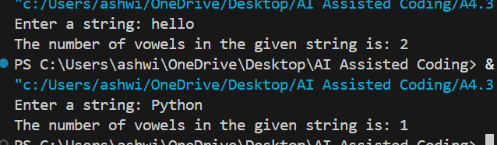

Comparison Table :

Criteria | Zero-Shot Prompting | Few-Shot Prompting
Accuracy | Correct for most inputs | More reliable due to examples
Readability | Simple and clear | Very clear and beginner-friendly
Logical Clarity | Logic is correct but generic | Logic closely follows examples
Guidance | No examples given | Multiple examples guide behavior

Conclusion :
Zero-shot prompting works, but the AI has no examples to follow, so the output can be basic.
Few-shot prompting gives examples, which helps the AI understand the problem better.
Because of the examples, the logic is clearer and the results are more accurate.
Few-shot prompting reduces confusion and improves code quality.
So, few-shot prompting is better for problems like counting vowels.

Task 5: Few-Shot Prompting – File Handling
Scenario
File processing requires clear logical understanding.
Task Description
Use few-shot prompting to generate a Python function that:
• Reads a .txt file
• Counts the number of lines in the file
• Returns the line count
Expected Output
• Working Python file-processing function
• Correct line count
• Sample .txt input and output
• AI-assisted logic explanation

Prompt:

Generate a Python function that reads a text file and counts the number of lines.

Example 1:
File content:
Hello
World
Output: 2

Example 2:
File content:
Python
is
easy
Output: 3

Code:

def count_lines_in_file(file_path):
try:
with open(file_path, 'r') as file:
lines = file.readlines()
return len(lines)
except FileNotFoundError:
print("The specified file was not found.")
return 0
# Example usage
file_path = input("Enter the path to the text file: ")
line_count = count_lines_in_file(file_path)
print(f"The number of lines in the file is: {line_count}")

Justification:
The prompt provides clear examples of similar file-handling tasks to guide the
implementation of a new but closely related operation, ensuring logical consistency and
correct use of file reading concepts.

