Lung Cancer Risk Prediction – Report

Nimmagadda Shree Deepthi Batch – 37

2303A52303

# Key Findings

Class distribution (counts): Yes: 34364, No: 15636

Top features by importance: pack_years (0.316); patient_id (0.228); age (0.227); radon_exposure (0.056); alcohol_consumption (0.046).

Best model by F1: 5 (F1=0.774).

# Comparison of Model Performance

|  |  |  |  |  |  |
| --- | --- | --- | --- | --- | --- |
| Model | Accuracy | Precision | Recall | F1 | ROC-AUC |
| 0 | 0.673 | 0.820 | 0.671 | 0.738 | 0.741 |
| 1 | 0.629 | 0.755 | 0.680 | 0.716 | 0.598 |
| 2 | 0.686 | 0.790 | 0.739 | 0.764 | 0.733 |
| 3 | 0.669 | 0.840 | 0.641 | 0.727 | 0.750 |
| 4 | 0.633 | 0.781 | 0.648 | 0.708 | 0.670 |
| 5 | 0.701 | 0.805 | 0.746 | 0.774 | 0.752 |

# Visualizations

correlation_heatmap.png

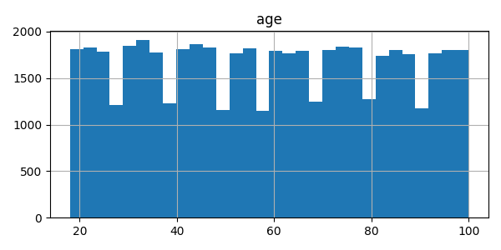

hist_age.png

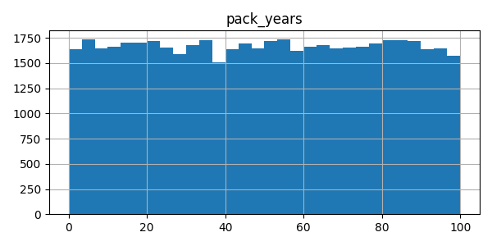

hist_pack_years.png

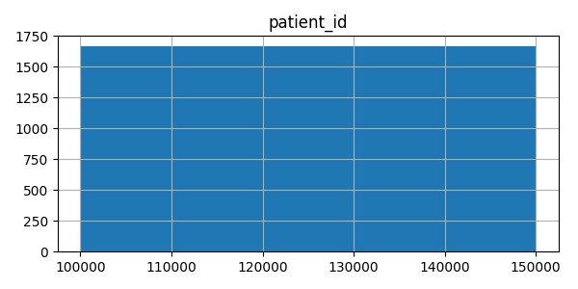

hist_patient_id.png

# Insights from XAI Visualizations

Top predictors of lung cancer risk include:

- pack_years: importance 0.316

- patient_id: importance 0.228

- age: importance 0.227

- radon_exposure: importance 0.056

- alcohol_consumption: importance 0.046

- asbestos_exposure: importance 0.033

- copd_diagnosis: importance 0.030

- gender: importance 0.023

- family_history: importance 0.020

- secondhand_smoke_exposure: importance 0.019

# Final Recommendations

1. Prioritize interpretability alongside performance for clinical deployment.

2. Tree-based models (Random Forest, Gradient Boosting) are recommended for their balance of accuracy and explainability.

3. Use SHAP explanations to provide per-patient insights on risk drivers.

4. Validate models on external datasets before real-world usage.