Lab Assignment 17– AI Assistant Coding
2303A52304
V.HRK SRI HARSHA VIGNESH
Task 1: I-Employee Dataset Cleaning
Prompt used:
Create a Python script in Google Colab to clean an employee dataset. Create a dataset manually using pandas.Handle missing values in salary using median.Handle missing values in designation using mode. Handle missing values in experience using mean.Remove duplicate employee IDs.Convert all job titles (designation) to lowercase. Encode categorical columns (designation, employment_type) using LabelEncoder.Display the cleaned dataset.
Code:
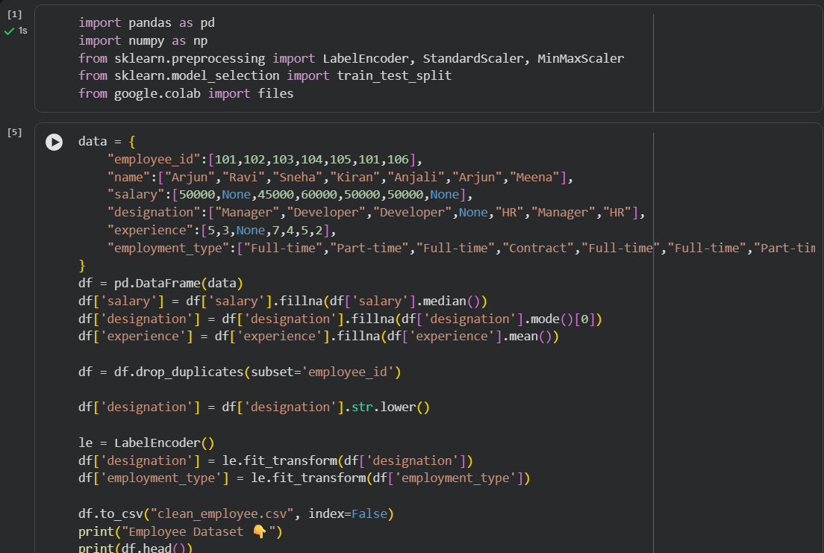
Input:
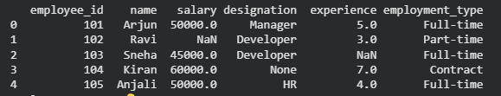
Output:
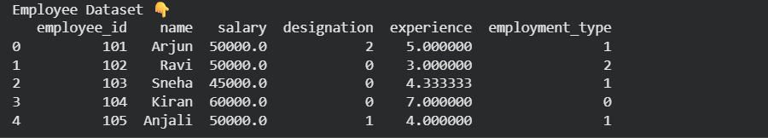
Justification:
Cleaning the employee dataset ensures accurate HR analysis by handling missing values in salary, designation, and experience to avoid incorrect insights.Removing duplicate IDs and standardizing and encoding data makes the dataset consistent and ready for machine learning
Task 2: Student Performance Data Preprocessing
Prompt used:
Create a Python script to preprocess student performance data.Create dataset manually using pandas.Convert exam_date column into datetime format.Extract new features: month, day, and semester.Normalize total_marks using MinMaxScaler.Detect and remove outliers using IQR method.Display the transformed dataset.
Code:
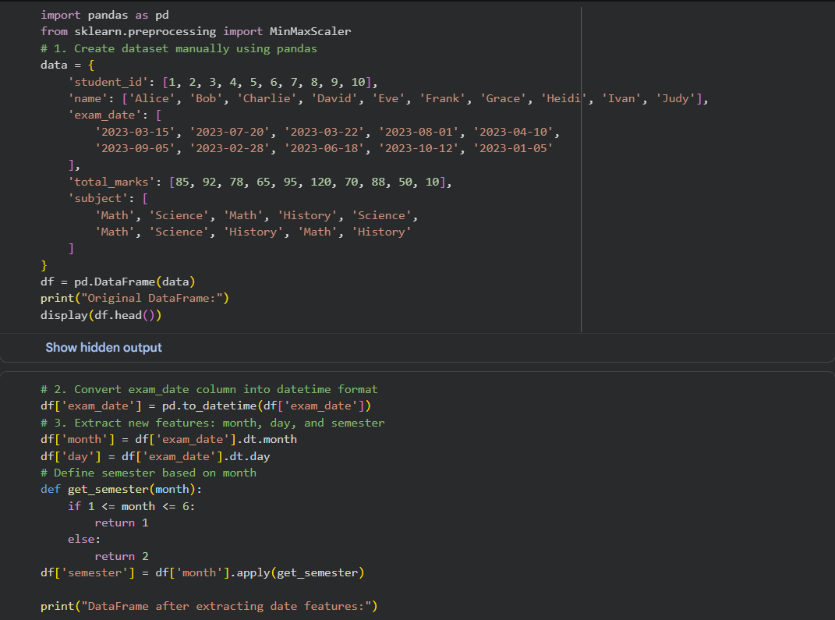
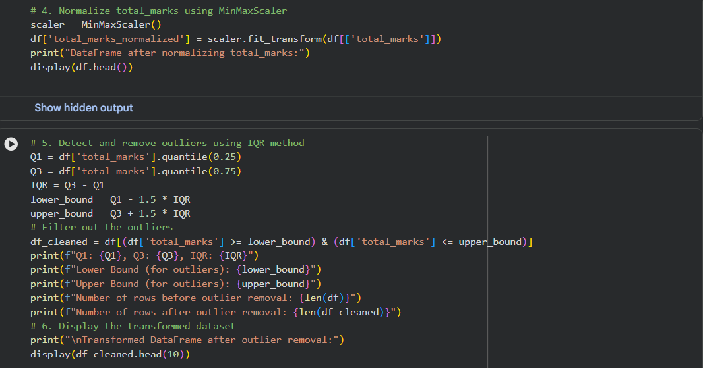
Input:
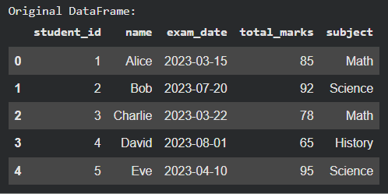
Output:
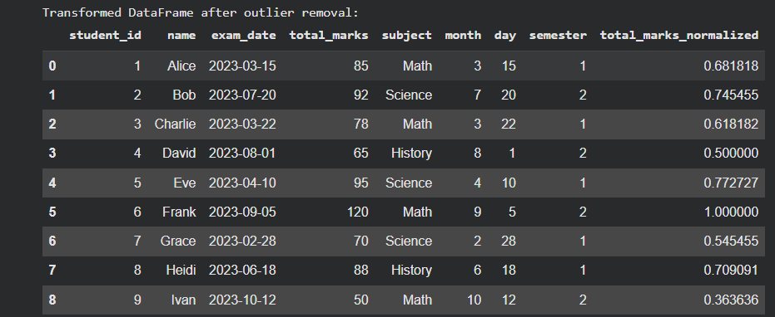
Justification:
Preprocessing student data helps in understanding academic patterns more effectively. Converting exam dates allows extraction of useful features like month and semester. Normalizing marks ensures all values are on the same scale, improving model performance. Removing outliers prevents extreme values from affecting analysis, making predictions more reliable.
Task 3: Student Health Data Preparation
Prompt used:
Create a Python script for student health dataset preparation. Create dataset manually using pandas.Handle missing values in height, weight, BMI using mean.Encode categorical features (medical_condition, fitness_status) using one-hot encoding.Scale numerical features using StandardScaler.Split dataset into training and testing sets (80:20). Display processed dataset and shapes of train/test sets.
Code:
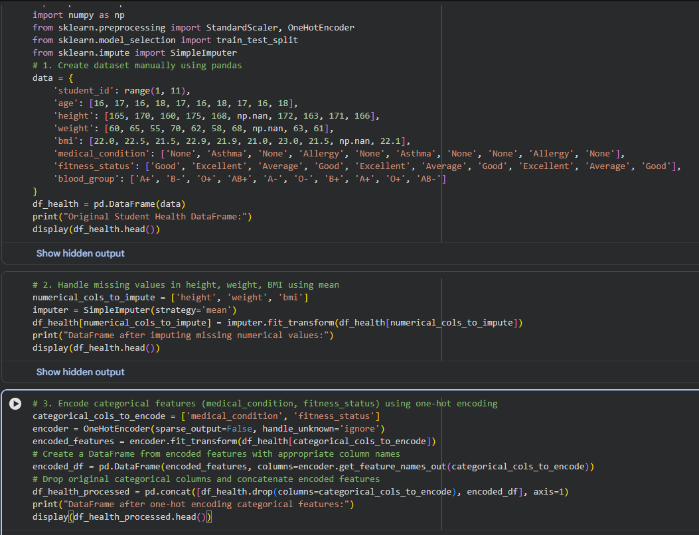
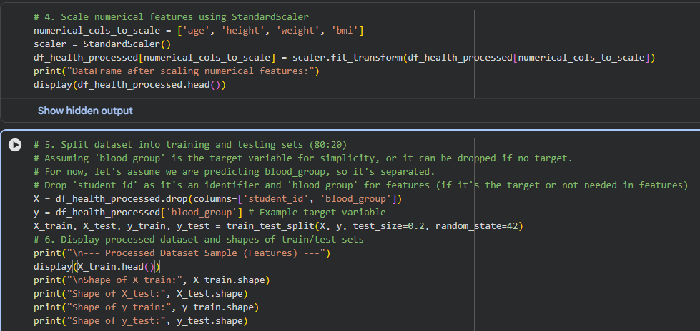

Input:
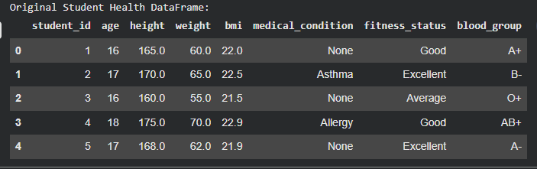
Output:
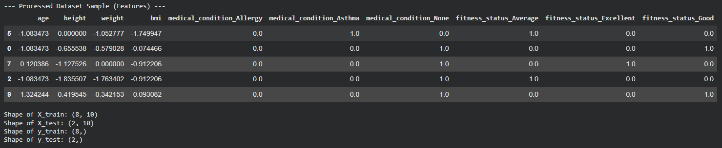
Justification:
Preparing health data is essential for building accurate predictive models. Missing values in height, weight, and BMI are handled to avoid incomplete records. Encoding categorical data makes it usable for machine learning algorithms. Scaling ensures all features contribute equally, and splitting the dataset helps evaluate model performance effectively

Task 4: Real-Time Application: Ride-Sharing Data Cleaning
Prompt used:
Create a Python script in Google Colab to clean ride-sharing data.Create dataset manually using pandas.Standardize pickup and drop locations (lowercase and remove spaces).Fill missing fare values using median.Remove duplicate rows.Normalize driver_rating using MinMaxScaler.Display cleaned dataset.Generate a summary (shape and missing values).
Code:
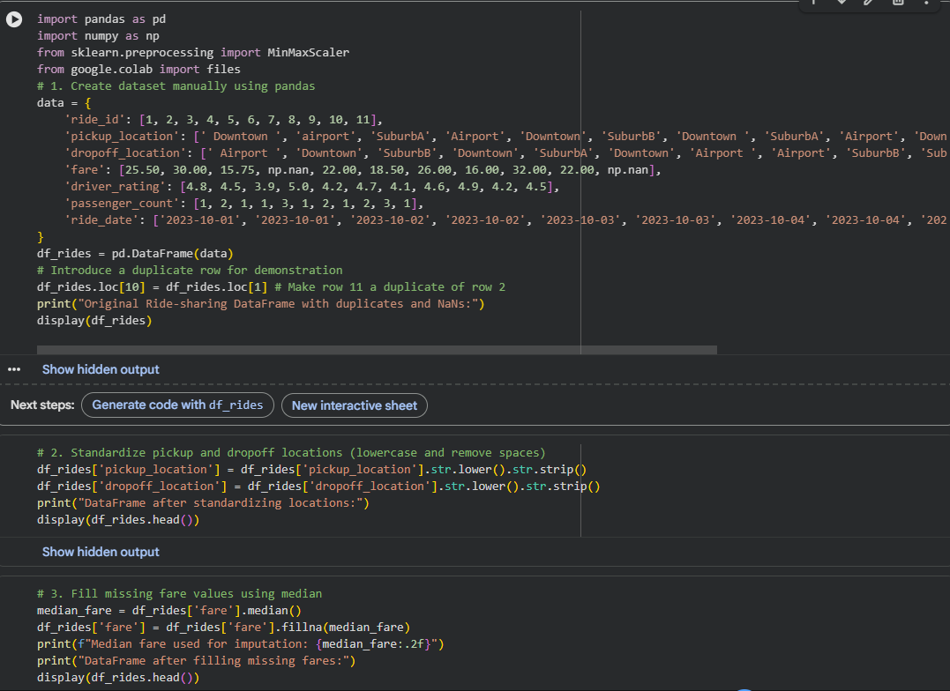
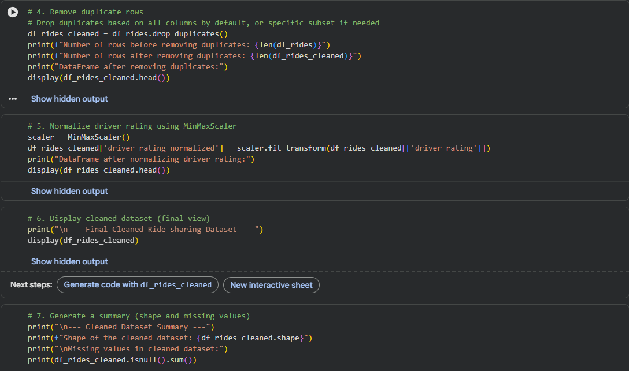

Input:
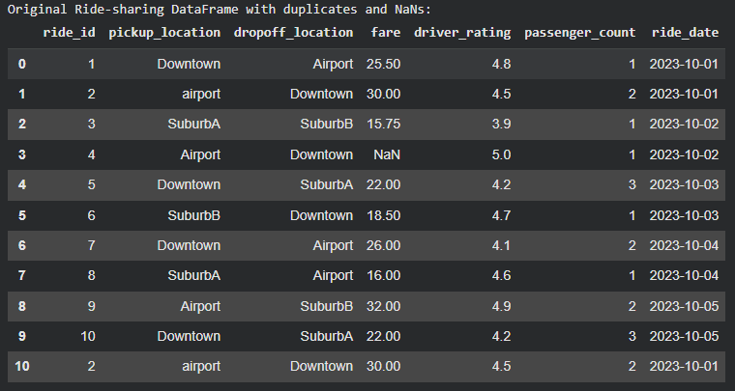
Output:
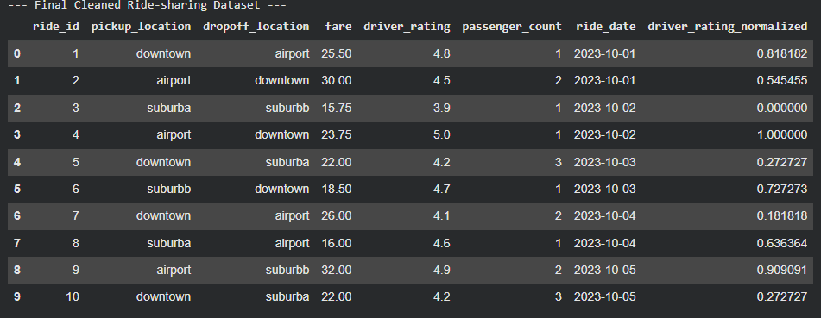
Justification:
Cleaning ride-sharing data improves operational efficiency and decision-making. Standardizing location names avoids duplication and confusion. Filling missing fare values ensures revenue analysis is accurate. Removing duplicate entries prevents incorrect records, and normalizing ratings helps in fair comparison. Overall, the cleaned dataset becomes reliable for business insights and analytics.

